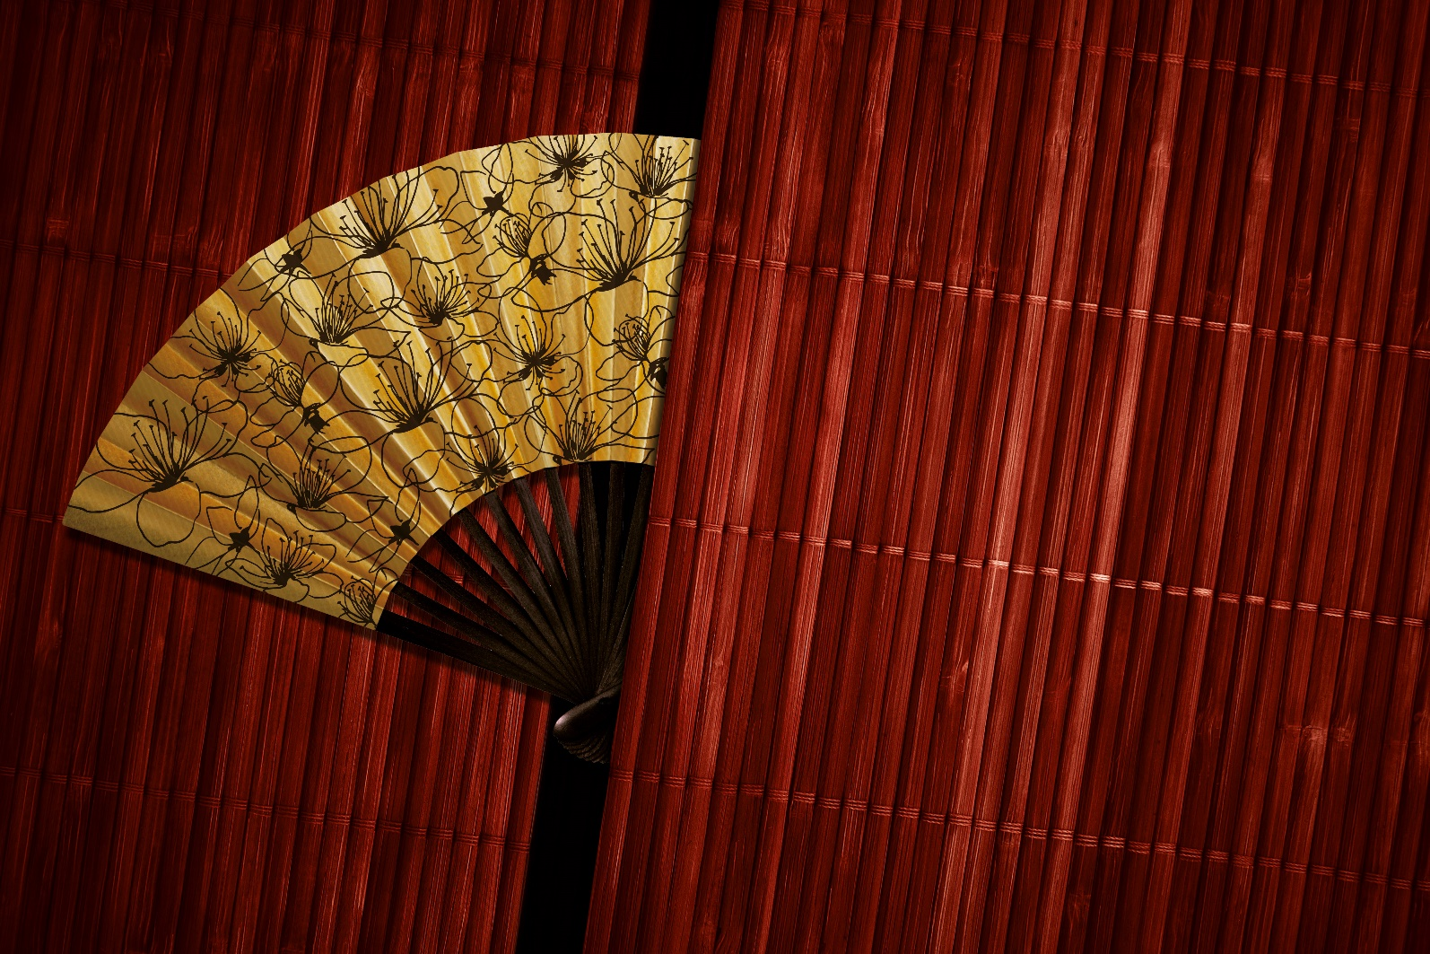
Hong Kong Arts Centre FUNd-Raising Dinner 2015
Charity Art Auction
AUCTION
Live Auction (By invitation only)
Wednesday, 9 December 2015
Assaggio, 6/F, Hong Kong Arts Centre

Enquiries
Ms Wendy Chiu
T: (852) 2582 0283
E: wchiu@hkac.org.hk

Item | Artist | Artwork Image | Artwork Info | Estimated Price (HK$)
1 | Wesley TONGSON | 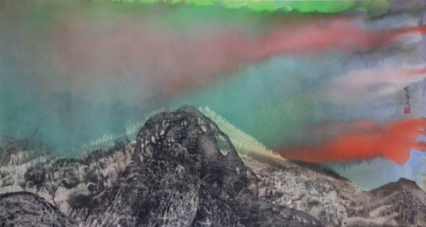 | The Silent Mountains  《寂寂群山》  1995  Ink and colour on paper  180 (W) x 96 (H) cm  Artwork donated by  The Family of Wesley Tongson | 80,000
2 | LI Lei | 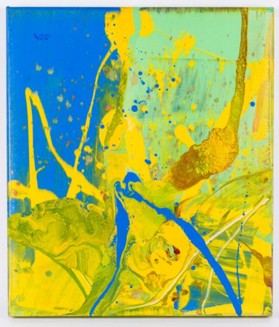 | Summer Memories No. 27  《初夏的回憶 No. 27》  2010  Acrylic on canvas  60 (W) x 70 (H) cm  Artwork donated by  the artist | 50,000 – 80,000
3 | Annie LEIBOVITZ | 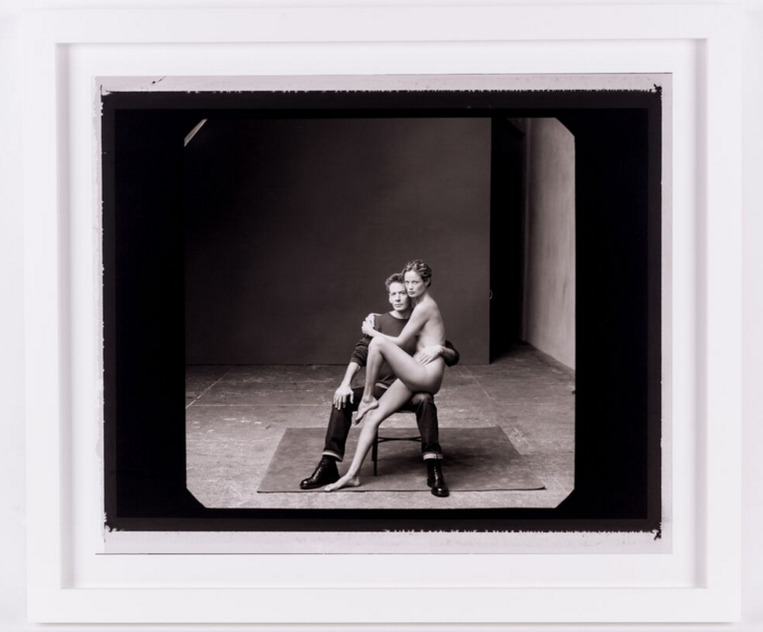 | Calvin Klein and  Carolyn Murphy, New York City  1999  Archival pigment print  91(W) x 77.5 (H) cm  Artwork donated by Sundaram Tagore Gallery | 150,000 – 180,000

Item | Artist | Artwork Image | Artwork Info | Estimated Price (HK$)
4 | Antony GORMLEY | 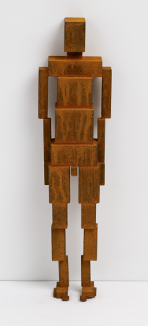 | MEME CCCXXVI  2013  Cast iron  9.5 (W) x 37 (H) x 8 (L) cm  3.9kg  Artwork donated by  the artist  c/o White Cube | 400,000 – 450,000
5 | HEUNG  Kin-fung, Alex | 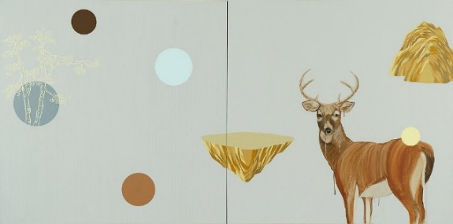 | Wild Deer Garden. Reversed World  2010  Acrylic and charcoal on linen  152 (W) x 76 (H) cm  Artwork donated by  the artist | 40,000
6 | HEUNG  Kin-fung, Alex | 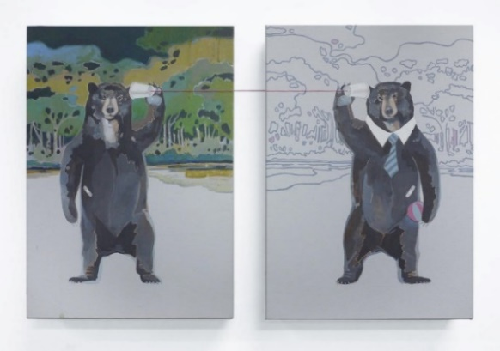 | Ear Consciousness  2013  Magenta line, acrylic on linen A set of two  25 (W) x 35 (H) cm each  Artwork donated by  the artist | 20,000
Item | Artist | Artwork Image | Artwork Info | Estimated Price (HK$)
7 | Danful YANG | 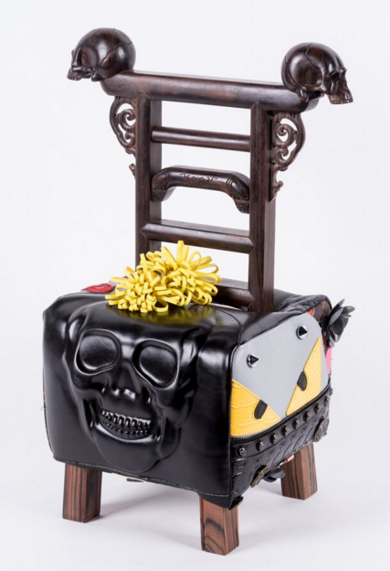 | Mini Fake  2012  African hei tan, fake bags, foam  30 (W) x 55 (H) x 28 (L) cm  Artwork donated by  Pearl Lam Galleries | 48,000
8 | Nadim ABBAS | 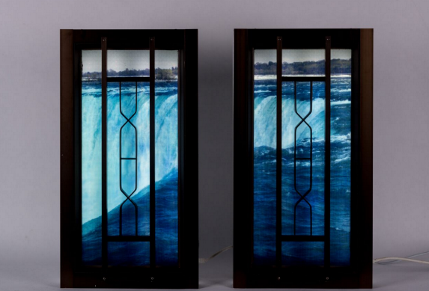 | Niagara  2010  Kinetic lightbox with Duratran print and aluminum window frame  A set of two  40 (W) x 75 (H) x 11(L) cm each  Edition 2 of 5  Artwork donated by  the artist and  Hugh Zimmern (Faux Ltd.) | 40,000

Item | Artist | Artwork Image | Artwork Info | Estimated Price (HK$)
9 | Pia FRIES | 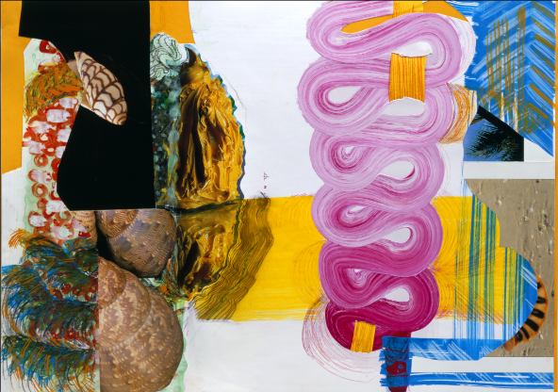 | Esse No. 2  2003  Mixed media on paper  Sheet 69 (W) x 51 (H) cm  Framed 83 (W) x 64 (H) cm  Artwork donated by  the artist | 30,000 –48,000
10 | Vaan IP | 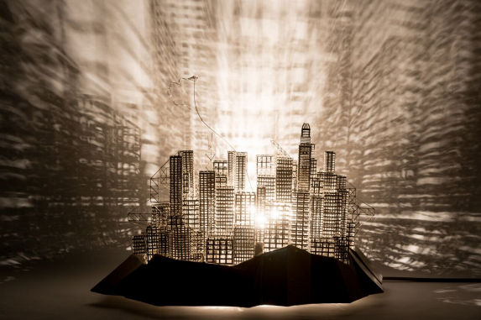  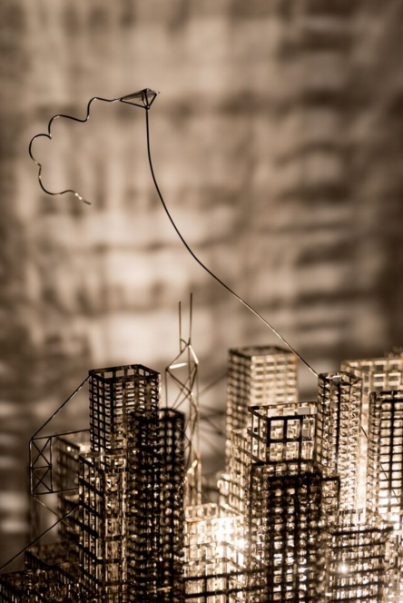 | Lost City – HKG Special Edition  2015  Stainless steel, electronic components, light bulb  63 (W) x 44 (H) x 64 (L) cm | 40,000 –50,000

Item | Artist | Artwork Image | Artwork Info | Estimated Price (HK$)
11 | Chihoi | 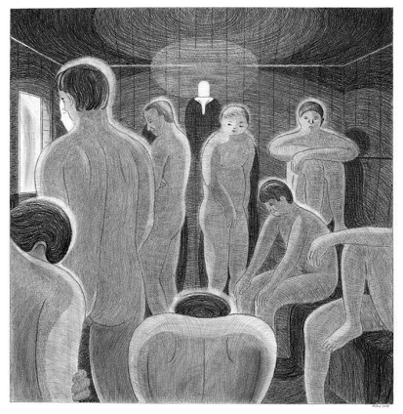 | Sauna Room 2  2014  Pencil on paper  37 (W) x 38 (H) cm  Artwork donated by  Gallery Exit | 35,000
12 | Bo LAW | 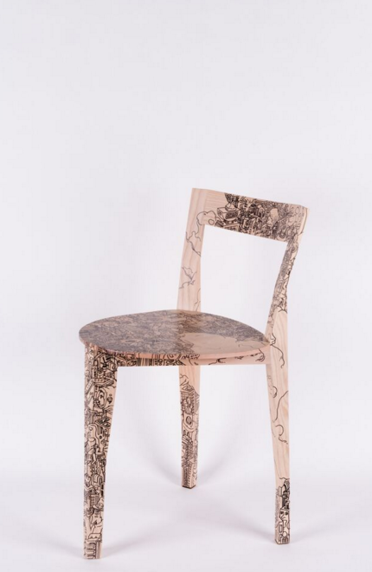 | My Home  2015  Paint and oil marker on Italian oak Petite Gigue wood chair  40 (W) x 70 (H) x 40 (L) cm  Artwork donated by  the artist | 18,000 – 25,000
Item | Artist | Artwork Image | Artwork Info | Estimated Price (HK$)
13 | HO Sin Tung | 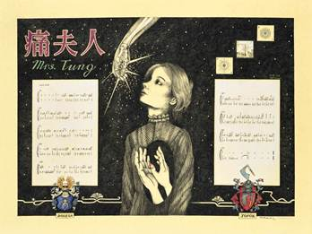 | Miss Dong Quartet: Mrs. Tung (Pain)  2015  Colour pencil and ink on paper mounted on board  92 (W) x 70 (H) cm  Artwork donated by  Hanart TZ Gallery | 60,000 –70,000
14 | LAM Tung Pang | 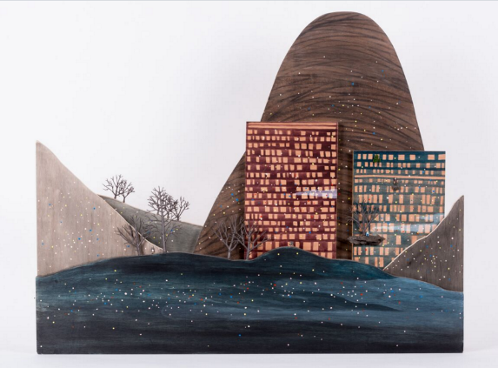 | Scale Mountain No.2  2011  Acrylic, charcoal and scale models on plywood  100 (W) x 80 (H) x 9 (L) cm  Artwork donated by  Hanart TZ Gallery | 85,000 – 110,000
Item | Artist | Artwork Image | Artwork Info | Estimated Price (HK$)
15 | Joseph Chak WONG | 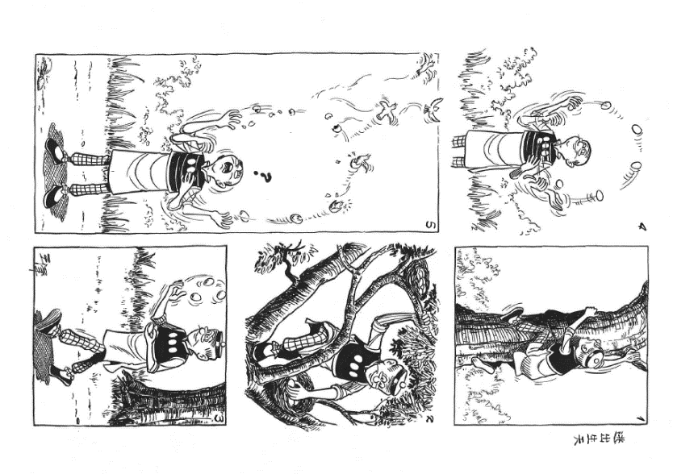 | Find a Way Out –  Original Work of  Old Master Q Comic Strip  2015  Ink on paper  Sheet 29.7 (W) x 42 (H) cm  Framed 35 (W) x 47 (H) cm  Artwork donated by  the artist | 55,000
Item | Activity |  | Details | Minimum Donation Amount (HK$)
16 | Family Portraiture Activity  by Hong Kong Art School Graduate (Jimmy KEUNG)  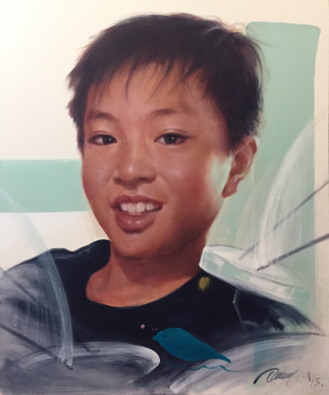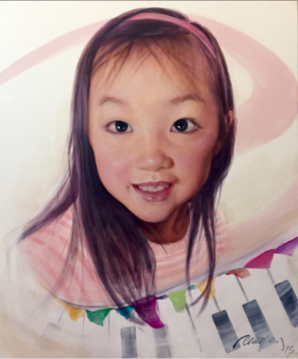  (Artwork reference by Jimmy KEUNG) |  | A family portrait to be created by the painting artist  Maximum no. of family members: 5  Maximum size of artwork: 120 (W) x 100 (H) cm (unframed) | 20,000

Item | Artist | Artwork Image | Artwork Info | Estimated Price (HK$)
17 | Valérie BUESS | 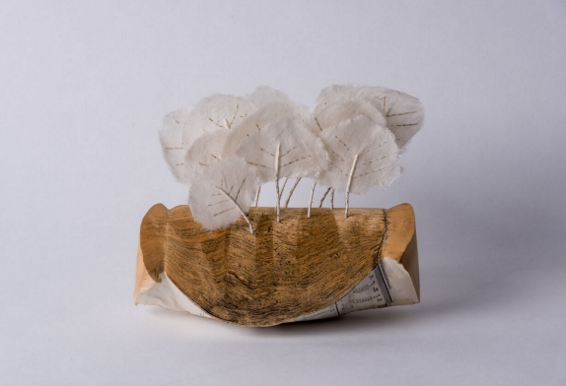 | * Silent Auction Item  revolt of the woods  2009  Paper (various)  21 (W) x 19 (H) x 15.5 (L) cm  Artwork donated by  the artist | 5,000
Item | Activity |  | Details | Minimum Donation Amount (HK$)
18 | Family Studio Photography  by Hong Kong Art School Graduate (SO Wing Hon)  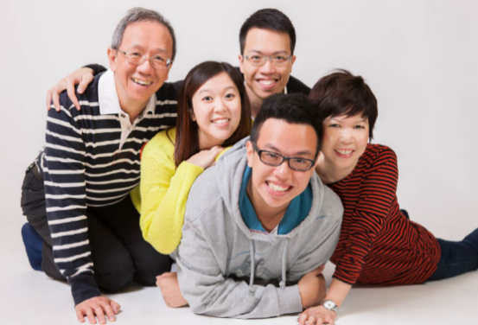  (Artwork reference by SO Wing Hon) |  | * Silent Auction Item  Maximum no. of family members: 10  Products:  - 1 big photo framed in 18R size or 2 combined photo frames  - 10 hardcopies in 8R size  - 30 edited softcopies  - All softcopies of the shooting without editing | 15,000
19 | Dinner for Eight at Crown Wine Cellars Private Members’ Club 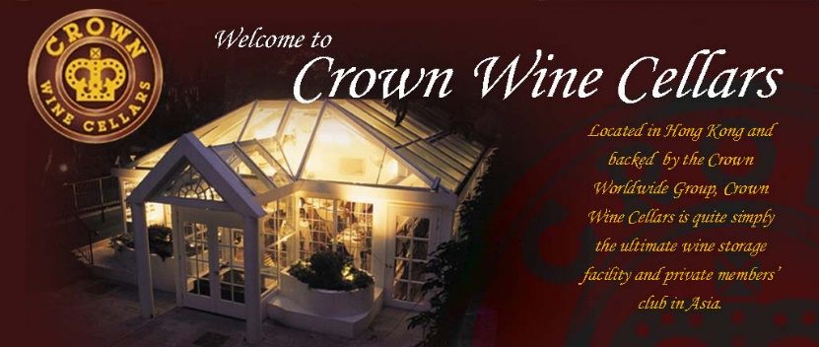 |  | * Silent Auction Item  A four-course dinner for eight at Crown Wine Cellars Private Members’ Club  Donated by  Mr James Thompson, GBS | 10,000
Item No. 1
The Silent Mountains
《寂寂群山》

1995
Ink and colour on paper
180 (W) x 96 (H) cm

Estimate HK$80,000

Generously donated by
The Family of Wesley Tongson
Wesley TONGSON唐家偉
Wesley Tongson was enchanted with ink, dedicating his life to exploring its many methods and effects. The artist studied under Madame Koo Tsin-yaw and Harold Wong, and was inspired by many great ink artists of the past. His work has been shown in numerous solo and group exhibitions, most recently, a November 2014 retrospective at the Hong Kong Arts Centre. His work is in collections including the Hong Kong Museum of Art, Morgan Stanley Asia Limited, First Eastern Investment Group as well as numerous private collections worldwide.

Item No. 2
Summer Memories No. 27
《初夏的回憶No. 27》

2010
Acrylic on canvas
60 (W) x 70 (H) cm

Estimate HK$50,000 – $80,000

Generously donated by the artist
LI Lei李磊
Li Lei is currently the Deputy Director of the China Art Museum, Shanghai and a Professor at Tongji University. Li Lei was also previously the Executive Director of the Shanghai Art Museum and Executive President of the Shanghai Oil Painting & Sculpture Institute. He had a solo art exhibition, “Water to Water”, in the Pao Galleries of Hong Kong Arts Centre in October 2015.

Li Lei embarked on the practice and research of Chinese Abstract Art from 1996, striving to combine the essence of Chinese culture with an international abstract art visual language, and to develop a new direction for Chinese abstract art. His main works include the series: Dhyana Flower, Jiang Nan (Memories of South), Drunken Lake, Shanghai Flower, and Flame of Pompeii. He has held solo exhibitions in Beijing, Shanghai and Hong Kong, China, and has also exhibited widely in America, Germany, Holland, and Belgium.

His works have been collected by private collectors in China and Hong Kong.

Item No. 3
Calvin Klein and Carolyn Murphy, New York City

1999
Archival pigment print
91 (W) x 77.5 (H) cm

Estimate HK$150,000 – $180,000

Generously donated by
Sundaram Tagore Gallery
Annie LEIBOVITZ
Annie Leibovitz began her career as a photojournalist for Rolling Stone magazine in 1970 while she was still a student at the San Francisco Art Institute. In 1983, she joined the staff of Vanity Fair magazine, where, over three decades, she has developed a large body of work—images of actors, directors, writers, musicians, athletes, and political and business figures—offering a collective portrait of contemporary life.

Today, her photographs of celebrated figures assume gestures and poses that expose a private side of their personalities. Leibovitz is the recipient of many honours, including the International Center of Photography’s Lifetime Achievement Award, The American Society of Magazine Editors’ first Creative Excellence Award and the Centenary Medal of the Royal Photographic Society in London. Several collections of Leibovitz’s work have been published and exhibitions of her work have been held at museums and galleries worldwide, including at the National Portrait Gallery and the Corcoran Gallery of Art in Washington, DC; the International Center of Photography in New York; the Brooklyn Museum; the Stedelijk Museum in Amsterdam; the Maison Européenne de la Photographie in Paris; the National Portrait Gallery in London; the Hermitage Museum in St. Petersburg and the Pushkin Museum of Fine Arts in Moscow.

Several collections of Leibovitz’s work have been published. They include Annie Leibovitz: Photographs (1983); Annie Leibovitz: Photographs 1970–1990 (1991); Olympic Portraits (1996); Women (1999), in collaboration with Susan Sontag; American Music (2003); A Photographer’s Life, 1990-2005 (2006); Annie Leibovitz at Work (2008), a first person commentary on her career; and Pilgrimage (2011).

Item No. 4
MEME CCCXXVI

2013
Cast iron
9.5 (W) x 37 (H) x 8 (L) cm
3.9kg

Estimate HK$400,000 – $450,000

Generously donated by the artist c/o White Cube
Antony GORMLEY
Antony Gormley is widely acclaimed for his sculptures, installations and public artworks that investigate the relationship of the human body to space. His work has developed the potential opened up by sculpture since the 1960s through a critical engagement with both his own body and those of others in a way that confronts fundamental questions of where human beings stand in relation to nature and the cosmos. Gormley continually tries to identify the space of art as a place of becoming in which new behaviours, thoughts and feelings can arise.

Gormley’s work has been widely exhibited throughout the UK and internationally with exhibitions at Zentrum Paul Klee, Bern (2014); Centro Cultural Banco do Brasil, São Paulo, Rio de Janeiro and Brasilia (2012); Deichtorhallen, Hamburg (2012); The State Hermitage Museum, St Petersburg (2011); Kunsthaus Bregenz, Austria (2010); Hayward Gallery, London (2007); Malmö Konsthall, Sweden (1993) and Louisiana Museum of Modern Art, Humlebæk, Denmark (1989). He has also participated in major group shows such as the Venice Biennale (1982 and 1986) and Documenta 8, Kassel, Germany (1987). Permanent public works include the Angel of the North (Gateshead, England), Another Place (Crosby Beach, England), Inside Australia (Lake Ballard, Western Australia) and Exposure (Lelystad, The Netherlands).

Gormley was awarded the Turner Prize in 1994, the South Bank Prize for Visual Art in 1999, and the Bernhard Heiliger Award for Sculpture in 2007, the Obayashi Prize in 2012 and the Praemium Imperiale in 2013. In 1997 he was made an Officer of the British Empire (OBE) and was made a knight in the New Year’s Honours list in 2014. He is an Honorary Fellow of the Royal Institute of British Architects, an Honorary Doctor of the University of Cambridge and a Fellow of Trinity and Jesus Colleges, Cambridge. Gormley has been a Royal Academician since 2003 and a British Museum Trustee since 2007.

Antony Gormley was born in London in 1950.

Item No. 5
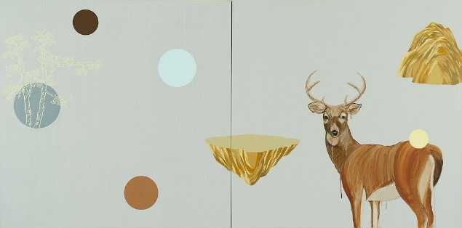 | Wild Deer Garden. Reversed World  2010  Acrylic and charcoal on linen  152 (W) x 76 (H) cm  Estimate HK$40,000  Generously donated by the artist
HEUNG Kin-fung, Alex 香建峰
Heung Kin Fung, Alex, received his BA (Fine Art) and MFA degrees from Royal Melbourne Institute of Technology (RMIT) University (co-presented with the Hong Kong Art School). He is a lecturer of the Hong Kong Art School. Alex has taken part in a number of local and overseas exhibitions. His works have been collected by the Hong Kong Museum of Art and private collectors.

Item No. 6
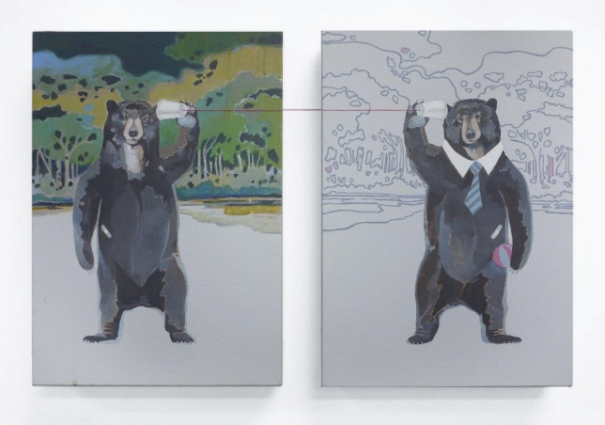 | Ear Consciousness  2013  Magenta line, acrylic on linen  A set of two  25 (W) x 35 (H) cm each  Estimate HK$20,000  Generously donated by the artist
HEUNG Kin-fung, Alex 香建峰
Heung Kin Fung, Alex, received his BA (Fine Art) and MFA degrees from Royal Melbourne Institute of Technology (RMIT) University (co-presented with the Hong Kong Art School). He is a lecturer of the Hong Kong Art School. Alex has taken part in a number of local and overseas exhibitions. His works have been collected by the Hong Kong Museum of Art and private collectors.

Item No. 7
Mini Fake

2012
African hei tan, fake bags, foam
30 (W) x 55 (H) x 28 (L) cm

Estimate HK$48,000

Generously donated by
Pearl Lam Galleries
Danful YANG楊丹鳳
Born in 1980, the young Chinese designer Danful Yang reinvents traditional Chinese art and craft techniques using modern Western materials to create playful and visually dynamic works.

Although she is not formally trained in design, she has worked closely with internationally renowned designers including Martin Szekely, André Dubreuil, Jurgen Bey, Mattia Bonetti, and Maarten Baas as well as skilled craftsmen, who have contributed to her design education. The designer’s works have been collected by the Montreal Museum of Fine Arts, Craig Robins (part-owner of Design Miami), and Billie Weisman (The Fredrick R. Weisman Art Foundation).

Her iconic ‘Fake’ armchair is an over-the-top hybrid chair that is an amalgamation of Chinese and western Rococo styles upholstered with fake designer handbags. The creative work is a cross-cultural bombardment of visual stimuli, turning imitation into originality and reflecting the onslaught of a globalised consumer culture. Her works are often playful and incorporate objects and materials in unexpected ways.

Item No. 8
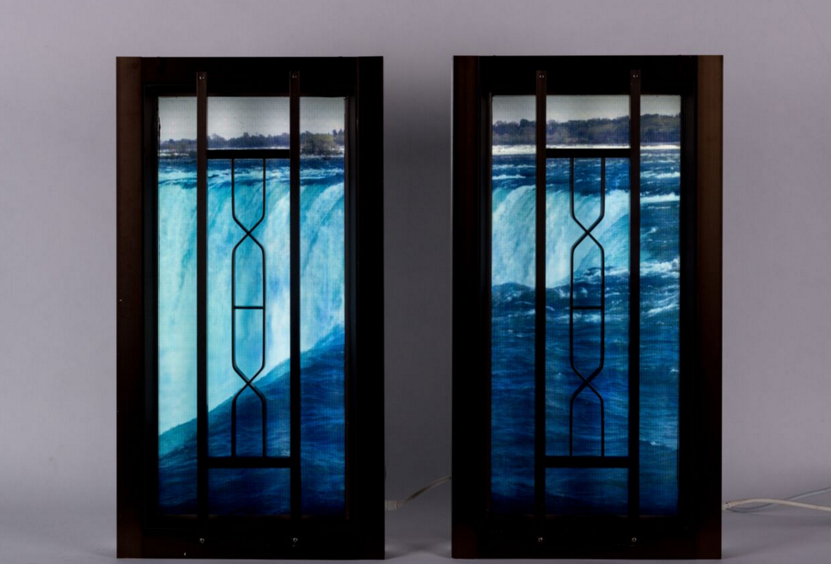 | Niagara  2010  Kinetic lightbox with Duratran print and aluminum window frame  A set of two  40 (W) x 75 (H) x 11 (L) cm each  Edition 2 of 5  Estimate HK$40,000  Generously donated by the artist and Hugh Zimmern (Faux Ltd.)

Nadim ABBAS唐納天
Nadim ABBAS examines the structural and political properties of images and their precarious relationship with reality. Revolving around the psychological influences of kitsch and cliché, his sculptural installations are immersive environments of ambiguous forms. Frequently incorporating objects from flea markets and dollar shops, casting, animation and photography, ABBAS weaves together extensive research with sophisticated visual manoeuvres to destabilise our perception of space. Abbas received his BFA from London's Chelsea College of Art & Design and MPhil from the University of Hong Kong Department of Comparative Literature. He teaches at the City University Hong Kong School of Creative Media and the Hong Kong Art School/ RMIT University. His work has been widely exhibited in Hong Kong and internationally with exhibitions at New Museum, New York (2015), NRW- Forum Dusseldorf, Germany (2015), Hong Kong Arts Centre (2014), etc. His works have been collected by museums and private collectors.

Item No. 9
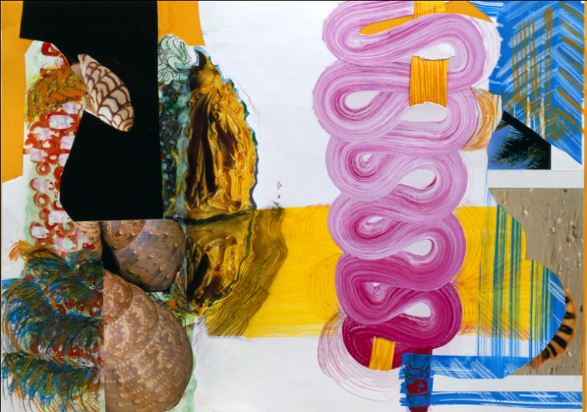 | Esse No. 2  2003  Mixed media on paper  Sheet 69 (W) x 51 (H) cm  Framed 83 (W) x 64 (H) cm  Estimate HK$30,000 – $48,000  Generously donated by the artist
Pia FRIES
Pia Fries (born October 6, 1955) is a Swiss painter. Fries was born in Beromunster, Switzerland and studied sculpture in Lucerne in 1980, and painting under Gerhard Richter at the Kunstakademie Düsseldorf in 1986.

Fries works are paintings but the paint is so sculpted that is almost sculpture. Fries has received numerous awards and scholarship in Europe. Her works have been widely collected in museums and private collectors.

 | Item No. 10
Lost City – HKG Special Edition

2015
Stainless steel, electronic components, light bulb
63 (W) x 44 (H) x 64 (L) cm

Estimate HK$40,000 – $50,000

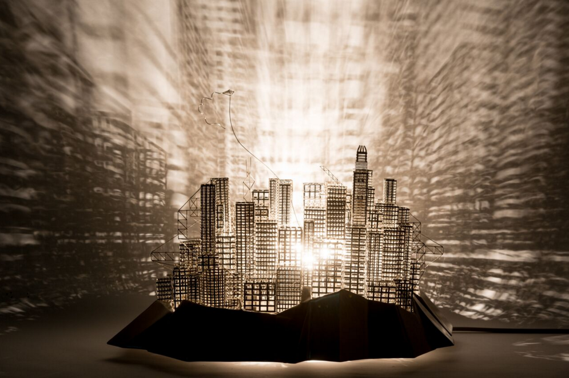
 | Vaan IP葉梵
Born in Hong Kong in 1987, Ip graduated from the Hong Kong Art School, major in Painting.

Ip works as a full-time artist. His work is a tangible expression of the desire to unlock and blur boundaries of forms within the city. He has worked on depictions of the local cityscape and the urban architecture intensively.

He has participated in various art exhibitions actively since 2007. Ip's work has been exhibited in different cities such as Hong Kong, Tokyo, Bangkok, Incheon, etc. In the summer of 2015, he was invited by the Incheon Metropolitan City Government to join “The 18th International Sculpture Symposium Incheon”. His 5 meter-tall Lost City public art sculpture was selected by the City Government to be exhibited in the park of Incheon city. Collectors of his art include local galleries and private collections in Hong Kong and abroad.
Item No. 11
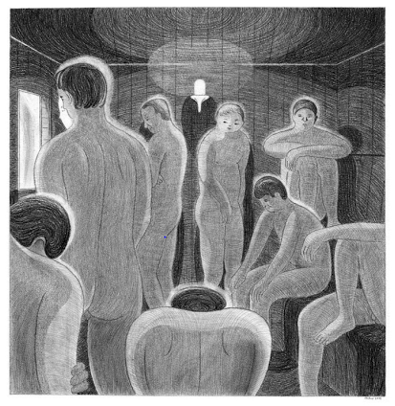 |  |  |  |  | Sauna Room 2  2014  Pencil on paper  37 (W) x 38 (H) cm  Estimate HK$35,000  Generously donated by Gallery Exit
Chihoi智海
Born in 1977 in Hong Kong, Chihoi has liked drawing since childhood. He graduated from the Chinese University of Hong Kong (1999), majoring in Food and Nutritional Sciences. Since 1996, the self-taught artist began to release comics, illustration and writing in local press media, and his comics have appeared in various international anthologies. His comics have been translated into Italian, French and English.

Chihoi has participated in various art exhibitions actively around the globe since 2005. In 2006, he had a solo exhibition called "Comix Homebase -- Comix Magneto"(漫畫工地：漫有引力) at the Hong Kong Arts Centre. In the same year, he joined the group exhibition "District Borders" at Shanghai Street Artspace in Hong Kong; "The Inner, Outer Sphere – Hong Kong Contemporary Arts Exhibition", at KK Gallery in Hamburg Germany; and Hong Kong Springrolllll -- Past Continuous Tense", Fumetto Comix Festival at Luzern, Switzerland.

In 2007, Chihoi participated in other renowned group exhibitions like, Comix World Expo (Exposition universelle de la bande dessinée) -- #1 Seul dans la foule", International Comic Festival of Angoulême, France; "Comix Magneto -- Singapore Version", Substation, Singapore; "Autobibliophiles -- Artists who make or use books", Studio Bibliotheque, Fo Tan, Hong Kong; and Poetry and Comics" in Taipei Poetry Festival, NTUE Nanhai Gallery, Taipei.

In 2010, Chihoi joined "Legacy and Creations - Art vs Art", Museum of Contemporary Art Shanghai, Shanghai; Hong Kong Museum of Art. In 2011, he was awarded the Désirée and Hans Michael Jebsen Fellowship, by the Asian Cultural Council. His works have been collected by private collectors in Hong Kong.
 | Item No. 12
My Home

2015
Paint and oil marker on Italian oak Petite Gigue wood chair

40 (W) x 70 (H) x 40 (L) cm

Estimate HK$18,000 – $25,000

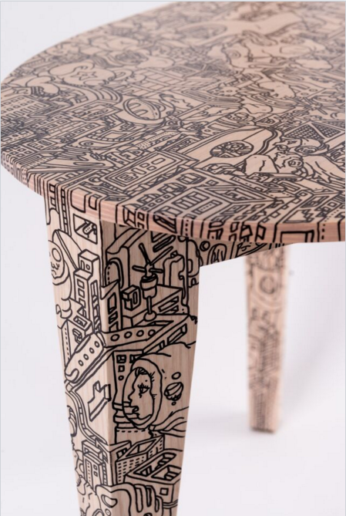
Generously donated by the artist
 | Bo LAW羅浩光
 | Born in 1984, Law Ho Kwong is a Hong Kong‐based illustrator who received his higher diploma in Communication Design from Hong Kong Art School in 2008. Law actively participates in various art projects with local non‐profit organisations and commercial corporates. Constantly inspired by the living environment around him, Law focuses on projecting the cityscape of Hong Kong in his paintings subsequently. In 2013, he was invited to Japan for the "Setouchi Triennale 2013 - Asia Art Platform ‘Fukutake House’ Project" as an illustrator. Law has been invited by Hong Kong Arts Centre for tram and airport art project. His works have been collected by corporate and private collectors in Hong Kong.
 | Item No. 13
Miss Dong Quartet:
Mrs. Tung (Pain)

2015
Colour pencil and ink on paper
mounted on board
92 (W) x 70 (H) cm

Estimate HK$60,000 – $70,000

Generously donated by Hanart TZ Gallery

 | HO Sin Tung何倩彤
 | Ho Sin Tung was born in Hong Kong in 1986 and started learning painting at Cultural Corner founded by Gaylord Chan in 1989. She graduated from the Department of Fine Arts of the Chinese University of Hong Kong and obtained her Bachelor of Arts in 2008. Her solo exhibitions include Don’t shoot the messenger (Hanart TZ Gallery, Hong Kong, 2010), Folie à deux (Experimenta, Hong Kong, 2011), You Are Running A Business Called None of My Business (Hanart TZ Gallery, Abu Dhabi Art Fair, 2011), and Hong Kong Inter-vivos Film Festival (Hanart TZ Gallery, Hong Kong, 2012). Ho participated in the Hong Kong International Contemporary Art Fair (Hong Kong Convention and Exhibition Centre, 2007 and 2008), the Hong Kong International Art Fair (Hong Kong Convention and Exhibition Centre, 2008), and Artwalk (Central district, Hong Kong, 2008 and 2009). In addition to a number of awards she received during her undergraduate study, Ho was the semi-finalist of the Art Competition of the Philippe Charriol Foundation (2005), the finalist of the Hong Kong Contemporary Art Biennial Awards (2009), and the finalist of Societe Generale Chinese Art Awards (2010). Her works has been exhibited in Beijing, Paris, Shanghai, Singapore, and Taipei.

Item No 14
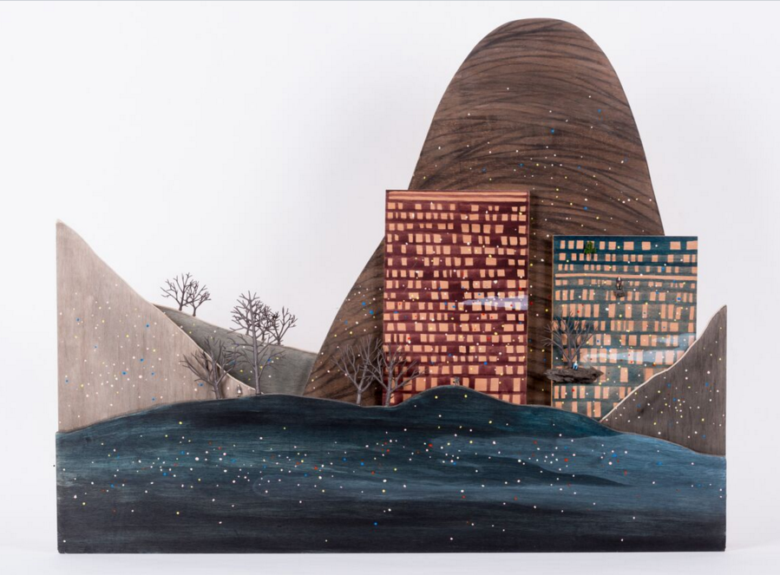 | Scale Mountain No.2  2011  Acrylic, charcoal and scale models on plywood  100( W) x 80 (H) x 9 (L) cm  Estimate HK$85,000 – $110,000  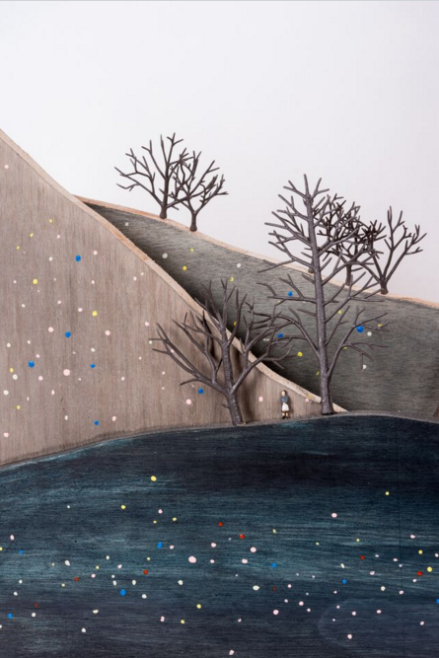  Generously donated by Hanart TZ Gallery
LAM Tung Pang 林東鵬
Hong Kong born, and currently lives and works in Hong Kong. Lam studied Fine Art at The Chinese University of Hong Kong before undertaking a MA at Central St Martins College of Art, London in 2004. He has been awarded numerous scholarship and awards, including Arts Scholarship from Hong Kong Arts Development Council (2003) and Hong Kong Contemporary Art Biennial Awards (2009).

Lam’s works are mostly related to specific situations or social contents and some of them are in monument scale by given a touch of humanity. He has exhibited extensively world-wide and has worked in many private and public collections, including Deutsche Bank, Hong Kong Museum of Art and commission work by Hong Kong Legislative Council. In 2012, he was awarded the Asian Cultural Council Fellowship and outstanding contributions to the development of culture and arts by The Secretary for Home Affairs, Hong Kong and the Award for Best Artist (Visual Arts) of the Hong Kong Arts Development Awards in 2013.
Item No 15
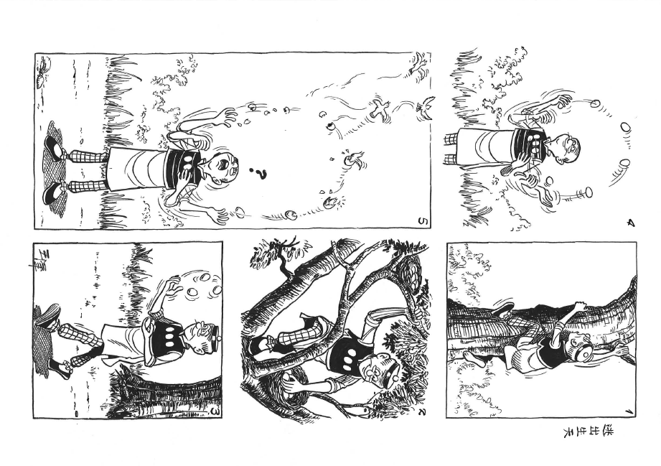 | Find a Way Out –  Original Work of  Old Master Q Comic Strip  2015  Ink on paper  Sheet 29.7 (W) x 42 (H) cm  Framed 35 (W) x 47 (H) cm  Estimate HK$55,000  Generously donated by the artist
Joseph Chak WONG王澤
Joseph Chak Wong was born in 1950. He is the eldest son of the popular Hong Kong comic artist, Alfonso Wong. In 1962, using his name "Wong Chak" as a pen-name, his father created one of the longest running comic strip Old Master Q. Joseph Chak Wong is an architect professor in Shih Chien University, Taiwan. He has taken over the Old Master Q enterprise, became the second generation of Old Master Q, so as to continue his father’s work into the new millennium. He continues his father’s legacy by creating Old Master Q Zemedia Limited, in order to further promote the comic and pursue his passion as a cartoonist.

About the comic, Old Master Q, or Lao Fu Zi, is a learned and rather mischievous old man. Through this character, and his friends Big Potato and Mr. Chin, Wong makes social commentary and pokes fun at society. In addition, Old Master Q is a visual representation of nostalgia for the past. Wong explained that the character reflects the growth and the struggle of Hong Kong society in the 60s. The comic strip reflects the everyday life of Hong Kongers, together with the strong sense of humour in the dialogue, resulting in high popularity across Asian society throughout decades until now.

Item No 16
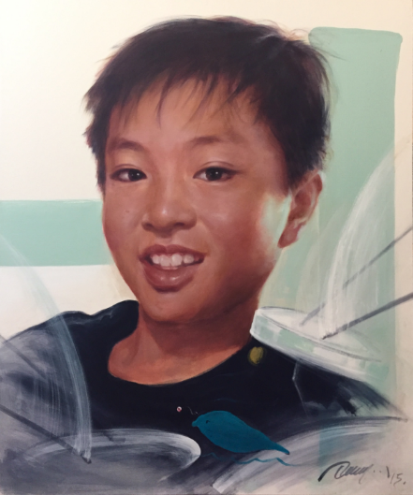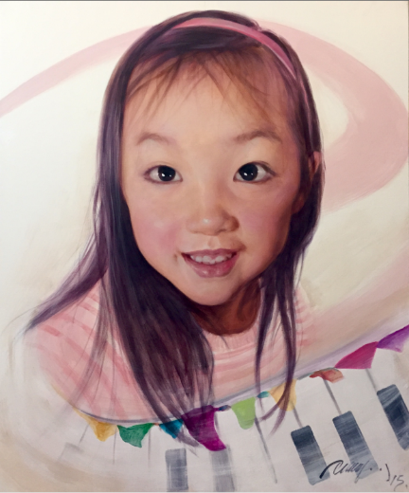  (Artwork reference by Jimmy KEUNG) |  | Family Portraiture Activity  by Hong Kong Art School Graduate  (Jimmy KEUNG)  Minimum Donation Amount  HK$20,000
Jimmy KEUNG
A successful story of an artist trained under the apprentice system during the early 70s in Hong Kong. Jimmy proved that endeavouring to be creative could lead to extraordinary achievement, even under the tough social situation at that time.

An art educator for almost two decades, he has spent tremendous effort in training hundreds of young artists and encouraged their pursuit of excellence in art. Jimmy's serious and humourous teaching approach has inspired his students. Many of his students have become distinguished artists in Hong Kong or are taking up leading artistic posts in different corporations, in Hong Kong and Mainland China.
Continuous exchange with his students has contributed to his continued artistic development. Jimmy aims to maintain Hong Kong's artistic standing through its vitality and the quality of art production and invention.
He currently is a Lecturer at the School of Technical Arts at the Hong Kong Academy of Performing Arts, and a Part-Time Lecturer for the Hong Kong Art School.
Details
Format & Duration: | 2.5-hour posing/ initial sketching* session for a maximum of 5 family members  *The artist may take some photos for reference during the posing/ sketching
Medium: | Oil on canvas
Size: | 120(W) x 100(H) cm (Maximum)
Finishing: | Unframed
Venue: | Bidder’s choice of venue
Expected completion & delivery date of artwork: | - Preferred schedule for posing/ initial sketching session: June 2016  - The artwork will be completed within 3 months after the posing / initial sketching session
Item No 17 * Silent Auction Item
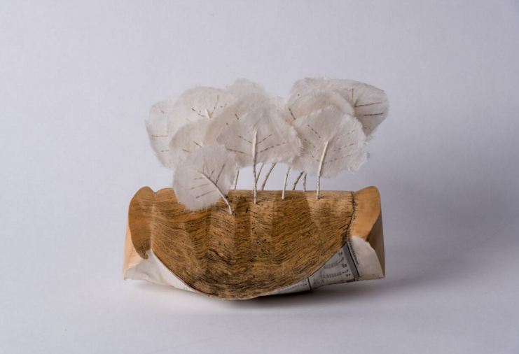 |  | revolt of the woods  2009  Paper (various)  21 (W) x 19 (H) x 15.5 (L) cm  Estimate HK$5,000  Generously donated by the artist
Valerie BUESS
Valerie Buess was born in Switzerland and is now based in Germany. She has been experimenting with paper for the last twenty years.

By twisting, turning, folding paper and sometimes adding some colour to her work, she creates organic and often abstract shapes inspired by underwater sea creatures.

These sea urchins, coral reefs, algae, and seagrass, all made from recycled books, hint at mysteries of the deep sea and constitute a sculptural world above the surface.

Her work has been exhibited across Asia, Europe and the U. S.

Item No. 18 |  |  | * Silent Auction Item
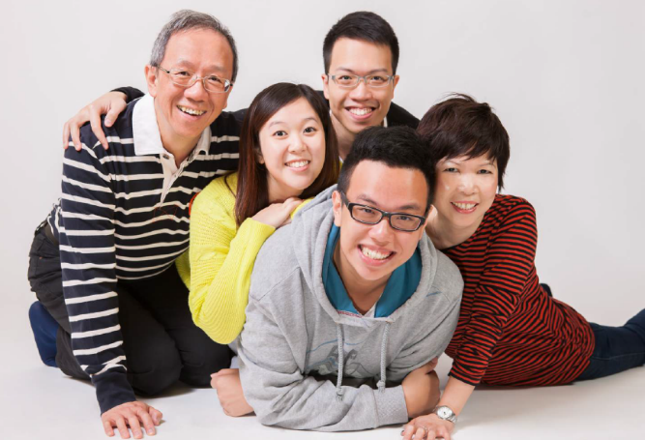 (Photos reference by SO Wing Hon) |  |  | Family Studio Photography  by Hong Kong Art School Graduate  (SO Wing Hon)  Minimum Donation Amount  HK$15,000  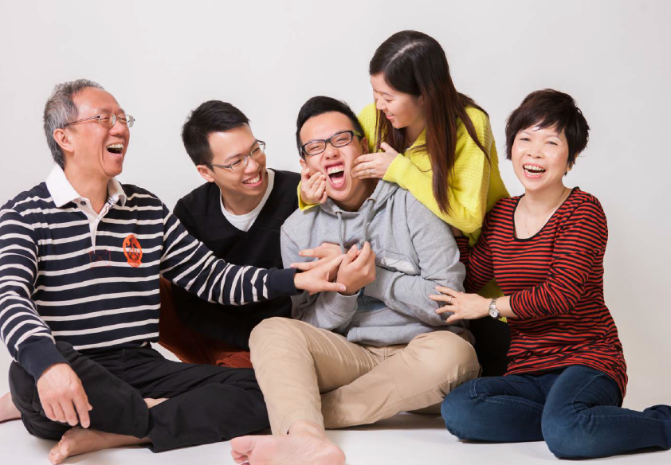
SO Wing Hon蘇詠康
So Wing Hon, born in Hong Kong. Works as an artist and professional photographer. Wing Hon graduated with Bachelor of Art (Fine Art) from RMIT University (cooperated with Hong Kong Art School). He has participated in exhibitions such as "Post-Straight: Contemporary Hong Kong Photography“, "Free Individual Travel… How Much Free?", “Dali International Photography Festival and "Pingyao International Photography Festival". Wing Hon also hosts different kinds of photographic workshops. His artwork explores the essence of artifacts, the relationship between humanity, nature and animals, as well as the endless possibilities of photography.
Details
Format & Duration: | - 2-hour studio photography for a maximum of 10 family members  - Group photos plus individual shot for each member  - Shooting in white background
Final Products: | 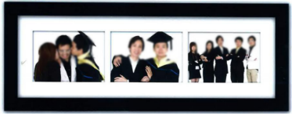  - 1 big photo framed in 18R size (46 x 30 cm) or  2 combined photo frames (see the images on the right)  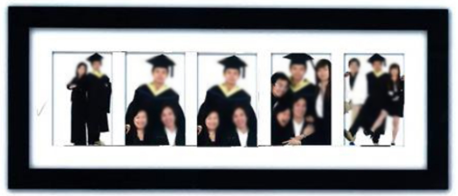  - 10 hardcopies in 8R size  (5 in 1 frame: 63 x 23 cm)  (3 in 1 frame: 53 x 15 cm)  - 30 edited softcopies  - All softcopies of the shooting without editing
Venue: | Unit 2, 14/F, Chai Wan Industrial City Phase 1, 60 Wing Tai Road, Chai Wan, Hong Kong
Item No 19 * Silent Auction Item
Dinner for Eight at Crown Wine Cellars Private Members’ Club

Minimum Donation Amount
HK$10,000

Generously donated by Mr James Thompson, GBS
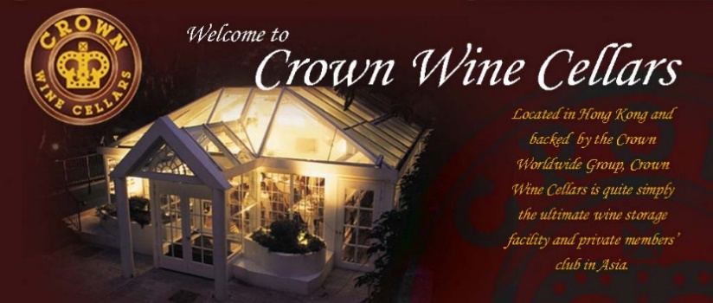
Details
Description: | - A four-course dinner for eight at Crown Wine Cellars Private Members’ Club  - Includes 1 bottle of Champagne, 1 bottle of white wine, and 1 bottle of red wine
Venue: | 18 Deep Water Bay Drive, Shouson Hill, Hong Kong
Expiry Date: | 31 December 2016

ABSENTEE BID FORM

Live Auction: 9 December 2015 (Wednesday), Assaggio Trattoria Italiana, 6/F Hong Kong Arts Centre
Absentee Bids: Closing time - 15:00, 8 December 2015 (Tuesday)

Absentee Bids are accepted prior to the auction period. You should indicate in this form the highest price at which you are willing to bid and pay for each lot.
To submit an absentee bid, please fill in this form and attach a copy of your identification document*. Please send us before 15:00, 8 December 2015 (Tuesday).

Submission to: Ms. Wendy Chiu, Executive Director’s Office

Tel: +852 2582 0283 Fax: +852 2519 2005 Email: wchiu@hkac.org.hk

Lot Number | Artwork Name | Price Bid (HK$)

Bidder’s information
First name: | Last name:
Contact Person (if different from the bidder):
Contact number:
Email:
Address:
*Collection of copy of your identification document is necessary for protecting the interest of all parties concerned, including yours, in view of (i) the absentee nature of your bid; and (ii) the occurrence of such activities as identity theft and money-laundering. All information will be collected solely for the purpose of processing your bidding application.

By signing below, I hereby: (i) agree that the contract between me and Hong Kong Arts Centre relating to the auction sale/ purchase of the lot(s) shall be concluded upon the striking of the auctioneer’s hammer with regards me as the successful bidder in the case of the live auction; and (ii) commit to the payment of the purchase price for any lot(s) as stated above in this Absentee Bid Form, in the event of the conclusion of such contracts as referred to in (i) above.

Signed: ____________________________________ Dated: __________________________
Payment: Unless otherwise agreed, the full purchase price of successfully bought lots is due in Hong Kong dollars from each lot buyer by 16 December 2015. For the avoidance of doubt, the contract between the buyer and the Hong Kong Arts Centre is concluded on the striking of the auctioneer’s hammer with regards the buyer as the successful bidder. Hong Kong Arts Centre reserves the right to hold the successful bidder accountable for payment form the time the auctioneer’s hammer falls on the lot.

