[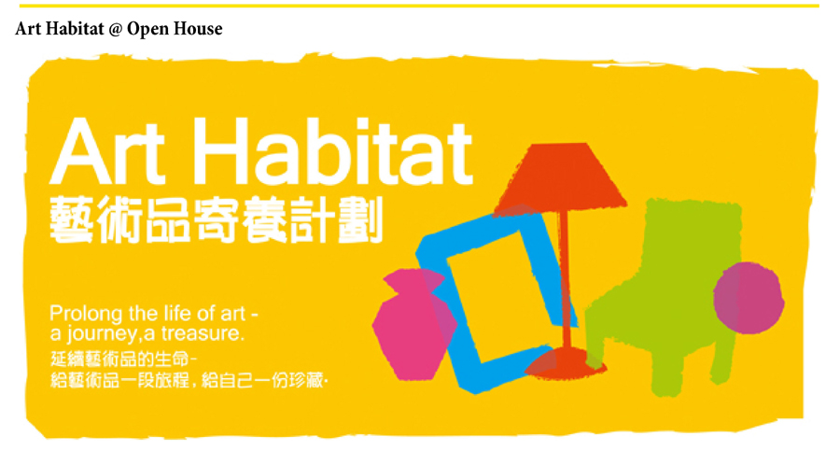](http://mailman.surfmanhk.com/hkac11/cl.php?mbid=10&eid=86&lid=8&utm_campaign=hkac_20120508_1&utm_medium=edm&utm_source=surfman&utm_content=86)

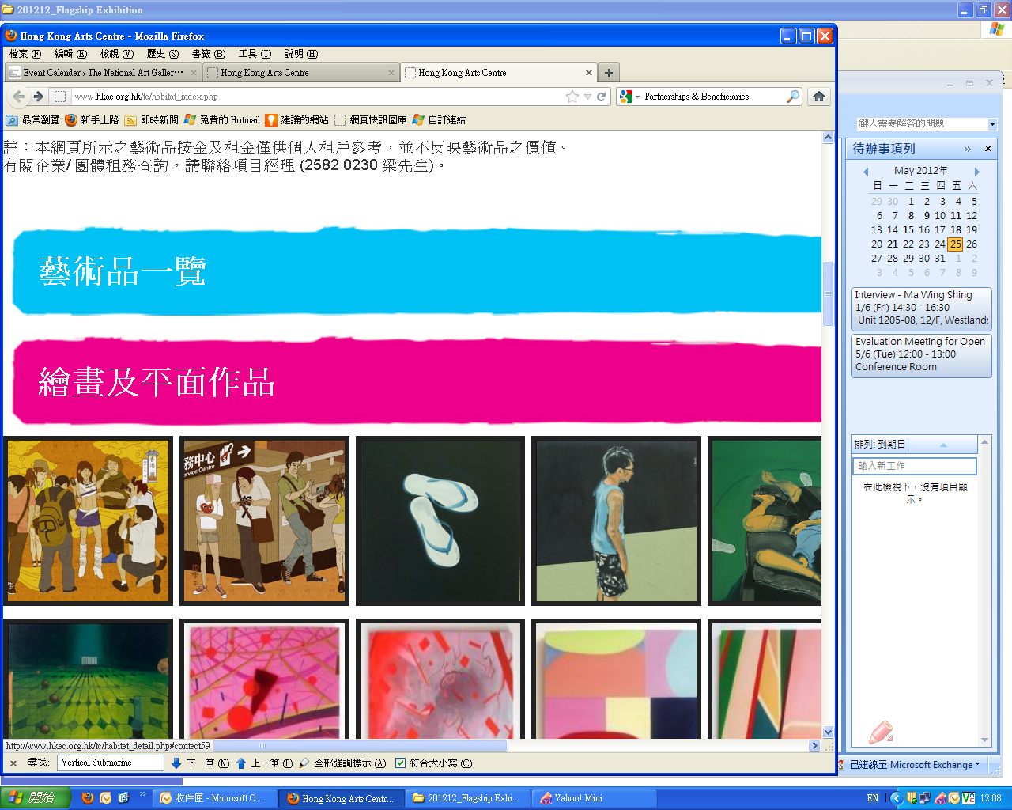

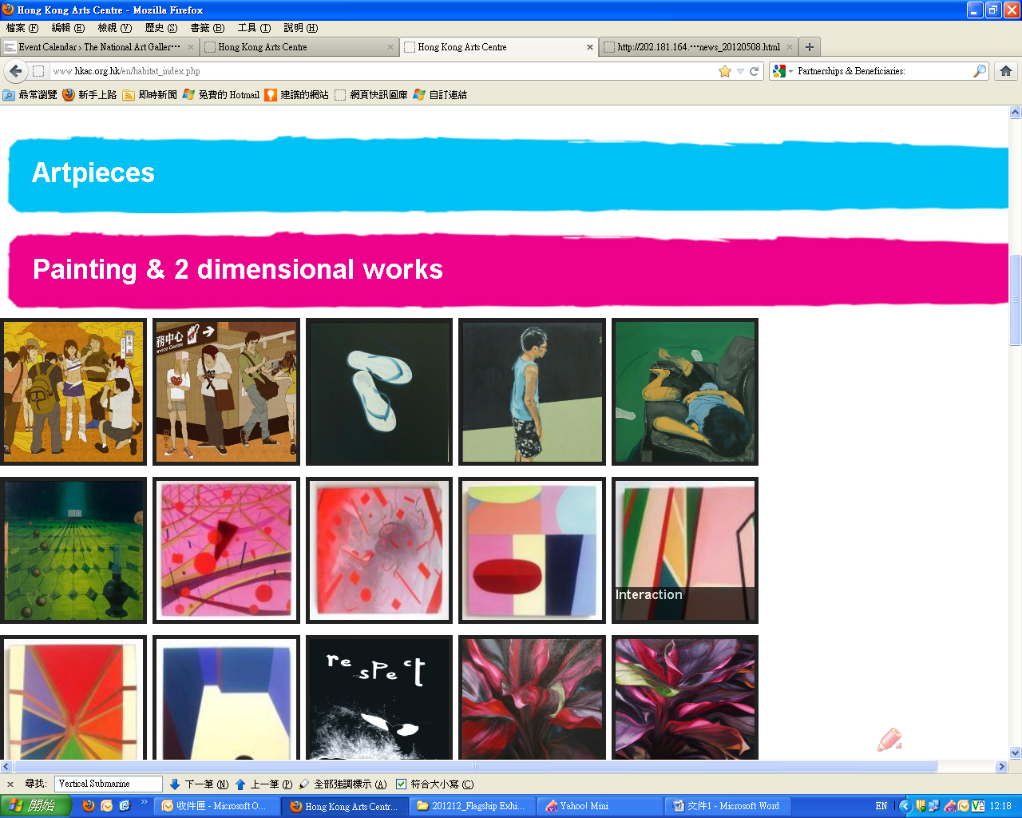

[](http://mailman.surfmanhk.com/hkac11/cl.php?mbid=10&eid=86&lid=8&utm_campaign=hkac_20120508_1&utm_medium=edm&utm_source=surfman&utm_content=86)

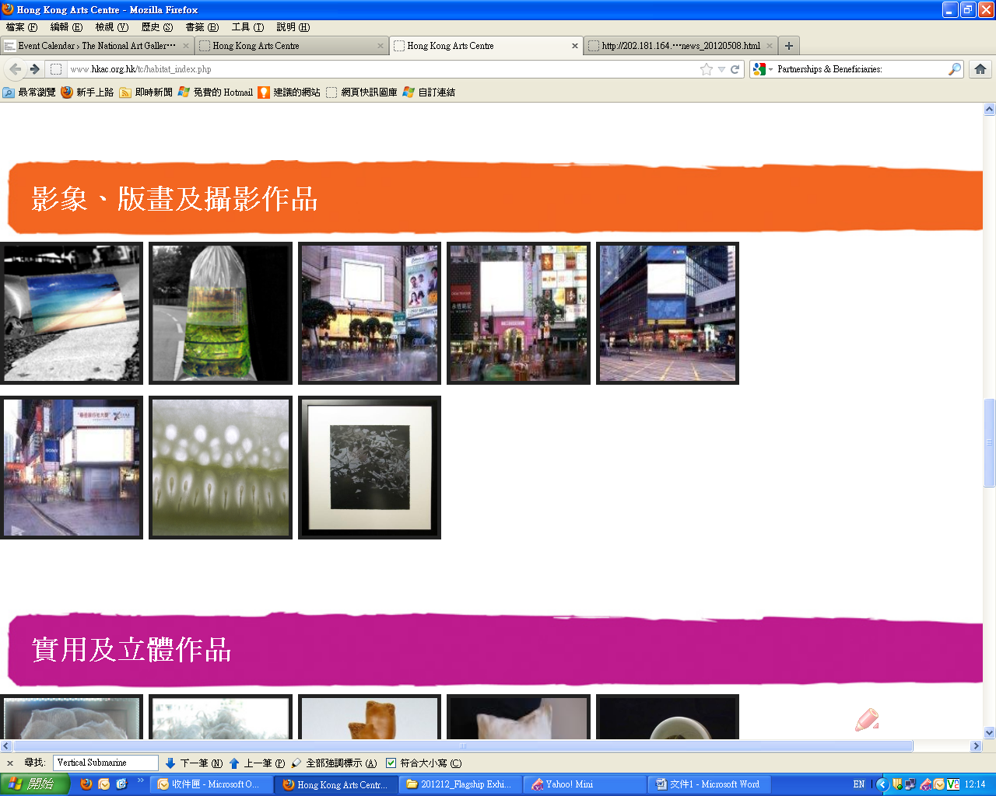

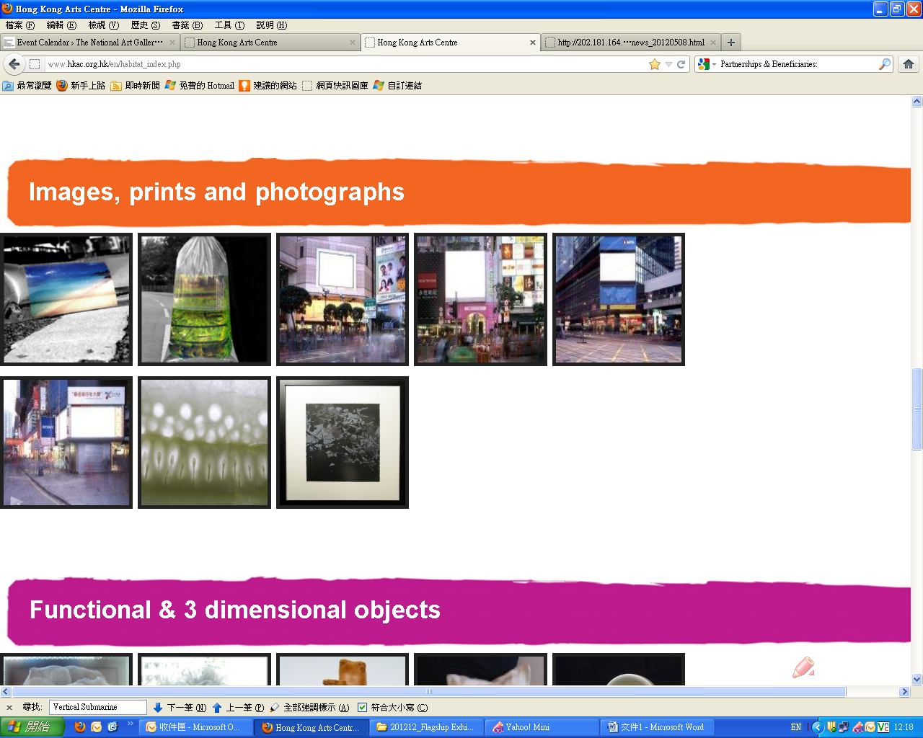

[](http://mailman.surfmanhk.com/hkac11/cl.php?mbid=10&eid=86&lid=8&utm_campaign=hkac_20120508_1&utm_medium=edm&utm_source=surfman&utm_content=86)



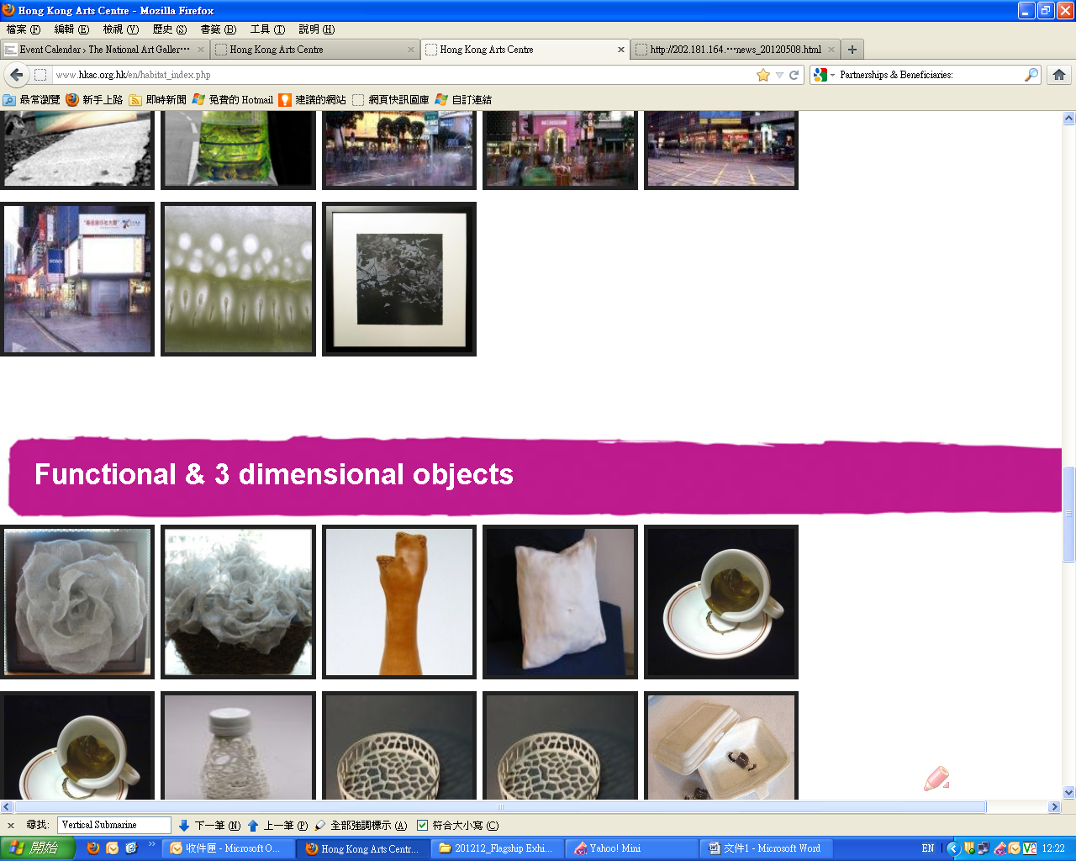

[](http://mailman.surfmanhk.com/hkac11/cl.php?mbid=10&eid=86&lid=8&utm_campaign=hkac_20120508_1&utm_medium=edm&utm_source=surfman&utm_content=86)

