All About Us Film Festival 2021 – Programme detail and film list
The First Ethnic Minorities Film Festival in Hong Kong
A special project to celebrate the tenth anniversary of “All About Us” – The Premiere of The Poem of Pakistan
30/10/2021 (Sat) | 6pm | Louis Koo Cinema, Hong Kong Arts Centre
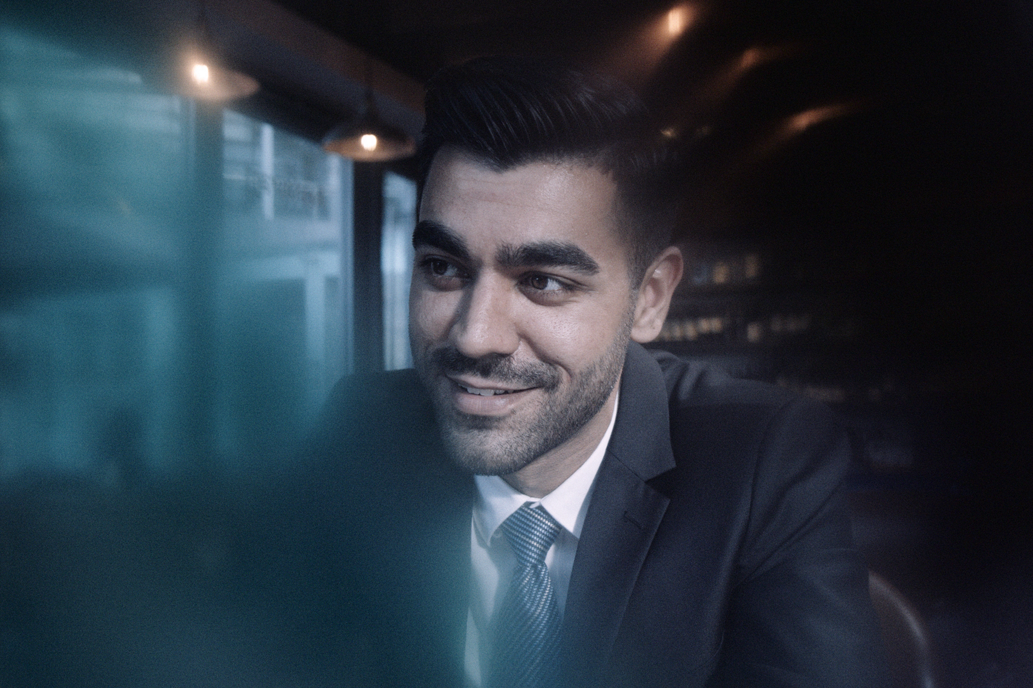
The Poem of Pakistan
Ryan Chan Hon-yan
Col / 25’00”/ In Cantonese and Urdu with Chinese and English subtitles

Nominated for The 58th Golden Horse Awards, 2021 Taipei Film Festival and 2021 Kaohsiung Film Festival.

After screening discussion with Ryan Chan Hon-yan (Director), Inderjeet Singh (Main Cast), Wong Wai-nap (Cinematographer)

Hamid, a young Pakistani, is an insurance and investment broker. No matter how hard he tries, he finds it hard to be part of the society. He works hard to earn a living and has to take shortcuts sometimes. While handling a medical claim issue, he gets to meet a Pakistan youth who loves Pakistani literature. This encounter brings back Hamid’s memories of his homeland and his family, leading him to reflect on his current way of life.

Conversation: What it's like to grow up an ethnic minority in Hong Kong - Special Screening：Melting Pot by Bipin Karma
30/10/2021 (Sat) | 2.30pm | Louis Koo Cinema, Hong Kong Arts Centre

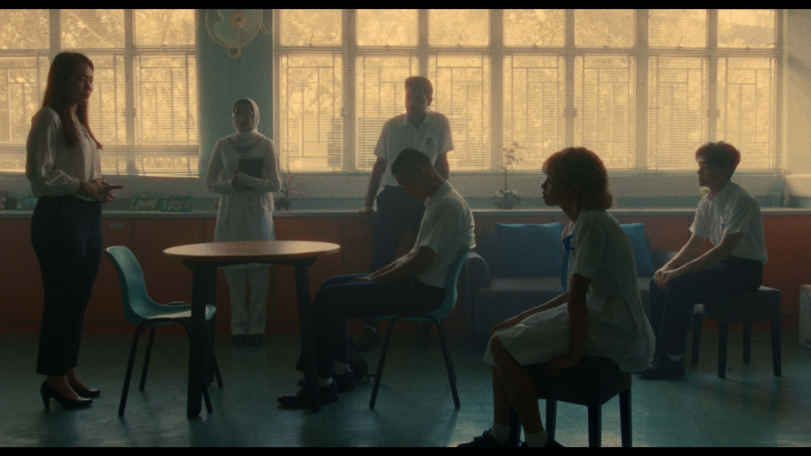
Panel discussion with Bipin Karma (Director), Mo Lai Yan-chi (Teaching Artist), and more guest speakers

Like the locals, ethnic minority youths are facing challenges during their life stage: school climate, mental health and peer relationship. “All About Us” has served as the first step to introduce moving image creation to many of the ethnic minority youths in Hong Kong. Among them is Bipin Karma, who first participated in the programme in 2013, has eventually continued to join in consecutive years, and directed his first short film Melting Pot. He made his major film debut this year with his role in Hand Rolled Cigarette.

Melting Pot
Bipin Karma
Col / 16’00”/ In Cantonese, English, Hindi and Urdu with Chinese and English subtitles

A teacher in a designated secondary school selects five ethnically diverse students to compete for a representative role before a counsellor but they must find a solution to what has recently divided them first.

A documentary about abandoned Vietnamese refugees - Gone with Wind
30/10/2021 (Sat) | 8.15pm | Louis Koo Cinema, Hong Kong Arts Centre

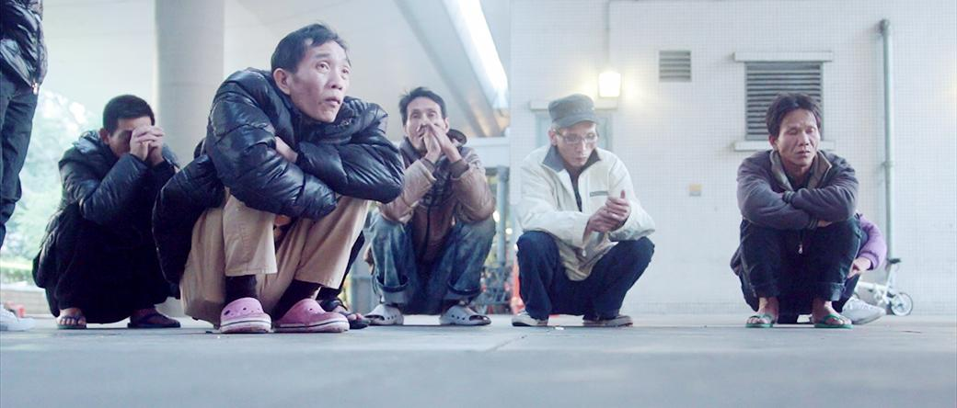
Gone with Wind
Wan King-fai
Col & B&W/ 90’/ In Cantonese with Chinese and English subtitles

After screening discussion with Wan King-fai (Director), and more guest speakers

To the group of homeless people living under a bridge in Sham Shui Po, they need to cope with passersby’s stares and face the frequent raids by government officials in daily basis. Led by a local pastor, a group of volunteers show them there are people who actually care and are willing to lend a helping hand.

Ethnic Minorities in Hong Kong: Dreams vs Reality

The “All About Us” programme has groomed moving image creatives across generations with works focusing on the conditions, mentality and daily lives of ethnic minority. This city has been through drastic changes over the years, did this also bring changes to the subject matters of students’ works? To many of us, this should be a land of dreams, but there seem to be an enormous distance between the two. Two showcases of selected works from the programme, not only allow audiences to revisit the past, but also to anticipate a better future.

Programme 1
20/11/2021 (Sat) | 7.15pm | Louis Koo Cinema, Hong Kong Arts Centre
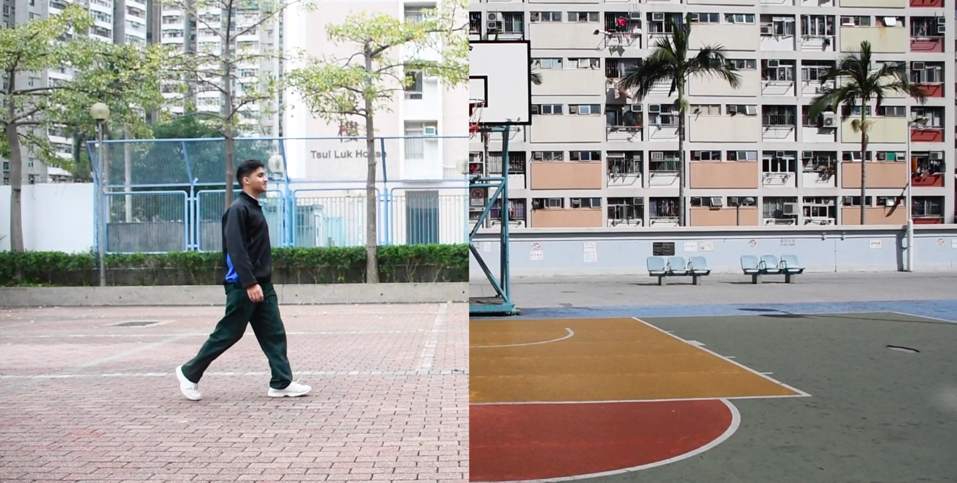 |  |  | US  Muauuidh, Dil Ajmaeen Pel-Ingen, Muaadh Makhdoom, Haris Muhammad, Pargat Singh Gill, Muhammed Ibrahim Numan, Shamsu Thabrej, Salam Abul, Ummar Haryat Khan  Col / 7’8”/ In Pashto and English with English subtitles
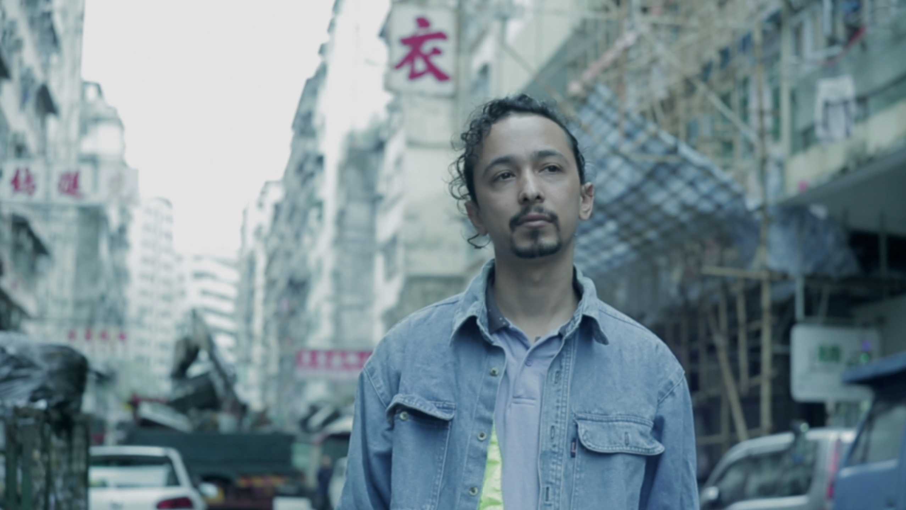 |  |  | YATRI  Hui Chi-sang  Col / 13’10”/ In Nepalese with Chinese and English subtitles
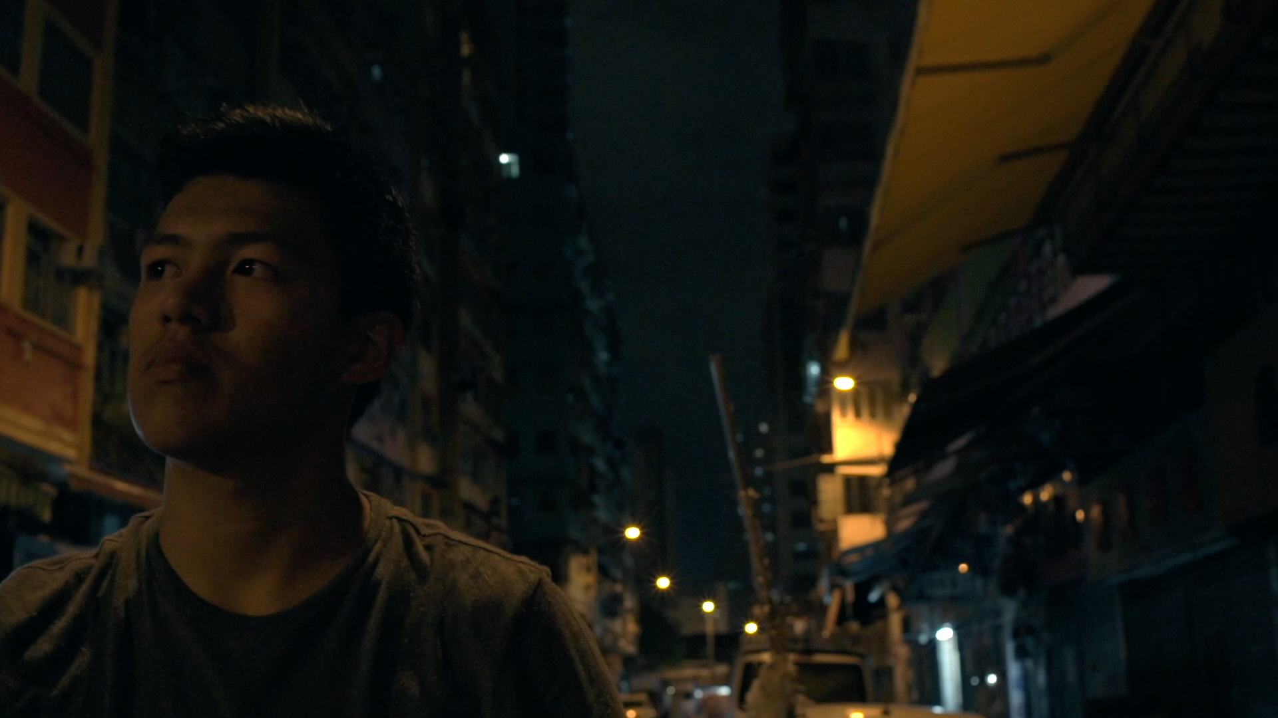 |  |  | Be a Rider or a Fool  Law Wai-leung  Col / 11’08”/ In Cantonese with Chinese and English subtitles
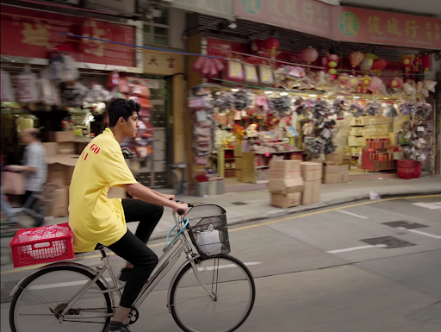 |  |  | Summertime Blues  Lam Sum  Col / 17’02”/ In Cantonese with Chinese and English subtitles
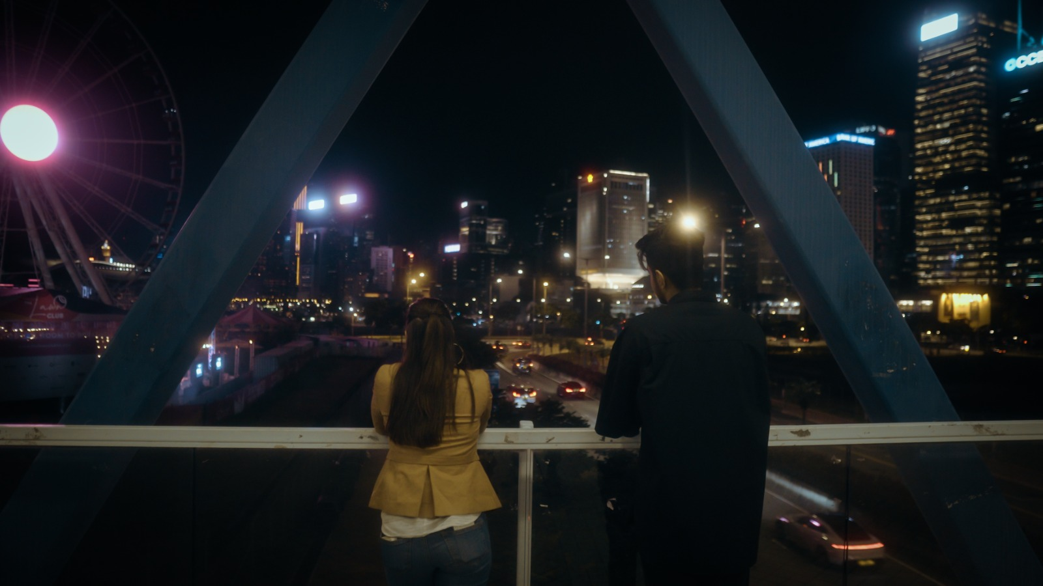 |  |  | Before It's Too Late  Ali Shamaz, Butt Abdul Mueed Sajid, Atique Hamza  Col & B&W / 11’36”/ In English with English subtitles
Programme 2
20/11/2021 (Sat) | 9pm | Louis Koo Cinema, Hong Kong Arts Centre

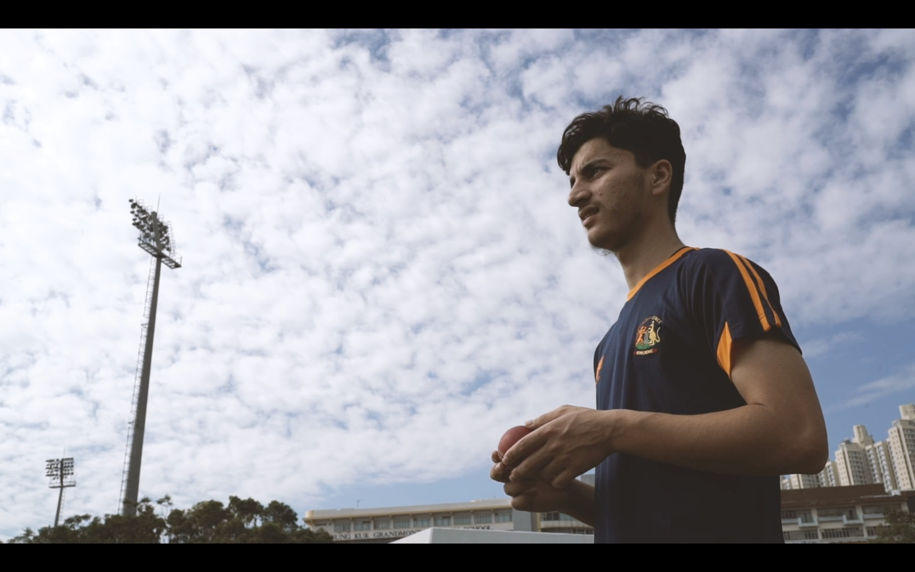 |  | I Am Owais  Owais Muhammad, Ajab Khan, Wavoo Seyed Abdur Rahman Fareed, Salam Abdul, Sadakkathullah Insaf Idris, Reza Md Nahyan, Haris Muhammad, Pargat Singh  Col / 7’06”/ In Pashto with English subtitles
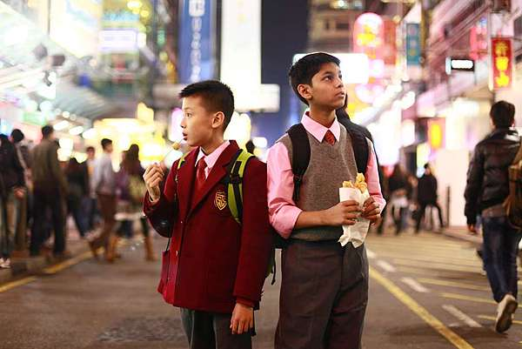 |  | Drifting  Lam Sum  Col / 26’/ In Cantonese with Chinese and English subtitles
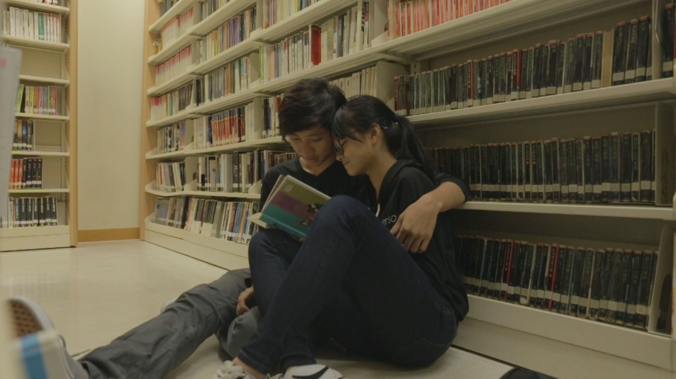 |  | Drive  Bipin Bishwokarma, Cheng Tsz-ching, Rai Phirens, Remi Iwasaki  Col / 17’14”/ In Cantonese and English with Chinese and English subtitles
The Waterside
Joseph Wu
Col / 20’/ In English with English subtitles

Moving images of Ethnic minorities: Showcase in Community
On top of cinema screenings, the film festival will be organising thematic community screenings with local organisations, bringing moving images and documentaries of ethnic minorities to the different corners of the city. More programmes to come, including collaboration with Gay Games Hong Kong 2021, Eaton Hotel! Stay tuned at social media platform of ifva and All About Us.

Selected films screening @YMCA  27/11 (Sat) | 8:00pm | YMCA - Tin Shui Wai Tin Ching Centre (No.101, 1/F., Ancillary Facilities Block, Tin Ching Estate, Tin Shui Wai, N.T., Hong Kong) | Screening + discussion @ Book Punch  6/11 (Sat) | 7:30pm | Book Punch (3/F, Tai Nam Commercial Building, 169-171 Tai Nan Street, Sham Shui Po, Kowloon)

