HKAC Official Description

香港藝術中心──彰顯多元藝術 、薈萃創意靈感
香港藝術中心是一所多元藝術創意中心，多年來積極將創新前瞻的當代藝術引進香港，同時亦努力將本土藝術家介紹給海外觀眾。

中心更是本地唯一獨立自主的非牟利多元藝術機構，一直致力鼓勵、推廣創意，竭力促進本地與國際的藝術交流；透過舉辦不同形式的藝術活動及跨界合作，把香港和世界聯繫起來。

歡迎來到香港藝術中心，透過體驗藝術豐富生活，藉著欣賞藝術啟發創意。

Hong Kong Arts Centre - The relevant destination for arts and creative inspirations in Hong Kong
HKAC is a multi-arts centre that fosters artistic exchanges locally and internationally, bringing the most forward creations to Hong Kong and showcasing homegrown talents abroad.

HKAC stimulates innovation and promotes creativity. Being Hong Kong’s only independent non-profit multi-arts institution, HKAC offers exhibitions, screenings and performances, connecting the arts of Hong Kong to the rest of the world through programmes and collaborations.

Come to HKAC to experience, appreciate, learn and be inspired by arts.

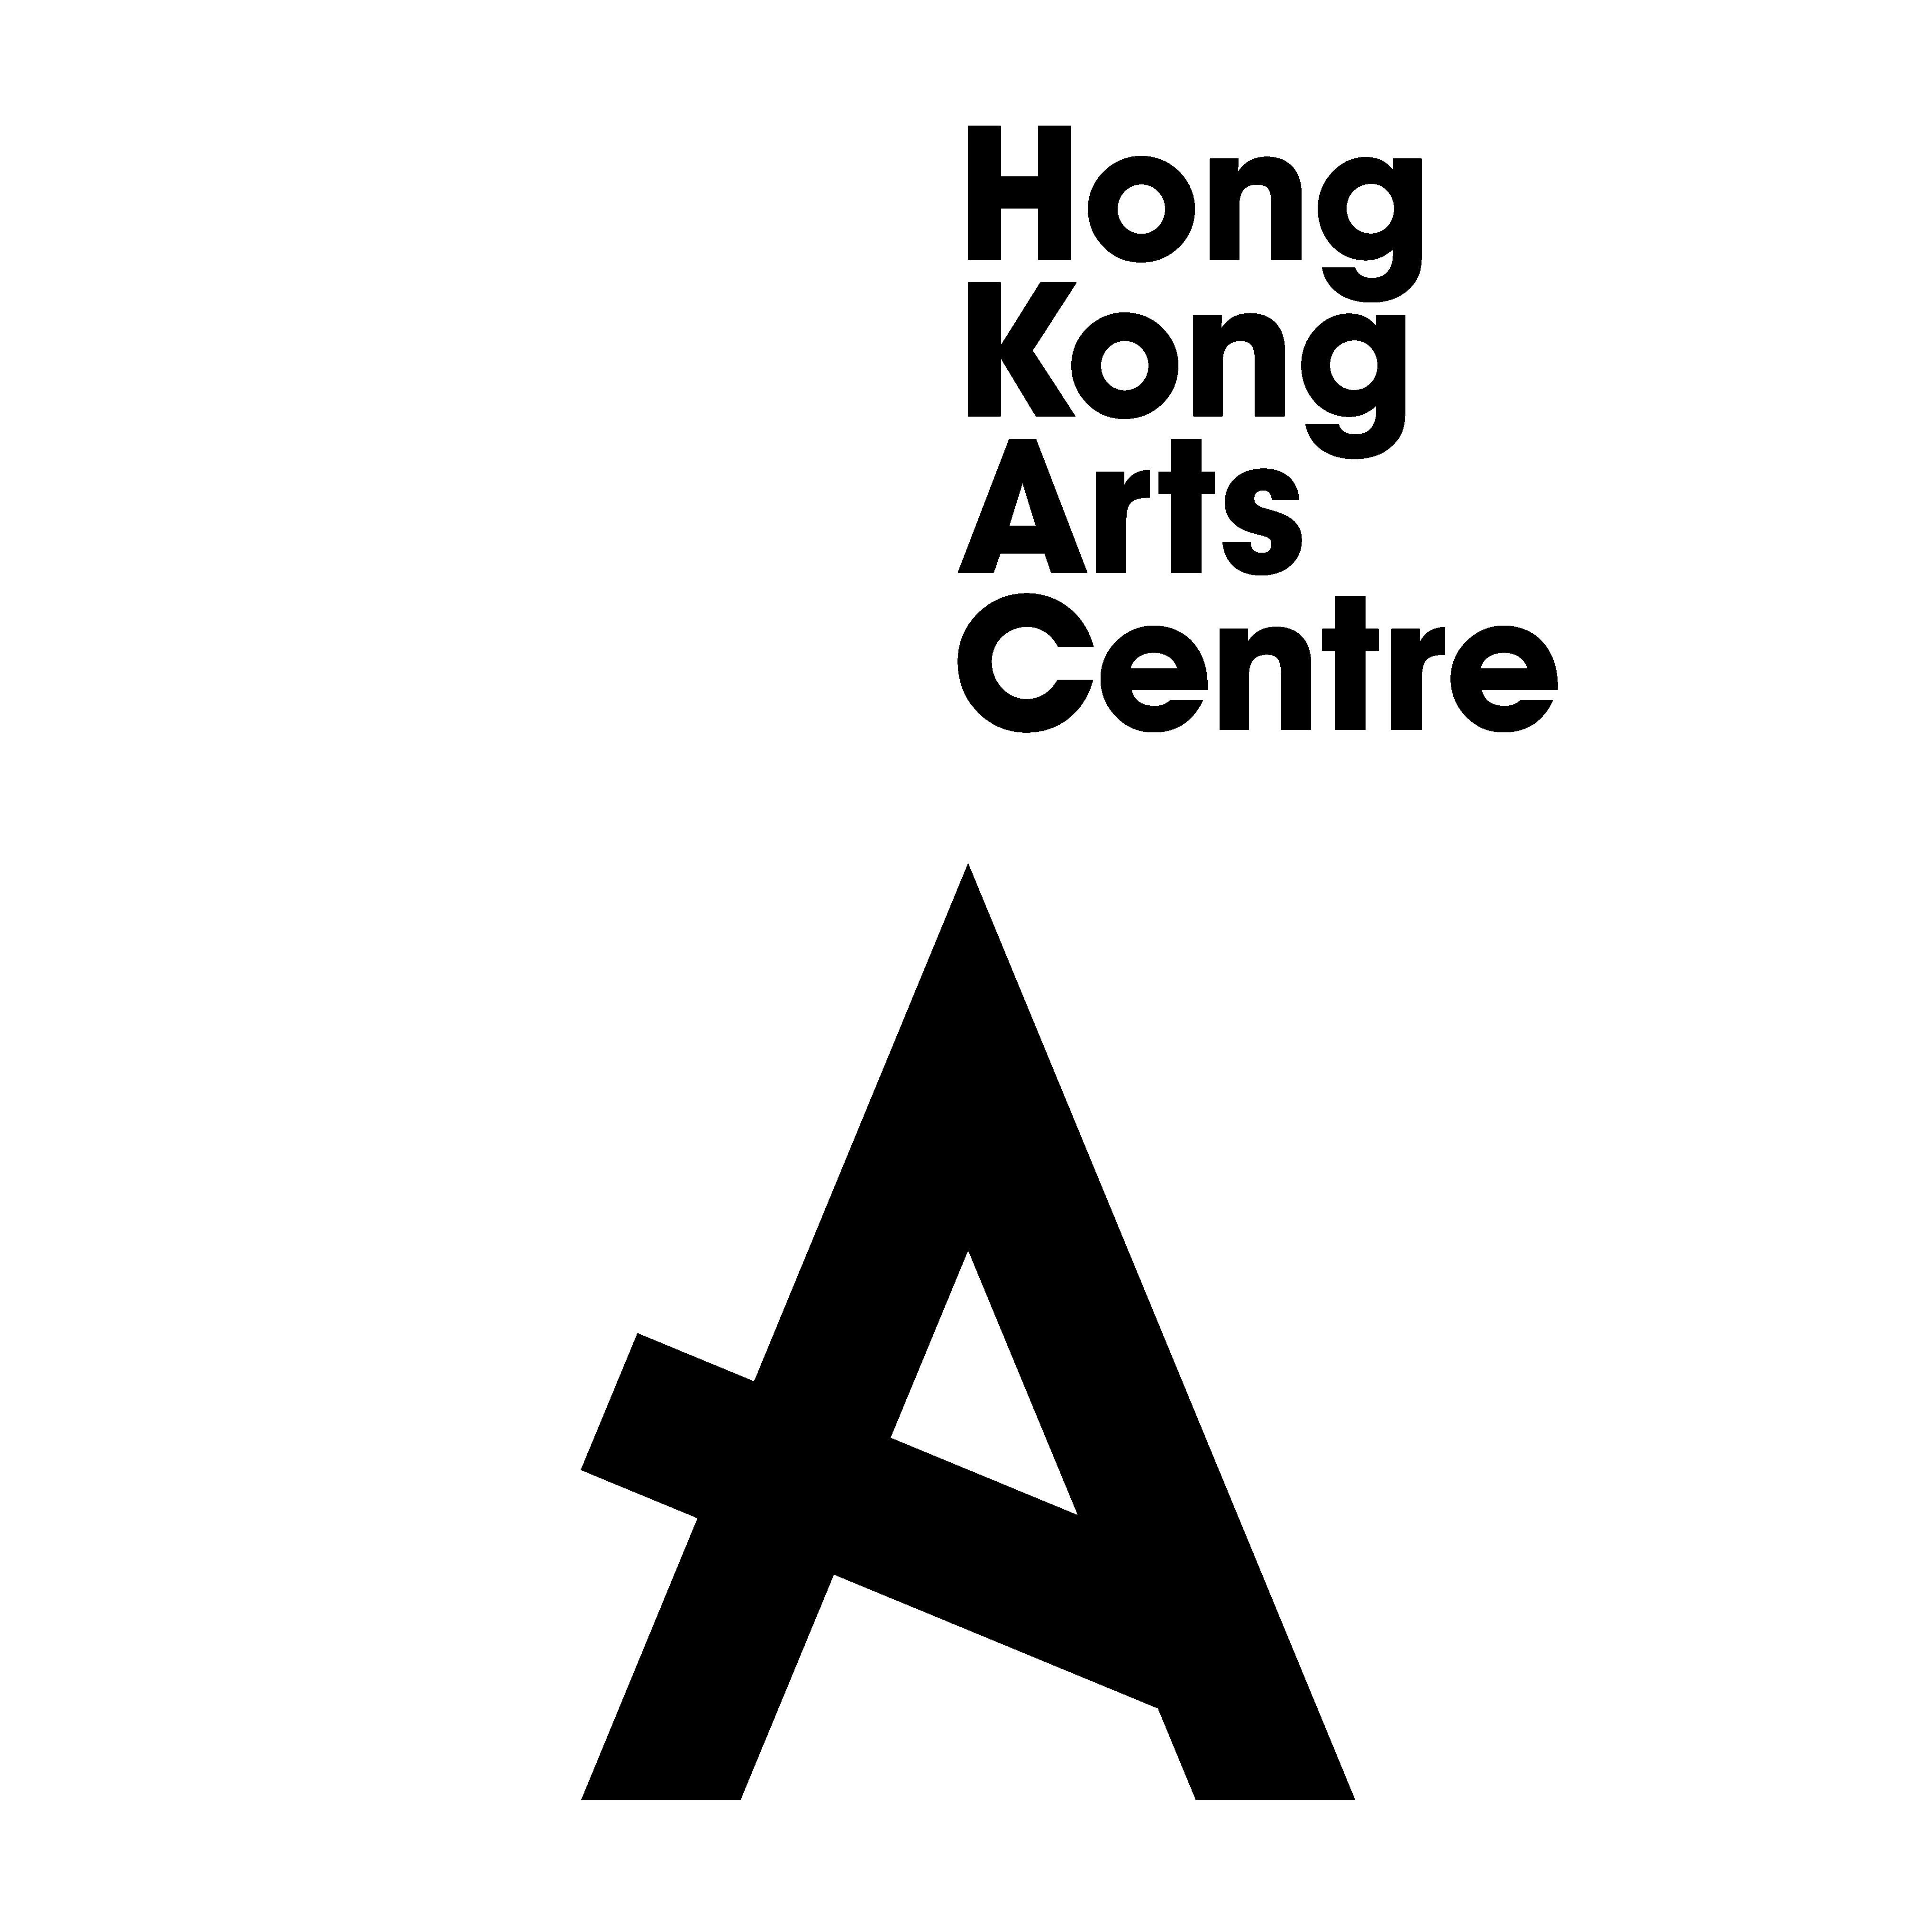

8:00am – 11:00pm (MON – SUN)
2 Harbour Road, Wan Chai, Hong Kong
(852) 2582 0200
www.hkac.org.hk
