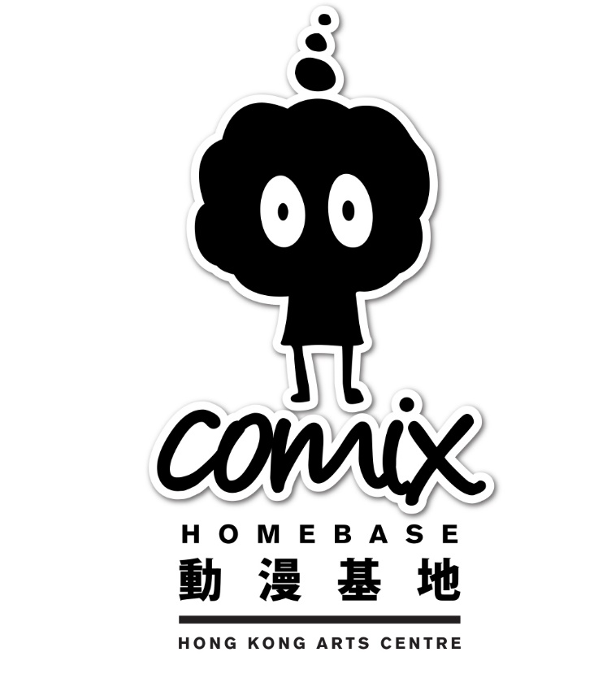

G/F Lobby to 4/F
10:00am – 8:00pm (may extend to 10:00pm for any special activities)
Comix Salon
12:00pm – 8:00pm (Closed on MON)
Public Open Space
8:00am – 10:00pm
7 Mallory Street, Wan Chai, Hong Kong
(852) 2824 5303
chb@hkac.org.hk
www.comixhomebase.com.hk

動漫基地
Comix Home Base

位於灣仔茂蘿街／巴路士街的「動漫基地」於二零一三年七月正式開幕，是市區重建局（市建局）首個純保育活化項目，香港藝術中心受市建局委聘負責「動漫基地」五年的營運和管理。中心銳意推動本地和國際動漫畫及其延伸媒介的長遠發展，不但為海內外的創作人、業界人士、學者和公眾提供展示作品、交流、合作和研究的綜合創意平台，同時著重發掘和培養動漫人才，進一步推動本土動漫行業的發展。

「動漫基地」亦是本港首個結合動漫創意和活化歷史建築的多元人文藝術社區。原址為十幢被列為二級歷史建築的戰前樓宇，於一九一零年代建成，原是草根階層的住所，這百年來經歷無數變遷，具超然的歷史文化價值。該項目經市建局修葺和活化後，建築群保留了不少原有的樓宇的建築元素和物料，其中包括懸臂式露臺、法式門窗、欄杆和木樓梯等。活化後的建築群包括一個約三百平方米的公共休憩空間，供社區享用，以及一個收集印刷及電子漫畫書刊的「動漫沙龍」。其他設施包括：展覽空間、多用 途活動室、與動漫藝術主題相關的零售空間和餐飲設施。

「動漫基地」與大眾分享最新、最優秀的動漫及其周邊創作，凝聚動漫創意力量，在發展成為灣仔區一個重要文化地標的同時，亦把動漫藝術帶入社區，鼓勵全城參與；而公眾在參與動漫活動的同時，亦能感受昔日的建築文化和城市風貌。

Comix Home Base (CHB), located at Mallory Street/Burrows Street in Wan Chai, was established in July 2013, and the Hong Kong Arts Centre (HKAC) was appointed by the Urban Renewal Authority (URA) as the Main Operator to manage the CHB under a five-year contract. The CHB is the URA's first pure preservation-cum-revitalisation project. It is also the first art community in Hong Kong combining creativity in comics and animation with revitalised historic architecture.

Comprising a cluster of ten pre-war Grade Two historic buildings built in the 1910s, these historically significant buildings were homes of the working class, having witnessed more than a century of urban development and transition. After refurbishment by the URA, prominent features of the project such as cantilevered balconies, tiled pitched roof, timber French doors and internal timber staircase are retained and preserved. The revitalised building cluster also includes a 300-square metre Public Open Space for comics and animation artists as well as a “Comix Salon” that collects print and digital comic publications. Other features include exhibition space, multi-function rooms, retail space for selling comics and related merchandise as well as food and beverages facilities/outlets.

The CHB is dedicated to sharing the latest and the best comics, animations and creative works of related media with the public, bringing art into the community. The establishment of the CHB heralds a milestone in the development of local comics.

