Appendix 1
Open House & Art X Late Night Series 2022 Programmes Overview
Movie Screenings: CLEO (Erik Schmitt, 2019) & SLEEP (Michael Venus, 2020)
We sleep, we dream. Novel journeys await us in our sleep. Some of them could be fantastical, some of them could be realistic. No matter what kind of dream it is, we could experience them – we could walk, we could talk. After waking up, we no longer stay in the same scenario but in a different, more dimensional world called reality. However, we still walk, we still talk. This year, the Hong Kong Arts Centre’s Open House & Late Night Series presents a multi-disciplinary experience “Sleep Walk; Sleep Talk” . We welcome two different cinematic journeys in sleep - CLEO, if I could turn back time, and SLEEP, it turns out the nightmares.
Screening Date: 25 June 2022 (Sat)
Venue: Louis Koo Cinema, Hong Kong Arts Centre (UB, 2 Harbour Road, Wan Chai)
Screening Standard ticket price: HKD 85 per ticket
Movie Screening 1:《CLEO》(Erik Schmitt, 2019)
Screening Time: 3:15pm
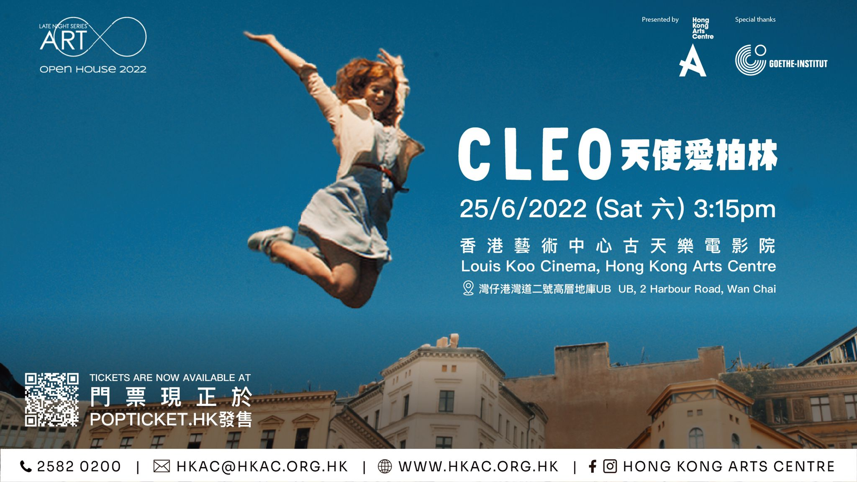
《CLEO》
Germany | 2019 | 99’ | In German with English subtitles | Colour
Director: Erik Schmitt
Cast: Marleen Lohse, Jeremy Mockridge, Heiko Pinkowski, Maximilian Mauff, Andrea Sawatzki, Jean Pütz, Fabian Busch, Gwendolyn Göbel
Awards: Karel Zeman Award Zlin 2019 Festivals: Berlinale 2019, Shanghai 2019, Zlin 2019, Melbourne 2019, Heartland IFF 2019, Sao Paulo 2019, Black Nights Tallinn 2019
The imaginative Cleo (Marleen Lohse) feels a very special kind of affinity for her home town of Berlin. But her deepest desire is to be able to turn back time – with the aid of a magic clock which was stolen during a robbery in the 1920s and has been missing ever since. She hopes that the clock might help her undo the death of her parents. One day, she meets the adventurer Paul (Jeremy Mockridge) who is living on a houseboat and had recently bought a treasure map at an auction. Cleo is bursting with tension – might the map lead to the treasure she is dreaming of? Cleo and Paul set off together on an adventurous trip through the pulsating city. They meet crazy characters, lovable figures, Berlin myths and urban legends. When they arrive in Berlin's dark underground at the end of their quest, Cleo is confronted by the most important question of all: should she want to turn back time in the first place?
Movie Screening 2:《SLEEP》(Micheal Venus, 2020)
Screening Time: 8:15pm
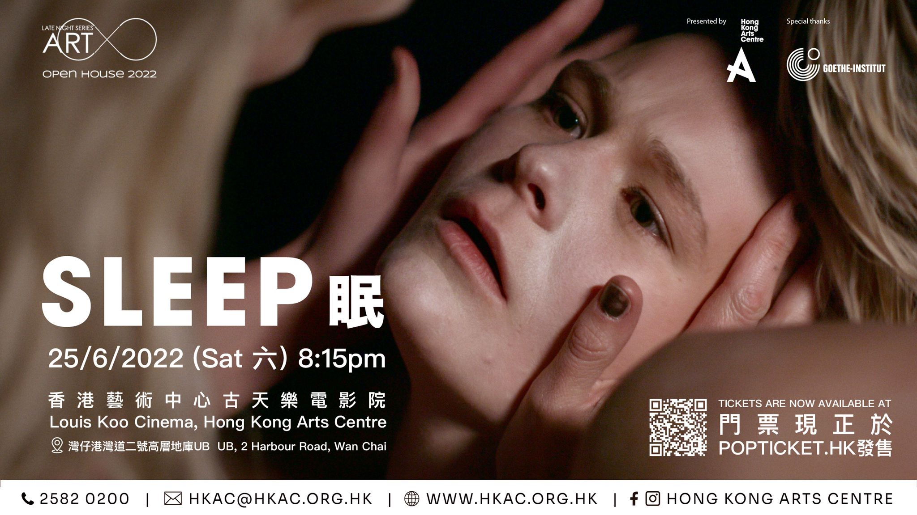
《SLEEP》
Germany | 2020 | 102’ | In German with English subtitles | Colour
Director: Michael Venus
Cast: Gro Swante Kohlhof, Sandra Hüller, August Schmölzer, Marion Kracht, Max Hubacher, Martina Schöne Radunski, Katharina Behrens, Agata Buzek, Andreas Anke, Benjamin Heinrich, Josefin Schäferhoff, Samuel Weiss
Awards: Special Mention, ToHorror Fantastic Film Festival Torino, Italy (2020) Audience Award for

Best Feature, Anomaly – The Rochester Genre Film Festival, USA (2020)
The idyllic village of Stainbach is being haunted by a mysterious demon. It turns out that the nightmares of Marlene (Sandra Hüller) are responsible for the dark events. She is driving some of the inhabitants of the village insane during her terrible dreams. When she discovers her nightmares are about a real place, she tracks down the village of Stainbach to get to the bottom of the mystery. There, she learns about the consequence of her dreams and suffers a nervous breakdown. Soon after, she is admitted to a psychiatric ward. Her daughter, Mona (Gro Swantje Kohlhof), journeys to Stainbach to find out the reason for her mother’s breakdown and the demonic nightmares she suffered from. She comes into contact with the peculiar villagers and discovers the dark history hidden within the quiet village. Perhaps the nightmare isn’t the demon that threatens the town after all, but rather – the past.
Sweet Dreams: Reed Diffuser Workshop
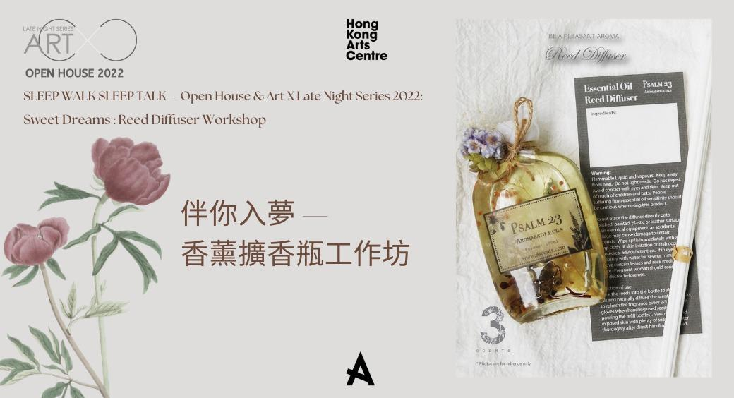
Learn how to create your own reed diffuser with your bespoke scent. This will be an elementary introduction on how to blend scents. You will be guided through the process of creating your own blend using different kinds of essential oils and luxurious fragrances and decorating your bottle with a choice of preserved flowers.
Enjoy a fun and relaxed time during the workshop experience. Bring it back to your home and enjoy the scent around your bedroom. Have a sweet Dreams!

You will bring home:
1. 1 bottle of 100ml Diffuser with reeds
2. personalized label (if ordered)
3. a Gift Box and packaging
*To help save our earth, please bring a recycle bag to carry your creation
Session 1: 25th June, 2022 (Saturday) : 1500-1630
Session 2: 25th June, 2022 (Saturday) : 1700-1830
Venue: Rm 1012, 10/F, Hong Kong Arts Centre
Number of participants: 12
Target Audience: 16 or above *Children <12 must be assisted by parent / guardian
Language: Conducted in Cantonese supplemented with English
Tutor: 3Scents
Meet in Dream: 1 on 1 Dream Interpretation Experience
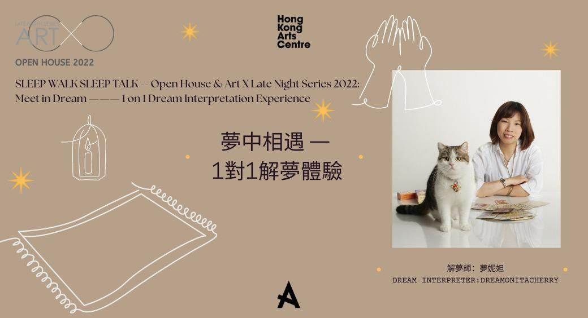
Dream is like a Love letter to yourself. Dream Interpretation is like a journey into your heart, it is always about Something deep down inside your subconsciousness. During the session, you only have to share a dream, no matter how broken it seems to be, and Dreamonitacherry will guide you through the whole process to the real message(s) of this dream via each layer, all you have to do is to listen with openness.

Session: 25th June, 2022 (Saturday)
* 20 mins for each session
1700-1720/1730-1750/1800-1820/1830-1850/1900-1920/1930-1950/2000-2020/2030-2050/2100-2120/2130-2150
Venue: 3/F Atrium, Hong Kong Arts Centre
Number of participants: 10 ( 1 person per each session)
Target Audience: 16 or above
Language: Cantonese
Dream Interpreter: Dreamonitacherry
About Dreamonitacherry:
Most of Monita’s life has been centred around the fields of psychology. She is a highly gifted and ,without doubt, a known remarkable Hong Kong dream reader and Psychic who has been studying and working in her field for over 7 years. She is highly adept at using the Tarot alongside her extensive reading skills of subconscious level on handwriting, intuition and Astrological knowledge and uses her skills and innate wisdom with empathy and sincerity. She has devoted most of her time to understanding human beings and researching their energies, traumas related to their diseases and behaviors. Monita is active in the field with her weekly radio dream reading programme on Commercial radio 2 (903), column in trendy young-adult magazine East Touch, and her irregular events and charity work, she believes she can do this until her next life.
Spoken Words Music x Art X Late Night Series - Mumble Bumble

Pop down the rabbit hole, float in the convergence where reality and fantasy meet. The unconscious mumble in your sleep could be the absurd imagination finding release, or the conversation with someone in your dream. Let's share the sleep talking through music and words, dream together and wake up together in spoken words music.

Music and writing workshop on sleep and dream. Participants will be guided through a creative writing process and incorporate them with songs, hand-pan and hand drum music.

Artists: Faye Leong^ | Gabriel Fung Kwok Kee | Bubbles Man*
Curator: Janice Poon^

Location: Eric Hotung Studio
No. of participants: 25
Language: Cantonese and English

^With support and kind permission of the Hong Kong Academy for Performing Arts
*With support and kind permission of Chung Ying Theatre Company

Other Complimentary Programmes

- 【Out Of The Cube - Your Little & Big Feelings】: Windmill Workshop - Explore Around with Your Five Senses
- HKAC CREATORS FOR TOMORROW - Murmuring in a Glass Tube
- Luis Chan Studio

Appendix 2
Ticketing Package Options
Items | Price (HKD) | Quota (PAX)
Sweet Dreams: Reed Diffuser Workshop (either session 1 or 2) + Screening (either CLEO/ SLEEP) | 650 | 12
Sweet Dreams: Reed Diffuser Workshop (either session 1 or 2) + Spoken Words Music Series x Art X Late Night Series - Mumble Bumble | 650 | 12
Meet in Dream: 1 on 1 Dream Interpretation Experience (choose between 10 sessions) + Screening (either CLEO/ SLEEP) | 650 | 5
Meet in Dream: 1 on 1 Dream Interpretation Experience (choose between 10 sessions) + Spoken Words Music x Art X Late Night Series - Mumble Bumble | 650 | 5
Screening (either CLEO/ SLEEP) Single Ticket | 85 | 84
Spoken Words Music x Art X Late Night Series - Mumble Bumble Single Ticket | 150 | 8

