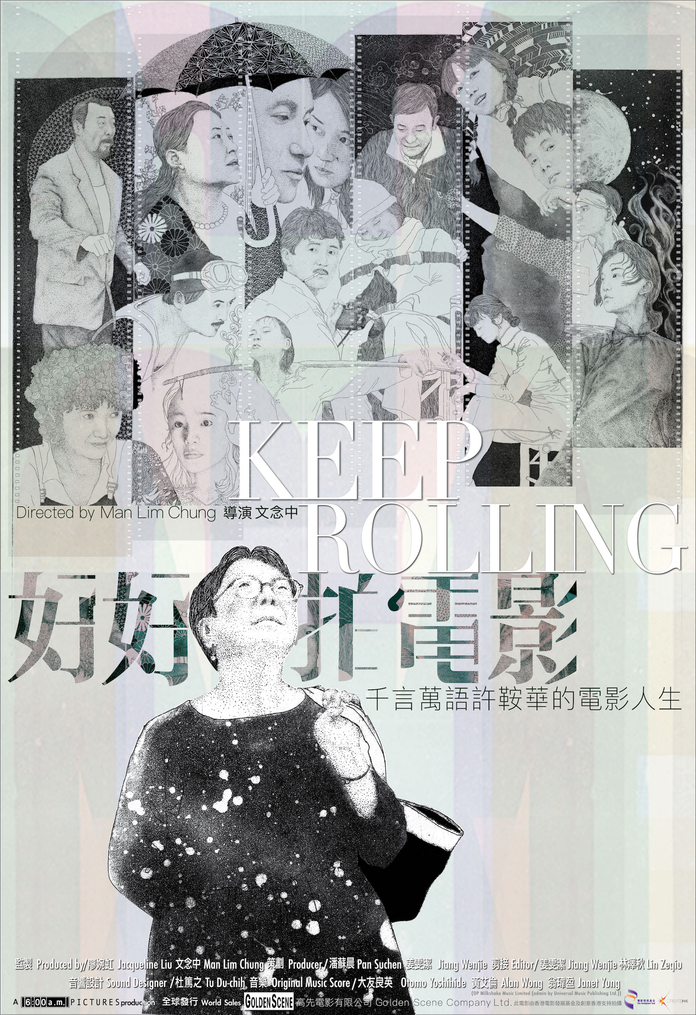

**KEEP ROLLING**

**Synopsis**

On a buzzing red carpet, a 70-year-old short-haired woman strides towards the stage with confidence. Behind the red carpet, it’s a muddy path that leads to a movie studio in New Territories, Hong Kong. To her, glory and hardship are nothing more than just different paths that lead to the world of cinema.

Born in Northeastern China, raised in Macau and educated in Hong Kong, Ann Hui stays true to her cultural heritage as a Chinese, yet she has always been fascinated by Western literature and therefore decided to further her studies in London. Eventually, she found movies. Through movies, she becomes fully immersed into the ‘East-meets-West’ culture and lifestyle of Hong Kong; She reconciles with her distant mother; And she gets to explore the cultural and social identity of her and the city she calls home. Movies also found her.

Having learned from veteran auteur King Hu, her directorial debut became part of the impetus behind Hong Kong’s New Wave as she explores marginalized characters in her movies.

40 years have passed, Ann Hui experienced numerous ups and downs in her career, but the turn of the tide has never threatened her dedication and integrity towards movies. Her works embody her humanistic concerns and deep interests for the people of Hong Kong. On the lonely journey of discovery, her life is now full because of movies.

**Director's Biography -** Man Lim Chung

Man entered the filming industry after graduating from The Hong Kong Polytechnic University – School of Design in 1991. During his early years in his career, he assisted the most acclaimed art directors in Hong Kong such as Mr. Tony Au and Mr. William Chang on many Hong Kong Blockbusters. He was awarded his first Hong Kong Film Award in 1999 for his art direction in ***Tempting Heart***and began his career as one of Hong Kong’s most notable art directors. From 2002 onwards, he has been working with Director Ann Hui and has worked as her films’ art director for ***July Rhapsody***, ***The Golden Era*** and ***Our Time Will Come***.

**Awards：**

1999 ⋯⋯⋯⋯⋯⋯ ***Tempting Heart*** (Directed by Sylvia Chang)

— Best Art Direction at the 19th Hong Kong Film Awards

2012 ⋯⋯⋯⋯⋯⋯***The Silent War*** (Directed by Felix Chong and Alan Mak)

— Best Costume Design at the 7th the Asian Film Awards

**2014 ⋯⋯⋯⋯⋯⋯*The Golden Era*** (Directed by Ann Hui)

— Best Costume and Make Up Design at the 34th Hong Kong Film Awards

**2017 ⋯⋯⋯⋯⋯⋯*Our Time Will Come*** (Directed by Ann Hui)

— Best Art Direction at the 37th Hong Kong Film Awards

2018 ⋯⋯⋯⋯⋯⋯*Project Gutenberg* (Directed by Felix Chong)

— Best Costume and Make Up Design at the 38th Hong Kong Film Awards

**Nominations：**

**2002 ⋯⋯⋯⋯⋯⋯*July Rhapsody*** (Directed by Ann Hui)

2004 ⋯⋯⋯⋯⋯⋯***Colour Blossoms*** (Directed by Yonfan)

2006 ⋯⋯⋯⋯⋯⋯***Isabella*** (Directed by Pang Ho Cheung)

2006 ⋯⋯⋯⋯⋯⋯***Confession of Pain*** (Directed by Alan Mak and Andrew Lau)

2010 ⋯⋯⋯⋯⋯⋯ ***Love In A Puff*** (Directed by Pang Ho Cheung)

2014 ⋯⋯⋯⋯⋯⋯***Overheard 3*** (Directed by Felix Chong and Alan Mak

2014 ⋯⋯⋯⋯⋯⋯***Aberdeen*** (Directed by Pang Ho Cheung)

2019 ⋯⋯⋯⋯⋯⋯***I'm Livin' It*** (Directed by Hing Fan Wong)

**Other Works:**

2004 ⋯⋯⋯⋯⋯⋯***20 30 40*** (Directed by Sylvia Chang)

2007 ⋯⋯⋯⋯⋯⋯***Trivial Matters*** (Directed by Pang Ho Cheung)

2007 ⋯⋯⋯⋯⋯⋯***Exodus*** (Directed by Pang Ho Cheung)

2008 ⋯⋯⋯⋯⋯⋯***If You Are The One*** (Directed by Feng Xiaogang)

2009 ⋯⋯⋯⋯⋯⋯***Overheard*** (Directed by Felix Chong and Alan Mak)

2010 ⋯⋯⋯⋯⋯⋯***If You Are The One 2*** (Directed by Feng Xiaogang)

2011 ⋯⋯⋯⋯⋯⋯***Overheard 2***(Directed by Felix Chong and Alan Mak)

2012 ⋯⋯⋯⋯⋯⋯***Love in the Buff*** (Directed by Pang Ho Cheung)

2015 ⋯⋯⋯⋯⋯⋯***Lost in Hong Kong*** (Directed by Xu Zheng)

2017 ⋯⋯⋯⋯⋯⋯***Love Education*** (Directed by Sylvia Chang)

2017 ⋯⋯⋯⋯⋯⋯***Love Off the Cuff*** (Directed by Pang Ho Cheung)

2018 ⋯⋯⋯⋯⋯⋯***Hello Mr. Billionaire*** (Directed by Fei Yan and Damo Peng)

2019 ⋯⋯⋯⋯⋯⋯***Cry of The Birds*** (Directed by Tian Zhuangzhuang)

Furthermore, Man was also involved in a wide range of other artistic work in the entertainment industry in China and Taiwan including but not limited to album cover, styling for concerts, art direction for performing art, commercial, and spatial design.

**Director's Statement**

Ann Hui was already 70 years old when she finished filming “Our Time Will Come”, but she was the kind of director who is energetic, decisive, extremely passionate towards movies, and still used to doing everything herself. Growing up in Hong Kong, Ann inherits the city’s unique cultural and historical heritage. She is a typical embodiment of the ‘Hong Kong spirit’ as she is extremely versatile and flexible. She works with a fast pace and she is often able to find pleasures in the midst of hardships. At the same time, she’s nothing short of extraordinary: she is one of very few directors who are educated intellectuals, not to mention that she is a female director in a male-dominated line of work. She insists on the importance of critical thinking, and she respects lives. For years, she has been struggling between artistic or commercial approach. Tsui Hark once said ‘Ann is a species that Hong Kong’s movie industry has to protect’. 70-year-old Ann Hui brought light, courage and empowerment to Hong Kong’s cinema with her life, her work, her passion and her diligence. This is a story about Ann Hui, Hong Kong movies and the growth of Hong Kong.

Produced by / Jacqueline Liu ; Man Lim Chung

Line Producer / Pan Suchen; Eva Jiang

Editor / Eva Jiang; Lin Zeqiu

Sound Designer: Tu Du-chih

Original Music Score: Otomo Yoshihide; Alan Wong; Janet Yung

Duration：111 mins