Source of the stills:

Still 02 – 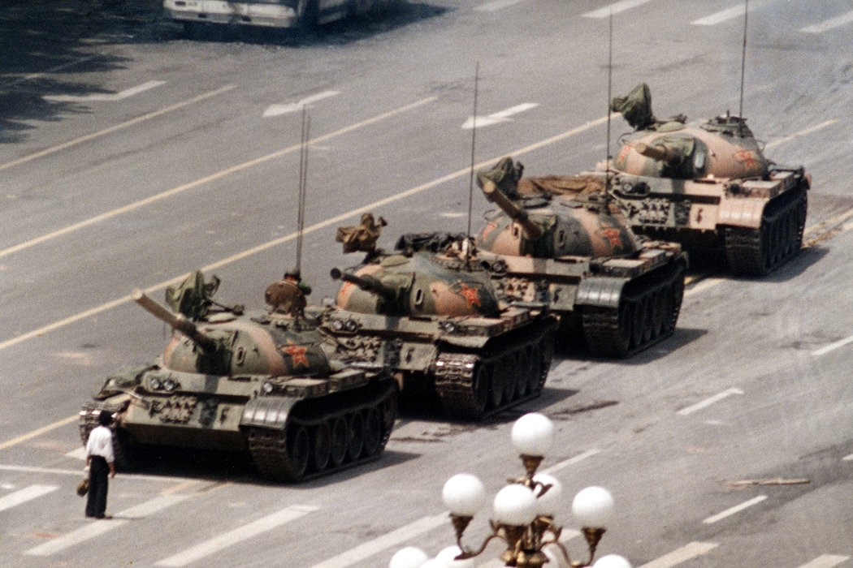
https://cn.nytimes.com/china/20160531/c31chinatiananmen/zh-hant/
Still 03 –
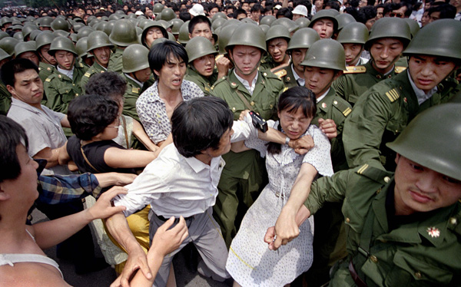
https://botanwang.com/articles/201406/北京是怎样改写天安门屠杀这段历史的.html

