**Co-Presented by**

**【Hong Kong Arts Centre】【Italian Cultural Institute Hong Kong & Macau】**

***The Passion of Reality: Documentary Film Retrospective of Pier Paolo Pasolini***

**"The cinema is an explosion of my love for reality." - Pier Paolo Pasolini**

**01 to 04 December 2022 @Louis Koo Cinema, Hong Kong Arts Centre**

**Individual tickets and All Access Pass are available on POPTICKET**

**[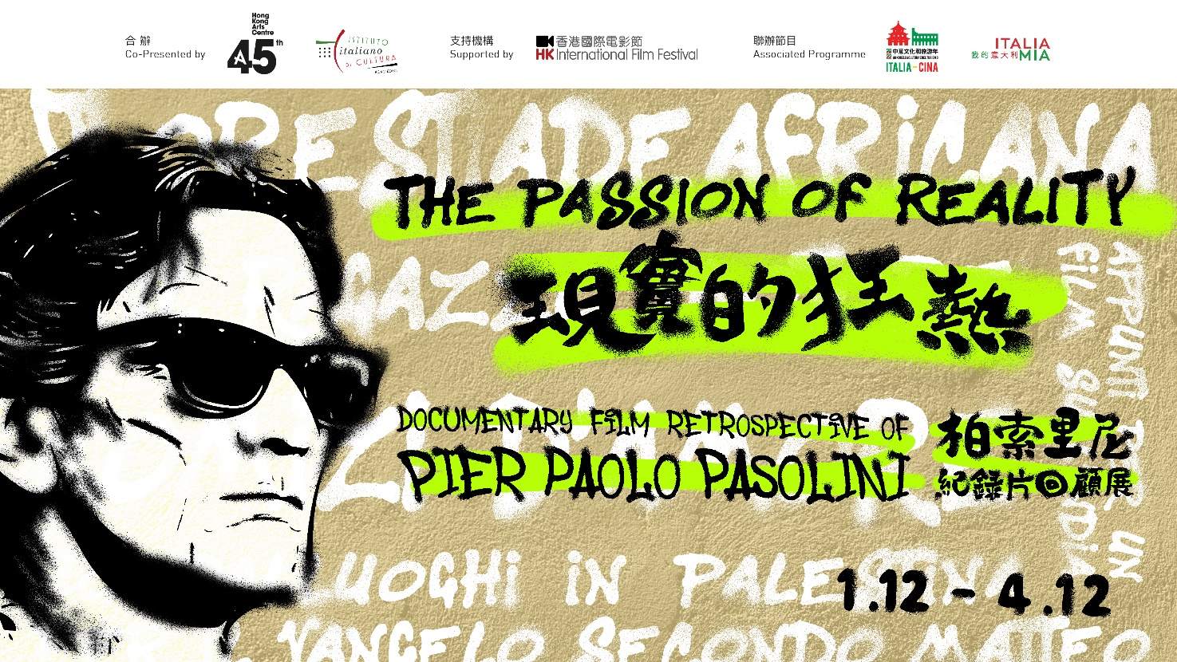](https://www.hkac.org.hk/calendar_detail/?u=WdcWMyvSCmc)**

**The Hong Kong Arts Centre co-presents with the Italian Institute Hong Kong & Macau, The Passion of Reality: Documentary Film Retrospective of Pier Paolo Pasolini** at the Louis Koo Cinema of the Hong Kong Arts Centre for the screenings of *Pasolini*, *12 December*, *Notes Towards an African Orestes*, *Love Meetings*, *The Anger*, *The Walls of Sana’a*, etc. This programme is part of the annual Italia Mia Festival.

To celebrate the centenary of his birth, the Hong Kong Arts Centre is proud to present the most comprehensive retrospective of documentaries by the late **Pier Paolo Pasolini** in Hong Kong.

One of the most prolific intellectuals of his time, Pasolini was more than just a filmmaker; he was also a writer, a journalist, a visual artist, an actor and an activist whose persona was just as loud as his films. As much as his fictional films conveyed and reflected his internal dichotomies – namely a Marxist who also often looked to religion for inspiration – his documentaries offer much-needed insight into the mind of the man who created some of the most controversial films ever made. More importantly, they serve as companion pieces to Pasolini’s fictional films, reinterpreting his creative concerns in real world terms.

While *Love Meetings* reflected his passion for all things regarding sex, *12 December* – produced for left-wing militant group Lotta Continua – and his half of *The Anger* saw Pasolini put his passion as a political activist front and centre. *Location Hunting in Palestine* offers a rare look at Pasolini in his element, searching for shooting locations in Palestine while his narration offers musings on the teachings of Christ and his thoughts on the land he is visiting. The programme even includes five short documentaries that were inspired by Pasolini’s writings, two of which are directed by the first Italian woman documentary filmmaker, Cecilia Mangini, showing Pasolini’s widespread influence on his fellow artists.

I**ndividual tickets and a tickets package (one ticket each for all 6 programmes)** **are available at** **www.popticket.hk** **now. Further discounts are available for group bookings of over 20 tickets, please visit the Hong Kong Arts Centre website for further details. Group booking form is attached.**

**Press interviews and programme previews are welcomed. Please contact the Hong Kong Arts Centre for further arrangements.**

|  |
| --- |
| **The Passion of Reality: Documentary Film Retrospective of Pier Paolo Pasolini** |
| **About the films**  **1/12 (Thu) 7:45pm**  **OPENING FILM: Love Meetings**  **Comizi D'amore**  Director: Pier Paolo Pasolini  Italy | 1964 | 92’ | In Italian with English subtitles | DCP | B&W  Pasolini puts on his journalist cap in this enlightening documentary, travelling across Italy with a microphone and a camera to interview strangers on the street about their views on sex, prostitution, homosexuality, divorce (which was illegal in Italy at the time) and everything else in between. The target is not only to capture existing opinions on matters surrounding sex, but also to reflect how attitudes can be challenged and gradually changed even in a country as traditional as Italy when the wave of sexual liberation reaches its shores.  Though *Love Meetings* plays out more like a time capsule nearly five decades after its release, it offers an intriguing insight into views on sexual taboos in other cultures. This engaging film truly gets interesting when the charismatic Pasolini begins to delve into how nationalism and religion intersect with sex.  **2/12 (Fri) 7:45pm**  **The Anger**  **La rabbia**  Director: Giovannino Guareschi, Pier Paolo Pasolini  Italy | 1963 | 105’ | In Italian with English subtitles | Digital | B&W  Though both were generally acknowledged as intellectuals and “influencers” who were outcast by their contemporaries, Giovannino Guareschi and Pier Paolo Pasolini stood literally on opposite ends of the ideological spectrum. The former is a right-wing conservative monarchist, while the latter is a left-wing Marxist who believes in progressive values. In this two-part film, the men each use documentary footage and voiceover to express their respective answers for important existential questions.  A true example of political art, *The Anger* attempts to find common ground between two very different men, but the result merely becomes a reflection of the polarising ideologies that fractured Italy at the time. Praised by most as the superior section, Pasolini’s half elegantly and creatively presents his arguments with intelligence and grace. After decades of limited availability, the full version of the film has now been restored so viewers can make their own judgment.  **3/12 (Sat) 3:00pm\***  **Pasolini**  Director: Abel Ferrara  Italy, France, Belgium | 2014 | 84’ | In English and Italian with Chinese and English subtitles | DCP | Color  It is the early 1970’s; Pier Paolo Pasolini had just finished *Salo*, which would later become his most divisive and controversial film. He has also become a social pariah for his sexuality and his loud public persona. Despite the objection of those closest to him, Pasolini pushes on with his new project while becoming increasingly distant from the press. Meanwhile, we see visualisations of Pasolini’s final projects, left unfinished due to his untimely death.  A long-time admirer of who shares Pasolini’s penchant for creating provocative cinema, Abel Ferrara pays tribute to the late filmmaker with this unconventional biopic about the days before his murder, which remains unsolved today. Anchored by another excellent performance by the great Willem Dafoe, Ferrara’s defiantly untraditional and unsentimental depiction of Pasolini’s last days likely would’ve gotten the director’s seal of approval.  *With seminar. Conducted in English.  **Pasolini has been rated as a category III film and can only be viewed by persons over the age of 18.  **3/12 (Sat) 7:30pm**  **Notes Towards an African Orestes**  **Appunti per un'Orestiade africana**  Director: Pier Paolo Pasolini  Italy | 1970 | 70’ | In Italian with English subtitles | DCP | B&W  In the late 1960’s, Pasolini had plans to adapt Aeschylus’s *The Oresteia* into a film. This documentary is a collage featuring snapshots of Pasolini’s attempt to make the film, capturing his location scouting trip in Africa, his casting process and a jazz group’s performance in Rome, all set to the filmmaker’s narration of his thoughts. The film’s key section is Pasolini’s meeting with a group of African students in the University of Rome, during which he expressed his vision and received honest feedback about the feasibility of the project. In the end, the film was never made.  More of a cinematic essay than a fleshed-out narrative, Pasolini’s third documentary on filmmaking is an honest portrayal about the uncertainties that plague a creative process. Though loose in structure, the film nevertheless offers essential insights into Pasolini’s mind, as well as proof that even geniuses can falter every once in a while.  **The Walls of Sana’a**  **Le mura di Sana’s**  Director: Pier Paolo Pasolini  Italy | 1971 | 13’ | In Italian with English subtitles | Digital | Color  In October 1970, Pasolini filmed parts of *The Decameron* in the city of Sena’a in Yemen, one of the oldest cities in the world. Addressed to UNESCO, this short documentary features Pasolini’s footage of the gorgeous city and a convincing appeal from the filmmaker asking UNESCO to protect the city from development. The body accepted Pasolini’s appeal and declared Sana’a a World Heritage Site.  **4/12 (Sun) 4:00pm**  **Location Hunting in Palestine**  **Sopralluoghi in Palestina per il vangelo secondo Matteo**  Director: Pier Paolo Pasolini  Italy | 1965 | 54’ | In Italian with English subtitles | Digital | B&W  In 1963, Pasolini travelled in Palestine in hopes that he could shoot his biblical epic *The Gospel According to Matthew* in actual historical locations. The film captures Pasolini’s trips through local villages and features Pasolini’s narration of his inner thoughts as he expresses his views on Christ and his growing disillusionment of the land he is visiting. Ultimately, it shows an artist facing the brutal truth that reality doesn’t always sync with an artist’s creative vision.  **Still They Toll**  **Stendalì: Suonano ancora**  Director: Cecilia Mangini  Italy | 1960 | 11’ | In Italian with English subtitles | Digital | Color  In post-war Italy, “Formula 10” films – documentaries that fit on a single 35mm film roll and made on a low budget – were popular among filmmakers as a way to express their views on social issues. Inspired by Pasolini’s novel *Ragazzi di vita* and featuring his lyrics, Cecilia Mangini’s avant-garde short film uses a funeral to show the traditions of Southern Italy, which have roots that go as deep as its days as a colony of ancient Greece.  **Unknown to the City**  **Ignoti alla Città**  Director: Cecilia Mangini  Italy | 1958 | 12’ | In Italian with English subtitles | DCP | Color  Cecilia Mangini’s first film unflinchingly captures the lives of a group of young men who live in the poverty-stricken suburbs of Rome. Banned by censors at the time, this raw neorealist exposé of post-fascism life in Italy is accompanied by commentary written by Pasolini, who was Mangini’s friend at the time.  **The Motorbike Boy**  **Il ragazzo motore**  Director: Paola Faloja  Italy | 1967 | 12’ | In Italian with English subtitles | DCP | B&W  Paola Faloja’s short documentary about Rome suburban youths’ obsession with motorbikes was inspired an encounter that happened to Pasolini, which is narrated by the filmmaker himself in the opening scenes. The observational film then captures scenes of young men with their bikes in bike shops or dangerous street races that can turn lethal in a matter of seconds. This is a depiction of passion among dispirited youths who have little else to live for.  **4/12 (Sun) 7:30pm**  **12 December**  **12 dicembre**  Director: Giovanni Bonfanti, Pier Paolo Pasolini  Italy | 1972 | 100’ | In Italian with English subtitles | DCP | B&W  On 12 December 1969, a bomb exploded at Piazza Fontana in Milan, killing 17 people. Anarchist activist Giuseppe Pinelli, one of the activists who were picked up for questioning by the police, fell from a police station after three days of interrogation. To raise awareness for the government’s campaign targeting left-wing groups, militant group Lotta Continua recruited Pasolini to direct this documentary tracing the turmoil that unfolded before and after the bombing.  Though initially uncredited to protect himself legally, Pasolini helped raise funding and worked closely with activist Giovanni Bonfanti to make this documentary out of his admiration for Lotta Continua’s cause. Featuring a heartbreaking interview with Pinelli’s family and amazing shots of protests at the time, this is a passionate and artfully crafted document of political and social turbulence that is an essential watch for contemporary history buffs. |

**Screening Schedule**

|  |  |  |  |
| --- | --- | --- | --- |
| **01/12 (Thu)** | **02/12 (Fri)** | **03/12 (Sat)** | **04/12 (Sun)** |
|  |  | 15:00  Louis Koo Cinema, HKAC **Pasolini**  **\*With seminar. Conducted in English.** | 16:00  Louis Koo Cinema, HKAC **Location Hunting in Palestine, Still They Toll, Unknown to the City, The Motorbike Boy** |
|  |  |  |  |
| 19:45  Louis Koo Cinema, HKAC **Love Meetings** | 19:45  Louis Koo Cinema, HKAC **The Anger** | 19:30  Louis Koo Cinema, HKAC  **Notes Towards an African Orestes, The Walls of Sana’a** | 19:30  Louis Koo Cinema, HKAC  **12 December** |

**【The Passion of Reality: Documentary Film Retrospective of Pier Paolo Pasolini】**

**Details:** <https://hkac.org.hk/calendar_detail/?u=WdcWMyvSCmc>

**Images Download:** <http://ftp.hkac.org.hk/MDD/Pier_Paolo_Pasolini/>

**Trailer on YouTube:** <https://www.youtube.com/watch?v=BJh2kAd0EoU>

**Website:** [www.hkac.org.hk](http://www.hkac.org.hk)

**Date: 01 - 04/12/2022**

**Venue: Louis Koo Cinema, Hong Kong Arts Centre**

**Co-Presenter:** Hong Kong Arts Centre, Italian Cultural Institute Hong Kong & Macau  
**Supported by:** Hong Kong International Film Festival  
**Associated programme:**Italy-China Year of Culture and Tourism, Italia Mia

**Individual tickets and tickets package are available on POPTICKET now**

**Website**: <https://www.popticket.hk/event/passion-of-reality>

**Tickets package: $366 (Includes 1 ticket of 6 programmes)** **| Individual** **ticket: $80 / $64\***

*20% off discount for full-time students, senior citizens aged 60 or above, people with disabilities and the minder and Comprehensive Social Security Assistance (CSSA) recipients. Tickets for CSSA recipients available on a first-come-first-served basis. Concessionary ticket holders must produce evidence of their identity or age upon admission.

*20% discount to HKAC members and CineClub Patron / Classic. Ticket holders must present a valid membership card upon admission.

*20% off for each purchase of 4 or more standard tickets.

*Group booking offer for each purchase of 20 or more tickets. Please refer to the website of the Hong Kong Arts Centre for more details.

*Only one discount offer could be applied to each ticket purchase.

**Hong Kong Arts Centre Moving Images**

**Facebook:** [www.facebook.com/hkartscentremovingimages/](http://www.facebook.com/hkartscentremovingimages/)

**Instagram:** [www.instagram.com/hongkongartscentremovingimages/](http://www.instagram.com/hongkongartscentremovingimages/)

**Programme enquiries:** 2582 0282 (Monday to Friday 10:00 – 18:30)

**Hong Kong Arts Centre – Art for Passion, Art for Life, Art for All**

This year marks the 45th Anniversary of the Hong Kong Arts Centre.

Since 1977, the Hong Kong Arts Centre (HKAC) has been a platform for nurturing and supporting artists, and infusing art into everyday life. Its unique arts and educational programmes aim to make the arts accessible for all. The HKAC believes in the transformational power of art for people from all walks of life. Established for more than four decades, the HKAC endeavours to bring arts to the people of Hong Kong – by presenting programmes for visual arts, performing arts, moving images and media arts, comics and animation. Our other areas also cover arts education, conferences, festivals, public art and community projects. All with the vision and mission of engaging and inspiring creativity in the Hong Kong community.

In 2000, HKAC founded its education arm, Hong Kong Art School (HKAS). The HKAS provides award-bearing programmes to nurture artists and art practitioners, as well as short enrichment courses for the general public. The HKAC aspires to engage everyone in the community to become an active participant in the arts – as an enthusiast, an artist or a patron.

Let’s continue to embrace ‘Art for Passion, Art for Life, Art for All’, and share the inspiration.

Official website: [hkac.org.hk](https://linkprotect.cudasvc.com/url?a=https%3a%2f%2fhkac.org.hk%2f&c=E,1,U-qFpfQWxcUVIlLbLd-tZIyFxRIXkBMAgHG20uzahqOBFljK57-cx6QG93qupJIGy1spwZJhloGJI5FqmyLOLrgUt-PYTRfXmrnvboIxQcmY8Xsb8Q,,&typo=1) | Facebook: [Hong Kong Arts Centre](https://www.facebook.com/HongKongArtsCentre) | Instagram: [@hongkongartscentre](https://www.instagram.com/hongkongartscentre/)

|  |  |
| --- | --- |
| **Media Enquiry:【Hong Kong Arts Centre】** | |
| **Hong Kong Arts Centre**  Jacqueline Tong  Project Manager  Tel: 2582 0247  Email: [jtong@hkac.org.hk](mailto:jtong@hkac.org.hk) | **Sense Connect Limited**  Mona Chu  Director  Tel: 9276 5601  Email: [mona@senseconnectasia.com](mailto:mona@senseconnectasia.com) |

- end -