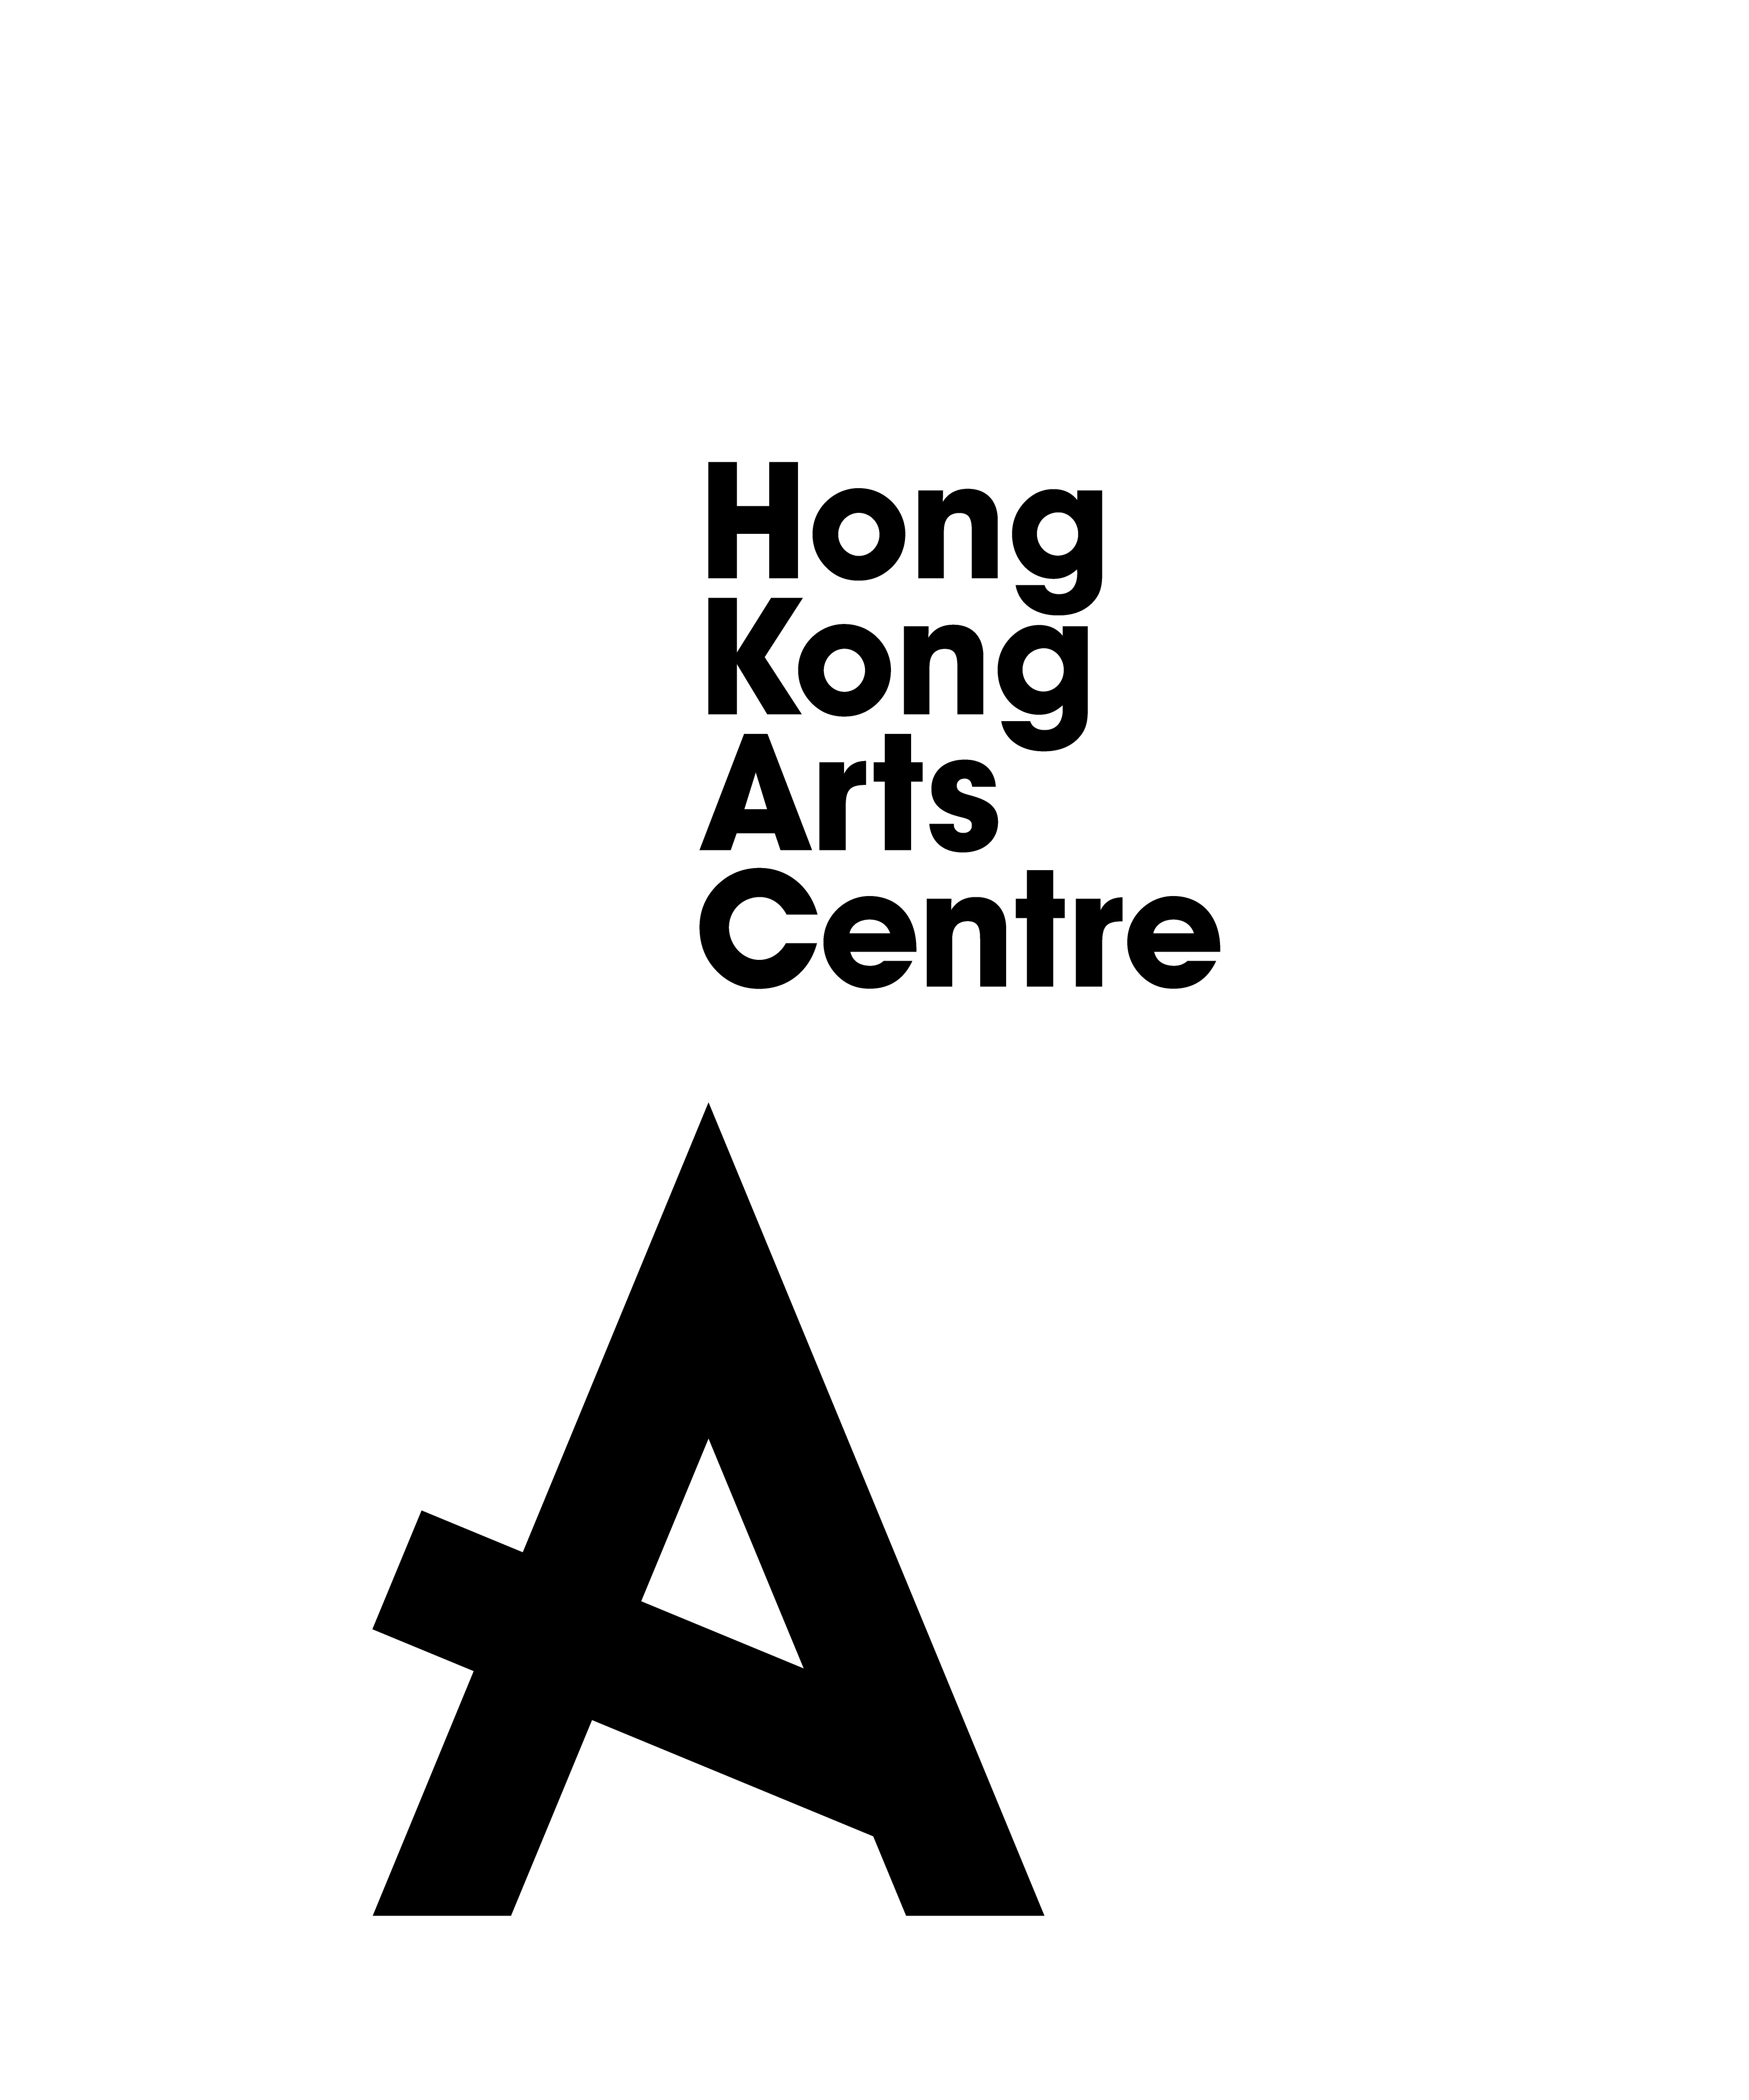
Presented by Hong Kong Arts Centre &
in Collaboration with Fu Hong Society on
Penguin Pilar and the Sky of Hope A Collection of Poems
by Michelle Ling Allcock
Exhibition Opening and New Book Launch
Overcome the age and physical barriers, embody the spirit of arts for all

Hong Kong Arts Centre (HKAC) works in close partnership with author Michelle Ling Allcock for the fourth time to publish an illustration book Penguin Pilar and the Sky of Hope A Collection of Poems by Michelle Ling Allcock in Art for All programmes, following her illustration book series Daisy Fairy and the Bear and A Penguin Named Pilar and Other Short Stories. This time, Michelle made a new step forward in her creative writing and successfully completed her first poetry work. Expressing Michelle’s reflections about life, the illustration book includes nine original poems and stories with life-affirming and inspiring messages about dream, hope and friendship.
HKAC, in the belief that everyone is creative, is pleased to engage service users of Fu Hong Society in the participation of artistic creations for this book, allowing persons with disabilities to freely explore and unleash their boundless creativity to the fullest through art activities. An exhibition will be held in Diana Cheung Experimental Gallery, 3/F, HKAC (2 Harbour Road, Wan Chai, Hong Kong), from 3rd to 30th December 2021 (10am – 6pm), showcasing a selection of colourful and vibrant artworks from the illustration book by these special art talents. Through this opportunity, it is hoped that an inclusive and supportive platform can be provided to empower the disabled persons, and the public will appreciate and embrace diversity through the lens of arts.

In the meantime, HAKC offers support to Fu Hong Society by collaborating with cookbook author Dominica Yang and publishing her new cookbook Mum’s Kitchen – Back to Basic. All proceeds from the sale of this cookbook benefit Fu Hong Society and Priscilla’s Home nested in Fu Hong Society. The book combines elements of culinary art and comics by Hong Kong artist, Tweety Bao, through which the author retells her heart-warming cooking stories with her late mother. The exhibition will also showcase the touching comics drawn for the book by Tweety Bao.

Penguin Pilar and the Sky of Hope A Collection of Poems by Michelle Ling Allcock and Mum’s Kitchen – Back to Basics published by HKAC are now available at the HKAC Art Shop and online store (hkacartshop.store).

Penguin Pilar and the Sky of Hope A Collection of Poems by Michelle Ling Allcock contains nine pieces of children’s poems and stories featuring animals and nature. Continuing in her signature pure and enchanting writing style, this time not only does she continue to share with her readers the power of love, longing and dreams, she naturally integrates her own reflections about life into her work, guiding readers on this amazing journey of hope and friendship.
The book, Mum’s Kitchen – Back to Basics published by HKAC is now available at the HKAC Art Shop and online store (hkacartshop.store); outlet of Fu Hong Society’s Social Enterprises - Madam Hong Care as well as bookstores including The Commercial Press (H.K.); Joint Publishing; Chung Hwa Book Company and Cosmos Books, Kelly and Walsh, Bookazine and Towngas Customer Centres.
Mum’s Kitchen – Back to Basics makes a crossover into art and cooking, highlighting the mission of "art is life". The book is a collection of 30 Chinese, Western and Southeast Asian recipes including the best loved recipes of the author’s mother, some of the author’s family favourites and the sweet must-haves. All proceeds of this book benefit Fu Hong Society as charity donations, expressing the concept of “art for wellbeing” and injecting a sense of social concern into art.

Details of the Exhibition:
Presenter: Hong Kong Arts Centre
Collaborator: Fu Hong Society
Date: 3 December 2021 to 30 December 2021
Time: 10am – 6pm (Opening hours may change if Shouson Theatre has day-time performance)
Venue: Diana Cheung Experimental Gallery, 3/F, Hong Kong Arts Centre (2 Harbour Road, Wan Chai)
Free admission
Poem and Story: Michelle Ling Allcock
Artworks:
Service users of Fu Hong Society:
Anonymous, Chan Y. Y., Tracy Fong, Ho Wing Fat Stanley, Lam Mui, Lau Ka Kuen, Lee Kit Ming, Lo Mun Kei, Tang Fuk Hing, Coke Tsang, Tsang Yuk Sing, Wong Chang Ming, Wong Shun Hi, Wong Wai Lun, Yau Tak Ming

About Michelle Ling Allcock
A creative artist from Hong Kong born to a Chinese mother and an English father, Michelle received her formal education at the Chinese International School in Hong Kong and graduated with a degree in Creative Events from the University of Kent, England. In her works Michelle draws upon the aestheticism and traditions of East and West. She has many hobbies and interests, including dancing, singing, song writing, flower arranging, jewellery making, ice skating and surfing.

About Dominica Yang
Born and bred in Hong Kong, Dominica Yang is the author of four cookbooks – all to benefit charities. Dominica’s love for cooking stems from her mother, growing up in a family where cooking and food are very much part of quality time and sharing with loved ones. Mum’s Kitchen – Back to Basics is a tribute to her mother and all proceeds benefit Priscilla’s Home for persons with disabilities, nested in Fu Hong Society in Hong Kong.

Dominica is a keen supporter of art, culture and meaningful causes particularly to help those with dementia, disabilities, special needs and the less privileged.

About Tweety Bao
Tweety loves to create warm and joyful illustrations. Watercolour is her major medium for art creation. Her favourite subject matters include the scenes of Hong Kong and the traditional culture, as well as food and animals. She has published Love’s Cooking Battle, a comic book about couples’ daily lives with hand-drawn illustrated recipes.

About Hong Kong Arts Centre – Art for Passion, Art for Life, Art for All
Since 1977, the Hong Kong Arts Centre (HKAC) has been a platform for nurturing and supporting artists, and infusing art into everyday life. Its unique arts and educational programmes aim to make the arts accessible for all.

The HKAC believes in the transformational power of art for people from all walks of life. Established for more than four decades, the HKAC endeavours to bring arts to the people of Hong Kong – by presenting programmes for visual arts, performing arts, moving images and media arts, comics and animation. Our other areas also cover arts education, conferences, festivals, public art and community projects. All with the vision and mission of engaging and inspiring creativity in the Hong Kong community.

In 2000, HKAC founded its education arm, Hong Kong Art School (HKAS). The HKAS provides award-bearing programmes to nurture artists and art practitioners, as well as short enrichment courses for the general public.

The HKAC aspires to engage everyone in the community to become an active participant in the arts – as an enthusiast, an artist or a patron.

In 2023, the HKAC will celebrate its 45th anniversary. Let’s continue to embrace ‘Art for Passion, Art for Life, Art for All’, and share the inspiration.

About Fu Hong Society
Inspired by the spirit of Father Enea Tapella, PIME who had offered his caring and selfless contribution to the underprivileged, Fu Hong Society was established. The Society has started providing rehabilitation services since 1977. Currently, the Society has operated about 70 service units and projects providing services for about 4,000 persons with disabilities annually. Among them there are persons with intellectual disabilities, persons with autism spectrum disorders, persons in psychiatric recovery, persons with physical disabilities, etc.. Core services provided by the Society include: residential care services, day training services, vocational rehabilitation and development services, community psychiatric services, services for persons with autism spectrum disorders and developmental disabilities, and community support services for persons with disabilities.
For all these years, the Society has upheld its service spirit “Take the Lead, Meet the Need with Love” and has strived to make innovative efforts in meeting the changing needs of persons with disabilities, enabling them to develop their abilities and to be fully integrated with the community. In addition, the Society puts emphasis on the promotion of social inclusion. In 2004, the Society was invited by the headquarters of “Best Buddies International” in the U.S. and was authorised to be the sole organisation for setting up the “Best Buddies Hong Kong” movement in Hong Kong. Hundreds of “Best Buddies” have been paired up every year, making one-to-one friendship between members of the community and persons with disabilities possible.

Image download: http://ftp.hkac.org.hk/MDD/Penguin_Pilar_and_the_Sky_of_Hope_A_Collection_of_Poems

~~~~~~~~~~~~~~ E N D ~~~~~~~~~~~
Media Enquiry
Hong Kong Arts Centre
- Annie Ho (Marketing & Development Director) | Tel: 2824 5306 / 9481 8706 | Email: aho@hkac.org.hk
- Charis Chau (Marketing & Communications Officer) | Tel: 2582 0290 | Email: cchau@hkac.org.hk

