【Hong Kong Arts Centre】 Partnering Programme
Join the Peer to Peer: UK/HK 2022 Symposium
26 September to 9 October
Details announced

The Peer to Peer: UK/HK 2022 Symposium is a key part of the public online festival, running from 26 September until 9 October 2022, and an exciting culmination to the programme of exchange between visual arts organisations in the UK and Hong Kong.
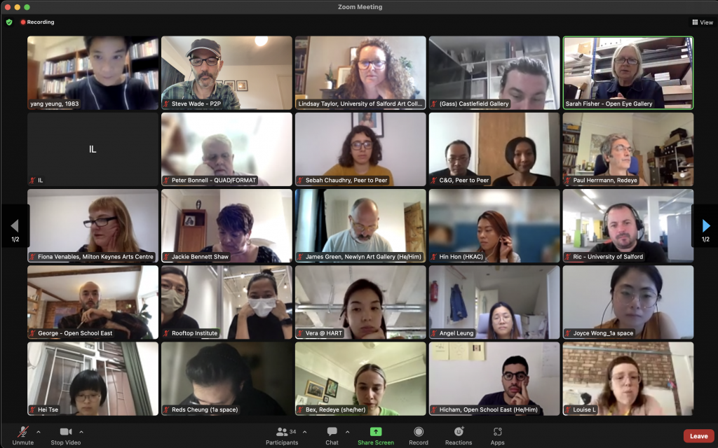
Screenshot of Peer to Peer: UK/HK 2022 meeting on 8th September 2022

Curated and shaped by and with the partner organisations, the symposium and festival content encourages collaboration, sharing, learning and discussion, and is now available for everyone to view and book on events at peertopeerexchange.org.
Information on events and activities can also be found across Facebook, Instagram and Twitter following #PeertoPeerUKHK22.
A varied programme of symposium talks and events, involving artists, arts organisations and specialists from the UK and Hong Kong is rolling out across the festival period including:
26 September, Launch of Peer to Peer: UK/HK 2022 Festival, Sarah Fisher, Open Eye Gallery and Lindsay Taylor, University of Salford Art Collection
26 September, Journey – live performance by Morgan Wong - Morgan Wong’s new lecture performance piece Journey looks into scenic imageries taken in rural China in the 1970s to connect oral history, archive, and teaching and learning
29 September, Artists Ama Dogbe and Yarli Allison – experiences of their shared online ‘micro’ residency. Expect issues such as the gender health data gap and the assimilation of diasporic communities through game art
30 September, Artist, Power and Place - can we move to a future where artistic careers are not linked to location? A discussion re-imagining the way artists work and collaborate
2 October, Back/Forth: Questions on the Road! - live event where the artists and curator in the Back/Forth Mail Art Project will respond to questions for Hong Kong, raised by public participants from Sheffield’s streets
4 October, Ways of Learning – join artists Morgan Wong and Hicham Gardaf to discuss their newly commissioned artworks Journey and The Storyteller as part of their collaborative commission Ways of Learning
5 October, Worldbuilding and Wellbeing - a discussion exploring the quickly developing realm of worldbuilding by artists using digital technology, and the wellbeing applications that might result from it
7 October, Noughts and Crossings - interactive and participatory event currently being devised by artists at The Chinese University Hong Kong and Falmouth University, UK
8 October, Art at the Edge of Language - artists and partner organisations come together to think about art as both something that operates at the very edges of what we might understand language to be
Artworks from project partners/visual artists can also be viewed online from 26 September peertopeerexchange.org/projects.
The Peer to Peer: UK/HK programme began with a pilot festival in 2020. Since then, nine UK and nine Hong Kong visual arts organisations have developed partnerships, encouraging exchange between more than 43 artists and over 160 students in, and from, each country.

Notes to editors:
Peer to Peer: UK/HK 2022 has been developed by Sarah Fisher, Open Eye Gallery and Lindsay Taylor, University of Salford Art Collection, with contributions from Ying Kwok, independent curator, Hong Kong and support from the Arts Council England.
It is a UK/Hong Kong bilateral arts exchange programme that encourages creativity and hopes to build lasting partnerships and legacy through the use of visual arts as a medium.
Of key importance in Peer to Peer: UK/HK 2022 is the distributed leadership model where partners have worked together for mutual benefit; each creative process has emerged through discussion, exploration and learning about each other.
Peer to Peer: UK/HK 2022 contemplates how the visual arts sector can continue to be outward facing and international whilst considering the future of our planet and the need to reduce our impact on it. Building on learning from the Covid pandemic, none of the participants has travelled to the UK or Hong Kong. A series of online webinars and discussions have enabled nine very different partnerships to form but each with a shared commitment to supporting emerging artists to develop their international networks and profile.

Hong Kong Arts Centre - Art for Passion, Art for Life, Art for All
Since 1977, the Hong Kong Arts Centre (HKAC) has been a platform for nurturing and supporting artists, and infusing art into everyday life. Its unique arts and educational programmes aim to make the arts accessible for all. The HKAC believes in the transformational power of art for people from all walks of life. Established for more than four decades, the HKAC endeavours to bring arts to the people of Hong Kong – by presenting programmes for visual arts, performing arts, moving images and media arts, comics and animation. Our other areas also cover arts education, conferences, festivals, public art and community projects. All with the vision and mission of engaging and inspiring creativity in the Hong Kong community.

In 2000, HKAC founded its education arm, Hong Kong Art School (HKAS). The HKAS provides award-bearing programmes to nurture artists and art practitioners, as well as short enrichment courses for the general public. The HKAC aspires to engage everyone in the community to become an active participant in the arts - as an enthusiast, an artist or a patron.

HKAC will continue its 45th anniversary celebrations into 2023. Let’s continue to embrace ‘Arts for Passion, Arts for Life, Arts for All’, and share the inspiration.

Official website: hkac.org.hk | Facebook: Hong Kong Arts Centre | Instagram: @hongkongartscentre

Media Enquiry

Hong Kong Arts Centre

 | Phone | Email
Annie Ho (Marketing and Communications Director) | +852 2824 5306 /  +852 9481 8706 | aho@hkac.org.hk
Charis Chau (Marketing and Communications Officer) | +852 2582 0290 | cchau@hkac.org.hk
Hin Hon (Project Coordinator) | +852 2582 0278 | whhon@hkac.org.hk

Peer to Peer: UK/HK 2022 (Marzipan PR)
 | Phone | Email
Jackie Bennett Shaw (Managing director) | +44 07802 323 413 | jackie@marzipanpr.co.uk

