Appendix 3 Go Chat (Online intimate talks)
There is a myriad ways to present, interrupt and understand a person, a story, an artwork or an exhibition. For an in-depth exploration of the Park, artworks, artists, stories behind this event, as well as our city, our times and ourselves, join us.

＃ | Name | Details
1 | Live Chat with the Artists | The four participating artists from different parts of the world will engage in online conversations with Hong Kong audience. Join these intimate chit-chats for a carefree venture into the playground of the heart as they share and exchange their views on art, creativity, experiences and stories with the audience.  January >> Stuart SEMPLE (United Kingdom)  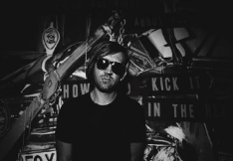  Date: 31 Jan, 2021  Facebook live @JCPopUpArtPark  One of the UK’s leading post Young British Artists, Semple is perhaps best known for his Happy Cloud performance at Tate Modern. He subsequently presented this performance in Moscow, Manchester, Milan, Australia, Denver & Dublin.  Semple has held 15 critically acclaimed solo exhibitions internationally in Hong Kong, New York, Los Angeles and Milan. He has participated in over 50 group exhibitions alongside artists such as Peter Doig, Basquiat, Warhol, Richard Prince, Ai Wei Wei and The Chapman Brothers. He has been featured across the media in The Times, Modern Painters, Italian Vogue, iD, Financial Times and many others. He has presented for the BBC and spoken at Oxford University, ICA, Denver Art Museum, Southbank Centre & Irish Museum of Modern Art. Honoured as a UN Happiness Hero – a distinction given to mark the first UN International Day of Happiness on 20th March 2013 – Semple is also an ambassador for ‘Mind’, the mental health charity.  February >> Wyan YEUNG (Hong Kong)  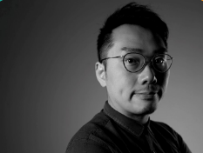  Date: 27 Feb, 2021  Facebook live @JCPopUpArtPark  Yeung is an Architect & Design Educator, he received a Master of Arts and Master of Architecture from Central Saint Martins, UK and The University of Hong Kong respectively. He is currently a partner of A&B Architects and the principal of Studio MEHH in Hong Kong.  Yeung’s interests and background are at the intersection of graphic, fashion, spatial, architecture and furniture. A recipient of multiple design awards, he is a frequent participant in prominent architectural and public art exhibitions, including the Bi-City Biennale of Urbanism\Architecture both in Hong Kong and Shenzhen, as well as La Biennale di Venezia – Hong Kong Exhibition, an international architecture exhibition in Italy.  March >> Nimrod WEIS, Founder and Creative Director of ENESS (Australia)  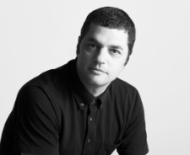  Date: 27 Mar, 2021  Facebook live @JCPopUpArtPark  Part sculptor, part technologist dreamer, artist and designer, Nimrod Weis is one of the co-founders and Creative Director of ENESS, a multidisciplinary design studio founded in 1997 and dedicated to exploring the intersection between the virtual and the physical world via its unique brand of interactive public art installations worldwide.  Nimrod is passionate about a future of cities filled with new experiences designed to bind us as art and technology bring us closer together. Nimrod delves into the deeper potential of interactivity to elicit emotional responses from his audience. Rebelliously playful and accessible, he invites viewers to get closer and experience the unexpected by taking art out of the exhibition hall and into public spaces where people of all ages and backgrounds are free to explore his works.  April >> Jen LEWIN (United States)  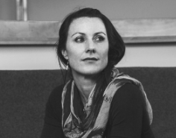  Date: 11 Apr, 2021  Facebook live @JCPopUpArtPark  Internationally renowned new media and interactive sculptor currently based in New York. Over her 20-year career, Lewin has honed her architectural background and a highly technical medium to fabricate large-scale interactive, public sculpture that encourages community interaction and play.  Her technically complex works have been featured at events including the Istanbul Light Festival, Vivid Sydney 2014 and 2018, iLight Marina Bay, Signal Fest and Burning Man, Art Biennales in Denver and Gwangju, South Korea and solo exhibitions across the United States and in Mexico, Portugal and England. She has designed and installed permanent public interactive sculptures worldwide including the Side Walk Harp in Minneapolis, Magical Harp in Palo Alto, Promenade in Denver, Ascent in Coral Springs Florida and has worked in collaboration as a dynamic lighting designer for permanent, public installations.  (More details to be announced soon)
2 | Touring across the Virtual and the Reality | Interacting with the four featured art pieces, dancer Rhyn CHEUNG uses his body to lead audience into a virtual-physical journey into the heart of Jockey Club Pop-up Art Park. He will also conduct an online session of mindfulness stretching exercises, demonstrating how we can live slower and build our own playgrounds in our bodies and minds.  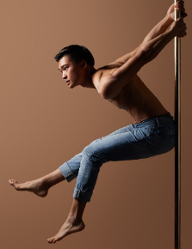  Rhyn Cheung, a performing artist proficient in multiple dance styles such as pole dance and contemporary dance. He especially focuses on the research and performance on acrobatic art by flexibly using his dance skills, movement theory and three-dimensional space to realise his artistic concepts. He has been participating in various international competitions and has won the second place in the French Pole Dance Competition. In addition, he engages in the choreography of various international and local aerial ribbon dances, performances and films. He also taught classes in the US, Israel, South Korea, Japan, and mainland China. Rhyn is recently forming a community with the local trapeze to explore new possibilities of acrobatic art through experimental practice. (Details to be announced soon)
3 | Artwalkers – Artists-in-Pandemic | The pandemic, since the end of 2019, forced many museums, art galleries, theaters, exhibitions and performance venues to temporarily shut down. The overwhelming majority of pre-planned arts programmes are either stuck in limbo or compelled to make drastic changes, like Jockey Club Pop-Up Art Park did by shifting to online. In these uncertain times, how can the creatives cope with all the unexpected changes? This forum will invite art practitioners to share how they are moving ahead in this ever-changing environment. (Details to be announced soon)
4 | Playground the Legend | Outdoor playgrounds for children first appeared in Hong Kong in the late 1920s, bringing countless fond childhood memories to generations. As online and virtual games bring new surprises each passing day, classic playground facilities such as swings and rocking boards appear even more exciting to kids today, who are often found to be glued to their screens. Let us uncover the ageless legend of playgrounds. (Details to be announced soon)

Details to be announced soon >> https://www.jcpopupartpark.hk/en/go-chat-en/

