Appendix 2 Go Play (Online play sessions & IG filters)

- Online Play Sessions
Playground is Where the Heart Is

Artists, play specialists and arts therapists get together to play online, even sending the ‘Park’ directly to your home (registered participants will receive a special material pack). No matter where you are, what your age is, or who you are with, one thing is certain: you will have fun!

＃ | Name | Details
1 | January events【Bubble Magic】 #Wishing  Limited material pack: One book of Chinese storybook ‘泡泡的魔法’ (literally means ‘the Magic of Bubbles’), 3 droppers, 2 drawing templates  *Suitable for all ages  *Participants aged 9 or below should be accompanied by an adult  *Conducted in Cantonese only | Now open for registration  Whether it is blowing bubbles or playing with them, together with Little Green Feet, we hope to spread positive energy to everyone. As we watch the Happy Cloud rises and mystifyingly multiplies, we are sending off our desires, stories, dreams and wishes to faraway places. Somehow, nothing seems impossible anymore.  About Little Green Feet  Dedicated to promoting a positive parent-child culture, green family philosophy and community building, Little Green Feet harnesses social resources and the power of stories to encourage parents and children to establish new relationships with people and nature.  Date Time（2 sessions per day）  1 23 Jan 2021 (Sat) - 2:30pm – 3:30pm - 4pm – 5pm  2 21 Jan 2021 (Sun) - 2:30pm – 3:30pm - 4pm – 5pm  3 30 Jan 2021 (Sat) - 2:30pm – 3:30pm - 4pm – 5pm  4 31 Jan 2021 (Sun) - 2:30pm – 3:30pm - 4pm – 5pm  Link: https://www.jcpopupartpark.hk/post-go-play/bubble-magic/  (Enrolled online; first-come-first-served)
2 | 【Mindfulness Workshop】  #Co-play #Sharing  Limited material pack: A bird-shaped ocarina (random)  *Suitable for all ages  *Participants aged 9 or below should be accompanied by an adult  *Conducted in Cantonese only | Now open for registration  Sound artist Hakgwai plays a variety of unique instruments that mimic bird singing, insect screaming, trees quenching and water flowing through stones to create a symphony of nature with Six-swing Donut that swings and hums in harmony with our breath and heartbeats. Abandon the stresses during the pandemic to trek into the soul and search for voices that are waiting to be heard, the quietness of sound and the music of silence.  About Hakgwai (Lau Chun-ho)  A local sound artist dedicated to producing music and theatre, Hakgwai, in addition to be a designer and performer, can also be seen busking in the streets or teaching music. Inspired by traditional and modern unique instruments ranging from the Australian Didgeridoo to the handpan, he seeks to achieve the perfect balance between breath, music and zen to express the very concept of ‘zen music’. Playing aboriginal music while performing breathing exercises, he invites the public to respond to their physical and psychological needs.  Date Time（2-3 sessions per day）  1 6 Feb 2021 (Sat) - 3:30-4:30pm - 5-6pm - 8-9pm  2 20 Feb 2021 (Sat) - 8-9pm - 9:30 – 10:30pm  3 27 Feb 2021 (Sat) - 3:30-4:30pm - 5-6pm - 8-9pm  4 28 Feb 2021 (Sun) - 8-9pm - 9:30 – 10:30pm  Link: https://www.jcpopupartpark.hk/en/post-go-play/mindfulness-workshop-en/  (Enrolled online; first-come-first-served)
3 | 【Rhythm of the Memory】  #Co-play #Sharing  Limited material pack: (including all the accessories and stationery needed for the play sessions)  *Suitable for aged 14 or above  *Conducted in Cantonese only | Now open for registration  Art therapists from Not a Gallery guides us back to our origin. As we imagine we are rocking on Six-swing Donut, we hear the sound of water and then silence; it dawns on us that we have changed path to embark on a journey into the subconscious and back to the dawn of life. Wandering in the distant past through the depths of consciousness, we finally recapture the blissful memories of life’s commencement.  About Not a Gallery  Co-founded by a registered art therapist and an independent documentary filmmaker, Not a Gallery is offering arts workshops, 1 to 1 counselling, documentary filmmaking workshops, etc. Going beyond the traditional definition of beauty, it uses a unique combination of arts and professional counselling skills to encourage audiences to let off some steam, tackle their problems and cater to their emotional needs in order to gain a better understanding of themselves. It also promotes the use of arts as a way to improve mental wellness and empower socially vulnerable groups.  Date Time（2 sessions per day）  1 7 Feb 2021 (Sun) - 3-3:45pm - 4:15-5pm  2 28 Feb 2021 (Sun) - 3-3:45pm - 4:15-5pm  Link: https://www.jcpopupartpark.hk/en/post-go-play/rhythm-of-the-memory-en/  (Enrolled online; first-come-first-served)
4 | 【Moving Playground】  #Balance | Open for registration soon  Explore new games by moving our body as if we are playing with The Light Seesaw, under the guidance of a Moving Playground instructor. Leave emotions behind, step on the rocking board and let our senses feel the exhilarating purity of height, lightness and speed. Use the body to experience the power of the universe, break through boundaries and find the balance between the self, others and the cosmos.  About Moving Playground  Moving Playground is committed to promoting creative movement and physical education. It believes the body can ignite happiness, enhance freedom, release fantasy and fuel creativity. By orchestrating different forms of experiences, participants can develop physical and mental self-awareness while strengthening their movements and enhancing their perceptions.  Details to be announced soon >> https://www.jcpopupartpark.hk/en/post-go-play/moving-playground-en/  (Enrolled online; first-come-first-served)
5 | 【Creative Dance】 #Reflection #Connection | Open for registration soon  Savour the flow and fluidity of us and Passoverdance dancers in Aqueous, which extends from the virtual Park to our home through imagination, as we touch and intersperse between people. Feeling across the fuzzy distance and staggered space between each other, we weave new relationships through dance, body communication and an open mind. By opening our senses, we ignite our ability to observe the world from a new perspective.  About Passoverdance  Passoverdance is a local non-profit dance organisation which has been a recipient of the Hong Kong Arts Development Council Year Grant since 2016. It is dedicated to fostering and developing local dance culture, as well as discovering and nurturing new talents in the community. Dedicated to exploring the infinite possibilities of the art of dance, it strives to reveal the purity and uniqueness of each work in order to create a deeper dialogue between the audience and the work.  Details to be announced soon >> https://www.jcpopupartpark.hk/en/post-go-play/creative-dance-en/  (Enrolled online; first-come-first-served)

- IG Pop-up Clallenges (Instagram filters) ig@jcpopupartpark
During quarantine at home, browsing social media is a way of entertainment for many adults and children. Jockey Club Pop-up Art Park brings the notion of ‘the park is just around the corner’ to instagram, allowing art and fun to penetrate into daily life. Let us explore the Park on instagram with ‘IG Pop-up challenges’. Have fun, experience art and play everywhere.

Date：from now to 16 Apr 2021

＃ | Image | Details
1 | 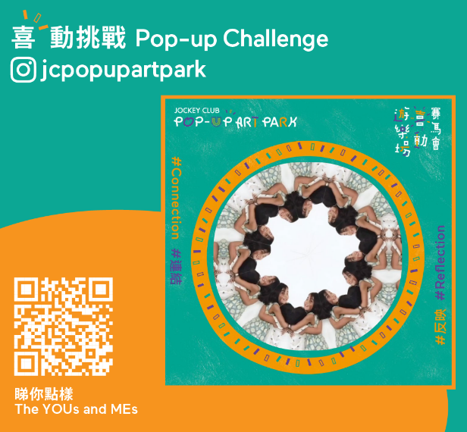  【The YOUs and MEs】  #Reflection #Connection | To encourage participants to take a closer look at themselves, and be more aware of their facial expressions, emotions and mental wellbeing.
2 | 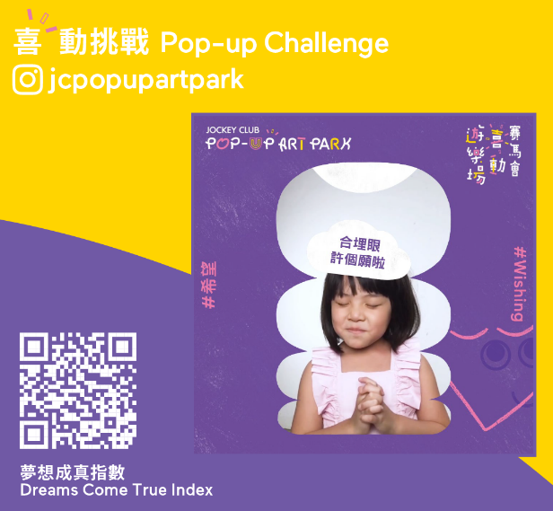  【Dreams come true index】#Wishing | To encourage participants to make a wish, so as to spread the ideas of positive thinking.
3 | 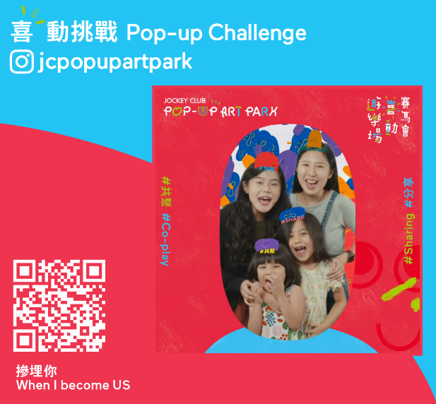  【When I become US】  #Co-play #Sharing | To encourage participants to play together, have fun, be refreshed and relaxed.
4 | 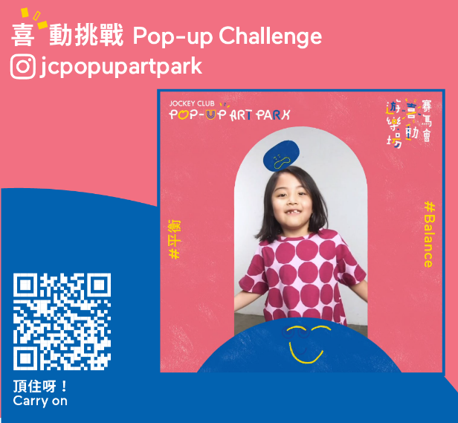  【Carry on】#Balance | To encourage participants to exercise their body and strike a balance between the body and the mind.

More details >> https://www.jcpopupartpark.hk/post-go-play/ig-pop-up-challenges/

