Appendix 1 – Participating artworks and artists

＃ |  | Artworks | Details
1 |  | 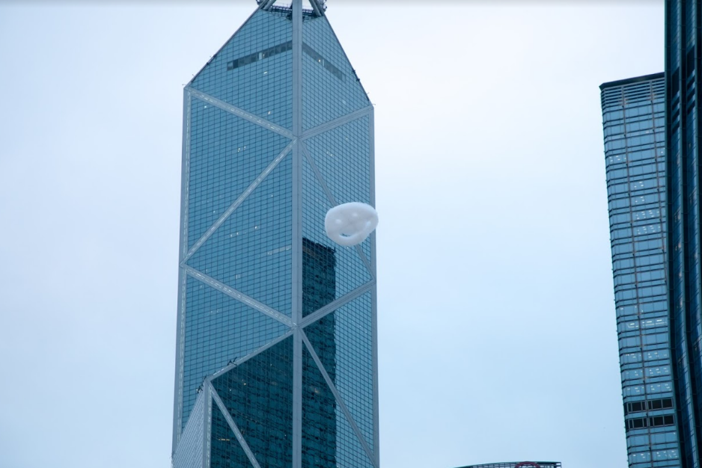  Happy Cloud  #Wishing  Physical showcase  Details：  Date：from now to 31 Jan, 2021  Time：1 – 8pm  Location：Hong Kong Arts Centre & Wan Chai | Some dreams are worth chasing. Happiness Hero’s most famous work Happy Cloud is finally landing in Hong Kong! Expect lots of surprises and happy faces as giant bubbles shaped like happy faces fill the virtual space of Jockey Club Pop-up Art Park. Make a wish to have your dream come true if you see one!  Artist Profile:  Stuart SEMPLE │ United Kingdom  One of the UK’s leading post Young British Artists, Semple is perhaps best known for his Happy Cloud performance at Tate Modern. He subsequently presented this performance in Moscow, Manchester, Milan, Australia, Denver & Dublin.
2 |  | 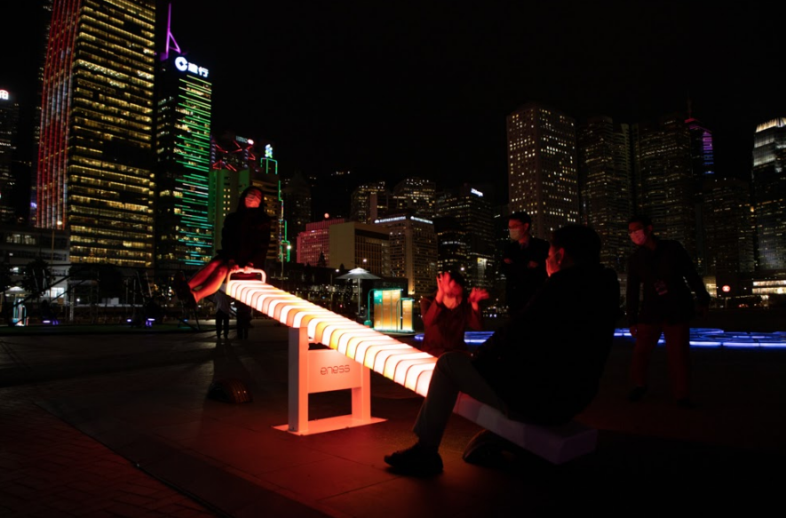  The Light Seesaw  #Balance  Remarks: Due to the current situation of COVID-19, the artwork will be showcased online only. | Find your balance and yourself. As you go up and down on this illuminated seesaw of infinite cosmic power, ignite sounds and lights and anticipate your opponent’s reaction. As you feel the pull of gravity and adjust your position, are you developing a deeper understanding of your adversary? Light and shadows are but joys and sorrows; once you have been through life’s ups and downs, you might realise the best views are those shared ‘together’.  Artist Profile:  ENESS │ Australia  A multimedia design studio works at the intersection of art and technology, and combines disciplines such as lighting, software, interaction design, product design, sculpture and architecture, to generate outcomes which are often unique and unexpected.
3 | 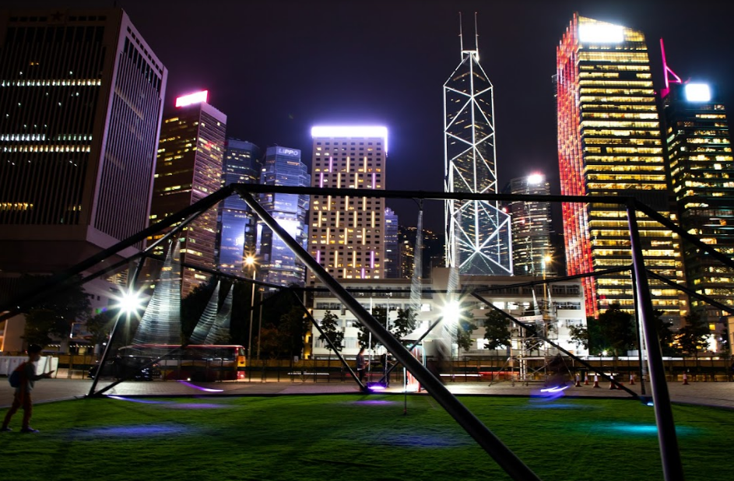  Six-swing Donut  #Co-play #Sharing  Remarks: Due to the current situation of COVID-19, the artwork will be showcased online only. |  |  | Let’s fly! Suspended in a common space, six strangers sitting on six different swings are united yet separated for a transient moment. Swinging at different angles towards a common middle, your unique identity and personal stories are instantly reflected in the modulation of sounds and swaying of lights triggered by your shared humanity.  Artist Profile:  Wyan YEUNG Li-shung │ Hong Kong  Cross-disciplinary creative, Architect & Design Educator, Wyan received a Master of Arts and Master of Architecture from Central Saint Martins, UK and The University of Hong Kong respectively. He is currently a partner of A&B Architects and the principal of Studio MEHH in Hong Kong.
4 | 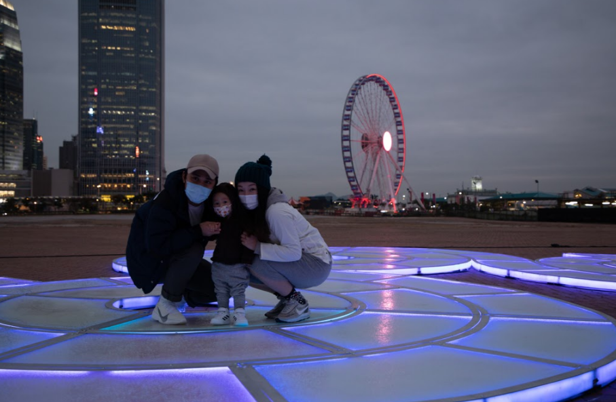  Aqueous  #Reflection #Connection  Remarks: Due to the current situation of COVID-19, the artwork will be showcased online only. |  |  | When was the last time you truly looked at yourself? During the day, it reflects every face and scene with absolute fidelity like a mirror for the sky. At night, it morphs into a rainbow-like passage that records your moods and movements with colours. Don’t be intimidated: simply follow the steps and embrace they rhythm that feel right.  Artist Profile:  Jen LEWIN │ United States  Internationally renowned new media and interactive sculptor currently based in New York. Over her 20-year career, Lewin has honed her architectural background and a highly technical medium to fabricate large-scale interactive, public sculpture that encourages community interaction and play.

