Appendix 1: portrait photo shooting of Lau Chun-him, Jennifer Yu and Kaki Sham in the theme of cyberpunk
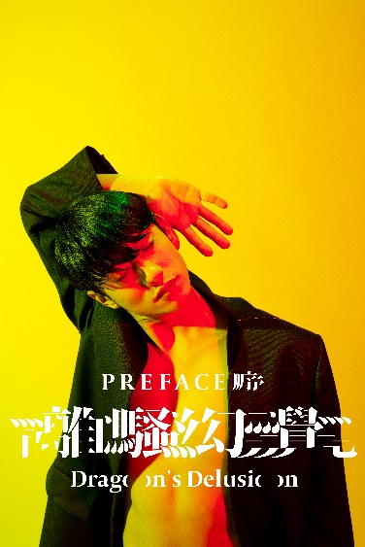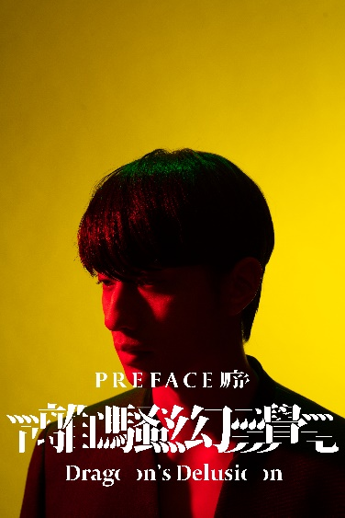
Lau Chun-him
The voice of Joe & Qu Yuan

Hair：Nick Lam (orient4.com.hk)
Makeup：Carmen Chung @carmencmakeup_hair
Wardobe by Maison Margiela Coat from Lanecrawford, Dark Shaw from Dmop

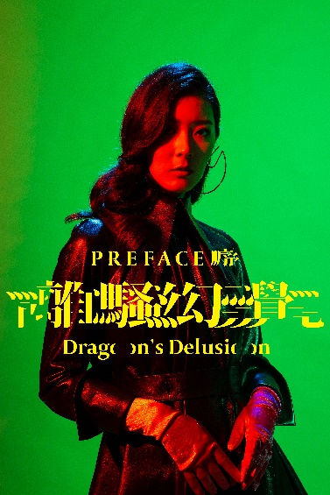
Jennifer Yu
The voice of Catherine

Hair : KenHui@iiAlchemy
Make up: Melody Chiu
Wardobe by 16 Arlington Dress from Lane Crawford, and SportsMax Boots
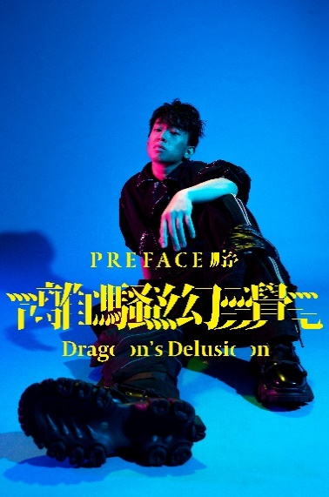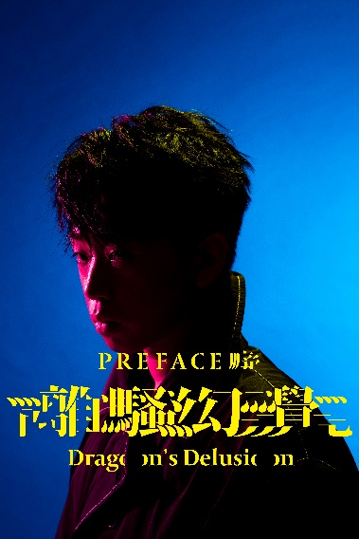
Kaki Sham
The voice of Dice

Hair & Make up: Echo
Wardobe by UNITED STANDARD Shirt & MOSTLY HEARD RARELY SEEN Pants from Dmop
Art Director: Kongkee@penguinlab
Fashion Director: Mayao & Yoyo Kwan @Fameglory
Photographer: Jason@chanaphotostudio
Venue Sponsor: Seyami Studio
Sponsors: First Initiative Foundation @fif.hk , Leo & Xaviour@Number 2 Ltd

Photo download: http://ftp.hkac.org.hk/MDD/Independently_Yours_Future_Pictures/
Appendix 2: Hong Kong Arts Centre Moving Image Programme in December – Independently Yours – Future Pictures

Screening details:

Independently Yours – Future Pictures
Date: 11.12.2020 (Friday)
Time: 8pm
Venue: Louis Koo Cinema, Hong Kong Arts Centre
Price: Standard ticket: $80. Tickets are now available at hkmovie6.com
***After-screening discussion will be arranged (conducted in Cantonese)

From 2019 to 2020, we were brought into so many exceptional challenges like never before. Numerous of cancelled events, disrupted plans, and unpredictable consequences – when the future imagined might never come, disappointment, anger and frustration grow among us.

Yet, we picture the future, mostly because we believe and hope that the best is yet to come at the first place. These longing and imagination in your head are the last things that others can hardly take away from you. As such, the hardest the times are, the more we should imagine.

In the coming December, Independently Yours – Future Pictures presents to you 6 short films picturing the future far and near. Through immersing into the unique future worlds, together we imagine: as 2020 is coming to an end, how shall our 2021 be?

GwanGong VS Alien
Director: Leung Chung-man
Hong Kong | 2013 | 16’ | In Cantonese with Chinese and English subtitles | HD | Colour

When a dangerous alien creature attacks Hong Kong and disrupts our harmonious society, the People's Liberation Army sends out its greatest weapon - A Mech Lei Feng robot controlled by elite operators from Mainland China, Macau, and Hong Kong. But when even the best of Mainland Chinese technology fails us, there's always one man we can count on: Gwan gong, the legendary hero who stands for loyalty, justice, and righteousness. This ambitious, larger-than-life sci-fi action satire shows that faith is the greatest weapon we have against even the greatest evil.

Hong Kong will be destroyed after 33 years
Director: Ng Siu-lun
Hong Kong | 2013 | 7’ | In Cantonese with Chinese and English subtitles | HD | Colour

As forecasted by the Meteorological Administration, an asteroid will crash into Hong Kong in 33 years’ time. How should the people handle the approaching catastrophe?

Wisdom Tree
Director: Ho Man-kit, Tsui Ka-hei, Tsui Ka-long, Chan Siu-chung
Hong Kong | 2008 | 8’ | no dialogue and subtitles | HD | Colour

The short depicts the familiar theme of environmental protection but sets it in an unspecified apocalyptic time in the future.

Back to Base
Director: Mak Siu-fung, Ho Ka-chiu
Hong Kong | 2010 | 19’ | No dialogue and subtitles | HD | Colour

Two explorers with different special abilities arrived at an unknown planet for their adventure. They found a strange transport machine and brought it along to meet the monster.

21³
Director: Chu Yin-zhen
Hong Kong | 2018 | 4’ | no dialogue and subtitles | HD | Colour

When a person dies, 21 grams is lost in weight. Some call this the weight of soul; but how about inorganic matters? Do they have souls?
50 years from now, Hong Kong faces a biological disaster. Mob21, a medical robot, is sent by the government to attend the patients. Before long, Mob21 befriends them…

Dragon’s Delusion – Preface
Director: Kong Khong-chang (Kongkee)
Hong Kong | 2020 | 16’ | In Cantonese with Chinese and English subtitles | HD | Colour

If soul needs a shell, what is the different between human body and mechanic robot?
What if, behind the search of life, or death, there is the same truth waiting for us?
This is a story of an awakening robot searching for its own soul.

~~~~~~~~ The End ~~~~~~~~

