【Hong Kong Arts Centre】 & 【Jumu Tang】 Co-present
Here and There: Re-imagining Hong Kong Landscapes
Exploring the accumulated meanings and values attached to Hong Kong landscapes
From 8 to 30 October 2022, 10am to 8pm
@4/F, Pao Galleries, Hong Kong Arts Centre

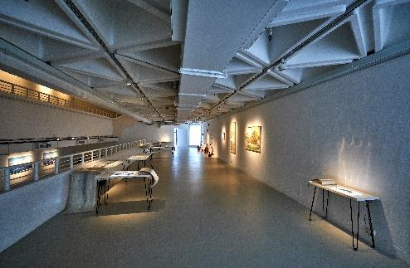
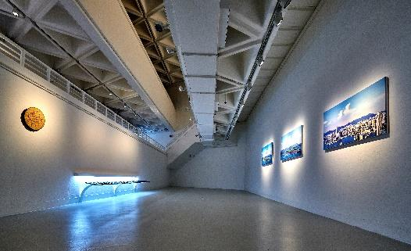

Here and There: Re-imagining Hong Kong Landscapes explores the accumulated meanings and values attached to Hong Kong landscapes and the intimate relationships and emotive bonds between people, landscapes, artistic geographical imagination, and sense of place. This place-based exhibition invited Ho Yuen Leung, Koon Wai Bong, Lam Tung Pang, Leung Ka Yin Joey, Wong Chun Hei Stephen, and Wong Lai Ching Fiona, to explore six sites, namely, Victoria Peak, Pok Fu Lam, Kowloon Mountain Ranges, Yuen Long, the peripheral islands, and the Hong Kong Island cityscape, that have long been ascribed historical and cultural value and have dominated the travel discourse of Hong Kong since the nineteenth century. To extend the spatial and temporal dimensions of the artists’ landscape imagination, the curator, Dr. Ting Wing Yan, Vivian built an archive on Hong Kong landscapes and provided the artists with archival research support. Through various mediums and art forms, including ceramic, installation, mixed media, moving image, painting, and sculpture, the artists transformed their landscape perceptions and imaginations into six newly commissioned artworks, which not only reveal the artists’ personal landscape experiences and encounters but also express various relations between the artists and Hong Kong landscapes. The exhibition offers multiple readings of the six sites through different creative approaches adopted by the artists, examining the inextricable bonds between people and place. The artists reinterpret cultural connotations of the landscapes and their significance in our times, inviting audiences to reflect on emotions, memories, and imaginations embodied by the places. (For Artwork Information and Artists’ Biographies, please refer to Appendix 1 and Appendix 2.)

“The curatorial team believes the exhibition to be a platform for the exchange of ideas, and a realm for the public and art to create meaning together. The six artists consider the scenery to be a medium to be understood and remembered, to imagine the place and respond to it with art, for an interpretation of local scenery by different generations. What this exhibition presents to the audience is the artists’ and the curatorial team’s sense of imagination and hope. Its meaning lies beyond just the creative works, connecting the public to the shared memories of landscape.” (Dr. Ting Wing Yan, Vivian’s curatorial statement)

“The local scenery we want to see not only lies in what we have at this moment, but also in our vision for the future.” (Dr. Ting Wing Yan, Vivian’s curatorial statement)

‘Here and There: Re-imagining Hong Kong Landscapes’ Exhibition
Exhibition period: 8 October 2022–30 October 2022
Venue: 4/F, Pao Galleries, Hong Kong Arts Centre
Opening hours: 10am to 8pm daily (30 October, closed at 4pm)
Opening ceremony starts at 6:30 pm on 7 October 2022

Curator: Dr. Ting Wing Yan, Vivian
Co-Presented by Jumu Tang & Hong Kong Arts Centre
Supported by Academy of Visual Arts & Knowledge Transfer Office, Hong Kong Baptist University・Hong Kong Arts Development Council

Sponsors:
Love On Time Charity
Asia Art Center
Grotto Fine Art
sensory ZERO
Val Chow
Mike S K Lui
Nancy Maria Chang
Maggie Fung
Anthony Choy
Elaine Kwok
Arthur De Villepin

Talks and Tours
Artist Talks: On Landscape, Place, and Memories
- (8 October 2022): Speakers: Koon Wai Bong, Leung Ka Yin, Joey, and Wong Lai Ching, Fiona
Moderator: Dr. Ting Wing Yan, Vivian

Artist Talk: On Landscape, Bodily Perceptions, and Sense of Place
- (9 October 2022): Speakers: Ho Yuen Leung, Lam Tung Pang, and Wong Chun Hei, Stephen
Moderator: Prof. Chan Pui Pedith
Public Seminar:
- (22 October 2022): “Revisiting the Early Hong Kong Travel Activities from Travel Guidebooks”
Speaker: Dr. Yuen Chi

Sketching Tours:
- (15 October 2022): “Re-imagining Hong Kong: Sketching Tour (I): The Peak and Pok Fu Lam”
- (29 October 2022): “Re-imagining Hong Kong: Sketching Tour (II): Wan Chai and the Peak”

Catalogue
The exhibition will be accompanied by a catalogue titled Here and There: Re-imagining Hong Kong Landscapes, edited by Dr. Ting Wing Yan, Vivian and published by Hong Kong Arts Center, featuring essays by Dr. Ting Wing Yan, Vivian and Prof. Chan Pui Pedith

Dr. Ting Wing Yan, Vivian
Ting Wing Yan, Vivian graduated from the history department at the Chinese University of Hong Kong and obtained a PhD at the School of Museum Studies, University of Leicester. She is now an independent curator and researcher. Her research interest focuses on the cultural imaginations of diverse audience groups and their cultural consumption patterns in considering how public life can be shaped in Hong Kong. She has been working with universities and art organisations to develop curatorial projects that encourage multiple narratives of local history articulated through creative means. Vivian has participated in various art projects, such as Hong Kong House Residency programme at Echigo-Tsumari Art Triennale (2019), 20/20 Hong Kong Print Art Exhibition (2020), and Via North Point, Public Art Programme: Social Generic Outcomes Assessment (2020-2022).

Prof. Chan Pui Pedith
Chan Pui Pedith is an assistant professor at the Chinese University and received her PhD from SOAS, University of London, where she also spent the 2020-21 academic year as a senior lecturer in Asian Arts and Cultures. She served as the assistant curator of Chinese Fine Arts at the Hong Kong Museum of Art and taught at the City University of Hong Kong. Her research interests center on the production and consumption of art and cultural heritage in modern and contemporary China. Most recently, she curated Hong Kong Impressions at the Art Museum of the Chinese University of Hong Kong and contributed to Embracing Sites/ Sights at the National Palace Museum, Taipei. She was selected to participate in the CAA-Getty International Programme in 2019 and 2020. She is the author of The Making of a Modern Art World: Institutionalisation and Legitimisation of Guohua in Republican Shanghai and co-editor of Hong Kong Impressions. She has published in Modern China, Twentieth-Century China, Burlington Magazine and European Journal of Asian Studies.

For more information, please refer to the website of Hong Kong Arts Centre https://www.hkac.org.hk/calendar_detail/?u=jO88y7Yp29M
Instagram: hereandthere.hk
Facebook: hereandthere.hk

About Hong Kong Arts Centre
Since 1977, Hong Kong Arts Centre (HKAC) has been a platform for nurturing and supporting artists, and infusing art into everyday life. Its unique arts and educational programmes aim to make the arts accessible for all. The HKAC believes in the transformational power of art for people from all walks of life. Established over four decades ago, HKAC endeavours to bring arts to the people of Hong Kong – by presenting programmes for visual arts, performing arts, moving images and media arts, comics and animation. Other areas cover arts education, conferences, festivals, public art and community projects, all with the vision and mission of engaging and inspiring creativity in the Hong Kong community.
In 2000, HKAC founded its education arm, Hong Kong Art School (HKAS). HKAS provides award-bearing programmes to nurture artists and art practitioners, as well as short enrichment courses for the general public.
HKAC aspires to engage everyone in the community to become an active participant in the arts - as an enthusiast, an artist or a patron.
HKAC will continue its 45th anniversary celebrations into 2023. Let’s continue to embrace ‘Arts for Passion, Arts for Life, Arts for All’, and share the inspiration.

Official website: hkac.org.hk | Facebook: Hong Kong Arts Centre | Instagram: @hongkongartscentre

+++++++++++++++++++++++++++++++++++++++++++++++++++++++++++++++++++++++++
Media Enquiry:
- Annie Ho (Marketing and Communications Director) | Tel: 2824 5306 / 9481 8706 |
Email: aho@hkac.org.hk
- Charis Chau (Marketing and Communications Officer) | Tel: 2582 0290
Email: cchau@hkac.org.hk

