Co-Presented by
【Hong Kong Arts Centre】&【Consulate General of Switzerland in Hong Kong】&【Swiss Films】
Distance and Intimacy:
Documentary Film Retrospective of Jacqueline Zünd
(Postponed Programme)
"To head for the place you’re most afraid of is the most efficient way to get rid of your fear.”
- Jacqueline Zünd
17 to 20 November 2022@Louis Koo Cinema, Hong Kong Arts Centre
Individual tickets and All Access Pass are available on POPTICKET

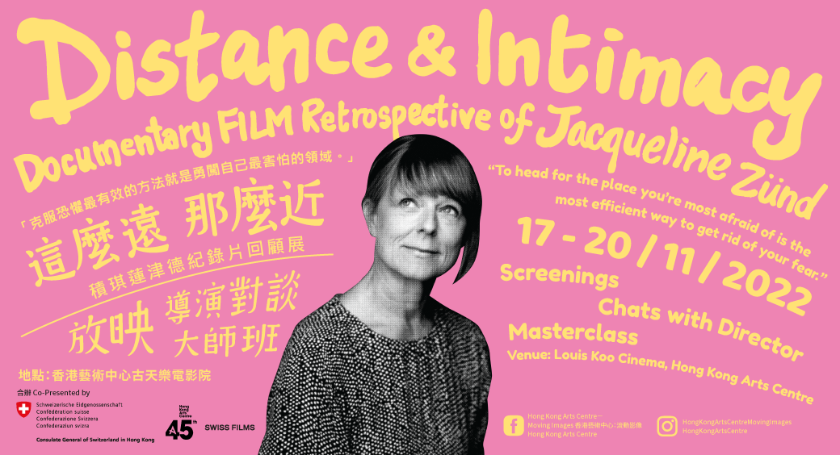

Co-Presented by the Hong Kong Arts Centre, Consulate General of Switzerland in Hong Kong and Swiss Films, moving image programme Distance and Intimacy: Documentary Film Retrospective of Jacqueline Zünd takes place at the Louis Koo Cinema, Hong Kong Arts Centre from 17 to 20 November 2022. Swiss documentarian Jacqueline Zünd frequents the distant but intimate lives of people from around the world – the insomniacs, the aged and the children – embracing their delights and disappointments, regrets and hopes, and other contrasting sensations. As these people wander along their paths of ritual, befittingly or unfittingly, they understand life anew with wisdom, dignity and vitality.

Where We Belong asks what it means to live in constant transition between homes and approaches five children’s realities. It focuses on how fragile, but also how brave, smart and funny they are in perceiving their volatile situations. The film is a work of love, labour and openness for the children who are often neglected, and whose feelings are difficult to define. Goodnight Nobody follows four insomniacs in Burkina Faso, Ukraine, America and China who are forced to dream awake throughout long nights. While sleeplessness is frustrating and debilitating, these insomniacs have also turned their sleeplessness into intimate enlightenments and delightful discoveries. Almost There tells the story of three men who decide to embark on new journeys to discover the unknown sides of themselves in the autumn of their lives. In their journeys to search for the meaning of life, they make choices that are not easy, but there are serendipities. Megacities explores the contradictions the inhabitants of Mumbai, New York, Mexico City and Moscow have to live with day in, day out, when they all share the dream of a better life. The stories of these dignified survivalists challenge easy moralisation and sparked frantic controversies upon its release. Sworn Virgin portrays the story of a woman who takes an oath of eternal virginity in a traditional Albanian village and lives as a man, but from then on, he is restricted from marriage, sex and parenthood. Avoiding traps and clichés, subdued and intricate, the film has received praises from critics and audiences alike. (Please refer to Appendix 1 for more information of Jacqueline Zünd and the films)

Audience members are also welcomed to join the virtual After-screening Masterclass in which Zünd will talk about the process of how she transforms intimate human subjects into film. (Please refer to Appendix 2 for Screening Schedule)

***Press previews and interviews with Jacqueline Zünd can be arranged.

【Distance and Intimacy: Documentary Film Retrospective of Jacqueline Zünd】
Details: https://hkac.org.hk/calendar_detail/?u=29NNToFo82k
Images Download: http://ftp.hkac.org.hk/MDD/Documentary_Film_Retrospective_of_Jacqueline_Zund
Trailer: https://youtu.be/5QNbe-MsYRM
Website: www.hkac.org.hk

Date: 17-20/11/2022
Venue: Louis Koo Cinema, Hong Kong Arts Centre
Co-Presenters: Hong Kong Arts Centre, Consulate General of Switzerland in Hong Kong, Swiss Films

Individual tickets and tickets package are available on POPTICKET now
Website: https://www.popticket.hk/distance-and-intimacy

Tickets package: $305 (Includes 1 ticket of the 5 films) | Individual ticket: $80 / $64*
*20% off discount for full-time students, senior citizens aged 60 or above, people with disabilities and the minder and Comprehensive Social Security Assistance (CSSA) recipients. Tickets for CSSA recipients available on a first-come-first-served basis. Concessionary ticket holders must produce evidence of their identity or age upon admission.
*20% discount to HKAC members. Ticket holders must present a valid membership card upon admission.
*20% off for each purchase of 4 or more standard tickets.
*Group booking offer for each purchase of 20 or more tickets. Please refer to the website of the Hong Kong Arts Centre for more details.
*Only one discount offer could be applied to each ticket purchase.

Hong Kong Arts Centre Moving Images
Facebook: www.facebook.com/hkartscentremovingimages/
Instagram: www.instagram.com/hongkongartscentremovingimages/
Programme enquiries: 2582 0282 (Monday to Friday 10:00 – 18:30)

Hong Kong Arts Centre – Art for Passion, Art for Life, Art for All
Since 1977, the Hong Kong Arts Centre (HKAC) has been a platform for nurturing and supporting artists, and infusing art into everyday life. Its unique arts and educational programmes aim to make the arts accessible for all. The HKAC believes in the transformational power of art for people from all walks of life. Established for more than four decades, the HKAC endeavours to bring arts to the people of Hong Kong – by presenting programmes for visual arts, performing arts, moving images and media arts, comics and animation. Our other areas also cover arts education, conferences, festivals, public art and community projects. All with the vision and mission of engaging and inspiring creativity in the Hong Kong community.

In 2000, HKAC founded its education arm, Hong Kong Art School (HKAS). The HKAS provides award-bearing programmes to nurture artists and art practitioners, as well as short enrichment courses for the general public. The HKAC aspires to engage everyone in the community to become an active participant in the arts – as an enthusiast, an artist or a patron.

HKAC will continue its 45th anniversary celebrations into 2023. Let’s continue to embrace ‘Art for Passion, Art for Life, Art for All’, and share the inspiration.

Official website: hkac.org.hk | Facebook: Hong Kong Arts Centre | Instagram: @hongkongartscentre

Media Enquiry:【Hong Kong Arts Centre】
Annie Ho  Marketing & Communications Director  Tel: 2824 5306 / 9481 8706  Email: aho@hkac.org.hk | Charis Chau  Marketing & Communications Officer  Tel: 2582 0290  Email: cchau@hkac.org.hk | Jacqueline Tong  Project Manager  Tel: 2582 0247  Email: jtong@hkac.org.hk

- end -

