**Exhibition Introduction**

**Landing on the East**

‘Landing on the East’ is the first thematic exhibition by Tang Kwong San and Yuen Nga Chi.

A landing project imagined from the perspective of astronauts, in which the gravitational pull of the moon affects the tides and leads them upon a discovery of a Hong Kong we never know.

With photography, video and installation featuring the deserted borders of Tung Ping Chau and picking up on abandoned objects washed up on the tourist-filled beaches, the exhibition creates an otherworldly visual space through interspersing with objects, islands and the moon. As the tide rises and falls, the astronaut lift off again.

**關於展覽**

**登陸東途**

鄧廣燊與袁雅芝兩人首次專題展覽《登陸東途》。

一個以太空人身分作聯想的登陸計劃，月球的引力影響著潮汐，考察我們沒有認知的香港。 拍攝邊境荒蕪的東平洲、遊人滿佈的岸灘，拾取被遺下的棄置物。

作品由攝影、錄像與裝置組成，透過物證、小島和月球互相穿插，營造一個異度的視覺空間。 潮起潮落，「太空人」再度升空。

**Exhibition Information**

Exhibition Dates: 2021.09.05 - 2021.09.28

Opening Hours: 10:00 - 18:00

Venue: Diana Cheung Experimental Gallery, 3/F, Hong Kong Arts Centre

Price: Free Admission

Exhibition Opening Reception: 2021.09.05 (14:00 to 15:30)

*Exhibition opening hours may change if Shouson Theatre has day-time performances.

**展覽資訊**

展覽日期: 2021.09.05 - 2021.10.01

展覽開放時間: 10:00 - 18:00

地點: 香港藝術中心三樓，張靜蘭實驗畫廊

費用: 免費入場

展覽開幕式：2021.09.05 (14:00 to 15:30)

*若壽臣劇院進行日場演出，展覽開放時間將會稍作更改。

**Selected Image**

**節錄圖片**

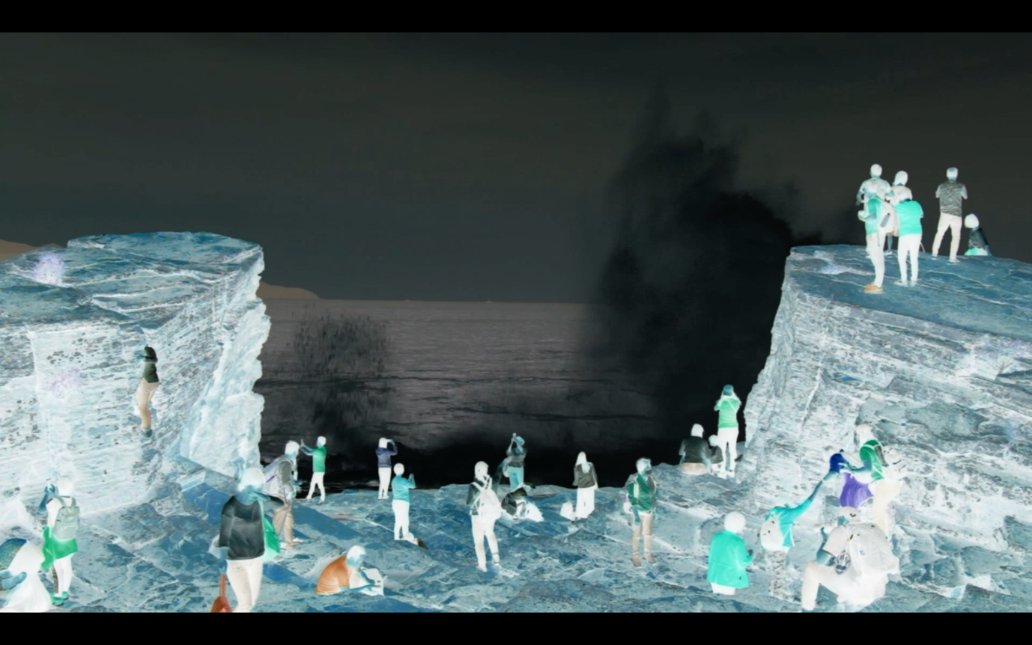

東途島, 2020

East Island, 2020

Still from the video錄像截圖



Moon, 2020

月球, 2020

Still from the video 錄像截圖

**Artists Biography**

**Tang Kwong San**

Tang Kwong San received his BAFA from RMIT University, Australia, in 2019. His practice combines photographs, drawings, objects and video that trace intergenerational family memories and social history. Through reorganising and reinterpreting old belongings, family photo albums and documents in a range of media, Tang explores the subtle, intricate and complex connections between longing, loss and belonging.

Tang has been invited to participate in various exhibitions, solo exhibition of ‘NIGHTBIRDS’ (Gallery EXIT); solo exhibition of ‘Wanding. At Sea’ (HiddenSpace).

**Yuen Nga Chi**

Through photography to explore the contradictions and gaps in society. As a family member, Yuen Nga Chi is aware of the formation of self-worth and social consciousness of parents in micro view, extend to the meaning of home. In recent years, she has observed the power and analogic relationship between humans and animals.

‘4 9 39 33 27 45 35’ Photobook was shortlisted in the 6th Singapore International Photography Festival Photobook Open Call in 2018. She received a Bachelor of Arts (Hons) in Visual Arts from Hong Kong Baptist University in 2019. and awarded the WMA Young Talent Award in Graduation Exhibition of the Academy of Visual Arts, Hong Kong Baptist University.

**藝術家介紹**

**鄧廣燊**

2019年取得純藝術學士學位(澳洲皇家墨爾本 理工大學與香港藝術學院合辦)。作品結合照片、素描和錄像來追索家族記憶與社會歷史。透過錯置的手法重組不同時序的物件，記錄與家人的緊密聯繫和自身的缺失與渴望。鄧氏獲邀參加不同展覽，包括《夜夜鳴》個人展覽(安全口畫廊);《渡來踱去》個人展覽(HiddenSpace)。

**袁雅芝**

出生於香港，透過攝影窺探社會價值的矛盾與缺口。以至家人身分微觀雙親的自我價值及社會意識的形成; 延至探視家庭的意義。近年，她觀察人與動物之間的權力與類比關係。

攝影集《4 9 39 33 27 45 35》入圍 2018年第六屆新加坡國際攝影節攝影集單元。

2019年獲得香港浸會大學視覺藝術文學士，於畢業展中獲得WMA 媒體藝術新秀獎。

Tang Kwong San and Yuen Nga Chi’s collective artwork ***Somewhere in Time*** is selected as a Finalist of the WMA Master Awards (Light) in 2019/20.

鄧廣燊與袁雅芝創作的攝影作品《此時某處》入選WMA大師攝影獎2019/20。