Hong Kong Arts Centre ifva Co-production
The first Virtual Reality project by Hong Kong filmmaker Tsang Tsui-Shan
Chroma 11 will be showcased at Freespace, West Kowloon Cultural District from 17 September to 1 October
Premiere at the 79th Venice International Film Festival
An immersive experience documenting a dance artist duo’s journey of transgressing between life and death

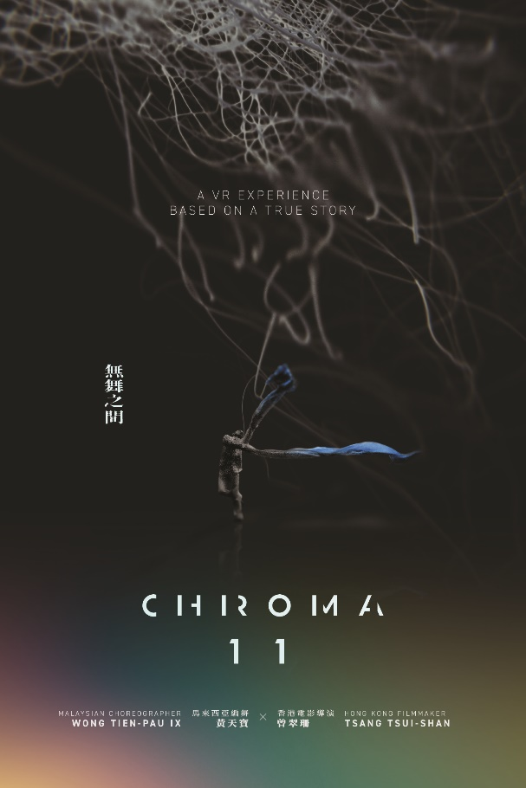

[Hong Kong, 16 September 2022] Virtual Reality (VR) project co-produced by Hong Kong Arts Centre ifva and Hong Kong filmmaker Tsang Tsui-Shan, Chroma 11, premiered at the 79th Venice International Film Festival as the first Hong Kong VR project being selected! The project documented the intimate moments and sentiments between dance artists Ix Wong Thien-pau (Malaysia) and Aaron Khek Ah-hock (Singapore) during the heart-rending last days of Aaron. Through clips of rearranged memories and volumetric video captured by DepthKit, the creative team reconstructed a reunion of the parted souls in the form of a duo dance afterlife, expanding our imagination and understanding of videography with VR technology. Chroma 11 will be showcased in Freespace, West Kowloon Cultural District from 17 September to 1 October.

Chroma 11 innovatively recreates love transcends life and death
‘Could love transcend life and death?’ Previously directed Big Blue Lake and The Lady Improper, Chroma 11 is the extension of Tsang Tsui-Shan’s dance documentary film Ward 11 which won her the Silver Award (Open Category) at the 25th ifva festival. The work documented the love story of dance artist Ix Wong Thien-pau and Aaron Khek Ah-hock. The couple struggles along the way as being gay, Ix being HIV positive and Aaron being a cancer patient. Aaron passed away when Tsang Tsui-shan was filming a dance video Ward 11 for the couple in 2019. Witnessing how death separated loved ones, Tsang wishes to use video and technologies to bring the couple back and let Ix and Aaron dance together once more. With the help of VR, Tsang reconstructed the dance of the artist duo, bringing back the intimate moments of companionship. Arranging a reunion for the departed soul and the alive, where they could dance with each other between the space of virtual and reality.

The idea of Chroma 11 comes from “dancing with the dead”, choreographed by Ix Wong Thien-pau. The piece is about life and death, homosexuality/ LGBTQIA+, illness and isolation, addressing these philosophical yet realistic topics. Apart from questioning the boundary between real and virtual, the work reflects on the relationship between art and technology. Tsang Tsui-shan once expressed ‘Losing someone you love is one of the hardest things in the world to deal with. The periphery of life and death could be indistinctly broad. Could VR this relatively new medium enable the couple who had accompanied each other and had danced together for years to dance once more? I wish this work could invite visitors to enter the daily lives of the couple and experience their profoundly moving affections.’
Download Chroma 11 trailer and installation documentation: http://ftp.hkac.org.hk/MDD/Chroma11/

Supported and produced by Hong Kong Arts Centre | First time integrating VR with filmmaking
Hong Kong Arts Centre has always been supporting the local moving images, its flagship programme ifva established itself as a platform to unite the independent film and media arts talents based in Hong Kong and Asia. Constantly promoting and supporting local creative talents to experiment with different mediums and technologies in moving images.

Chroma 11 to premiere at the Venice Immersive section of 79th Venice International Film Festival as the first Hong Kong VR project being selected. Chroma 11 has been selected at the 77th Venice International Film Festival, Biennale College Cinema (Virtual Reality Project category). At the time, the producer and director of ifva, Kattie Fan, and director Tsang Tsui-shan travelled to Venice and participated in the programmes organized by the Biennale College, learning how to adopt VR technology in art making. Kattie Fan expressed, ‘We are honoured to be selected at the Biennale College and able to learn about the latest VR technology from viewing international projects in Venice. This was a huge encouragement to artists who specialized in VR. I hope there would be more resources in Hong Kong to provide exchange and learning opportunities for artists who work with VR.’

The first local showcase is supported by Meta
Chroma 11 has also gained the support of Meta. Meta provides all the VR hardware and technical support for the first local showcase that takes place at Freespace, West Kowloon Cultural District from 17 September to 1 October. This showcase, apart from the VR videos, incorporates elements such as installation, dance and moving images. With the VR headsets, visitors will have a full sensory experience in the virtual space, immersing in the love story of Ix Wong Thien-pau and Aaron Khek Ah-hock.

Chroma 11 Creative Team
Director: Tsang Tsui-Shan
Choreographer: Ix Wong Thien-pau
Performer: Ix Wong Thien-pau, Aaron Khek Ah-hock
Producer: Kattie Fan, Teresa Kwong
Creative Technologist: Lam Chi-fai
Art Director – VR Production: Iv Chan
Art Director – Installation: Carmen Cheng
Sound Designer and Mixing: Benny Chan
Composer and Sound Designer: Eunice Martins

Virtual Reality immersive experience: Chroma 11, Tsang Tsui-Shan | Hong Kong Premiere
- 17 September to 18 September (Saturday to Sunday)
- 20 September to 25 September (Tuesday to Sunday)
- 27 September to 1 October (Tuesday to Saturday)
- Venue: The Room, Freespace, Art Park, West Kowloon Cultural District
- Tickets available from 11 August, 10am (Thursday) onwards.
Download Chroma 11 trailer, installation documentation and press kit: http://ftp.hkac.org.hk/MDD/Chroma11/PressKit/
Including synopsis, director’s statement, film info and technical specifications, introduction of director, performer and creative team, download link of trailer, poster and director portrait.

For media interview bookings
We welcome press interviews:
Tsang Tsui-shan, director, Ix Wong Thien-pau, artist and Kattie Fan, producer, are pleased to share the process and challenges of the project
“Angles” for interview
Life and Death Education | How to mourn the dead through different mediums (such as through art or technology)?  How does art-making help the living to transform their pain and sorrow?  Tangibility and intangibility of life and death
Topics of homosexuality/ LGBTQIA+, illness and isolation | The moving love story of Ix Wong Thien-pau and Aaron Khek Ah-hock  The supportive journey of the artist duo battling illness  Comparing to the pressure and difficulties general public need to face under the pandemic, there are still a lot of pressure and obstacles HIV/AIDS patients need to face daily in modern society, especially on traveling and quarantine. How to overcome them and what role does art play in these circumstances?
Dance, Film and Virtual Reality (VR) | This is the first time Tsang Tsui-shan uses VR to create, what is the journey and story behind it.  How does VR intervene a familiar art form like dance video?
Art and Technology | What are the director thoughts on combining art and technology in this work?  How does VR help creatives to express and present their ideas?  When technology no longer stays merely technical but becoming part of arts, how does that change our daily lives?
Life and Healing | How to use dance and moving images to cope with the challenging times and sorrow of loved ones’ death?
Immersive experience | With the current technology, it creates a highly realistic environment in the virtual world that allows users to be fully immersed and connected. What will be the development of it?  What will be the development of immersive experience and is there any space for us to excel it in Hong Kong?

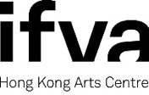

ifva, was founded by the Hong Kong Arts Centre in 1995. Over the years, ifva has established itself as Asia’s pioneering force in short film, animation and media arts, by providing a unique and professional platform for Hong Kong and Asian creative talents to unite, exchange and promote their works.

With the aims to promote short film and media arts and defend independent creative spirit, every year, in addition to the professionally renowned ifva Awards and ifva Festival, ifva also organises a series of extended programmes including the followings: “CINEMA 2.0” media arts exhibition examines different subject matters at the intersection of arts, culture, technology and society; “All About Us” celebrates diversity and the creative voices of young people from the ethnic minority backgrounds; “Jockey Club ifva Everywhere” makes film and media arts accessible to people from all walks of life; and Community and School Tour encourages students to experience and appreciate different media art forms.

Official Website: www.ifva.com | Facebook: ifva | Instagram: @ifva_hk

Hong Kong Arts Centre - Art for Passion, Art for Life, Art for All
Since 1977, the Hong Kong Arts Centre (HKAC) has been a platform for nurturing and supporting artists, and infusing art into everyday life. Its unique arts and educational programmes aim to make the arts accessible for all. The HKAC believes in the transformational power of art for people from all walks of life. Established for more than four decades, the HKAC endeavours to bring arts to the people of Hong Kong – by presenting programmes for visual arts, performing arts, moving images and media arts, comics and animation. Our other areas also cover arts education, conferences, festivals, public art and community projects. All with the vision and mission of engaging and inspiring creativity in the Hong Kong community.
In 2000, HKAC founded its education arm, Hong Kong Art School (HKAS). The HKAS provides award-bearing programmes to nurture artists and art practitioners, as well as short enrichment courses for the general public. The HKAC aspires to engage everyone in the community to become an active participant in the arts - as an enthusiast, an artist or a patron.
HKAC will continue its 45th anniversary celebrations into 2023. Let’s continue to embrace ‘Arts for Passion, Arts for Life, Arts for All’, and share the inspiration.

Official website: hkac.org.hk | Facebook: Hong Kong Arts Centre | Instagram: @hongkongartscentre

Media Enquiry
Hong Kong Arts Centre

 |  | Annie Ho (Marketing and Communications Director) | 2824 5306 / 9481 8706 | Email: aho@hkac.org.hk
 | Charis Chau (Marketing and Communications Officer) |  | 2582 0290 | Email: cchau@hkac.org.hk
 | Kate Lau (Senior Programme Officer) (ifva) |  | 2824 5322 | Email: klau@hkac.org.hk
 | Joris Wu (Programme Officer) (ifva) |  | 2582 0280 | Email:  jwu@hkac.org.hk

