“CINEMA 2.0: Counter Visions” Artworks
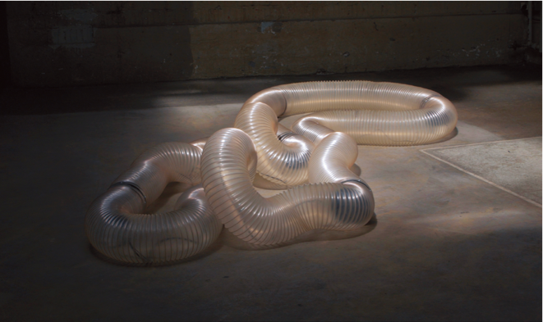 | πTon/2 (2017)  Cod. Act / Switzerland  πTon/2 is a sound installation that features a flexible enclosed ring set in motion by the torsional motors inside its body. By twisting and waving on itself, the piece moves in with a natural but unpredictable pattern. Movements of the ring projects sounds sampled from a bass clarinet, and is diffused by the loudspeakers inside. When it moves slowly, its contractions and dilations produce sensual sounds similar to deep breaths. When movements turn fast and brutal, sharp sound is generated to fill up the room like a nervous flow.
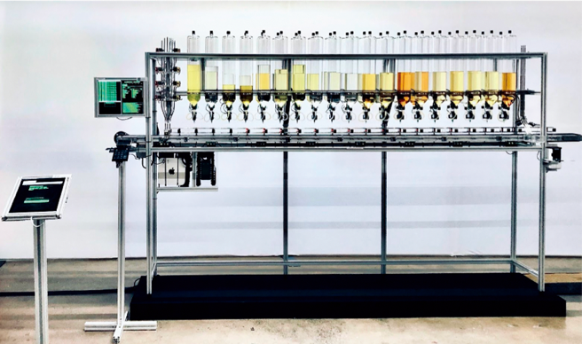 | Algorithmic Perfumery (2020)  Frederik Duerinck / Netherlands  At Algorithmic Perfumery, participants walk away with a tangible and usable memorabilia of the work. A unique scent is made and compounded on-site, based on a questionnaire to be finished by the participant. The test consists of psychological, sociological, cultural questions and a few focused on scent preference. By experiencing the artwork physically or online, participants contribute to the on-going research to improve the Artificial Intelligence and reinvent the future of perfumery.
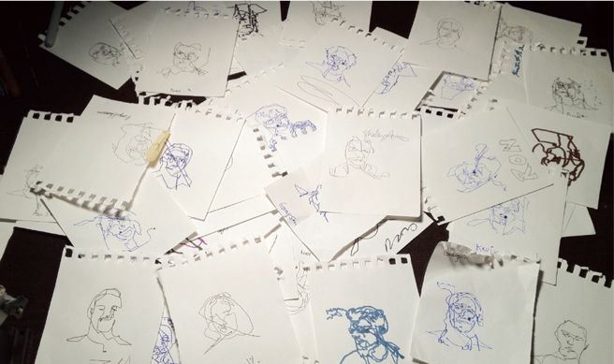 | Blind Self Portrait (2012)  Kyle McDonald, Matt Mets / United States  Blind Self Portrait uses computer vision algorithms to build a contour drawing of the visitor. While the visitors keep their eyes shut, a moving platform guides a pen in their hands to draw their self-portraits. The result is a machine-aided drawing, a self-portrait they could never draw alone. In a time when everyone’s face is partly covered, would it still be possible to draw a unique portrait of one’s own? When the drawing is complete, it remains unclear who should be signing the work.

The 26th ifva Media Art Category Finalists

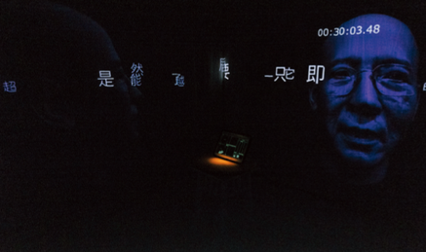 | Aesthetics and Freedom of Human Beings  Chan Kwan-chi / Hong Kong  Could art set human beings free from social turmoil? In Aesthetics and Freedom of Human Beings the only spectator in the installation is trapped inside a particular space for 31 minutes while having complete “freedom” to create their own artistic experience. Once the button is pressed, no two spectators would walk on the same journey.
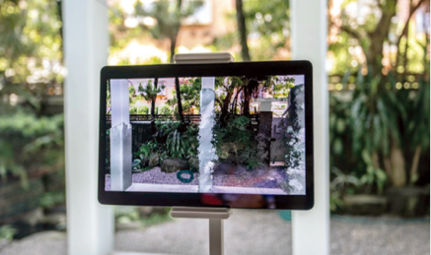  © Hu Ching-chuan & Chi-Wen Gallery All rights reserved | Awakening  Hu Ching-chuan / Taiwan  Can robots with humanity and morality have a social identity and the right to control their own freedom? Have our own levels of social status become blurry and unstable? In this project, Augmented Reality (AR) images and machines interact with one another where humans can only observe and feel, losing the identity of being the “controller”.
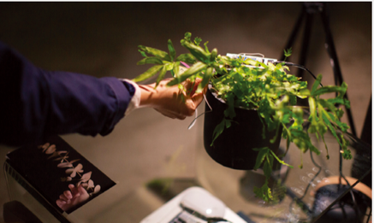 | Give No Words but Mum  Lo Lai-lai Natalie / Hong Kong  Personal private underground TV station “Slow-so TV: Give No Words but Mum” continues to serve distracted audiences and provides them with programmes to pass time. Thoughts that are uprooted together with the plants and fine debris which are serenely scattered calmly reveal the long-suppressed desires and obsessions. When the audience touches the aluminium foil attached to the plants, TV programmes will be played.
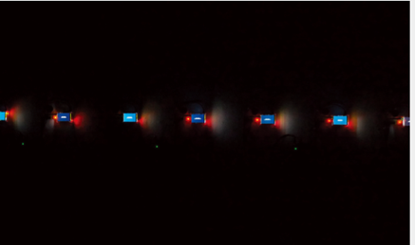 | Living to Die  Hoi In-wai Kelvin / Macau  The unique journey of new data begins once you browse the website. Starting from the local machine, data travels through numerous nodes and reaches its destination, the web server. This journey only takes a few milliseconds, and then the mission of the data is completed. This artwork presents the travelling path of data instantly and visually, which leads us to a new perspective of death.
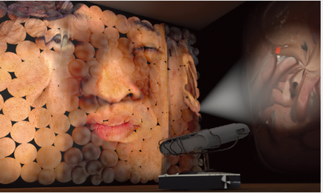 | Modern Body  Katsuki Nogami / Japan  The artist records his face every day by scanning his pores because that is also his identity. These days selfies are becoming disconnected from reality, virtual avatars will become the new norm very soon. So what does our body mean today? Scanned faces are limited by technology, and so do human bodies whose hands are attached to smartphones.
Spectrum
Mari Ohno / Japan

Spectrum is a sound installation that explores the visual appearance of inaudible sound. It is composed of visual objects made of nanogratings, which express the soundwaves of ultrasound, and a light source. The audiences can “hear” the inaudible sound waves through the co-composition between natural light reactions and artificially designed nanostructures.

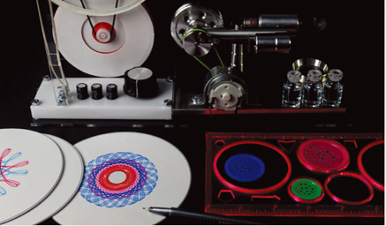 | Spirotrope  Witaya Junma / Thailand  The work is composed of Spirograph, Stirling engine and an Arduino, three inventions from different eras. Each visitor is invited to draw a pattern using the Spirograph, and place it in a special holder that spins it with a Stirling engine. This engine provides electrical power for the Arduino, allowing it to blink so that the Spirograph pattern will be animated differently at various rates.
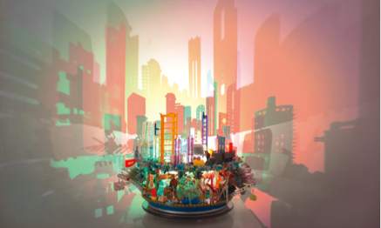 | The Puzzle I  Angela Yuen / Hong Kong  Each plastic object represents the historical development of the city’s manufacturing industries from the 1960s to now. These objects are assembled into a rotating light sculpture, with the silhouettes of objects forming an ever-changing skyline projection on wall. Each diorama is a symbol of the era; each object tells a fascinating story of the factory and local store from where it belonged.
Unerasable Characters II
Winnie Soon / Hong Kong

The project explores the politics of erasure and the temporality of voices within the context of digital authoritarianism. It presents the sheer scale of unheard voices by technically examining and culturally reflecting the endlessness, and its wider implications, of censorship that is implemented through technological platforms and infrastructure.

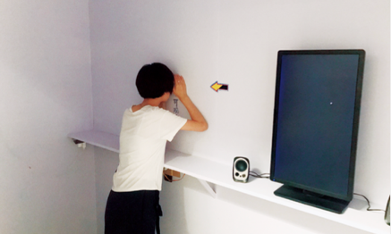 | What Are You Watching  Zhou Zixuan / China  The work reviews the relationship between social reality and artistic expression of privacy leakage from the perspective of psychology, “peeping” and “being peeped at”. Live-broadcasting softwares are free and convenient. Behind the peep, it reflects the ethical paradigm, aesthetic pursuit and the value standard of the contemporary.

More ifva Festival Programmes
Free Registration: www.ifva.com/reg

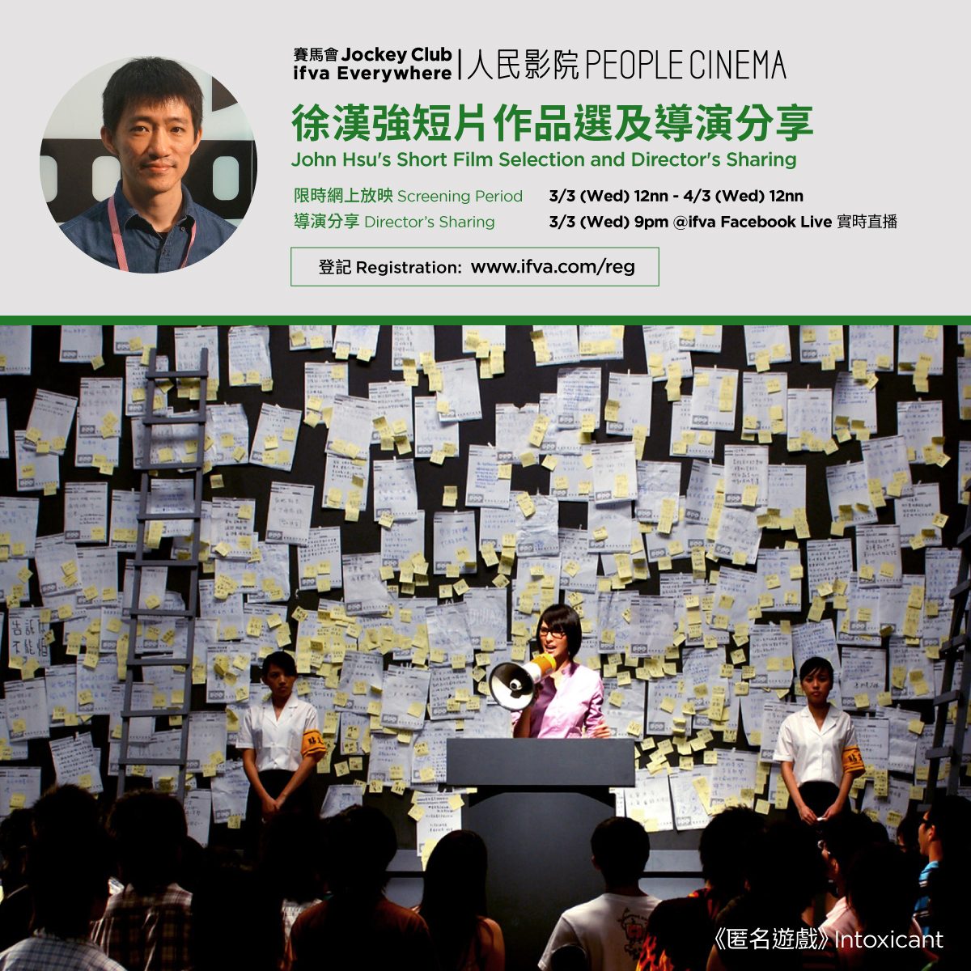 | Golden Horse Winning Director John Hsu (Detention)  Jockey Club ifva Everywhere People Cinema -  John Hsu’s Short Film Selection and Director’s Sharing  3 Mar (Wed) | Online Screening 12nn | Director’s Sharing 9pm | @ifva Facebook Live  John Hsu’s works have proved his passion for video games in terms of narrative, style and art direction. Intoxicant, awarded the 15th ifva Asian New Force Gold Award, depicts the crush of trust among six internet forum users after a hacker threatened to destroy the forum; the 20th ifva Asian New Force category finalist title, The Great Escape from Café City, takes on a slightly sarcastic tone to respond to the “a little happiness” trend in the 2010s.
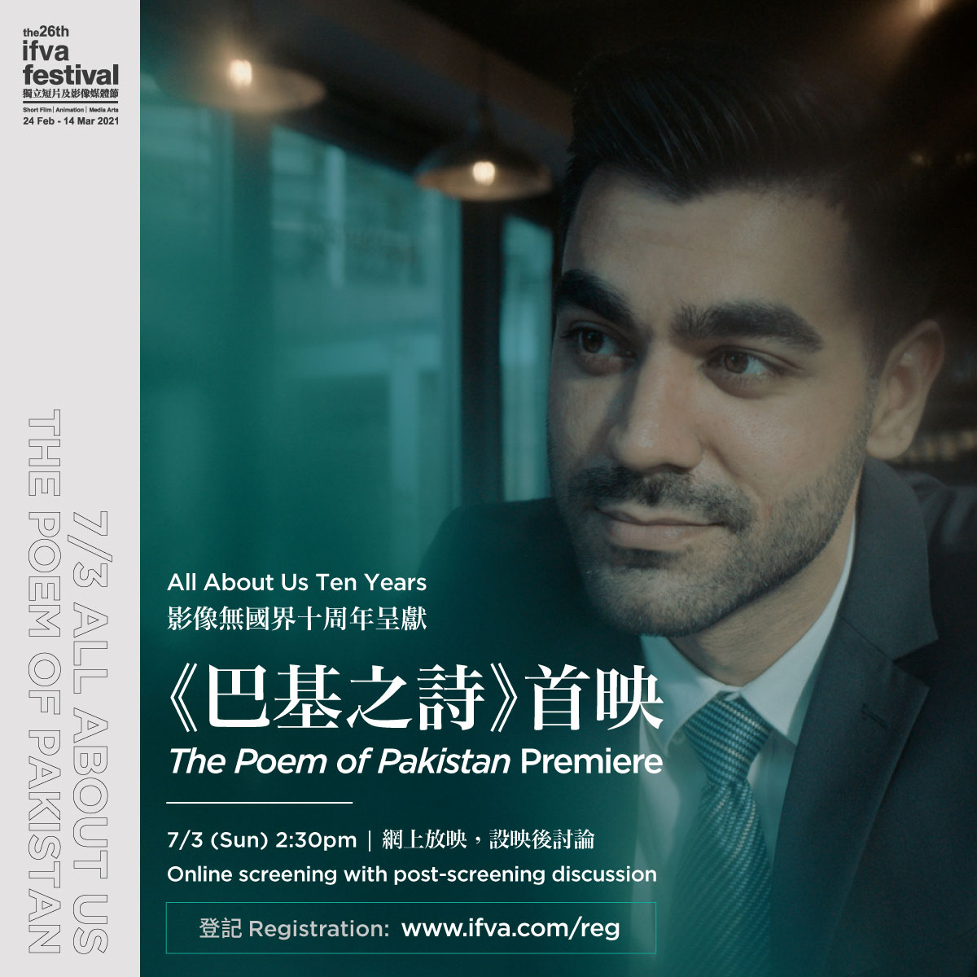 | A Collaboration between Hong Kong Director Ryan Chan and Ethnic Minority Youths  All About Us Ten Years: The Poem of Pakistan Premiere  7 Mar (Sun) | 2:30pm ｜Online screening with post-screening discussion  In celebrating the decade-journey of “All About Us”, teaching artist Ryan Chan has directed and co-produced the film The Poem of Pakistan with experienced members of the programme, depicting the struggle and experiences of local ethnic minority youths.
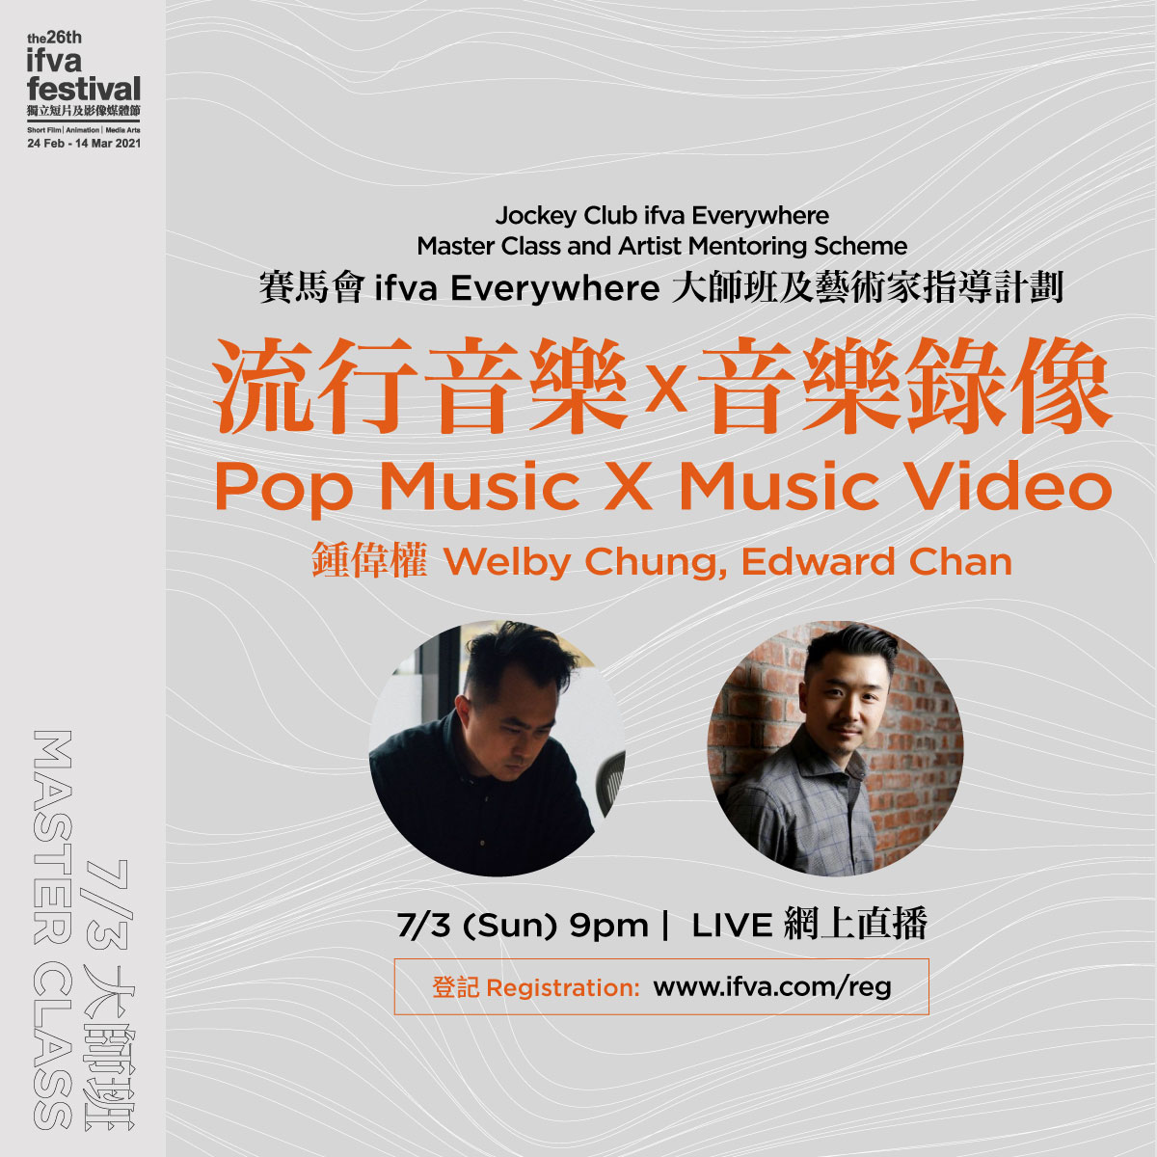 | MV Director Welby Chung Sharing X Music Producer Edward Chan Live Jamming  Jockey Club ifva Everywhere Master Class  Welby Chung X Edward Chan: Pop Music X Music Video  7 Mar (Sun) | 9pm | Online Live  The bonding between pop music and moving images have experienced an exploding popularity in the name of “music video” at the beginning of the 1980s. Pop music tunes can now be expressed and even elaborated through visual storytelling which could even give birth to a new narrative. Commercial and music video director Welby Chung will have an extended conversation with Hong Kong music producer Edward Chan to talk about the aesthetics of music and moving image.
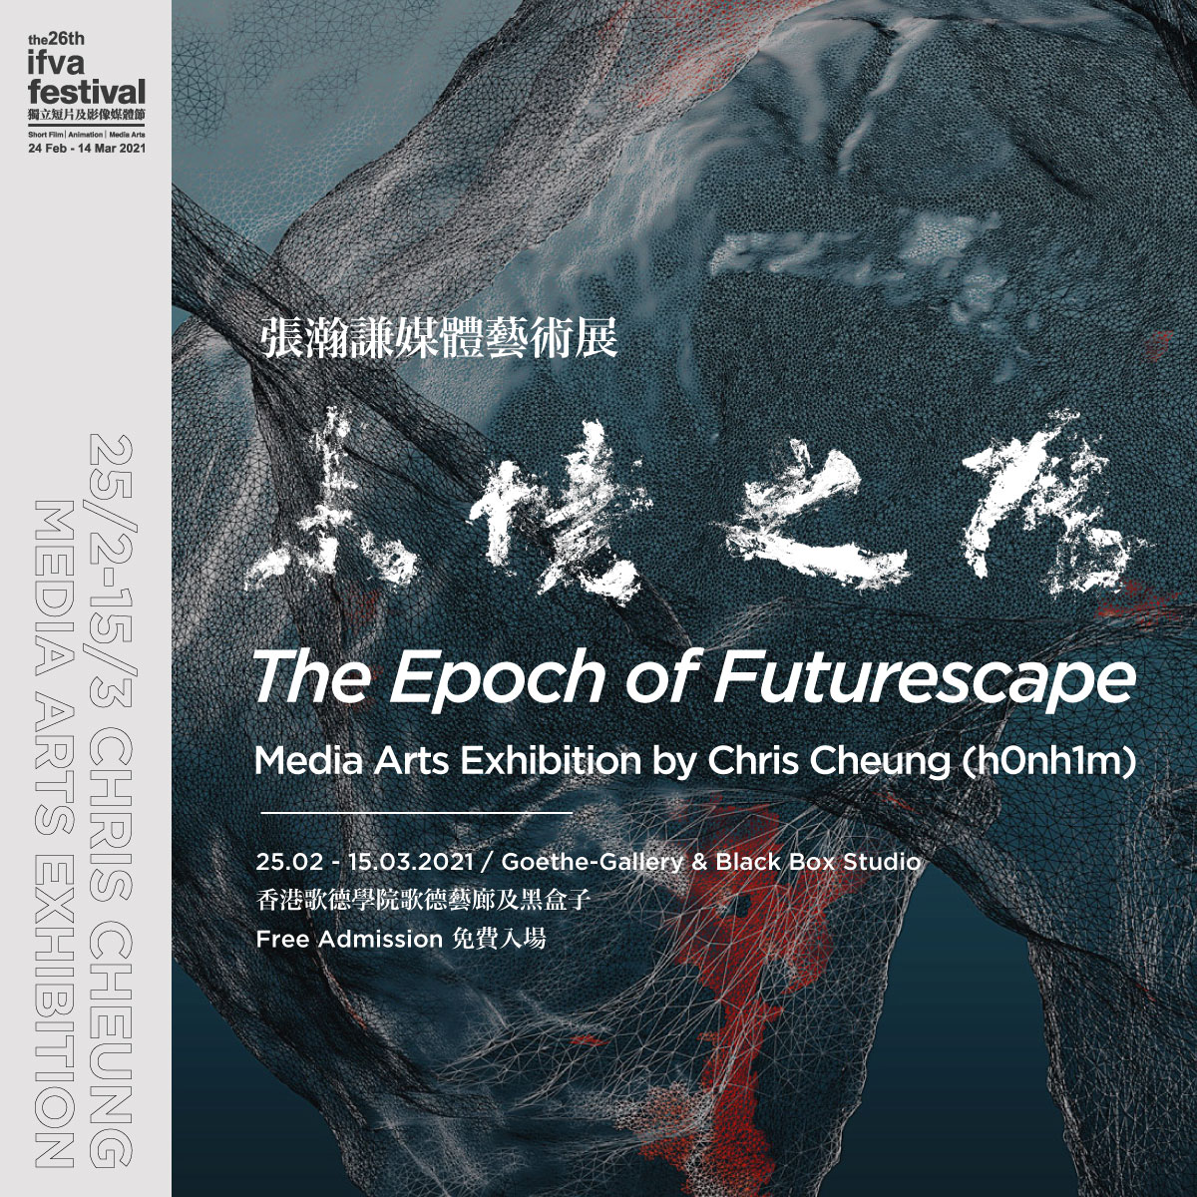 | Hong Kong Media Artist Chris Cheung’s first Solo Exhibition  “The Epoch of Futurescape” Media Arts Exhibition by Chris Cheung (h0nh1m)  25 Feb (Thu) – 20 Mar (Sat) | 9:00am – 8:30pm (Mon-Fri) / 9:30am – 6pm (Sat) | Goethe-Gallery & Black Box Studio, Goethe-Institut Hongkong | Free Admission  “Inheriting unfinished ambitions, embarking on an enlightening journey.”  After everything we have been through, we have arrived at the present moment and are now considering our future. We understand that art is a never-ending practice. Ink, stone and calligraphy descend from Eastern aesthetics. The beauty of the sky, the mountains, the sun, the moon, and the stars was captured by ancient literati in poetry, calligraphy and painting; passed down to this day, unforgotten after more than a thousand years. In the digital age, data has become the carrier of memory which also serves to inject new vigour into artistic creation. But will human memory fall into extinction due to interventions in technology?

