Jointly Presented by
【Hong Kong Arts Centre】&【Hong Kong Economic and Trade Office (Toronto)】
Beyond Borders: Reshaping the Ordinaries of Hong Kong

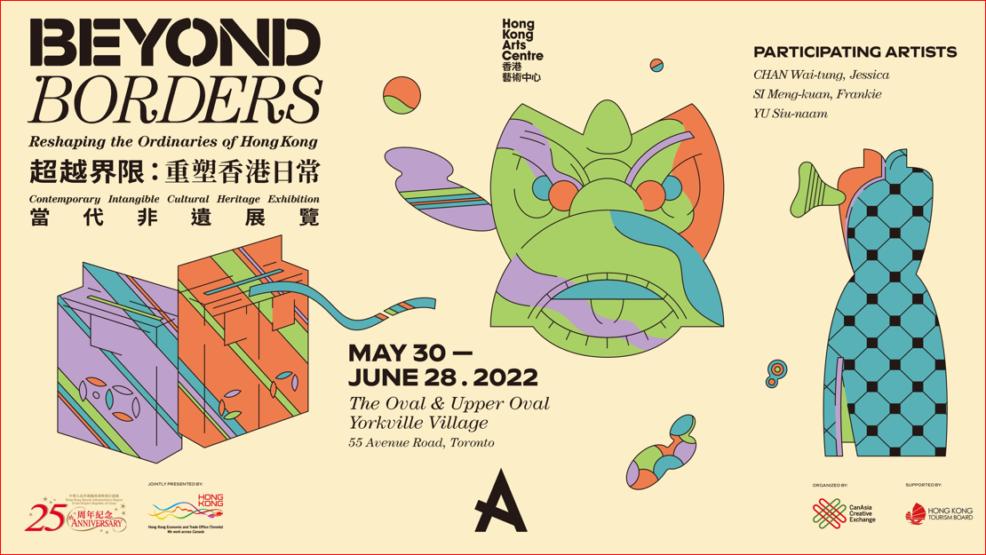

Toronto: 30 May – 28 June 2022
The Oval & Upper Oval, Yorkville Village
55 Avenue Road, Toronto, Canada

Jointly presented by the Hong Kong Arts Centre (HKAC) and the Hong Kong Economic and Trade Office (Toronto), Beyond Borders: Reshaping the Ordinaries of Hong Kong is a contemporary Intangible Cultural Heritage (ICH) exhibition which will be held on 30 May in Toronto this year, and is an extension of last year’s Transformative Chic – The Everlasting Cheongsam Exhibition curated by the HKAC. This year we hope to make another entry under the theme of “Beyond Borders”, to continue promoting cultural exchanges through exhibiting more contemporary ICH artworks to the community in Canada, reshaping the ordinaries of Hong Kong and sharing how ICH can integrate into our daily lives.

In this exhibition, we will be bringing our visitors 3 out of the total 480 Hong Kong ICH items, including ‘galvanised iron product making technique’, ‘paper crafting technique’ and ‘Cheongsam sewing technique’, fusing new and contemporary elements with cultural heritage, showcasing the charm and uniqueness of Hong Kong culture from the artworks. Audience will be taken further to understand how Hong Kong’s traditional galvanised iron work has its contribution to the coffee-drinking culture in Hong Kong’s context, and how the artist takes the Chinese paper-crafted lion head, the traditionally male-dominant ICH item, to explore femininity and many other possibilities. Moreover, we will refresh our audience perception about Cheongsam which are scaled down to miniatures and are created with inspiration of Hong Kong cultural motifs, allowing the audience to know more about the ‘made in Hong Kong’ story.

Ms. Connie Lam, Executive Director of the Hong Kong Arts Centre, said, “Those select ICH items will let audience gain a better understanding of the cultural and traditional stories of Hong Kong through the eyes of a local and experience these unique historical moments under a contemporary setting. We hope that this will be a fantastic opportunity to inspire new interpretations for these traditional concepts. In fact, HKAC was initiated with an aim to preserve, promote, redefine and revitalize the ICH of Hong Kong by means of a holistic model that integrates ‘Education’, ‘Revitalization’ and ‘Investigation’ as well as ‘Curating and Audience-building’ since 2018. By coining the title ‘ICH+’ attempt to rebrand the ICH items by presenting a brand new concept of ‘Contemporary ICH’ with the plus sign implying the infinite possibilities of the evolvement of such Contemporary ICH.”
The three Hong Kong artists participating in the Toronto exhibition are Chan Wai-tung, Jessica, Si Meng-kuan, Frankie and Yu Siu-naam who give new interpretation to traditional artisanship with their original creativity that integrates ICH into modern living. (For more information about the artists, please refer to the Appendix 1)

"Art is life", the two maintain a close, inseparable relationship.

Another contemporary Intangible Cultural Heritage exhibition Beyond Borders: Traces of Hong Kong Stories will be held from 13 June to 3 July 2022 in Vancouver.

Details of the Exhibition:
Jointly presented by 【Hong Kong Arts Centre】 and 【Hong Kong Economic and Trade Office (Toronto)】
Organised by CanAsia Creative Exchange
Supported by Hong Kong Tourism Board
Date: 30 May – 28 June 2022
Venue: The Oval & Upper Oval, Yorkville Village
Address: 55 Avenue Road, Toronto, Canada
Participating Artists: Chan Wai-tung, Jessica, Si Meng-kuan, Frankie and Yu Siu-naam

Please click to the following link for more Images, Video and the Appendix
http://ftp.hkac.org.hk/MDD/Beyond_Borders_Reshaping_the_Ordinaries_of_HongKong_Toronto

~~~~~~~~~~~~~~~~ E N D ~~~~~~~~~~~~~

Hong Kong Arts Centre - Art for Passion, Art for Life, Art for All
Since 1977, the Hong Kong Arts Centre (HKAC) has been a platform for nurturing and supporting artists, and infusing art into everyday life. Its unique arts and educational programmes aim to make the arts accessible for all.

The HKAC believes in the transformational power of art for people from all walks of life. Established for more than four decades, the HKAC endeavours to bring arts to the people of Hong Kong – by presenting programmes for visual arts, performing arts, moving images and media arts, comics and animation. Our other areas also cover arts education, conferences, festivals, public art and community projects. All with the vision and mission of engaging and inspiring creativity in the Hong Kong community.

In 2000, HKAC founded its education arm, Hong Kong Art School (HKAS). The HKAS provides award-bearing programmes to nurture artists and art practitioners, as well as short enrichment courses for the general public.
The HKAC aspires to engage everyone in the community to become an active participant in the arts - as an enthusiast, an artist or a patron.

In 2023, the HKAC will celebrate its 45th anniversary. Let’s continue to embrace ‘Art for Passion, Art for Life, Art for All’, and share the inspiration.

Official website: hkac.org.hk | Facebook: Hong Kong Arts Centre | Instagram: @hongkongartscentre

【Hong Kong Arts Centre】Media Enquiry:
Annie Ho  Marketing and Communications Director | Tel: 2824 5306 /  9481 8706 | Email: aho@hkac.org.hk
Charis Chau  Marketing and Communications Officer | Tel: 2582 0290 | Email: cchau@hkac.org.hk

Appendix 1
Participating Artists

Chan Wai-tung, Jessica
Paper Crafting Artist
Chan Wai-tung, Jessica is a Hong Kong Artist, who graduated from the Royal Melbourne Institute of Technology with a Bachelor’s of Fine Arts. She focuses on sculptures, installations and mixed-media works and is interested in topics such as religions, memories and contemporary human relationships.

In 2018, she joined the Jockey Club ICH+ Innovative Heritage Education Programme – paper crafting technique class. In recent years, she has been learning Chinese traditional bamboo crafts from the ICH master, exploring the characteristics of bamboo and related objects. Jessica’s work is a representation of contemporary ideas through traditional craftsmanship.

In this exhibition, Jessica deployed the traditional paper crafting technique to build the skeleton of the lion head. With a main colour theme of red and pink, the contemporary lion head was decorated with leather and modern accessories.

Si Meng-kuan, Frankie
Mini Cheongsam Artist
Si Meng-kuan, Frankie obtained a Master of Fine Art (Modern Art) from South China Normal University and a Higher Diploma in Visual Arts from Macau Polytechnic Institute. Frankie joined the Jockey Club ICH+ Innovative Heritage Education Programme – Cheongsam sewing technique class in 2018. Being a freelance artist, Frankie works as an arts teacher and participates in various exhibitions held in mainland China, Japan, Korea, Hong Kong and Macau. She specialises in pottery, photography, painting, installation, and textile arts.
Frankie used cheerful rainbow colours as the main focal point of the mini Cheongsam collection, incorporating different elements about Hong Kong into the design.

Yu Siu-naam
Galvanised Iron Artist
Yu Siu-naam graduated from the Hong Kong Polytechnic University with a Bachelor of Arts (Hons) in Industrial Product Design. He is passionate about product design, crafts and coffee. He has been designing and creating coffee products such as coffee roasters, drippers, coffee stands, etc. In 2020, through the Jockey Club ICH+ Innovative Heritage Education Programme – galvanised iron products making technique class, Naam was able to learn from local traditional galvanised iron master Yu Kwok-keung. Naam has been working on adding traditional galvanised iron techniques to modern household coffee products, exploring the possibilities of traditional craftsmanship within our daily lives.
This time, Naam created a series of galvanised iron letterboxes which are infused with modern features, bringing the audience to ponder on the issues of Hong Kong living space and flow of information in today’s society. With his new interpretation of the traditional galvanized iron craftsmanship, he also created a set of galvanised iron coffee dripper utensils.

