Independently Yours -
BLURRING THE COLOR LINE:
CHINESE IN THE SEGREGATED SOUTH
13 December 2022 @Louis Koo Cinema, Hong Kong Arts Centre
Tickets are now available at URBTIX.

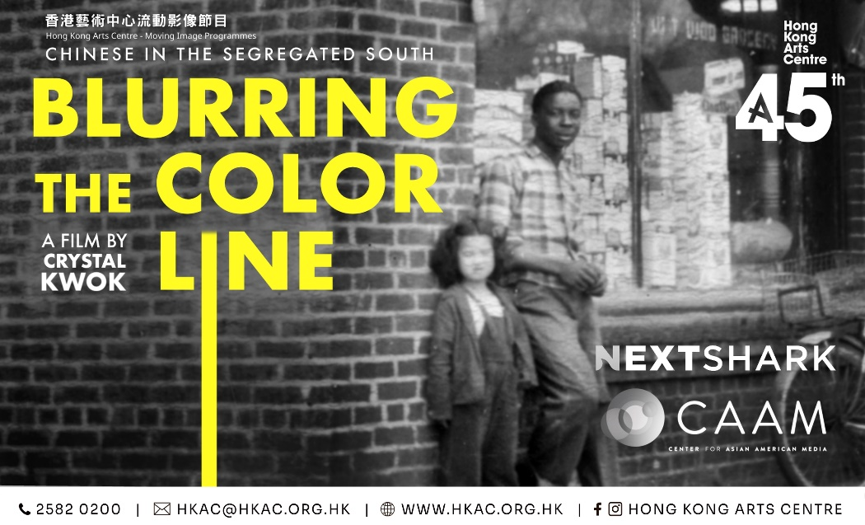

BLURRING THE COLOR LINE: CHINESE IN THE SEGREGATED SOUTH follows director Crystal Kwok as she unpacks the history behind her grandmother’s family, who were neighbourhood grocery store owners in the Black community of Augusta, Georgia during the Jim Crow era. This documentary serves to disrupt racial narratives and bridge divides.

Director/Producer Crystal Kwok will attend the after-screening discussion, with Noreen Mir (Producer & Presenter at Radio Television Hong Kong) as the moderator. Conducted in Cantonese.

“When I came back to America after being away for 20 years I forgot all about race and how I went through when I was teenager, as in Hong Kong where everyone’s don’t have to think about race. When Crystal brought the film to me, I realised that there was serious tensions between the Asian and black communities. In order for us to address these issues, we need to unpack a lot like going back to generations or why these things are either conscious of subconscious in people’s mind or how race should be in this country… so I thought the film is a great way to get this conversation started.” — Daniel Wu, Executive Producer

“At a time in America when we are aware of how divided we are, especially racially, this film bravely explores one of our nation's most discussed, most politicised, and most misunderstood racial divides. I’m of course referring to the relationship between Asian Americans and Black Americans.” — W. Kamau Bell, Executive Producer

For press tickets, interviews or further information, please contact Charis Chau (Tel: +852 2582 0290) of the Hong Kong Arts Centre.

Independently Yours - BLURRING THE COLOR LINE: CHINESE IN THE SEGREGATED SOUTH @ Louis Koo Cinema, Hong Kong Arts Centre
Images download: http://ftp.hkac.org.hk/MDD/BLURRING_THE_COLOR_LINE/
Programme details: https://hkac.org.hk/calendar_detail/?u=LHbpzx7CChE
Programme enquiries: 2582 0268

About Hong Kong Arts Centre - Art for Passion, Art for Life, Art for All

This year marks the 45th Anniversary of the Hong Kong Arts Centre.
Since 1977, the Hong Kong Arts Centre (HKAC) has been a platform for nurturing and supporting artists, and infusing art into everyday life. Its unique arts and educational programmes aim to make the arts accessible for all. The HKAC believes in the transformational power of art for people from all walks of life. Established for more than four decades, the HKAC endeavours to bring arts to the people of Hong Kong – by presenting programmes for visual arts, performing arts, moving images and media arts, comics and animation. Our other areas also cover arts education, conferences, festivals, public art and community projects. All with the vision and mission of engaging and inspiring creativity in the Hong Kong community.
In 2000, HKAC founded its education arm, Hong Kong Art School (HKAS). The HKAS provides award-bearing programmes to nurture artists and art practitioners, as well as short enrichment courses for the general public. The HKAC aspires to engage everyone in the community to become an active participant in the arts – as an enthusiast, an artist or a patron.
Let’s continue to embrace ‘Art for Passion, Art for Life, Art for All’, and share the inspiration.

Official website: hkac.org.hk | Facebook: Hong Kong Arts Centre | Instagram: @hongkongartscentre

Media Enquiry:【Hong Kong Arts Centre】
Roxane Tsui  Programme Manager  Tel: 2582 0268  Email: rtsui@hkac.org.hk | Charis Chau  Marketing & Communications Officer  Tel: 2582 0290  Email: cchau@hkac.org.hk

About the films

Independently Yours

BLURRING THE COLOR LINE: CHINESE IN THE SEGREGATED SOUTH
USA| 2022 | 77’ | In English, with Chinese subtitles | Colour
- Audience Award, Georgia Film Festival 2022
- Courage Award, DisOrient Film Festival 2022
- Mira Nair Rising Female Filmmaker Award, Harlem International Film Festival 2022
- Best Documentary Award, JXN Film Festival 2022
- Viewer’s Choice Award, Best Documentary Award, Black Cat Picture Show 2022
13/12 (Tue) 8pm*
*Director/Producer Crystal Kwok will attend the after-screening discussion, with Noreen Mir (Producer & Presenter at Radio Television Hong Kong) as the moderator. Conducted in Cantonese.
What did it mean to be Chinese in Black space during segregation? Following director Crystal Kwok’s personal journey of discovery, she digs into how her grandmother’s family navigated life as grocery store owners in the black neighbourhood of Augusta, Georgia. The film weaves personal family stories with memories from the larger Chinese and Black communities, opening up uncomfortable but necessary conversations around anti-black racism and the deeply rooted structure of white power and Chinese patriarchy that contributed to this. Which fountain did the Chinese drink from? Where did they sit on the bus? An entrance into our connected histories we never knew or dared speak about as told through the woman’s lens.
Director, writer, producer: Crystal Kwok
Executive producers: Daniel Wu, W. Kamau Bell, Lisa Ling
Editor: Kyung Lee
Director of photography: Lou Nakasano (San Francisco), Lester Lowry (Augusta)
Cast: Crystal Kwok, Stephen Wong, Lorraine Lum O’Quinn, Cedric Sturges
Supported by: CAAM, 127 Wall Productions, & NextShark
Director/Producer, Crystal Kwok
Crystal Kwok is an award-winning filmmaker with experience both in front of and behind the camera. Establishing her career in Hong Kong as an actress, Kwok also has several writers, producer, and director credits to her name. Crystal Kwok’s debut feature film, The Mistress, won the Audience Choice Award at the Deauville Asiatic Film Festival in 2000. As a strong women’s advocate, her talk show, “Kwoktalk” broke boundaries in the Hong Kong media with conversations about women and sexuality. Continuing efforts to create visibility in addressing women's issues, Crystal currently hosts a talk show on KTUH 90.1 FM in Honolulu, Hawaii, where she is also pursuing her Ph.D. in Performance Studies. Crystal also teaches courses in film and the media under the Womenʻs Studies Department and serves as an active member of the University of Hawaii’s Commission on Racism and Bias.

Tickets are available at URBTIX now.
Ticket Price: $85/ $68*
*20% discount for full-time students, senior citizens aged 60 or above, people with disabilities and the minder. Concessionary ticket holders must produce evidence of their identity or age upon admission.
*20% discount to Goethe-Institut Hongkong’s students. Discount is only available at the URBTIX Sales Counters, Goethe-Institut Hongkong’s students must present a valid discount letter upon purchase.
*20% off for HKAC Individual members & HKAC BEE. Discount is only available at the URBTIX Sales Counters, members must present a valid membership card upon purchase.
*20% off for each purchase of 4 or more standard tickets.

- End -

