Another Round: Re-Imagining COVID-19
《下回分解──新冠新觀》
Curator and Artist Bio 策展人及藝術家簡介

Curator策展人:
黎健強Edwin K. Lai

Participating Artist參展藝術家:
張志偉Cheung Chi Wai
張影薇Maria Cheung
朱德華Almond Chu
胡興宇Eric Hu
鄧鉅榮Ringo Tang
余偉建Vincent Yu
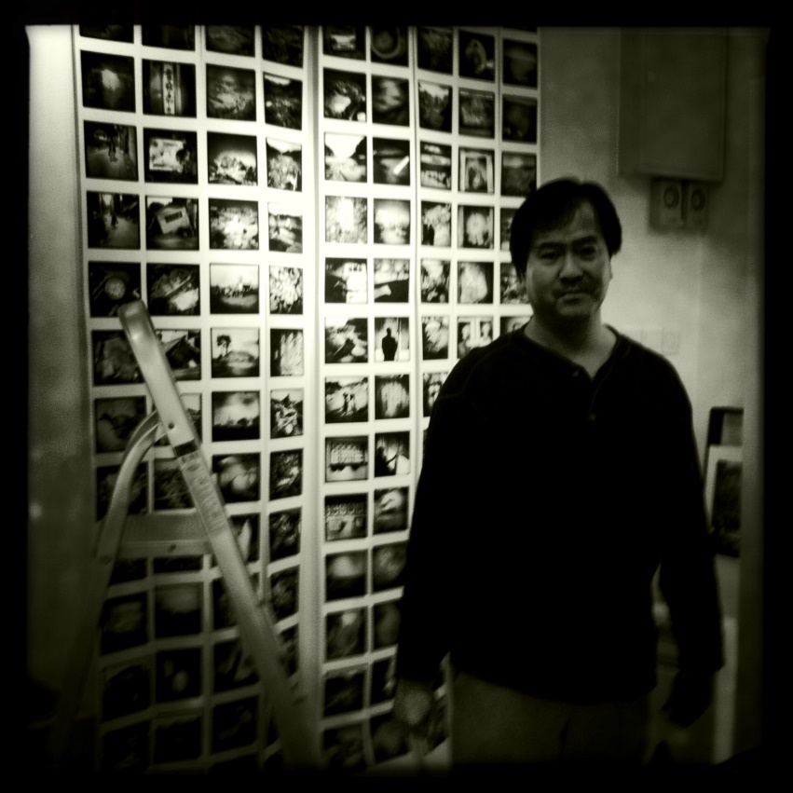
策展人 Curator:
Edwin K. Lai 黎健強
黎健強是香港藝術學院高級講師及攝影學科統籌，也是國際知名的中國及香港攝影學者。他所發表文章逾一百篇，攝影作品曾在英國、日本及香港展出。黎氏從2008年起策劃過多個攝影及藝術展覽，包括《影像香港當代攝影展覽》(2008)、《香港最早期照片1858-1875》(2010)、《藝術造假》(2010)、《後直：當代香港攝影》(2012)、《彩色香港 40s-60s》(2014)、《屾：當代香港攝影》(2014)、《珍影集：常惠珍鏡頭下的1960年代香港女性》(2015)及《此時這地 ─ 香港學苑攝影》(2018)等。

Edwin K. Lai is a Senior Lecturer and Subject Coordinator (Photography) at the Hong Kong Art School, and an internationally recognized scholar of Chinese and Hong Kong photography. He has published more than one hundred essays and articles, and his photographic works have been exhibited in the United Kingdom, Japan, and Hong Kong. Starting from 2008, Lai has curated a number of exhibitions on Hong Kong photography and art, including ‘Imaging Hong Kong – Contemporary Photography Exhibition’ (2008), ‘The Earliest Photographs of Hong Kong’ (2010), ‘Faking It’ (2010), ‘Post-Straight: Contemporary Hong Kong Photography’ (2012), ‘Colour Hong Kong 40s-60s’ (2014), ‘Twin Peaks: Contemporary Hong Kong Photography’ (2014), ‘Rare Encounters: Nancy Sheung's Portraits of Hong Kong Women in the 1960s’ (2015), and ‘Synchronic’ (2018).

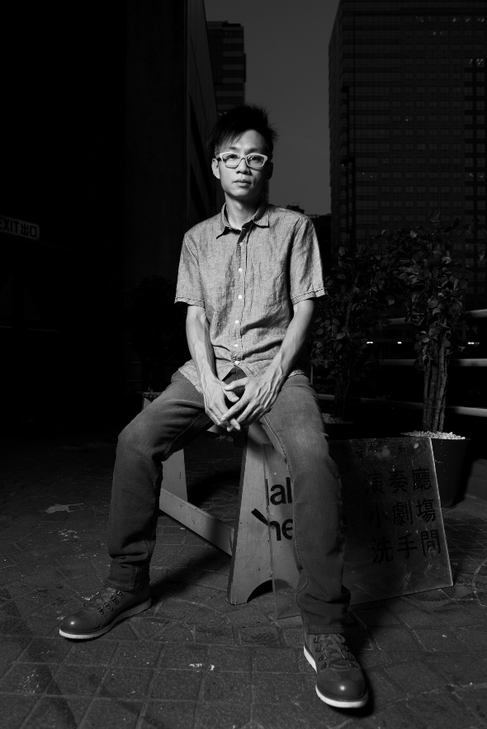
藝術家 Artist:
張志偉Cheung Chi Wai

張志偉擁有20多年拍攝表演舞台藝術的經驗，涉足平面設計、美術指導及藝術行政等範疇，曾出版攝影作品集《Action Fingers》及《交換身份》，部份作品收錄在《一攝無邊：香港劇場攝影集》。其於1996年獲亞洲文化協會獎學金赴紐約深造交流，回港後成立「Moon 9 Image」工作室。2010年開始進行「蛻變3部曲」，包括「交換身份」、「風雨羣像」、「小島靜舍」，探索生活的藝術。他亦於2016年獲香港藝術館邀請製作裝置《15.6－創作者的日常生活》，首次介紹「渡、靜、感、悟」的生活藝術。在2020 年疫情期間，張氏與造型化妝師張楚琦及藝術行政麥曉蕾緊密合作至今，開展統籌造型攝影，包括「搶耳音樂廠牌計劃」，統籌18 個音樂單位的攝影計畫，透過造型攝影，鼓勵參加者即興地表達身體動作，探索自我身份。

Cheung Chi Wai has over twenty years of experience in performing arts photography, while also engaging in the areas of graphic design, artistic direction, and arts administration. He has published the photobooks Action Fingers and ID Exchange, and some of his works are also featured in A Snap beyond Borders: Hong Kong Theatre and Performance Photography. In 1996, Cheung received the Asian Cultural Council Fellowship to go on cultural exchange in New York, and upon his return, established the Moon 9 Image Studio. In 2010, Cheung started the ‘Morph in Trilogy’ photography project including ‘ID Exchange’, ‘Statues Amidst a Storm’, and ‘Minim’ to explore the art of life. At the invitation of the Hong Kong Museum of Art, Cheung curated the exhibition produced the installation 15.6—Creator Daily in 2016 to introduce, for the first time, the art of life through ‘crossing, tranquillity, feeling, and enlightenment’. During the COVID-19 pandemic in 2020, Cheung began closely working with the make-up artist Alice Cheung and arts administrator Crystal Mak on photography and styling design, including the ‘Ear Up Incubation’ programme featuring portrait photography of 18 music groups, which encourage participants to explore self-identity through improvised body movement.

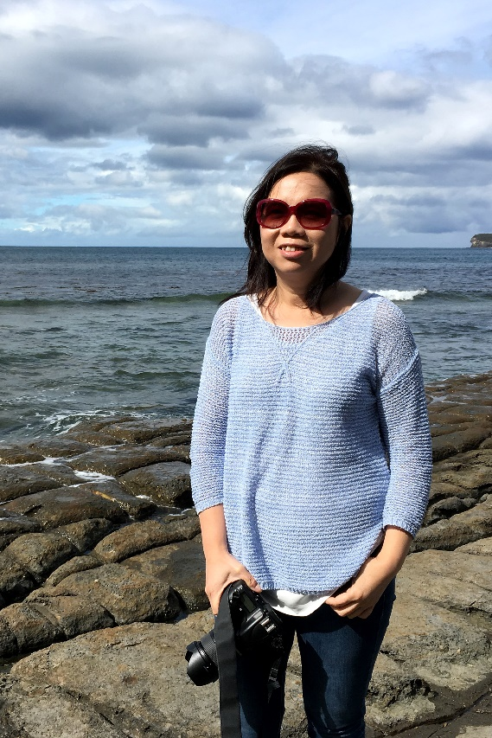

藝術家 Artist:
張影薇Maria Cheung
張影薇於香港出生及成長，2020年獲得香港藝術學院的藝術高級文憑, 主修攝影, 並榮獲最佳畢業作品和最佳學術表現獎。她現正修讀墨爾本皇家理工大學（RMIT）及香港藝術學院合辦的藝術文學士課程。她擅長利用不同手法和多媒體來創作影像與裝置藝術。其攝影作品曾於典亞藝博 (2021)、香港藝術學院藝廊 (2020) 及香港文化中心 (2017-19) 展出，同時被香港醫院管理局網站（2018）採用。

Born and raised in Hong Kong, Maria Cheung obtained her Higher Diploma of Fine Arts, majoring in photography, from the Hong Kong Art School in 2020 and received the Outstanding Artwork Award and Academic Performance Award. Cheung is currently enrolled in the Bachelor of Arts degree in Fine Arts in the Royal Melbourne Institute of Technology (RMIT) University, co-offered by the Hong Kong Art School. Cheung specializes in leveraging various techniques and media for image creation and multimedia installation. Her photography has been exhibited at Fine Art Asia (2021), The Gallery of Hong Kong Art School (2020), and the Hong Kong Cultural Centre (2017-19), as well as previously featured on the Hong Kong Hospital Authority website (2018).

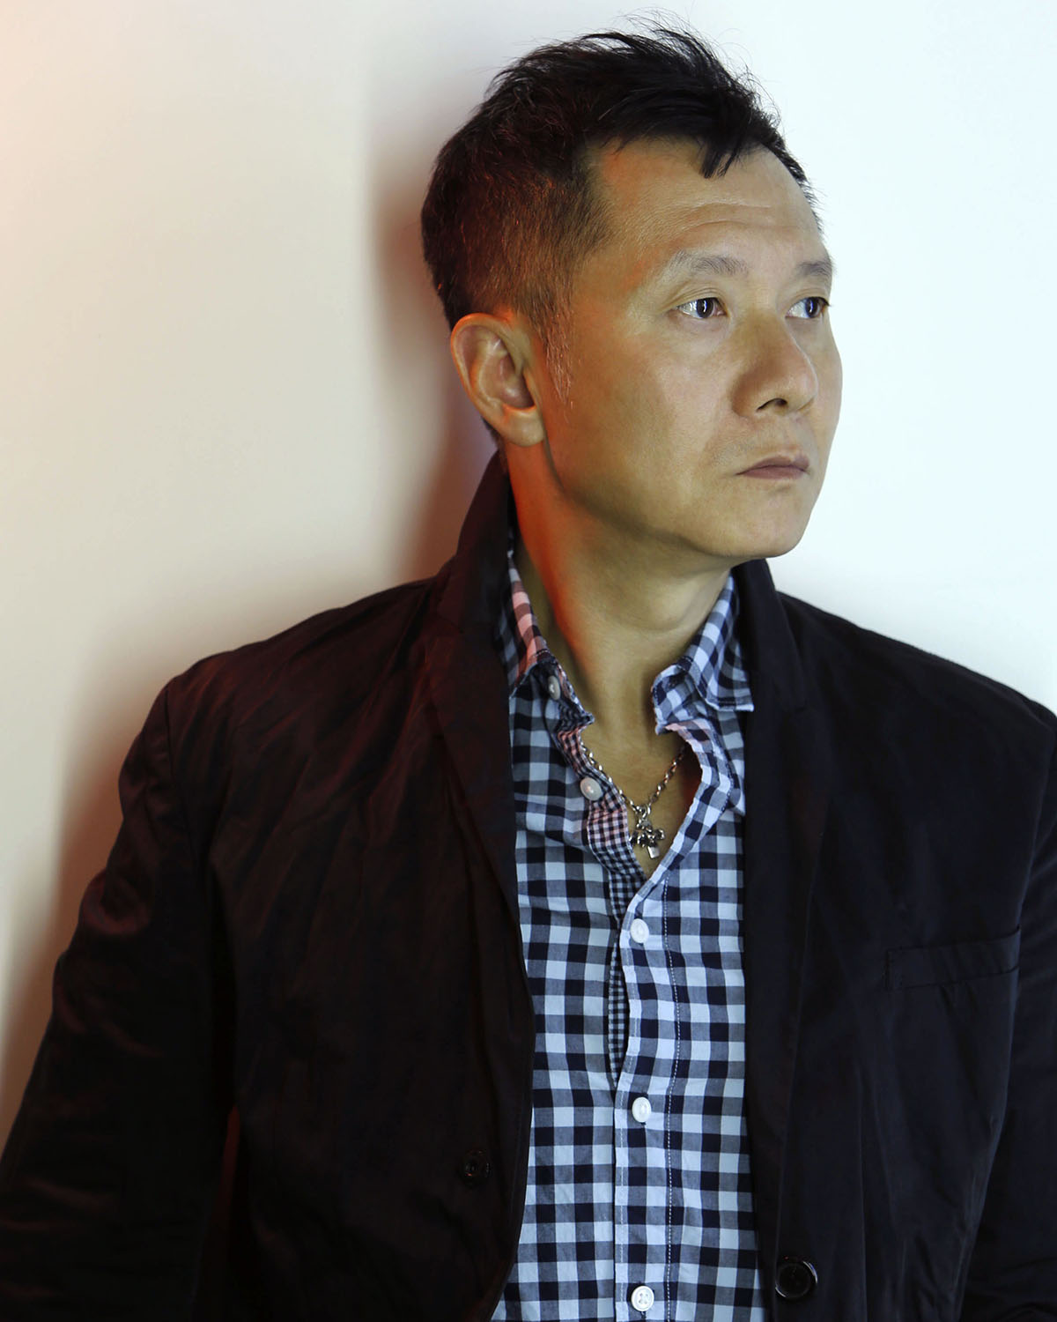
藝術家 Artist:
朱德華Almond Chu
現定居香港的攝影家及藝術家。朱德華畢業於日本東京綜合寫真專門學校藝術攝影系，於1993年開設朱德華工作室，至今從事藝術創作及商業企劃。
其作品曾於德國、法國、比利時、瑞士、意大利、丹麥、美國、加拿大、俄羅斯、日本、中國、香港、新加坡以及新西蘭等地展出，同時亦被多份國際攝影刊物收錄及介紹出版。
朱氏於1993年獲亞洲文化協會 （前身洛克斐勒三世亞洲文化交流計劃基金）頒發愛克發基金青年攝影家獎。2004年應德國波恩大學邀請出席 Art & Exhibition Hall of Deutschland 所舉辦的國際藝術研討會為主講者之一。2005年創立攝影組織pH5攝影連動，致力推動香港藝術攝影文化。他亦是香港國際攝影節創辦人之一。2015年被提名百達世界環保攝影獎及2018年被提名以色列博物館舉辦的The Shpilman International Prize of Excellence in Photography。
其作品獲俄羅斯莫斯科國立普希金造型藝術博物館、台北文華東方酒店、廣東美術館、深圳華．美術館、香港M+博物館、香港藝術館、香港文化博物館、香港大學美術博物館、奧莎畫廊、利希慎基金會、德意志銀行、香港半島酒店、蘭桂坊酒店、 新世界發展有限公司、國泰航空公司、愛克發吉華 (香港) 有限公司及私人收藏家收藏包括比利時Collection Uhoda和香港林偉而生活收藏。
他的代理畫廊包括比利時的Yoko Uhoda Gallery 和香港的La Galerie Paris 1839。他亦是香港的刺點畫廊和奧沙畫廊的展覽藝術家。

Almond Chu is a Hong Kong-based photographer and artist who has graduated from the Fine Art Photography Department of the Tokyo College of Photography in 1986. Chu set up his own studio in 1993 to work on art and commercial projects.

Chu has exhibited his work in Germany, France, Belgium, Switzerland, Italy, Denmark, USA, Canada, Russia, Japan, China, Hong Kong, Singapore, and New Zealand. In addition, his work has been featured in numerous international publications.

In 1993, Chu was awarded the Agfa Fellowship Young Photographer Award by Asian Culture Council (previously the John D. Rockefeller III Fund Asian Cultural Program). In 2004, he was invited to be one of the prominent speakers of the Internationally Literary and Aesthetic Symposium organized by Bonn University and the Art & Exhibition Hall of Deutschland, Germany. In 2005, he founded the art photography organization pH5 Photo Group, which focuses on promoting art photography in Hong Kong. He is also the founder of Hong Kong International Photo Festival. In 2015, he was nominated for the Prix Pictet in France, and in 2018, he was nominated for The Shpilman International Prize of Excellence in Photography in Israel.

Chu’s works have been collected by The Pushkin State Museum of Fine Arts, Russia; Guangdong Museum of Art and OCT Art & Design Gallery, Shenzhen, China; Mandarin Oriental Hotel, Taiwan; M+ Museum, Hong Kong Museum of Art, Hong Kong Heritage Museum, University Museum and Art Gallery of the University of Hong Kong, Osage Gallery, Lee Hysan Foundation, Deutsche Bank Collections, Peninsula Hotel Hong Kong, Hotel LKF, New World Development Co Ltd., Agfa-Gavert (HK) Ltd, and Cathay Pacific Airways, Hong Kong; and other private collectors including Collection Uhoda in Belgium and William Lim Living Collection in Hong Kong.

He is represented by Yoko Uhoda Gallery, Belgium and La Galerie Paris 1839, Hong Kong. He is also an exhibition artist of Blindspot Gallery and Osage Gallery in Hong Kong.

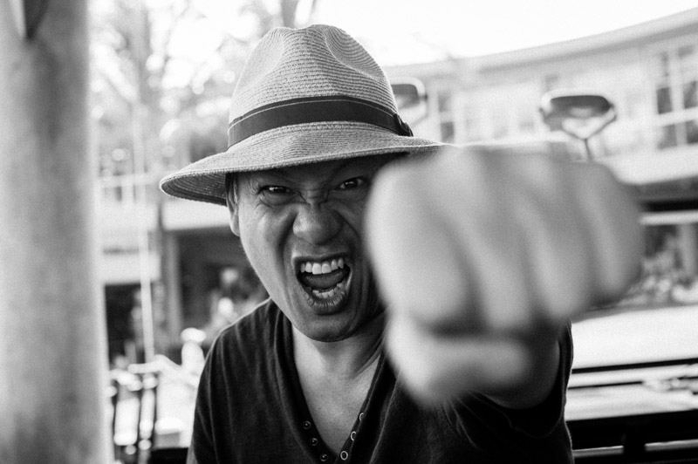

藝術家 Artist:
胡興宇Eric Hu

胡興宇出生於香港，並在英國接受教育，畢業後回港發展廣告製作事業，期後於香港及上海成立「錄點製作有限公司」，歷年導演多個本地及海外廣告。

胡氏近年主力藝術創作及攝影， 2010年於藝術家 Simon Birch的Hope and Glory系列中，聯合創作驚慄故事 《Khor Virap》。二人於2017年再度攜手創作大型裝置《The Inevitable》，利用十多部攝影機一鏡拍攝撞毀一架法拉利跑車，作品展於美國洛杉磯的 《14th Factory》藝術展。

Born in Hong Kong, Eric Hu graduated from law in the United Kingdom and relocated to pursue a career in the film industry. Hu established his own production house ‘Greenspot’ in Hong Kong and Shanghai, and has since shot numerous TV commercials, music videos, and documentaries globally. He has previously collaborated with the artist Simon Birch in the exhibition 'Hope and Glory' (Hong Kong, 2010) with the horror film Khor Virap. His other installation The Inevitable involved a large scale destruction of a Ferrari filmed with multiple cameras and was shown in the exhibition ‘14th Factory’ (Los Angeles, 2017).

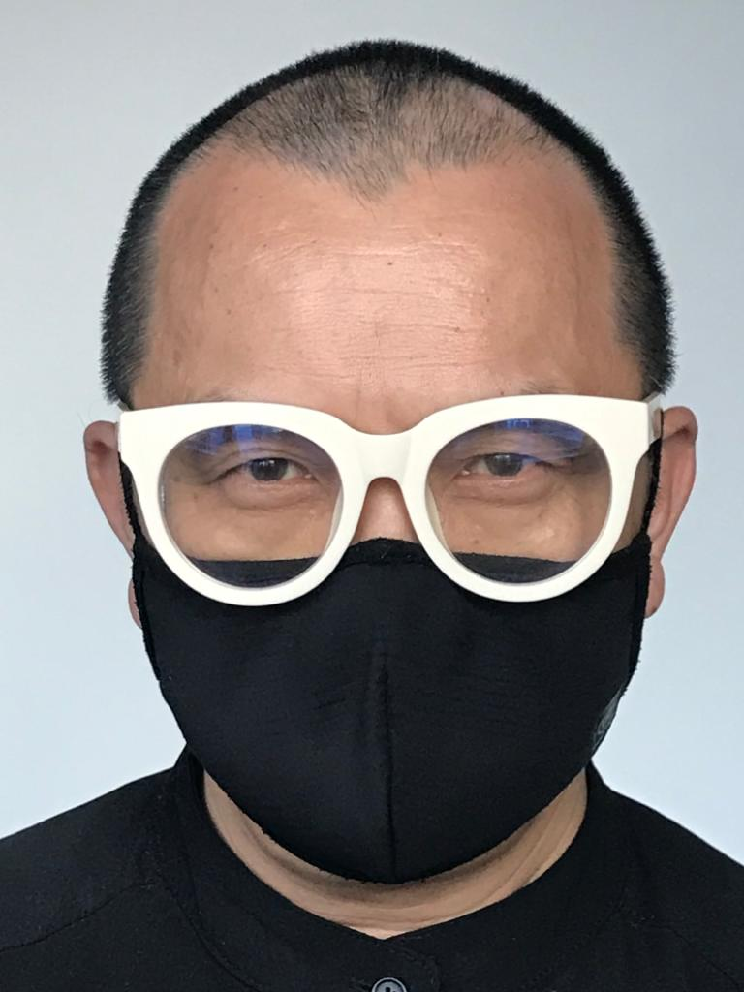

藝術家 Artist:
鄧鉅榮Ringo Tang

鄧鉅榮在1961年生於香港，現為多媒體視像工作者、攝影師及廣告導演。鄧氏於1984年開始從事專業攝影活動，其多面化的作品遊歷於人風物境之間，具有敏銳及獨特的個人風格。他於1994年開始參與廣告拍攝及導演工作，並積極參與多項社會文化義務，曾联同香港歷史博物館及香港大學製作香港歷史之纪绿片及有關文化推廣活動等。

其作品曾多次展出於本地及海外，個展包括《如去：如來》（香港，2014）、《物流/勿留》（日本神戶，2013）、《自主之城》（多倫多，2001）及《靜觀萬物》（香港，1991）；群展包括《屾》（香港文化博物館，2014）、《生息》（香港ArtisTree，2013）、《從城市到城市》（香港ArtisTree，2012）、《生息》（北京798西門子藝廊，2011）、《念影度形》（深圳華·美術館，2010）、《影像香港—當代攝影展》（香港中環廣場，2009）及柏林香港藝術節等。

鄧氏曾獲頒多項國際性獎項，包括英國D＆AD年獎（2011）、ARC攝影銀獎（2003）、美國全幀紀錄片電影節榮譽表揚（2002）、龍璽金獎及銀獎（2000）、第42屆紐約節銀獎（1999）、第四十一屆紐約節金獎及銀獎（1998）、時代亞太廣告獎金獎及銀獎（1996）、香港4A廣告商會攝影金獎（1996）、香港專業攝影師公會最佳作品獎（1995）、紐約攝影地區新聞金獎（1994）、紐約美術指導會最佳攝影（1993）及香港設計師公會攝影金獎（1990）。

Born in Hong Kong in 1961, Ringo Tang is a multimedia visual artist, photographer, and TVC director. Tang has worked as a professional photographer since 1984. His multi-faceted works intersect portrait, scenery, and objects with a keen and unique personal style that continues to experiment and push boundaries. Tang began filmmaking in 1994 and actively takes part in various community services. In collaboration with the Hong Kong Museum of History and the University of Hong Kong, he has produced a documentary about Hong Kong history and other special projects on the cultural development of Hong Kong.
Tang’s solo exhibitions include ‘And time future contained in time past’ (Hong Kong, 2014), ‘Release /Relief’ (Kobe, Japan, 2013), ‘Autonomous City’ (Toronto, 2001), and ‘Think Thing’ (Hong Kong, 1991). He has also taken part in many group shows including ‘Twin Peaks: Contemporary Hong Kong Photography’ (Hong Kong Heritage Museum, 2014), ‘Breathe Life’ (ArtisTree, Hong Kong, 2013), ‘From City to City’ (Hong Kong ArtisTree, 2012), ‘Breathe life’ (Siemens, 798 Beijing, 2011), ‘Magnificent seven’ (Hua Art Museum, Shenzhen, 2010), ‘Imaging Hong Kong – Contemporary Photography Exhibition’ (Central Plaza, Hong Kong, 2009), and ‘Hong Kong Arts Festival in Berlin’.
Tang is the recipient of numerous international and local awards, including D&AD awards (2011), Silver of International ARC Awards (2003), Full Frame Documentary Film Festival (2002), Longyxi Awards (2000), NY Festivals Film & Video Awards (1998), Mobius Awards (1998), Time Asia Pacific Advertising Awards (1996), HK4A Best Photography & Creative Awards (1996), HKIPP Gold (1995), Photo District News Award for Excellence (1994), Communications Arts and the Art Director’s Club Awards of New York (1993), and HKDA Photography Gold (1990).

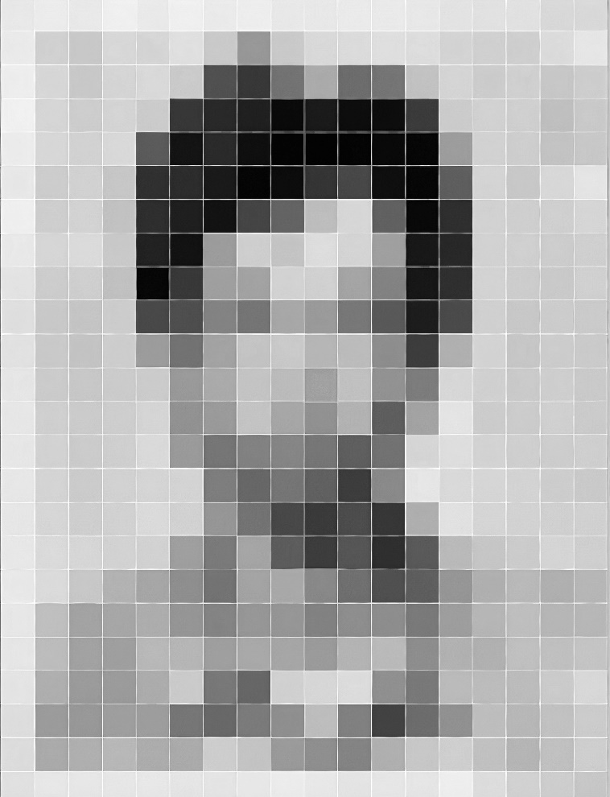
藝術家 Artist:
余偉建Vincent Yu
余偉建是一名出生於香港的攝影記者，自1985年以來採訪過亞太地區眾多轟動一時的新聞事件。

作為香港急速發展的細密觀察者，余氏對本地日新月異的城市景觀帶著一份特別的覺察，著力記錄正在消失的文化遺產和建築，以及因此而受到影響的不同社群。

余氏曾獲得多個獎項，包括2004 年National Headliner Awards、2010年世界新聞攝影獎「People in the News」單一照片比賽單元第三名、2013年全球年度圖片獎（Picture of the Year Awards）年度攝影師優異獎，以及多個香港攝影記者協會年度獎項。余氏的多幅作品獲香港文化博物館收藏。

Born and raised in Hong Kong, Vincent Yu has worked as a photojournalist covering major news events across the Asia-Paciﬁc region since 1985.

As a close observer of Hong Kong’s rapid development, Yu has acquired a special sensitivity towards its ever-changing cityscape. In particular, he is interested in documenting disappearing heritage and architecture, as well as communities affected by these changes.

His works have been recognized by many honours, including the 2004 National Headliner Awards, 2010 World Press Photo Awards 3rd Prize in the “People in the News” singles category, 2013 Award of Excellence for “Photographer of the Year” in the Picture of the Year Awards, and numerous Hong Kong Press Photographers Association Annual Awards. His works are collected by the Hong Kong Heritage Museum.

