Dear Editors,
Appendix and Images for download: http://ftp.hkac.org.hk/MDD/All_The_Worlds_A_Stage/

Presented by【Hong Kong Arts Centre】
HKAC 45th Anniversary Flagship Exhibition
“All the World’s A Stage: The Art of Luis Chan”
Open to visitors from 10 December 2022 to 18 January 2023
Pao Galleries, Hong Kong Arts Centre (10am – 8pm)
Initiated and empowered by Ms Cissy Pao
Supported by Luis Trust
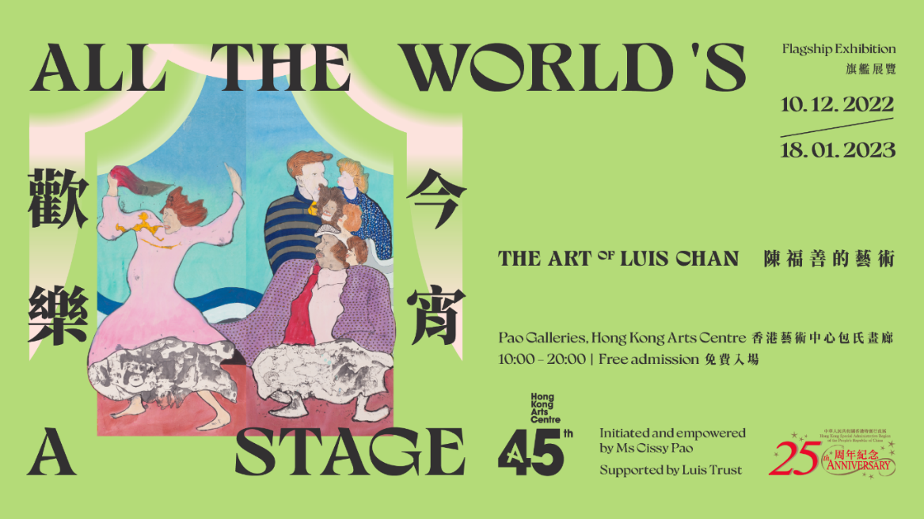
Presented by the Hong Kong Arts Centre, the exhibition ‘All the World’s A Stage: The Art of Luis Chan Flagship Exhibition’ is initiated and empowered by Ms Cissy Pao, supported by Luis Trust. The exhibition is curated by guest curator Ms Joyce Hei-ting Wong.

Widely regarded as Hong Kong’s pioneer of modern art, Luis Chan is known for his imaginative paintings of landscape, figures, and animals that defy art historical and cultural categorisation. Chan’s colourful works are matched by an equally vibrant personality. Referencing Shakespeare’s evocative phrase ‘All the world’s a stage’, this HKAC 45th anniversary flagship exhibition explores Chan’s art and legacy in a thematic investigation that highlights the artist’s perceptive portrayal of daily urban drama and identity, his love of narrative and storytelling, and his uplifting spirit throughout the tumultuous 20th century.

As a key part of the Hong Kong Arts Centre’s 45th anniversary, this exhibition provides an opportunity to enrich extant research on the artist with new archival materials and a long overdue institutional monograph since the artist’s passing. The exhibition will display Chan’s paintings of various styles, from early realistic landscape watercolour paintings to later fantastical abstract portraits, presenting Chan’s kaleidoscopic artistic trajectory in the local art scene to Hong Kong and international audience. (Please refer to Appendix for Curatorial Statement by Joyce Wong.)

**For press interviews, press preview (9 December), or further information, please contact Charis Chau (Tel: +852 2582 0290) of the Hong Kong Arts Centre by 5 December.

A series of Public Programme and Family Friendly Workshops will be held during the exhibition period. More information about these workshops will be launched on the Hong Kong Arts Centre official website soon.

About the Exhibition
Title: All the World’s A Stage: The Art of Luis Chan Flagship Exhibition
Exhibition Dates: 10 December 2022 –18 January 2023
Time: 10am – 8pm
Venue: Pao Galleries, Hong Kong Arts Centre (2 Harbour Road, Wan Chai)
Free admission

Exhibition Opening
Date: 9 December 2022, Friday
Time: 6:30pm – 8pm
Reception starts: 6pm
Venue: 5/F, Pao Galleries, Hong Kong Arts Centre (2 Harbour Road, Wan Chai)

Discover more about Luis Chan at Hong Kong Arts Centre
Luis Chan Studio
Hong Kong Arts Centre launched the 5-year project Luis Chan Studio in May 2022, with the Studio showcasing his living environment and the setting when he was still alive and drawing, allowing audience to gain an in-depth understanding of Luis Chan’s creations and his artistic world.

Luis Chan, also known as the ‘King of Watercolour’, is a local legendary artist and is significant in the Hong Kong art history. He lived in a home studio located at Lockhart Road in Wan Chai before—in that apartment, he drew numerous paintings. Streetscape of Wan Chai and nearby stores cultivated his inspiration. His artworks are traces of the past and rich in local characteristics. Taking reference from Luis Chan’s home studio at Lockhart Road in Wan Chai, Luis Chan Studio features Chan’s personal belongings, such as furniture, paintings, and books relocated from his studio. Visitors can glimpse Chan’s creative space of the old days through the glass window. And through understanding the meanings behind some of the displayed items, visitor can further explore different traits of Chan. It is hoped that the Studio can provide the public with an alternative visual experience and a deeper understanding of Chan’s life. More historical photos and written records about Chan are showcased to guide the audience through his artistic journey and development of styles, reflecting on important traces of Hong Kong art history.
About Luis Chan Studio
Date: Open for viewing until May 2027
Time: 8am – 11pm
Venue: 4/F, Hong Kong Arts Centre (2 Harbour Road, Wan Chai)
~~~~~~~~ END ~~~~~~~~

Hong Kong Arts Centre – Art for Passion, Art for Life, Art for All
This year marks the 45th Anniversary of the Hong Kong Arts Centre.
Since 1977, the Hong Kong Arts Centre (HKAC) has been a platform for nurturing and supporting artists, and infusing art into everyday life. Its unique arts and educational programmes aim to make the arts accessible for all. The HKAC believes in the transformational power of art for people from all walks of life. Established more than four decades ago, the HKAC bring art to the people of Hong Kong – by presenting programmes for visual arts, performing arts, moving images and media arts, comics and animation. Other areas also cover arts education, conferences, festivals, public art and community projects, all done with the vision and mission of engaging and inspiring creativity in the Hong Kong community.
In 2000, HKAC founded its educational arm, Hong Kong Art School (HKAS). The HKAS provides award-bearing programmes to nurture artists and art practitioners, as well as short enrichment courses for the general public. The HKAC aspires to engage everyone in the community to become an active participant in the arts – as an enthusiast, an artist or a patron.
Let’s continue to embrace ‘Art for Passion, Art for Life, Art for All’, and share the inspiration.

Official website: hkac.org.hk | Facebook: Hong Kong Arts Centre | Instagram: @hongkongartscentre

About the Guest Curator
Joyce Hei-ting Wong was formerly Curator at Asia Society Hong Kong Center. She assisted in the inauguration of ASHK’s “20th Century Chinese Female Artist Series” including exhibitions Painting Her Way: The Ink Art of Fang Zhaoling (2017) curated by Kuiyi Shen and Julia F. Andrews, Spring: Pan Yu-Lin in Paris (2018) curated by Eric Lefebver, and most recently curated A World Within: The Art and Inspiration of Irene Chou (2019). Wong holds a BA from the University of Hong Kong, with a double major in English Literature and Fine Art (2015) and received an MA of Contemporary Literature, Culture & Theory from King’s College London.

Media Enquiry:【Hong Kong Arts Centre】
Charis Chau
Marketing & Communications Officer
Tel: 2582 0290
Email: cchau@hkac.org.hk

