APPENDIX
Workshop details
Season 1: 2020.10.18 - 2021.01.08
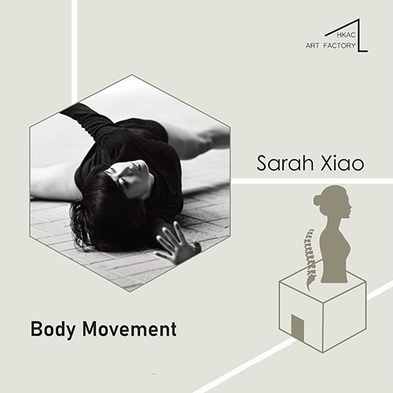
Body Movement Sarah Xiao
Every Tuesday 18:30 - 19:30
Every Sunday 19:00 - 20:00
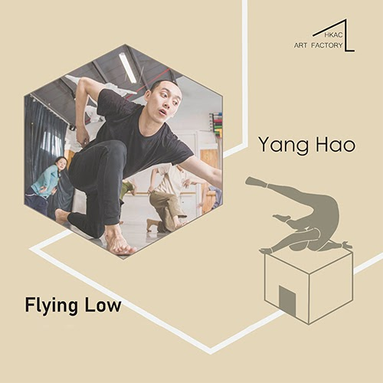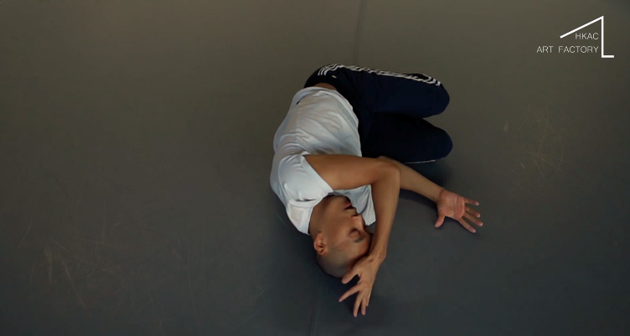
Flying Low Yang Hao
Every Sunday 12:00 - 13:00
Every Monday 19:00 - 20:00

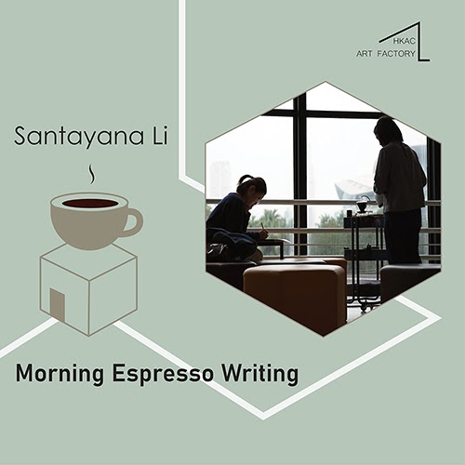
Morning Espresso Writing Santayana Li
Every Monday - Friday 08:00 - 09:00
09:00 - 10:00

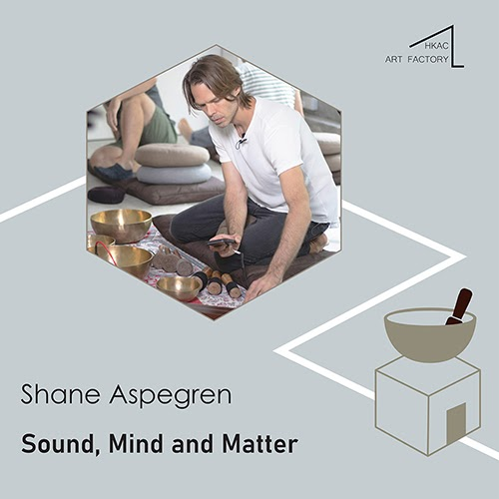
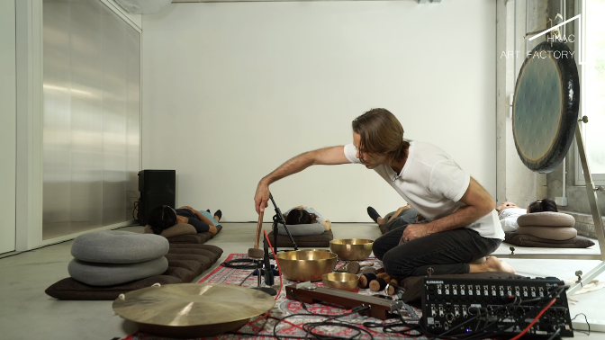
Sound, Mind and Matter Shane Aspegren
Every Wednesday 17:30 - 18:30

Ticketing
A token system will be used for all workshops. Patrons are free to spend their tokens in any of the workshops according to their preferences and are entitled to switch courses in the middle of the season as they see fit.

Tokens will be available at the HKAC Art Shop.
https://hkacartshop.store/

*1 Token = 60 mins of workshop

All tokens in the package should be used within two seasons
No. of Token Purchased Unit Price of Token Package Price
Single Token HKD150/hr /
6 Token Package HKD120/hr HKD720
12 Token Package HKD100/hr HKD1,200
18 Token Package HKD90/hr HKD1,620
24 or Above HKD80/hr HKD1,920 -

Every full course of the workshops will last for 8 - 12weeks, ranging from 1 to 5 60-minute sessions per week.
---
Scenario A – Tiffany is an office lady who is interested in trying and exploring different types of art forms. She opted for a 6 Token Package and decided to spend 1 token in each type of the workshop. After having a taste of each of them, she decided to spend the remaining 2 token on “Flying Low”. All at your own discretion.

Scenario B – Brandon is an experienced Hip Hop Dancer and would like to enlighten himself in a totally different type of dance form. He purchased the 24 token package and intended to join all sessions of “Flying Low”. Nonetheless, he fell sick and missed 1 session of “Flying Low”. He used the spare token for another workshop “Sound, Mind and Matter”. High degree of flexibility.

