Dear Editors,
Key Visual and Film Stills Download: http://ftp.hkac.org.hk/MDD/27th_ifva_AwardsResultsAnnouncement/
Festival Trailer: https://youtu.be/zQSjZ_pMA9M
Award Category Trailer: https://youtu.be/f23ddHm_n1o49m

Hong Kong Arts Centre
The 27th ifva Festival
Embark on the Adventure of Leaping into the Realm of Unknown

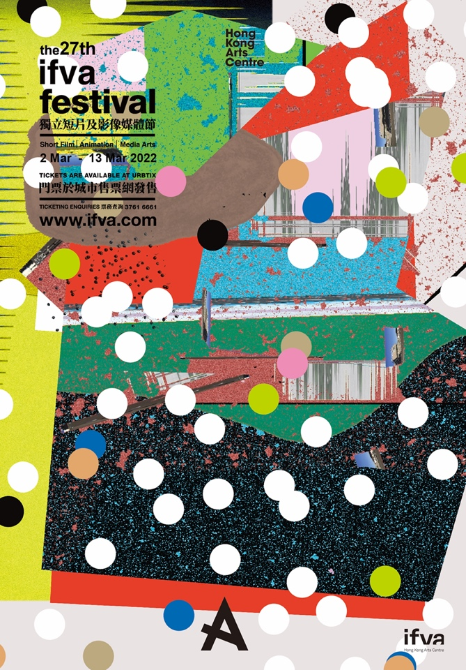

Organised by Hong Kong Arts Centre, the public events of the 27th ifva Festival will not take place as scheduled due to the venue closure. But even at such a time, ifva believes in the power of independent moving images and visual arts. Created by local director Wong Cheuk-man, one of the winners of the 23rd ifva Open Category, the key visual and trailer of the 27th ifva is themed around “leaping into the realm of unknown”. A collage in vibrant colours and dots symbolises the clashing of ideas in a time of chaos and unknown, where creative talents still live an adventurous heart. The trailer features young actors from HKICC Lee Shau Kee School of Creativity, with a garbage bag that takes the high school boys and girl on a romantic journey of their own, and along the way also explores the meaning to create.
Festival trailer: https://youtu.be/zQSjZ_pMA9M

The jury meetings are held online, and results will be announced at 7pm on 12 March (Sat) at www.ifva.com/live. ifva director Kattie Fan said, “Even though we cannot meet at the cinema or any other venues, ifva continue serves as the platform for creatives to exchange ideas, share experiences, and get connected.” Online sharing sessions will be organised for the finalists of this edition, and a set of house programme and festival pass will also be posted to all finalists as a token of appreciation of their enormous bravery in pushing their boundaries.
Award Category Trailer: https://youtu.be/f23ddHm_n1o49m

Finalist Works in Response to the Best and Worst of Times

The jury panel of this edition of ifva have shortlisted 50 finalist works for the 5 categories. The 10 Open Category finalist works not only depicts the struggle of staying alive but also the departure and reunion in the time of pandemic and diaspora. Chuk Tsz-yin’s Plain Sailing is a rendezvous of a Hong Kong girl and a Japanese boy in Kaohsiung; Erica Kwok’s The Dancing Voice of Youth remembers the chaotic age in the form of dance and documentary footages; Yeung King-lun’s directorial debut Moonshine features local up-and-coming actor Hanna Chan in this tale of missing the other side of the world under the same moonlight; the feature script of Wong Ka-ki’s Fire Room has been selected by Berlin Film Festival Script Station 2021; Tang Yi’s All the Crows in the World was awarded Best Short Film at Cannes Film Festival, while Benson Koo’s Cinema Quietude is a visual record of the last days of the deserted cinema in Cheung Chau.

The works of Youth Category is a solid proof that the youth in town remains fearless and furious in spite of the “new normal”. In face of the pandemic, the institution, and separations in various forms and also the reflections to mother nature, they response with moving images in utmost honesty.

This year’s finalist works of Animation Category is a showcase of style and subject matter, with themes ranging from everyday city life murmurs to surreal metaphorical tales. Local works include: Tang Kan-kei’s Once Upon a Time in Tuen Mun, a nostalgic tale by a Tuen Mun-born animator; melancholy’s Nyala is a metaphor about a nyala which has accustomed to urban life and lose its ability to communicate with other nyalas; Law Ho-wan and Lee Wing-lam’s Love Delivery records the daily routine of food delivery drivers; Step Cheung’s Depths of Night reminds us only if we survive, the dark night will soon pass. Other Asian works from Taiwan, China, Japan and Singapore include Honami Yano’s A Bite of Bones, which is produced by Koji Yamamura, whose work Mount Head was Oscar-nominated; Huan Shih-yen’s Butterfly Jam was nominated Best Animated Short Film at the 58th Golden Horse Awards.

Ten Media Art Category finalist works from Hong Kong, Taiwan and Japan, in the form of sound installation, video game, cassette tape, autonomous agents, attempt to portray imaginations of the past and the future in this time of turmoil. Local works include: Tang Jing and Kwan Tsz-wai Alan’s video game Forgetter, where players take up a job to remove traumatic memory blocks in dead artists’ minds; Tse Chun-sing’s “I am like sea waves, going up and down.” recreates the artist’s memories with his grandpa while looking at the sea and listening to the waves; Chan Long-fung Lazarus’ Petri.Vista is a complex system which simulates human phenomenon with autonomous agents; In the form of a stop-motion animation, Lau Ching-wa’s The Cave with a Wheeze displays a parallel of time in reality and the condensed time in the animation.

The results of the 27th ifva Festival will be announced at 7pm on 12 Mar (Sat).
Live website: www.ifva.com/live
List of Finalist Works: https://bit.ly/3p806YN
Programme details: www.ifva.com/festival
Enquiry: ifva@hkac.org.hk / 2824 5329

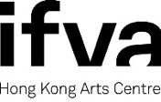

ifva, was founded by the Hong Kong Arts Centre in 1995. Over the years, ifva has established itself as Asia’s pioneering force in short film, animation and media arts, by providing a unique and professional platform for Hong Kong and Asian creative talents to unite, exchange and promote their works.

With the aims to promote short film and media arts and defend independent creative spirit, every year, in addition to the professionally renowned ifva Awards and ifva Festival, ifva also organises a series of extended programmes including the followings: “CINEMA 2.0” media arts exhibition examines different subject matters at the intersection of arts, culture, technology and society; “All About Us” celebrates diversity and the creative voices of young people from the ethnic minority backgrounds; “Jockey Club ifva Everywhere” makes film and media arts accessible to people from all walks of life; and Community and School Tour encourages students to experience and appreciate different media art forms.

Official Website: www.ifva.com | Facebook: ifva | Instagram: @ifva_hk

Hong Kong Arts Centre - Art for Passion, Art for Life, Art for All
Since 1977, the Hong Kong Arts Centre (HKAC) has been a platform for nurturing and supporting artists, and infusing art into everyday life. Its unique arts and educational programmes aim to make the arts accessible for all.

The HKAC believes in the transformational power of art for people from all walks of life. Established for more than four decades, the HKAC endeavours to bring arts to the people of Hong Kong – by presenting programmes for visual arts, performing arts, moving images and media arts, comics and animation. Our other areas also cover arts education, conferences, festivals, public art and community projects. All with the vision and mission of engaging and inspiring creativity in the Hong Kong community.

In 2000, HKAC founded its education arm, Hong Kong Art School (HKAS). The HKAS provides award-bearing programmes to nurture artists and art practitioners, as well as short enrichment courses for the general public.

The HKAC aspires to engage everyone in the community to become an active participant in the arts - as an enthusiast, an artist or a patron.

In 2023, the HKAC will celebrate its 45th anniversary. Let’s continue to embrace ‘Art for Passion, Art for Life, Art for All’, and share the inspiration.

Official website: hkac.org.hk | Facebook: Hong Kong Arts Centre | Instagram: @hongkongartscentre

【Hong Kong Arts Centre】Media Enquiry:
Annie Ho (Marketing and Development Director) | Tel: 2824 5306 / 9481 8706 | Email: aho@hkac.org.hk
Charis Chau (Marketing and Communications Officer) | Tel: 2582 0290 | Email: cchau@hkac.org.hk
Tobe To (Assistant Programme Manager, ifva) | Tel: 2524 5326 | Email: tto@hkac.org.hk

Appendix
"The 27th ifva Festival" Finalist Work and Filmmakers/ Artists' Biography

