"The 27th ifva Festival" Finalist Work and Filmmakers/ Artists' Biography
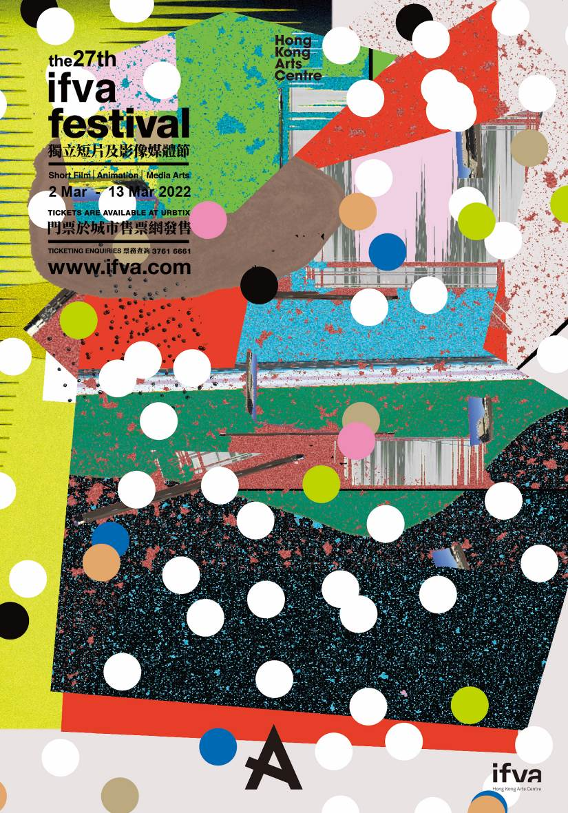
Download key visual and filmstills: http://ftp.hkac.org.hk/MDD/27th_ifva_AwardsResultsAnnouncement
Festival trailer: https://youtu.be/zQSjZ_pMA9M
Awards Category trailer: https://youtu.be/f23ddHm_n1o49m

"The 27th ifva Festival" Finalist Work and Filmmakers/ Artists' Biography
Open Category

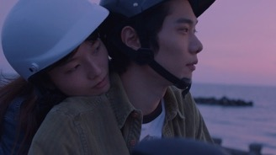 | Plain Sailing  Bai from Hong Kong takes a leisurely trip in Kaohsiung and meets a Japanese young man Hei there. Both are finding refuge in their own little world when the calmness of the water surface is shattered one day. They suddenly realise the world is not as large as they imagine; and their little world is not exactly that little.  Chuk Tsz-yin Chuk graduated from the Faculty of Arts at HKU. In 2020, her work Plain Sailing was selected to be screened at 109th Kaohsiung Shorts. That same year, her feature film project Fly Me to the Moon was chosen to be part of the First Feature Film Initiative in Hong Kong. Her previous work The Dropout Of Her won the Best Cinematography award at the 13th Hong Kong Fresh Wave Film Festival in 2019.
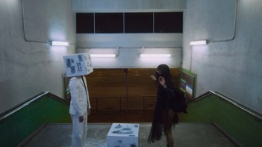 | The Dancing Voice of Youth  A girl with a mysterious background arrives at the city, whose existence gradually becomes as light as the floating air. In the dark night of a chaotic age, must we live like spectres?  Erica Kwok Erica Kwok is an audio-visual creator who is adept at creating combinations and exchanges with various media, and is fond of thinking about and exploring words and images. She has a special affinity for magical and philosophical literary and video works.
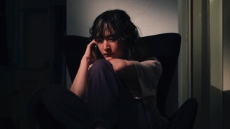 | Moonshine  On one auspicious full moon night, she receives an anonymous call from Taiwan. It pulls her from a quiet mid-autumn night into the sea of memories. A mix of sweat and tears, and a hint of saltiness, what a taste of summer... Miles apart, they gaze at the same moon while yearning for their homeland.  Yeung King-lun Yeung is an audio-visual creator who graduated from the School of Journalism and Communication at the Chinese University of Hong Kong. His main forte is editing and color grading. At the beginning of this year, he directed his first short film, Moonshine, with Hanna Chan as the leading actor.
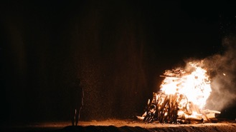 | Fire Room  A time and space that get mixed up,  A brother and a sister,  One who loves starting fire,  Whereas the other loves extinguishing it,  An unusual relationship.  Wong Ka-ki Wong graduated from the London Film School with an MA in filmmaking. Her graduation film, I Draw Inside A Sheep, was selected to be screened at the 2018 Sundance Film Festival in Hong Kong. In the same year, it was included in the 10th Golden Horse Film Academy. Her short film Wild Child won the Fresh Wave Award at the 14th Fresh Wave International Short Film Festival. In 2019, Fire Room was selected to participate in the Film Academy at the 72nd Swiss Locarno Film Festival. Produced by Heyward Mak, the script for the feature film version of Fire Room was chosen to take part in the Berlinale Talents Script Station 2021.
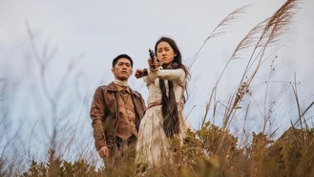 | The Silent Farewell  Matt, a mute bounty hunter, arrives at a jazz bar where he meets the bar owner who not only knows everything about him, but also his arrest warrant with a very high bounty. Matt originally is after his target and his family but fate drags him into the infighting of the corrupted governors. He and the orphan of his target face tedious situations and finally continue their journey in the wild wide west.  Lo Wai-lun Lo Wai-luen, a film director and editor who has participated in ifva Carnival as media artist.
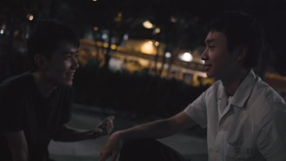 | The Moonlight is Shining Tonight  A lonely teenager hooks up with someone at the hotel, where they soon realise how their minds are both preoccupied during their encounter. Their bodily passion could hardly continue, and they have no other way but to tap into each other’s heart and soul.  Green Mok Green Mok is currently pursuing a Master of Arts degree at the School of Creative Media at CityU. His first film, The Dragon and Phoenix Show, was screened at the Fresh Wave Short Film and Video Festival as well as numerous other film festivals. Recently, he has won the Best Screenplay Award of Microfilm Production Support Scheme (Music) two years in a row for The Drifter and Queens, with the latter being selected by the Hong Kong Independent Film Festival. He is fond of going to the extremes and looks forward to discovering more narrative possibilities.
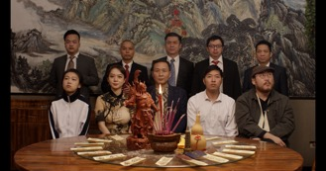 | All the Crows in the World  18-year-old Shengnan is invited by her cousin to a mysterious dinner party full of sleazy middle-aged men. But that man named Jianguo is entirely different.  Tang Yi Tang Yi studied accounting in a Hong Kong university and was signed as a singer and writer with Universal Records. She later graduated from NYU Tisch School of the Arts. She is committed to conveying little-known voices and stories from the perspective of women. Her debut short film Black Goat was eligible for the 2021 Oscar’s Award in the short film category. She was named one of the “25 Screenwriters to Watch in 2020” by Austin Film Festival.
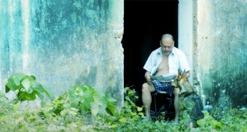 | Cinema Quietude  The film was shot on location in Cheung Chau in autumn 2020, at an actual pre-war historical site of a cinema. A middle-aged man from the urban district mindlessly takes up the role of a guard at this deserted cinema in Cheung Chau. He encounters a series of people and incidents, though he has no choice but to leave when the cinema gets demolished.  Benson Koo Benson Koo is a visual artist and short film director, founder of online video platform "Wave Channel". The director's short film Disappeared won first place at RTHK’s Filming Hong Kong competition as well as best director.
Entrance
12-year-old Anthony is disappointed with his secondary school place allocation. He is then taken by his mother to his first-choice school to ask for a reconsideration, with the hope of getting accepted in this final chance. Anthony does not know how to answer a mathematic question on the entrance exam, leaving it blank. To finish the test, he decides to cross the ethical line with no return.

Matthew Leung Leung is an independent short film director and film workshop instructor. He graduated from the School of Cinematic Arts at the University of Southern California, and has directed short films in Los Angeles and Hong Kong. His previous short film, Entrance, competed at the Los Angeles International Short Film Festival. He has served as a television commercials producer and has worked for various film festivals in Los Angeles.

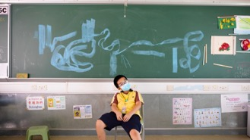 | Almost Summer  Tik, who was born with ADHD, is meticulously cared for by his single mother diagnosed with cancer. This early summer, he finally musters up his courage to step out of the motherly comfort zone and embarks on a journey of growth.  Pang Ka-ho | Lee Ka-yu | Li Tsz-wing | Chan Kit-chiu  Pang works in a media production company and has produced web-based videos. He is currently a third-year bachelor’s degree student at the School of Film and Television at the Hong Kong Academy for Performing Arts.  Lee Ka-yu is a student at the School of Film and Television at the Hong Kong Academy for Performing Arts, majoring in directing and production management. She is the editor on this work.  Li Tsz-wing has participated in various kinds of productions, and mainly works as a producer on the set.  Chan is a student at the School of Film and Television at the Hong Kong Academy for Performing Arts. He is the sound designer on this work.

Youth Category
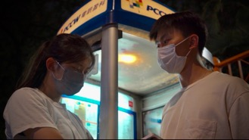 | The Endless Fate  The song “Deeply loving you” makes us realise we are really close, for “You are my hoped-for destiny”. Do we resign ourselves to fate after trying our best, or do we put in an effort despite knowing that we can’t change fate? Ah Keung bumps into his classmate Gil because of a music album. Due to their common interests, they gradually develop feelings for one another. However, with the emigration trend, the two face partings and reunion. What will the future bring for them?  Wong Wai-wa Wong is currently a Form 6 student at Yuen Long Merchants Association Secondary School. She likes to tell stories and record life through the lens.
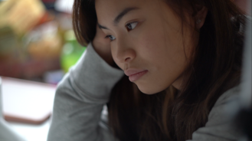 | Dear Pandemic  During the pandemic, it is inevitable that one may encounter various challenges, feeling powerless, losing direction in life and fear for contracting the disease. Yet we must stay positive and optimistic, and strive to overcome difficulties. Everything will become better in the future.  Ruby Yip  I love to create art using different media. I have the courage to innovate and not be restricted by mainstream society. I aspire to become a forensic doctor.
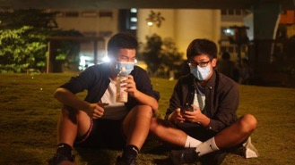 | In Pursuit of Friendship  A story that investigates the pursuit of love and friendship. Charles and Sam find the ambiguous chemistry between them. With the interference of their friend and public pressure, they give up on what they have, and part their ways. Meeting each other again brings back memories just to find out that, regretful as it is, they must let it go.  Sky San 16 years old, passionate about filmmaking and using it to promote ideas. I like all kinds of themes.
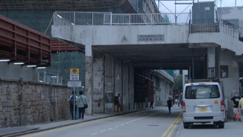 | Goodbye In A Time Of Despair  A friend is about to depart, and they meet each other before farewell. Time has passed and things have changed, they wonder when they will meet again.  Chan Po-yan A friend is about to depart, and they meet each other before farewell. Time has passed and things have changed, they wonder when they will meet again.
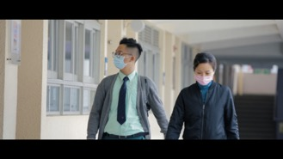 | Hide and Seek  During the pandemic, a school janitor lets a student to enter the campus to take online classes. When the student later disappears, the janitor searches everywhere but he is nowhere to be found. Is the missing boy the student of the school, or is he the custodian’s deceased son that she lost to SARS?  Cheung Tsz-ki | Chan Hei-loi | Wong Tsan-cheuk  Cheung, Chan and Wong are all members of the campus TV station at C.C.C. Fong Yun Wah Secondary School.
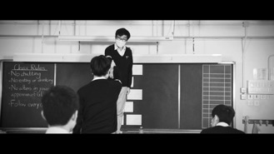 | Disregulation  In front of the empty teacher’s desk, students are monitoring each other, but is the teacher secretly monitoring them also? Could it be their mere imagination? A newcomer joins this panopticon-like classroom and challenges the existing power relations. What changes will he bring about? Does the teacher even exist?  Yuen Wai-ho A person who likes telling stories.
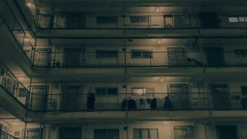 | Nightmare  The main character kills his girlfriend in the heat of the moment because she wants to break up. His guilty conscience causes him to have a nightmare. The ghost in red in the dream hints at his girlfriend’s revenge.  Yip Ching I have loved horror movies since I was a child, and that’s why I made Nightmare. I hopes that I could help inheriting the tradition of Hong Kong local horror cinema.
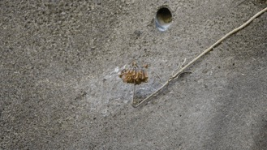 | Brown Flowers, Yellow Leaves  We never ask why things are coloured because we have not experienced the loss of colour perception. The protagonist suffers from colour blindness, and begins to fantasise about the things around them. When existing ideas about the world are shattered, after this confusion comes new awareness about life.  Choy Sin-man Jasmine Choi likes to organize her thoughts through creation. She stumbled into video as a creative medium and likes the possibilities it offers. She loves to sleep and wander the streets, is rarely awake and is never tired of the world.
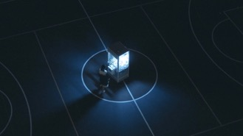 | Relinquished  Relinquishment is like life.  Things we are not satisfied with, things that are damaged,  are often relinquished.  But can we easily relinquish a relationship?  Life is like a drama and vice versa.  Destined to love with regrets.  Handle the world with care, even if they lack a soul within.  Li Hei-lam | Chan Yik-tung  Inmate Li: Human being, music and video producer.  JC: Human being, character unsure, no comment.
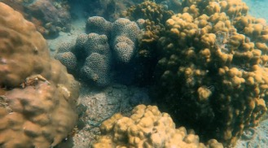 | The Living Sea  We are the only planet with oceans, and they are indispensable for our survival. However, many are unaware of the importance of ocean creatures and ways of protecting them. Young scuba diver Ema Poposka believes if people could see the beauty of the ocean and of the corals, they will change their minds about sea protection. This documentary was made by a student crew aged 12 to 15.  Ema Poposka Ema Poposka is an award-winning young photographer and filmmaker, and is passionate about protecting the ocean and marine life. She also loves surfing, sailing, and scuba diving.
Animation Category
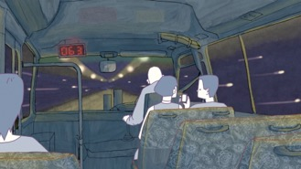 | Once Upon a Time in Tuen Mun  Ten thousand years is such a long period of time that the origins of everything are lost, and then reappear in the form of a fable. A young man dreams about the world of ten thousand years later and writes it down as a story. This is his dream, and his creation. The characters he writes about echo his own life so much that one can no longer differentiate the writer and the metaphor.  Tang Kan-kei Tang was born in Tuen Mun, Hong Kong and is studying animation at the Taipei National University of the Arts.
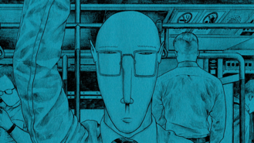 | Nyala  Nyala, a kind of antelope that lives in South Africa, enters the world of humans one day and soon becomes accustomed to urban life. Later, when the nyala returns to his birthplace, he plans to tell the other nyalas not to become humans, but is shocked to discover that he has lost the ability to communicate with them.  melancholy Melancholy is a Hong Kong visual artist. His artistic style uses dense lines that turn weird emotions into unique elements, portraying the deep feelings in the hearts of vulnerable people.
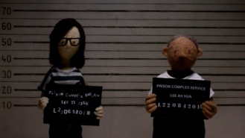 | The Visit  Month after month, Ting makes a trip to visit Father in prison. Forced to carry the emotional burden as a child of an incarcerated parent and a victim of circumstances, she is offered an opportunity to connect with Father through a glass panel in a windowless cell. But even in these tiring conditions, Ting is determined to not let anything separate their kinship.  Morrie Tan Director Morrie Tan is passionate about producing stories that are genuine, often drawing inspiration from her own experiences. The Visit is her directorial debut; a story close to her heart.
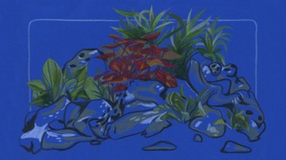 | Butterfly Jam  A young woman describes her father and his relationship to his many pets that he never managed to take care of. The animals consistently die one after the other in a context of a family being torn apart.  Huang Shih-yen Shih-yen Huang was born in 1987 in Taiwan. She lives and works in France. With more than ten years of experience and research in Art Video and in oil painting, she focuses on the marks of memory in objects and space through drawing and animation.
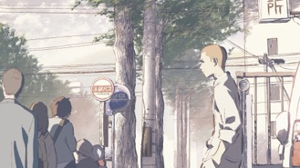 | Takano Intersection  In a certain city, for just a moment in time, the lives of three strangers intersect.  Mizuki Ito Mizuki Ito is a 2D animator and director based in Kyoto, Japan. Mizuki studied digital animation independently while attending a design school. After graduating, he continued to work intermittently as an animator, but also began producing his own works independently, aiming for a more personal expression not limited to entertainment.
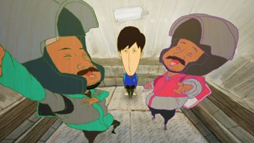 | Love Delivery  Ah Chung’s job involves driving a small scooter every day to deliver food. On one of his deliveries, he meets a female customer, Ching, who rekindles his motivation for work.  Law Ho-wan | Lee Wing-lam  Law graduated from the Department of Animation, Hong Kong Metropolitan University. He is enthusiastic about artistic graphic design and animation production.  Lee graduated from the Department of Animation, Hong Kong Metropolitan University, and is now working in games animation design
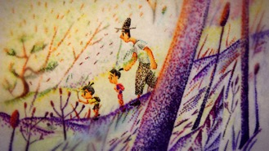 | A Bite of Bone  A little girl reflects on her last summer with her father at his funeral.  Honami Yano Honami Yano was born in a small island in Japan, and received the master’s degree at the Tokyo University of the Arts, Graduate School of Film and New Media.
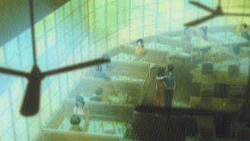 | Depths of Night  It is inevitable that we lose a certain part of ourselves while growing up. We all look for the things we have lost and hope to be accepted. However, after our souls are crushed countless times, can we still expect other possibilities? Only if we survive, the dark night will soon pass.  Step Cheung  Cheung’s works are filled with creative and fantasy elements. She likes to explore the relationship between people and to create art with different media. Her works include animation, advertising, graphic design, film, and stage production.
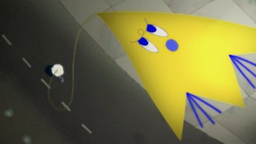 | Moon Monsoon  If I lose you now, how would I live my life?  Just come to me. Let us start a brand-new life.  Lin Shu-tzu | Chen Liang-jie  Chen is an active creative artist who likes to experiment and shoot stop motion animation while believing in accumulating experience with time.  Lin graduated from the Department of Animation at the Taipei National University of the Arts and now lives in the Xindian district in Taipei. He likes observing passengers and has recently become fond of canned eight-treasure porridge.
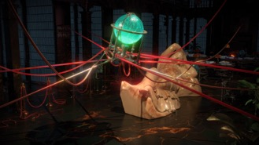 | A Comprehensive Theory  In many languages, the word “clue” carries a reference to the image of threads or ropes. The library, as a symbol of order, contains the collection and organisation of human knowledge. Knots and networks have different pairs of contrasting associations, such as connection and restriction, life-saving tools and deadly weapons, and chaos and order. The combination and tension of books, globes, ropes, knots, chains, and the statue of Sleeping Ariadne are metaphors of people finding their way through the network of information.  Rui Hu Rui Hu (born in 1990) is an artist working with moving images, installation, and video game technology to explore the issues of time and temporality from a multitude of perspectives.

Media Art Category
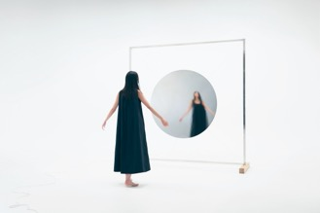 | Ether - liquid mirror -  The circular mirror that vibrates at very high speed is a speaker. It senses the viewer’s heartbeat and synchronises with it to suggest a transformation in self-awareness. The circular shape is influenced by Shintoism, which is unique to Japan. It asks us to question our sense of values in life.  Kaito Sakuma Born in Japan in 1992, he grew up with his Brazilian mother and Japanese father. Majored in Cognitive Science at university. He won the Newcomer's Award at the Japan Media Arts Festival in 2021. He has created various acoustic sculptures based on the theme of materialising sound.
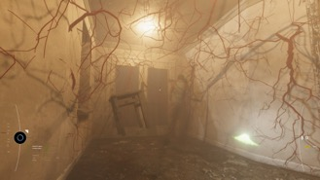 | Forgetter  Forgetter is an exploration video game in which the art collection from dslcollection seeps into the narrative. Set in the near future, players take up a job at a technology company as cleaners of dead artists’ brains, identifying and removing traumatic memory blocks in their minds, in order to recycle their brains for newborns. Many memory blocks are constituted by Chinese contemporary artworks.  Yang Jing | Kwan Tsz-wai Alan  Yang Jing is a game producer, curator, writer and researcher. Her work centres around the intersection between gaming and art, as well as games and human relationships.  Alan Kwan is an artist, game designer, and technologist. He is primarily interested in using videogame and virtual reality technologies to build worlds, stories, and immersive experiences that are outside of the traditional gaming paradigm.
“I am like sea waves, going up and down.”
My work is about the time that I missed. I tried to recreate the sea of my grandpa and I based on memories and imagination, and a pier that we had never been to together. The audience can look at the sea, listen to the waves, and listen to me humming an old Minnamese song – Sea Waves – that my grandpa would have understood.

Tse Chun-sing Tse Chun Sing’s art explores the possibilities in the often unnoticed daily objects or events, and presents the intriguing relationships through installations. With a passion for sounds, he explores various sounds and presents his imaginations and discoveries in his artworks. He obtained a master’s degree from The Academy of Visual Arts, Hong Kong Baptist University in 2021. His solo exhibition “Out of Focus” was held at PMQ in 2020.

(in)visible
Like a game of interpreting the messages of this world, (in)visible delves into the nano-scaled field, surpassing the limits within the human conceptions of time and space with the advancement of technological measurements. Through the lens of technology, we can reconsider the future possibilities of the living landscapes for human civilisations.

Hsu Hsun-hsiang | Huang Yin-hao
NANONANO, founded in 2019. NANONANO is an art group founded by artist Hsun-Hsiang Hsu and materials engineer Yin-Hao Huang, focusing on the environmental future phenomenon and using the top industrial technology to create the possible living future landscape.

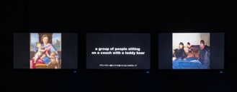 | Lesson  The left monitor shows a famous painting; the middle monitor shows a description of that painting generated by an image description generator; and the right monitor shows an image from text-to-image generator based on the aforementioned description. Lesson presents a series of AI-interpreted processes, questioning subjectivity and contingency of artwork interpretation and the act of creation from a machine’s perspective.  Tomoya Ishibashi | Kento Niikura  Tomoya Ishibashi: Graduated with an MS in Biology from Waseda University.  Kento Niikura: Graduated with an MS in Mathematics from Tokyo Institute of Technology.
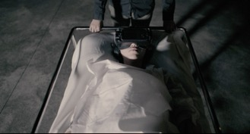 | N1801  The work is composed of a VR device with no vision function, and an interactive theatre. It is intended to explore Bardo and VR media, history and body perceptions. Viewers need to “shut eyes” and recreate the internal vision through abstract dynamic light stimulation and spatial audio. Through the movement of the body, each experiencer will embark on a personal path in the state of Bardo.  Ning Sen Ning Sen focuses on themes of memories, taboo, life and death. Its productions encompass different media, including VR, experimental film, sensory art, interactive virtual theatre, participatory art, photography, video installation and set design.
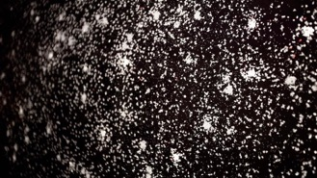 | Petri.Vista  Inspired by infection simulation during the pandemic, Petri.Vista is a complex system which simulates human phenomenon with autonomous agents. Those digital creatures are triggered by different events and memories, and then interact with others, resulting in an aerial view of cityscape inside a digital petri dish. The agents begin with one single dot and grow into shapes depending on their DNA, and will explore and learn.  Chan Long-fung Lazarus Lazarus Chan is a new media artist who explores human experience including life & death, consciousness and time.
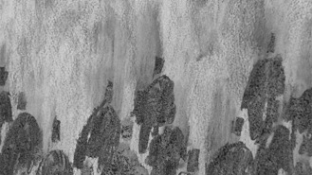 | The Cave with a Wheeze  In a stop-motion animation on a 2 x 3 m² wall, Lau drew one after another carbon-black being with charcoal, walking from edge to centre. Depicted, documented and erased – Lau repeated with each being until the wall was filled in black. She then wiped the charcoal with hands to revert the wall to white. The clock reflects the time in reality, in parallel to the condensed time in the animation.  Lau Ching-wa Born in the City of Hong Kong in 1991, Lau Ching-Wa Jess gained her BA (Honours) in Creative Media at the City University of Hong Kong in 2014. Jess is the selected artist of Tai Kwun Contemporary Artists' Studio Residency 2020. She is a member of the Floating Projects Collective, an experimental artist-run space in Hong Kong.
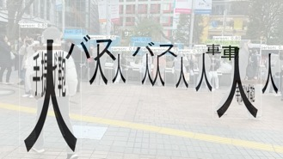 | Translated Landscape  Through object detection technology used in, for example, autonomous driving, the streets of Tokyo were converted into a landscape of letters. The names of the identified objects were converted into Japanese characters with kanji as the focus. The size of the characters reflects that of the detected object.  Tomoya Ishibashi | Kento Niikura  Tomoya Ishibashi: Graduated with an MS in Biology from Waseda University.  Kento Niikura: Graduated with an MS in Mathematics from Tokyo Institute of Technology.
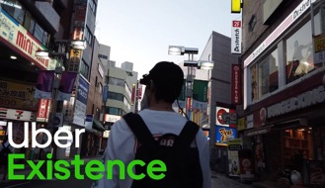 | Uber Existence  Uber Existence is an “existence agency” that provides service of “being there”. When users go to the official website, they see people lined up as products. Then, a user can choose an “actor” to represent him/her, according to where to go and what kind of body to have. The user can then connect with the “actor” through the app and actually “be” there. The catchphrase is: “Let's go outside while staying home.”  Hanagata Shin Born in 1995 in Tokyo, Japan. Graduated from the Faculty of Environment and Information Studies at Keio University, and enrolled in the master’s course in Information Design at Tama Art University. In this technologically accelerated capitalist society, he creates situations that drift across the wavering boundaries between self and other, human and non-human, and practices them with his own body.

Asian New Force Category
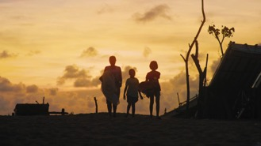 | The Secret of My Birth  Living a tropical, coastal town of Southern China, an 11- year-old girl hides her secret deep in her heart. With the introduction of the two-child policy, only child Lily learns on her birthday that her parents are expecting a second baby without telling her. Moreover, the baby is believed to be a boy. A “vicious” idea makes its way into Lily’s mind, and she starts carrying out her “brother-cide” plan.  Li Jing Li Jing was born in 1993 in Beihai, Guangxi. She graduated from Huazhong University of Science and Technology with a bachelor’s degree in Journalism and obtained a postgraduate degree in film from the Communication University of China.
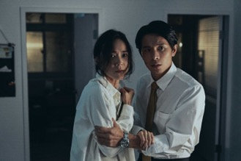 | Asphyxia  A burglary makes a woman ask for help from her estranged husband, and he accidentally kills the thief. Overnight, the husband is viewed as a hero by public opinion, but he may also be responsible for his involuntary manslaughter. As to the woman, whether her husband’s motivation is to protect or to kill leads her to reconsider their future from their past.  Chuang Shiang-an Born in 1987 and graduated from Department of Filmmaking for directing of Taipei National University of the Arts. His works are characterised by fantasy genres and contemporary issues. The director’s recent works include TV series Detention, and he is now preparing for the feature film Mama Pingpong Social Club.
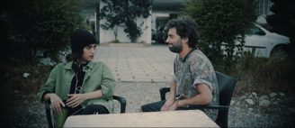 | Hawaii  Tell me you didn’t do what you shouldn’t have done, I’ll forget everything I saw.  Morteza Fereydouni Morteza Fereydouni is a graduate of architecture from Shiraz University, but since his adolescence, he has been pursuing cinema seriously alongside architecture. Before making Hawaii, he was involved in several short film projects as a writer and director consultant.
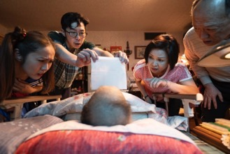 | Can You Hear Me?  Jhong wakes up and finds himself dead. He watches his family dealing with his death while they speak their thoughts over breakfast. Although his wife couldn’t hear what he has to say, she comprehends what’s on his mind.  Li Nien-hsiu Li has been involved in editing for numerous feature films and documentaries and was nominated for Best Editor at the 47th Golden Horse Awards for Hip-Hop Storm in 2010. Her directorial work Hebei Taipei won Best Documentary at Taipei Film Festival in 2015 and was nominated in the International Competition Section at YIDFF.
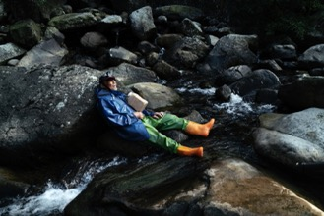 | FULL CIRCLE  In an ordinary morning after elver fishing all night, an old fisherman finds himself left alone in this desolate world. He wanders around in search of the spiritual trace of his deceased wife, seeking a way out in the endless cycle of nature and human world.  Chuang Yung-hsiang Born in Taiwan in 1987, Chuang Yung-Hsiang is a filmmaker based in Taipei. His work often sets eye on the minority, and at the same time keeps exploring the boundary of narration.
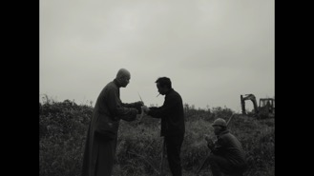 | SARIRA  A monk can’t find respite after a toothache leaves him unable to chant the sutras and he can’t escape the sounds of nearby construction. A bad tooth, an ancient Buddha, a temple, and a silent monk. When faith is against modern society, the monk starts his survey of this world.  Li Mingyang Li is a young director born after 1995 in the city of Chongqing. His short film works include Brown Night and Sarira, with the latter having won Special Mention at the 26th Busan International Film Festival Asian Short Film Award and shortlisted by more than 30 well-known festivals at home and abroad, including Clermont-Ferrand, ifva and Pingyao Film Festival.
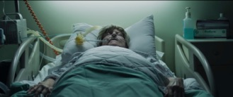 | The Exchange  A troubled young man and his conformist older brother need to put their differences aside to participate in the last goodbye to their dying grandmother.  Nimrod Raif 31-year-old director and screenwriter from Israel. Born and raised in Jerusalem, now based in Tel-Aviv. The Steve Tisch School of Film and Television | Tel Aviv University – BFA.
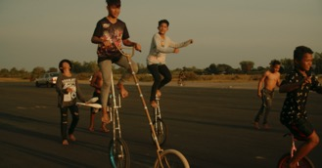 | A Little Circus  In the town of Battambang, birthplace of a Cambodian circus, bombastic virus and news bedevil an innocent young circus boy, Theara. His best friends unite and play a circus for him.  Yoshiro Osaka Originally from Hokkaido, Japan. A filmmaker. Before moving to the US. When he was 18, he grew up in a hometown that is rich in nature. He studied filmmaking at the City University of New York in Brooklyn, earning his bachelor's degree. After returning to Japan, he has been working on films, documentaries, and commercials based in Tokyo and Hokkaido. In recent years, he has been actively involved in projects in Asia.
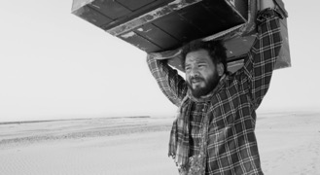 | PATH  When the pandemic hit us, we were soon to know about the phrase “embracing the new normal”. There is nothing normal about the loss of livelihood. While the privileged embraced a new world, those who were worst affected, fall through the gaps. Path is a personal story of a lone journey a man takes as India readies himself for the onslaught of the virus.  Pradip Kurbah Pradip Kurbah is a self-taught filmmaker and writer. He has won the National Film Award in 2014, 2016, and 2019. He wants to showcase the talent in northeast India. PATH is his first short film.
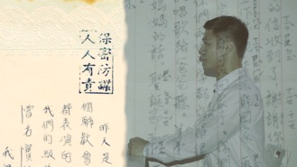 | K's Room — the Creation and Destruction of the World  K’s Room is a mental space that serves as a metaphor of the complex relationship between men, boundaries, and the homeland during martial law. All the lines in the film are quotes from the "New English Grammar”, one of Taiwan's most popular English grammar books, to reconstruct the mental status of its author, Mr. K, during his incarceration.  Hung Wei-lin Hung's works use images to portray hidden histories, and she has participated in several creation projects concerning the historical memories of Taiwan's White Terror period.

