Dear Editors,
Appendix Download: http://ftp.hkac.org.hk/MDD/27th_ifva_Award_Results/Appendix/

Hong Kong Arts Centre
The 27th ifva Award Ceremony
Announcement of Award Results &
The Collaboration with Meta on New VR Award

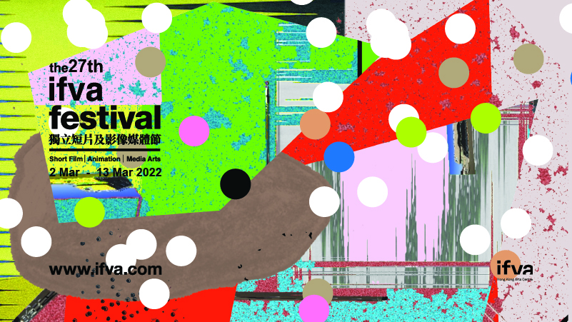

Organised by Hong Kong Arts Centre, the 27th ifva Award Ceremony was held on 12 March 7pm online with the announcement of award results. Due to the pandemic, the screenings and exhibition of finalist works were unable to take place, jury meetings were held and a total of 18 awards were handed out to five categories of short films, animation and media art finalists.
Archive link: www.ifva.com/live

Shortlists works recorded the era with moving images and creative works. A total of over 800 works of short film, animation and media art from over 40 Asian countries and areas had been received. Jury meetings were held online and after rounds of discussions, the 27th ifva results were finalised. Gold Awards for all five categories are as follows, please refer to Appendix for the full list of ifva Award results: http://ftp.hkac.org.hk/MDD/27th_ifva_Award_Results/Appendix/

Open Category – Moonshine (Yeung King-lun) & Plain Sailing (Chuk Tsz-yin)
The Open Category finalist works not only depicts the struggle of staying alive but also the departure and reunion in the time of pandemic and diaspora. After an enthusiastic debate among jury members, two works were selected to share the Gold Award: Yeung King-lun’s Moonshine and Chuk Tsz-yin’s Plain Sailing. The last time two works were awarded Gold Award had to date back to the 17th ifva 10 years ago. Moonshine is a tale of missing the other side of the world under the same moonlight. Juror Felix Tsang, Sales & Acquisitions Manager of Golden Scene, praises the moving acting of Hanna Chan as the only actor on screen, and “the nuanced script conveyed a rich backstory to the characters’ emotions and intentions.” Plain Sailing is a rendezvous of a Hong Kong girl and a Japanese boy in Kaohsiung. Juror Louisa So, renowned actress, thinks “The film is very complete, it is a fairly high-quality work. The script and the actors are very good. The main character is also the writer and director, which I admire a lot. The film reflects the contemporary period and conveys the thoughts and feelings of today's young people. Although it is a short film, it instantly made me understand the experiences and moods of the characters without a lot of dialogue.”

Youth Category – Disregulation (Yuen Wai-ho)
The Gold Award goes to Yuen Wai-ho’s Disregulation. While students are monitoring each other in front of the empty teacher’s desk, a newcomer joins to challenge the existing power relations. Juror Yoyo Sham, Hong Kong singer-songwriter, praises the work is like “the high school version of an episode of Black Mirror. The singing in the first scene and the acting is excellent. The use of B&W images do not seem pretentious, they actually elevates the quality of the film. I admire his courage of making a film with such tone and style.”

Animation Category – A Bite of Bone (Honami Yano, Japan)
The Gold Award goes to A Bite of Bone by Japanese animator Honami Yano. The work is about a little girl reflects on her last summer with her father at his funeral. Juror KongKee, animation director and comic artist, praises the work has taken the perspective of an innocent child, and “the pointillistic technique and flowing shots work seamlessly together and takes full advantage of the appeal of animation to create an ethereal and graceful world filled with sorrow and warmth.”

Media Art Category – The Cave with a Wheeze (Lau Ching-wa, Hong Kong)
The Gold Award winning work, Hong Kong artist Lau Ching-wa’s The Cave with a Wheeze, applies themes such as narrative fragments, body memory and focuses on iterative manual processes and the aggregation of time. Juror GayBird, local composer and media artist, finds the work “is highly impressive with a simple subject matter. I’m in particular fond of the clock installation within the video, it is a powerful choice to put the creator’s timeline and hard work on display.”

Asian New Force Category – Hawaii (Morteza Fereydouni, Iran)
The Gold Award goes to Iranian director Morteza Fereydouni’s Hawaii. In one shot the work depicts the human struggles in a patriarchic society. Juror Hsiao Ya-chuan, Taiwan director thinks the director “ ‘what is the reality in everyday life?’ and ‘is the life I am experiencing the reality?’. The director handled such matters with brilliant mis-en-scene. This makes me have the feeling that he has constructed an objective reality through the many subjective POVs.”

Winners of this year’s ifva are supported by a lot of parties with sponsorship in terms of cash prizes, trophies and solo exhibition, sponsored by Pure Art Foundation and Goethe-Institut Hong Kong.

Stay tuned for the calling of entry of 28th ifva that will start in mid-July 2022.

Metaverse is the talk of the town, where the bonding between art and technology has also been strengthened as never before. ifva and Meta (formerly known as Facebook) will join hands to collaborate on a series of Metaverse and Virtual Reality (VR) initiatives. Supported by Meta, ifva will for the first time setting a new special award in the 28th ifva Awards. The competition will open for submission from Hong Kong and Asia regions, and the winner will receive a bunch of attractive rewards including cash prize, VR device and Metaverse experiential trip. Stay tuned for more details to be announced in mid-July!

In addition to this new prize in the 28th ifva Awards, Meta will support the showcase of a VR project Chroma 11. In 2021, ifva collaborated with Hong Kong director and ifva alumni Tsang Tsui-shan on VR project Chroma 11, as an extension of her ifva Open Category Silver Award winning piece Ward 11. The work documents the heart-rending last days of dance artist Khek Ah Hock spent with his partner Wong Thien Pau, also a dance artist. Chroma 11 is the first work from Hong Kong selected as one of the international projects for the Biennale College Cinema – Virtual Reality under Venice Film Festival. Through clips od rearranged memories and volumetric video captured by DepthKit, the creative team strives to reconstruct a reunion of the parted souls in the form of a duo dance after life. The VR hardware devices and technical support will be provided by Meta at the VR installation of Chroma 11 which will be held in September 2022.

Website: www.ifva.com
Facebook: www.facebook.com/ifvaSince1995
Instagram: www.instagram.com/ifva_hk
YouTube: https://www.youtube.com/user/ifvaSince1995
Email: ifva@hkac.org.hk
Phone: 2824 5329

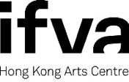

ifva, was founded by the Hong Kong Arts Centre in 1995. Over the years, ifva has established itself as Asia’s pioneering force in short film, animation and media arts, by providing a unique and professional platform for Hong Kong and Asian creative talents to unite, exchange and promote their works.

With the aims to promote short film and media arts and defend independent creative spirit, every year, in addition to the professionally renowned ifva Awards and ifva Festival, ifva also organises a series of extended programmes including the followings: “CINEMA 2.0” media arts exhibition examines different subject matters at the intersection of arts, culture, technology and society; “All About Us” celebrates diversity and the creative voices of young people from the ethnic minority backgrounds; “Jockey Club ifva Everywhere” makes film and media arts accessible to people from all walks of life; and Community and School Tour encourages students to experience and appreciate different media art forms.

Website: www.ifva.com | Facebook: ifva | Instagram: @ifva_hk

Hong Kong Arts Centre - Art for Passion, Art for Life, Art for All
Since 1977, the Hong Kong Arts Centre (HKAC) has been a platform for nurturing and supporting artists, and infusing art into everyday life. Its unique arts and educational programmes aim to make the arts accessible for all.

The HKAC believes in the transformational power of art for people from all walks of life. Established for more than four decades, the HKAC endeavours to bring arts to the people of Hong Kong – by presenting programmes for visual arts, performing arts, moving images and media arts, comics and animation. Our other areas also cover arts education, conferences, festivals, public art and community projects. All with the vision and mission of engaging and inspiring creativity in the Hong Kong community.

In 2000, HKAC founded its education arm, Hong Kong Art School (HKAS). The HKAS provides award-bearing programmes to nurture artists and art practitioners, as well as short enrichment courses for the general public.

The HKAC aspires to engage everyone in the community to become an active participant in the arts - as an enthusiast, an artist or a patron.

In 2023, the HKAC will celebrate its 45th anniversary. Let’s continue to embrace ‘Art for Passion, Art for Life, Art for All’, and share the inspiration.

Official website: hkac.org.hk | Facebook: Hong Kong Arts Centre | Instagram: @hongkongartscentre

【Hong Kong Arts Centre】Media Enquiry:
Annie Ho (Marketing and Development Director) | Tel: 2824 5306 / 9481 8706 | Email: aho@hkac.org.hk
Charis Chau (Marketing and Communications Officer) | Tel: 2582 0290 | Email: cchau@hkac.org.hk
Tobe To (Assistant Programme Manager, ifva) | Tel: 2524 5326 | Email: tto@hkac.org.hk

