【Hong Kong Arts Centre】
Cultural Masseur Festival 2022
Programme Announcement (Apr - June 2022) | Tickets Now on Sale
Cross-disciplinary Artful Experiences that Respond to Our Time

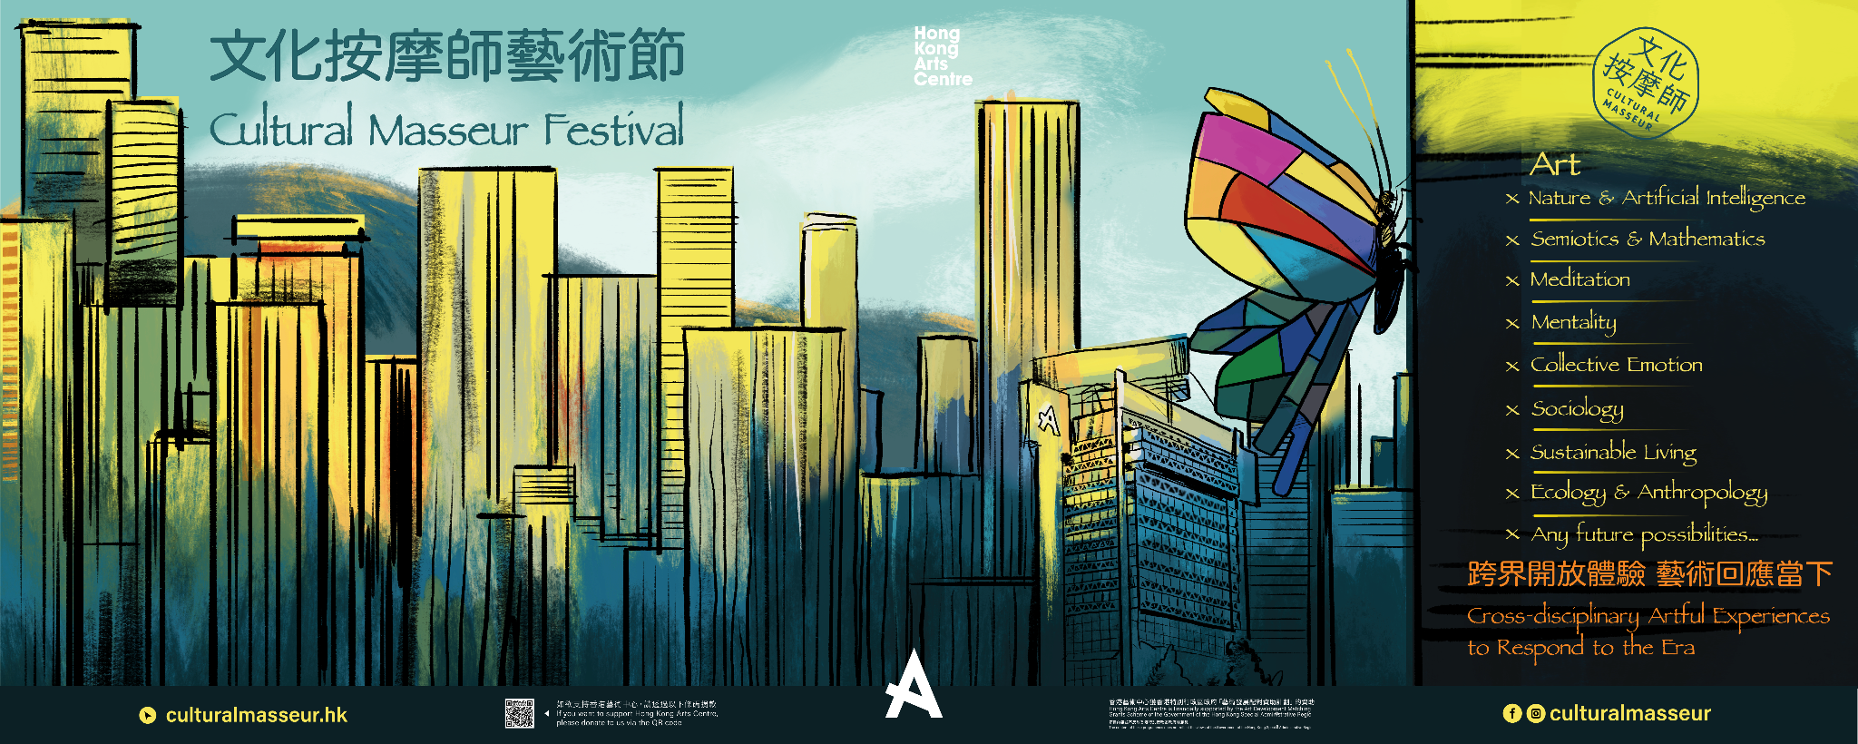
Organised by the Hong Kong Arts Centre, Cultural Masseur Festival 2022 will kick start in May with a freshly announced programme line-up. Cultural Masseur has transformed from the Talking Heads experiential showcase and artist presentation series, the Self Institute, where artistic initiatives are fulfilled, to give birth to Cultural Masseur Festival 2022. The Festival gathers local and overseas artists to collaborate with professionals from different disciplines to produce a series of cross-disciplinary arts programmes.

The concept and illustration for the Festival was created by Adolfo Arranz, with butterflies flying and stopping by different corners of the city. The forms and subject matters of art are infinite and this series of cross-disciplinary programmes will further demonstrate their possibilities, just as in the worst of times, creativity remains vibrant like such butterflies that fly high in the city.

The Festival kicks off with two Self Institute Seed Funding projects, which includes: “Art X Sustainable Living – Our Paths Cross Again”, initiated by Ng Yuen Mei, plant lover and former Food Experimenter in School of Everyday Life, which will guide people to find their own way to get immersed in nature through ikebana practice, exploration and observation of nature; independent researcher, writer and illustrator Teresa Chan’s project “Art X Ecology & Anthropology – When Trees Cry in the City” will take place in Wan Chai for its rich heritage, where the meaning of the existence of the street trees will be celebrated and explored from a new artistic perspective. Both projects will feature a series of community art tours and practices (please refer to Appendix 1 for details).

Prepare for even more exciting programmes in the second half of 2022. There will be multiple experimental artful experiences, participatory theatre works and exhibitions, which showcased the collaboration of art with nature and Artificial Intelligence, semiotics and mathematics, sociology and collective emotion, where boundaries of disciplines will further be expanded.

Cultural Masseur Talking Heads Podcast Series has launched on Spotify in mid April and will be updating on a bi-weekly basis. The first 7 episodes are themed around “Corporeality vs Virtuality”, and the first episode features Yeung Chun-yin (Uncle Salt) from Corrupt the Youth to analyse the metaverse with a philosophical POV. Guests from different fields will be joining the cast to further deconstruct the metaverse.

《Cultural Masseur Festival 2022》Programme and Event Details：
Website：www.culturalmasseur.hk
Facebook：https://www.facebook.com/culturalmasseur/
Intagram：https://www.instagram.com/culturalmasseur/
Ticketing ：https://www.popticket.hk/cultural-masseur-fes
About Cultural Masseur
“Cultural Masseur” connects the dots in the cultural scene, helping to uncover the beauty in our daily lives, as well as responding to daily lives with arts. The project, targeted at young people, adults, and early retirees, brings arts into life through an array of carefully curated programmes: guided tours, talks, workshops, internship and apprenticeship, as well as the process of art-making. These programmes may enlighten the participants to see the world in an artful way, and they will in turn enlighten others as an active audience through sharing of what they know about the arts, and ultimately becoming “cultural masseurs” themselves. Only through connecting arts and everyday living can arts thrive in a city and culture be passed on.
About Hong Kong Arts Centre (HKAC)
Hong Kong Arts Centre - Art for Passion, Art for Life, Art for All

Since 1977, the Hong Kong Arts Centre (HKAC) has been a platform for nurturing and supporting artists, and infusing art into everyday life. Its unique arts and educational programmes aim to make the arts accessible for all. The HKAC believes in the transformational power of art for people from all walks of life. Established for more than four decades, the HKAC endeavours to bring arts to the people of Hong Kong – by presenting programmes for visual arts, performing arts, moving images and media arts, comics and animation. Our other areas also cover arts education, conferences, festivals, public art and community projects. All with the vision and mission of engaging and inspiring creativity in the Hong Kong community.

In 2000, HKAC founded its education arm, Hong Kong Art School (HKAS). The HKAS provides award-bearing programmes to nurture artists and art practitioners, as well as short enrichment courses for the general public. The HKAC aspires to engage everyone in the community to become an active participant in the arts - as an enthusiast, an artist or a patron.

In 2023, the HKAC will celebrate its 45th anniversary. Let’s continue to embrace ‘Art for Passion, Art for Life, Art for All’, and share the inspiration.

Media enquiries： | Hong Kong Arts Centre
 | Annie Ho  Marketing and Communications Director  Tel: 2824 5306 / 9481 8706  E-mail：aho@hkac.org.hk | Christy Ho  Manager (Audience Development)  Tel: 2582 0211  E-mail: cho@hkac.org.hk | Amber Lau  Program Assistant  Tel: 54062576  E-mail: amberlau@hkac.org.hk

