Appendix 1 Cultural Masseur Festival 2022 Event Details (Apr-Jun 2022)

Art X Sustainable Living 《Our Paths Cross Again》Ng Yuen Mei
Event period: 1 May to 19 June 2022

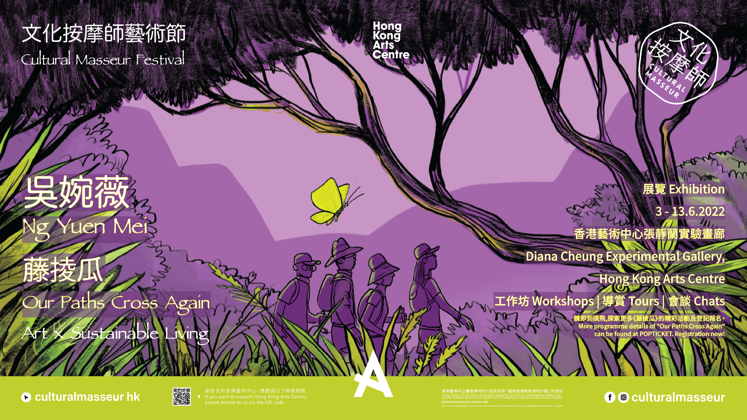

As one of the Self Institute Seed Projects, “Our Paths Cross Again”, through ikebana practice, exploration and observation of nature, develops ways of finding beauty and meaning in the way of symbiosis with others and the surrounding environment, from flowers to seeds and crops. People will be able to find their own way to get immersed in nature and become a part of it.

By presenting the thinking methods of Permaculture with its three ethics — Care to People, Care to Earth and Fair Share, this project enables participants to gain a deeper experience and understanding of how we, humans, plants and other well being in nature are interrelated and connected.

In the programme, we practise to cooperate with other beings and plants, make collaborative crafts and works as a way to grow the sensational connections with nature and the human community. Participants will experience “making things” with natural materials and our senses. We learn the logic of nature in the process of making and reconnecting, there are compassion and mindfulness flows. You may have an alternate way of seeing your place in the world and make it a happier and kinder one, make change the world from the inside out, cultivate the self and nature then lead our community and world better.

《Our Paths Cross Again》Event Listing

- Come Around - Habitats in Cities（ 3 sessions ）

The event trains participants’ sense of nature in the city. By searching for a habitat in the city to write up your observation note on finding the connection among people and community and nature, and be aware of the fact that we live in the cycle of nature and to see the plants and animals around us.

In three different “come around” sessions around the city, participants take a closer look at the living habitat of the living creatures in our urban life. The observation deepens throughout the three sessions.

Session | Date | Time | Venue | Fee
I. | May 1 (Sun) | 14:00 - 17:00 | Tuen Mun/Wan Chai | HKD$100
II. | May 8 (Sun)
III. | May 22 (Sun)

2.1 Learn from Nature (I) - Bamboo Craft Experience

Bamboo is a common plant that used to be made into different daily appliances and utensils, but such handcraft is rarer to be seen. The workshop will introduce the characteristics and potentials of bamboo. Participants will make their own flower vase by learning the skills of bamboo knitting, and the proper ways of taking care of bamboo appliances.

Session | Date | Time | Venue | Fee
I. | May 7 (Sat) | 14:30 - 17:30 | Eric HoTung Studio, Hong Kong Arts Centre | HKD$290

2.2 Learn from Nature (II) - Nature Instrument Workshop

Join us for a sound experiment through touching and listening to nature! The instructor will introduce a series of musical instruments made of natural materials, explain the mechanism of producing sounds and teach participants to make their own musical instrument.

The finished products from the workshops will be exhibited in the exhibition space to collaborate with the traces of other activities in the programme.

Session | Date | Time | Venue | Fee
I. | May 15 (Sun) | 14:30 - 17:30 | Eric HoTung Studio, Hong Kong Arts Centre | HKD$290

3. Be More Tree

“Trees, record life with their annual rings, and reach out to the world with their branches.”

If trees could talk, they would have a lot to say. They come in all shapes and sizes, fascinating us for millennia - there is a lot we can learn from their wise ways. Trees do not “think” or “feel” like us humans, yet they are wise and silent.

Let’s take a walk at the park near Hong Kong Art Centre - to embrace trees and be embraced by the wisdom of trees.

Session | Date | Time | Venue | Fee
1 | June 3 (Fri) | 15:00 - 17:00 | Wan Chai | HKD$50

4. Through the Grapevine（ 11 days ）

A space can be seen as an intersection of traces between humans and plants in the tours and workshops. As a meeting place, the space tries to show the traces of vines between people and plants.

Through ikebana practice, exploration and observation of nature, we develop ways of finding beauty and meaning in the way of symbiosis with others and the surrounding environment, from flowers to seeds and crops. Thus we will be aware of the past, present and future among people, among people and plants, to lead people to be able to see and become a ‘being’ in nature, to initiate visitors to find their own way to get immersed in nature.

Days | Date | Time | Venue | Fee
11 | June 3 to 13 | 10:00 - 18:00 | Diana Cheung Experimental Gallery, Hong Kong Arts Centre | Free

5. Share Fair（ 11 days ）

The Fair Share' principle is about sharing knowledge and experience as well as surplus harvest. Appreciate what has been shared, share what you wish to grow. Collect your seed when preparing your meal, come and share in this fair.

Days | Date | Time | Venue | Fee
11 | June 3 to 13 | 10:00 - 18:00 | Diana Cheung Experimental Gallery, Hong Kong Arts Centre | Free

6. Go Away in Greens
A tour to go away - To seek for the common denominator between nature and ourselves, learn
to flow with nature, thus to rediscover the cycle between plants and us. Access to the countryside, observe and connect whatever we could find in nature in different ways.

Ride on a boat and head to Lai Chi Wo on a weekend. With farmers as tour guides, participants will observe and get immersed in nature, and bring their experience back to town.

Session | Date | Time | Venue | Fee
1 | June 19 (Sat) | 9:00 - 17:00 | Lai Chi Wo | HKD$230

Art X Ecology & Anthropology 《When Trees Cry in the City》Teresa Chan
Event period：7 May to 29 May 2022

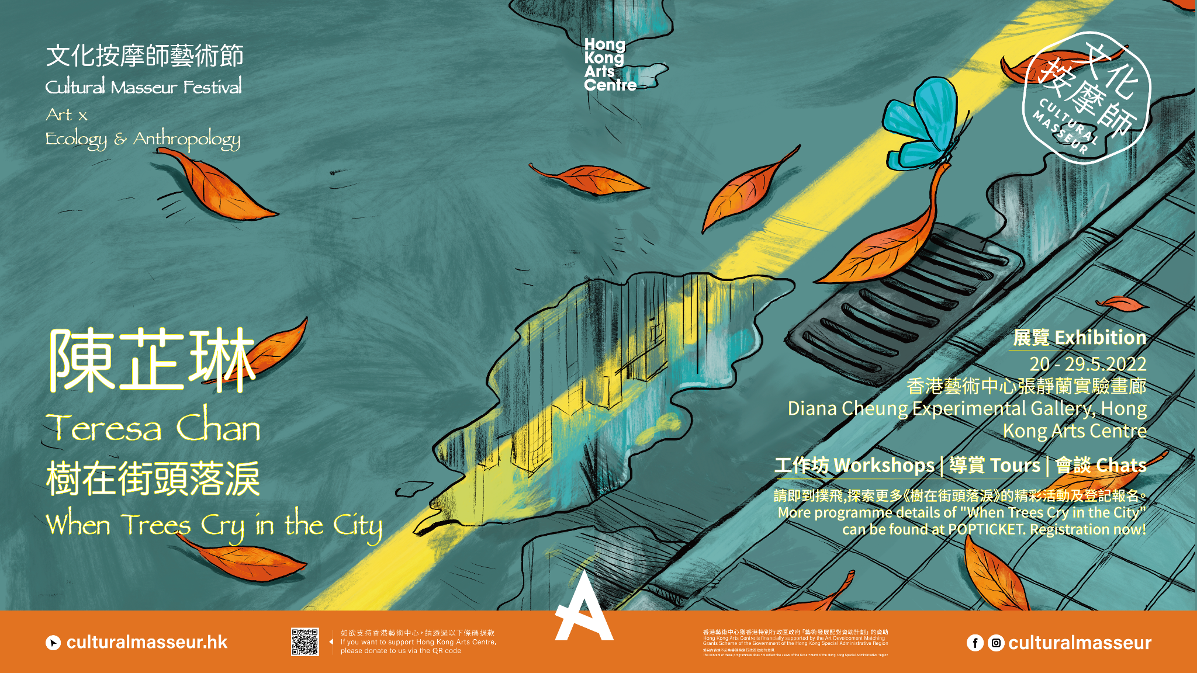

“When Trees Cry in the City” celebrates and explores the meaning of existence of the street trees from a new artistic perspective. The project takes place in Wan Chai because of its rich heritage manifesting the collective memories of Hong Kong people. The current Hong Kong roadside urban forest is dominated by about 20 common tree species. No matter native or exotic species, they have been living together with us for a long time to witness what is happening in the city. People come and go while the trees stay. With anthropological and ecological approaches, the project uses street trees and their fallen leaves as a medium to connect the minds and emotions of people and trees, so as to take some of the burdens off us as individuals living in Hong Kong.

The project is a Self Institute Seed Project which comprises three components: 1) Wan Chai Tree Tour Map; 2) Leaf Craft Stories Exhibition; and 3) experiential activities including tours, workshops and fireside chats.

The Tree Tour Map introduces trees of historical significance or related to the neighbourhood, bringing Hong Kong people to explore Wan Chai. Residents and artists are invited to share photos, sketches or any creations of the tree’s locations, developing daily life connections with street trees, and promoting coexistence between humans and trees.

The Leaf Craft Stories Exhibition showcases the fallen leaf craft artworks and photos with historical stories behind. The guided tours introduce the basic knowledge of plant identification and how to observe a leaf. By attending the workshops and fireside chats, participants will further understand the project intention and contribute to the discourse on the nature-culture divide.

《When Trees Cry in the City》Event Listing

- Pre-exhibition Event (1) Capture a Tree: Ecological Photography Workshop

As one of the public engagement events of “When Trees Cry in the City”, the workshop will lead participants through observing the street trees and the surrounding ecology. Explore the urban forest and coexistence between humans and trees with eyes and lens.

*All works by participants can be shared to the “Wai Chai Tree Tour Map” online platform.

Instructor biography: Pan Lau is a senior ecology educator with over 10 years experience in local conservation efforts. He is also an expert on birds, reptiles and amphibians in Hong Kong. His photography works are commonly used for education purposes

Session | Date | Time | Venue | Fee
1 | May 7 (Sat) | 9:30 - 11:00 | Wan Chai | Free

- Pre-exhibition Event (2) Draw a Tree: Urban Sketching Workshop

As one of the public engagement events of “When Trees Cry in the City”, the workshop will teach participants urban sketching techniques with watercolour drawing tools provided. Appreciate the beauty of street trees and turn these creatures into your own art creation.

*All works by participants can be shared to the “Wai Chai Tree Tour Map” online platform.

Instructor biography: Wai Wai is a local illustrator and silhouette artist who published "A Love Letter to Yau Ma Tei", her mural painting done at 618 Shanghai Street was shortlisted in the 2020 World Illustration Awards..

Session | Date | Time | Venue | Fee
1 | May 14 (Sat) | 15:30 - 16:30 | Wan Chai | HKD$100

- Exhibition: When Trees Cry in the City（ 10 days ）

The Leaf Craft Stories Exhibition showcases the fallen leaf craft artworks and photos with historical stories behind. The guided tours introduce the basic knowledge of plant identification and how to observe a leaf. By attending the workshops and fireside chats, participants will further understand the project intention and contribute to the discourse on the nature-culture divide.

Session | Date | Time | Venue | Fee
1 | May 20 to 29 | 10:00 - 18:00 | Diana Cheung Experimental Gallery, Hong Kong Arts Centre | Free

- Exhibition Tour with Curator（ Weekday/ Weekend )（ 8 sessions ）

The curator will lead participants through the exhibition “When Trees Cry in the City”, exploring the historical stories of Wan Chai behind the fallen leaf craft artworks and photos related to the tree tour map. Through interactive exercises, participants will learn how to identify street trees by looking at a leaf and their living conditions.

Session | Date | Time | Venue | Fee
Weekday | May 20 (Fri) | 13:15 – 14:00 | Diana Cheung Experimental Gallery, Hong Kong Arts Centre | Free
 | May 23 (Mon)
 | May 25 (Wed)
 | May 27 (Fri)
Weekend | May 21 (Sat) | 14:15 – 15:00
 | May 22 (Sun)
 | May 28 (Sat)
 | May 29 (Sun)

- Experiential Workshop: Wan Chai Street Tree Walk

The walk will begin at the Hong Kong Arts Centre, participants will be observing and learning different species of street trees in Wan Chai, as well as discovering the importance of trees in urban city life.

Biography: Dr. Law Man Suet Michelle, Ph.D of The Chinese University of Hong Kong (CUHK), Lecturer of the School of Life Sciences at CUHK specialising in soil ecology and ecosystem functioning of earthworm communities. ISA Certified Arborist and holder of Lantra Awards certificate (UK). She has participated in many local vegetation surveys and forest community studies, as well as the biodiversity education projects.

Session | Date | Time | Venue | Fee
1 | May 21 (Sat) | 15:30 - 16:30 | Wan Chai | Free

- Experiential Workshop: Leaf Art Family Workshop

The family workshop of “When Trees Cry in the City” exhibition will lead children and their parents to observe the structure of leaves and learn about the common species of street trees in Hong Kong. Children will make their own leaf crafts and picture books will be prepared for parents to read with them to further their imagination and emotional expression.

Session | Date | Time | Venue | Fee
1 | May 22 (Sun) | 12:00 - 13:30 | Online | HKD$100

- Fireside Chat (1) The History of Wan Chai Trees - Hong Kong Greening Initiatives

The first fireside chat will talk about the urban forest of Wan Chai such as Victoria Park, Hong Kong Cemetery and Dominion Garden. Discover the diverse species and historical values of the street trees and discuss the greening initiatives of Hong Kong.

Speaker Biography:
Jan Lai, Co-founder and President of Green Sense. Established in 2004, Green Sense aims to point out the non-environmentally friendly practices in society through research and monitoring, and enhance the environmental consciousness by education and publicity.

Session | Date | Time | Venue | Fee
1 | May 28 (Sat) | 15:15 - 16:15 | Eric HoTung Studio, Hong Kong Arts Centre | Free

- Fireside Chat (2) Hong Kong Cultural Landscapes from Oral History

Oral history focuses on the experiences, sentiments and subjective memories of people which are usually developed from their everyday life at a particular place. Sharing people’s stories about the place makes it possible for us to communicate, understand and identify with each other as a community. Therefore, a “place” does not only conceive a geographical meaning, but its social and cultural representation. In the second fireside chat the speaker will share her experiences in these aspects and discuss the methods of collecting people’s memories for art creations and community studies.

Speaker Biography:
Dr. Wong Wai-ling, Ph.D in Sociology of The University of Hong Kong (HKU). Her research interests include oral history studies of local communities. She has committed to several community oral history projects, such as Yau Ma Tei, To Kwa Wan, Nga Tsin Wai Village, the water communities in Aberdeen and South Lamma. Her related works include: “Memoryscape: Oral Histories of Fishermen in Aberdeen” (2015), and the online exhibitions on Hong Kong Memory website.

Session | Date | Time | Venue | Fee
1 | May 28 (Sat) | 16:30 – 17:30 | Eric HoTung Studio, Hong Kong Arts Centre | Free

- Fireside Chat (3) The Art of Philosophy: Pick Up Fallen Leaves and Yourself

The curator and her project mentor Yeung Chun Yin (Uncle Salt) will talk about the project ideas and how to deal with changes in life and society by learning from a fallen leaf.

Speaker Biography:
Yeung Chun-yin (Uncle Salt), graduated from the Faculty of Social Sciences of The University of Hong Kong and the Department of Philosophy at The Chinese University of Hong Kong. He went on to study a Ph.D Programme in Humboldt University of Berlin and King’s College London to further his study. In 2016, Uncle Salt and his comrades established the Philosophy study group “Corrupt the Youth”.

Session | Date | Time | Venue | Fee
1 | May 29 (Sun) | 15:30 – 17:30 | Eric HoTung Studio, Hong Kong Arts Centre | HKD$50

Art X Future Possibilities 《Talking Heads Podcast Series》
Event period：April to July 2022
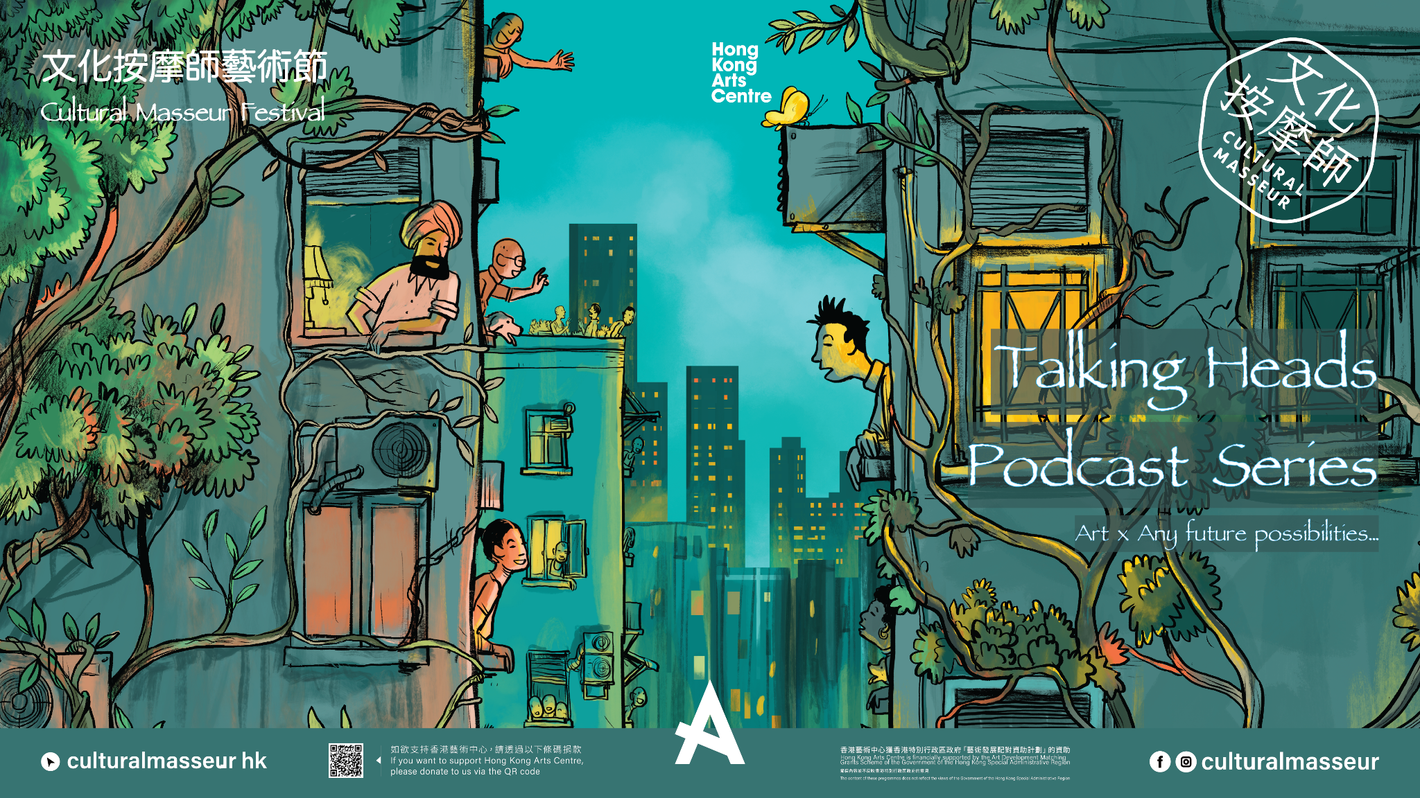
The ‘Cultural Masseur Talking Heads Podcast Series’ serves as a free space for conversations and curious hearts. Our hosts together with guest speakers from all walks of life, will invoke interdisciplinary conversations to explore topics from the up and coming trendies rise of NFT (Non-Fungible Token) to the most ancient question of the body and self relationship.

The podcast is a bi-weekly podcast hosted at the Hong Kong Arts Centre. The latest series is “Corporeality vs Virtuality” , and we will explore where humanity is heading towards with the rise of the ‘metaverse’. Does the physical world still matter when almost everything today can go virtual? Will immortality come true?

Get ready for a mind-blowing journey with us at Cultural Masseur Talking Heads Podcast!

《Talking Heads Podcast Series》Event Listing
Session | Date | Theme | Overview
1 | April 14 (Thur) | Metaverse: A Myth Comes True | The Metaverse is not a new concept. Since the dawn of civilization, humans have been living in multiple imagined realities in a culture-nature duality. But with the rise of the metaverse, do these ancient imaginations come true? In this episode, Cultural Masseur Talking Heads Podcast Series will take out the speculative tokenomics undertones of the Metaverse and explore its various dimensions starting with the philosophical lens.
2 | April 28 (Thur) | Metaverse 101 | In this episode, Cultural Masseur Talking Heads Podcast Series will feed everybody with the most fundamental concepts about the Metaverse, such as blockchain technology and its applications. We will shed light on how this technology is going to revolutionise our today and our future.
3 | May 12 (Thur) | Metaverse and the Body and Mind | The rise of the Metaverse begs the question of whether the human body still matters in the future. Indeed the Metaverse is opening up a world of infinite possibilities where only your imagination is the limit. But then does it mean that we can just leave behind our corporeal existence? What significance does our body then leave with?
4 | May 26 (Thur) | The Metaverse Experience | Are sensorial experiences seemingly lost in the Metaverse? Scientists are now working to rewire human sensations by developing wearable tools for people to explore performative brain waves to control elements virtually. How exactly is the experience like when we venture into the Metaverse?
5 | June 16 (Thur) | To be Immortal in the Metaverse | Immortality is one of the oldest dreams of our species. If preserving the mind in the Metaverse is possible, our conscience can really live forever, as long as the servers and the internet itself do not break down. “I think therefore I am” will no longer merely be a philosophical statement but a reality come true and will redefine the meaning of being alive.
6 | June 30 (Thur) | “Meme-taverse” | Meme is defined as “an image, video, piece of text, etc., typically humorous in nature, that is copied and spread rapidly by internet users, often with slight variations”. The transmission of memes often carries a prophetic nature and reveals to us what humanity is heading towards. What then, do memes have to say about the Metaverse?
7 | July 28 (Thur) | Metaverse as our New Paradise for Creativity | Having discussed so many different aspects about the Metaverse, we will turn our attention to its implication on creativity. Does the seemingly ‘free’ world ignite more creativity or will the opposite prevail? This episode will be taking place in a form of the Metaverse itself.

