OUAT_Image Title

朱成Samson CHU  自畫像Self-portrait  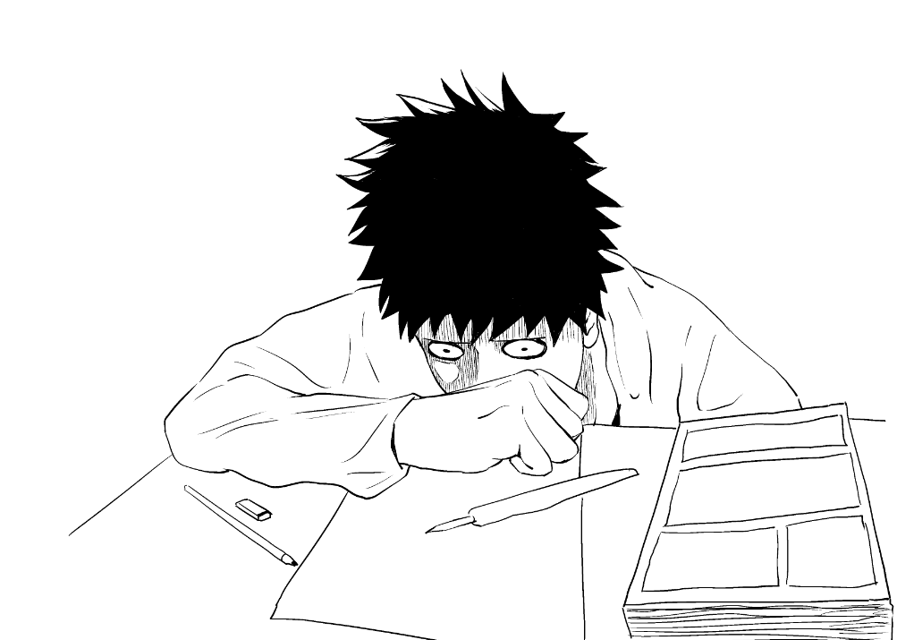 | 朱成Samson CHU  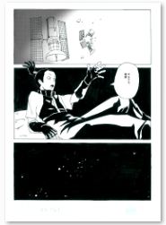  CHI: 再見地球  ENG: Goodbye, Earth
朱成Samson CHU  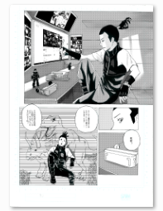  CHI: 再見地球  ENG: Goodbye, Earth | 朱成Samson CHU  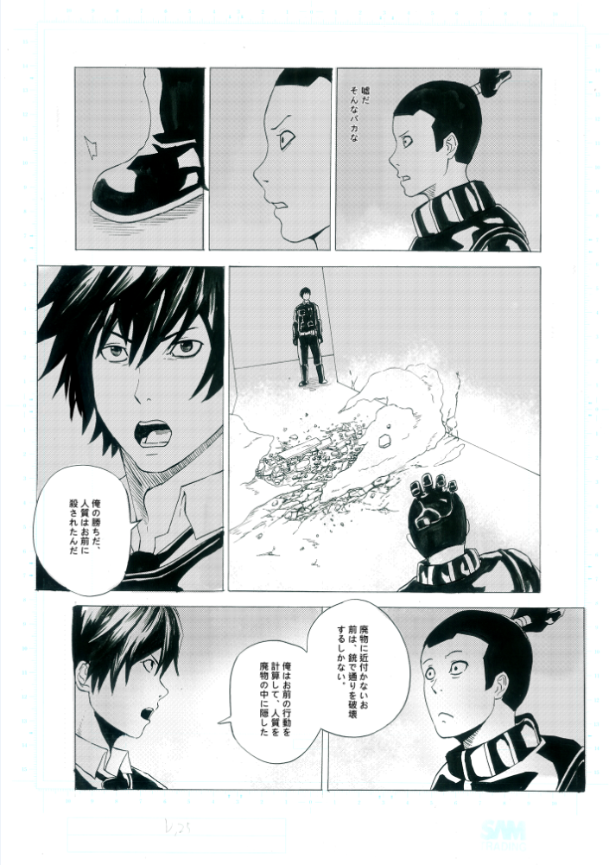  CHI: 再見地球  ENG: Goodbye, Earth
多利Dolly LEE  自畫像Self-portrait  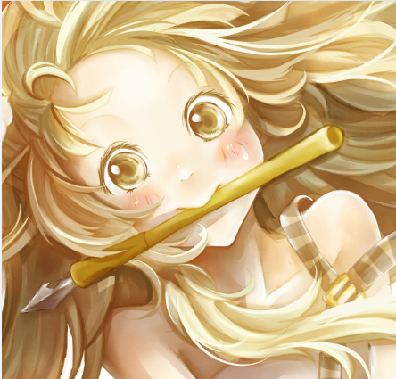 | 多利Dolly LEE  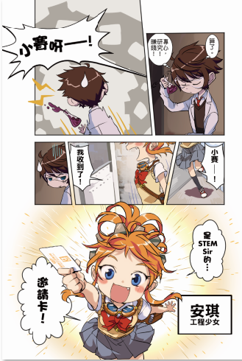  CHI: STEM少年偵探團  ENG: STEM Junior Detectives
多利Dolly LEE  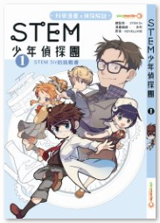  CHI: STEM少年偵探團  ENG: STEM Junior Detectives | 多利Dolly LEE  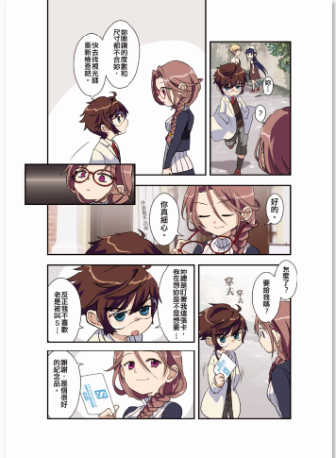  CHI: STEM少年偵探團  ENG: STEM Junior Detectives
李健良Kin-leung LEE  自畫像Self-portrait  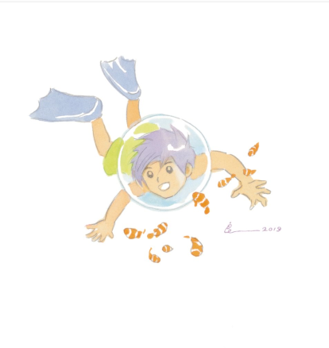 | 李健良Kin-leung LEE  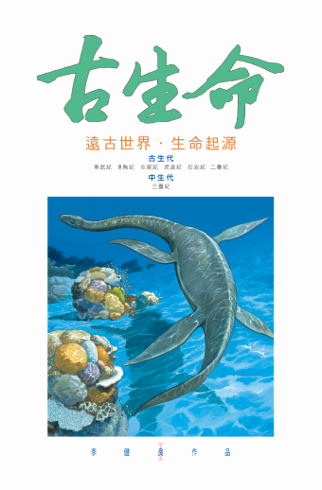  CHI: 古生命  ENG: Prehistorical Life
李健良Kin-leung LEE  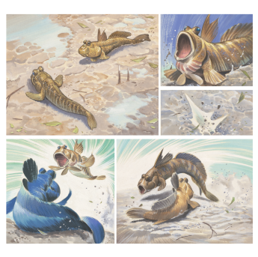  CHI: 《紅樹林‧香港濕地生態》  ENG: NA | 李健良Kin-leung LEE  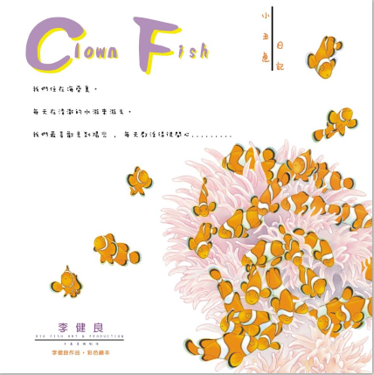  CHI: 小丑魚成長日記  ENG: Clown Fish
麥少峯Siu-fung MAK  自畫像Self-portrait  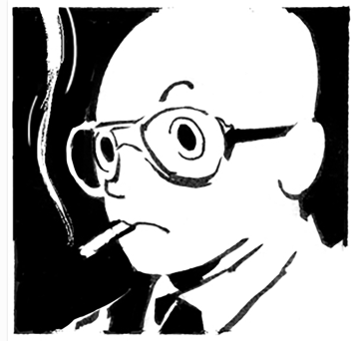 | 麥少峯Siu-fung MAK  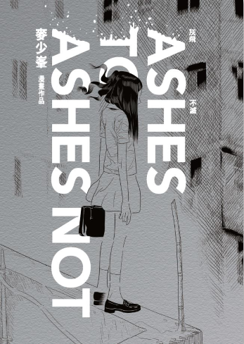  CHI: 灰飛不滅  ENG: Ashes to Ashes Not
麥少峯Siu-fung MAK  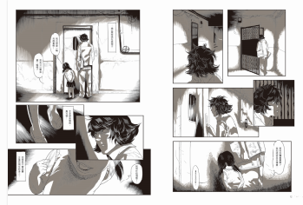  CHI: 灰飛不滅  ENG: Ashes to Ashes Not | 麥少峯Siu-fung MAK  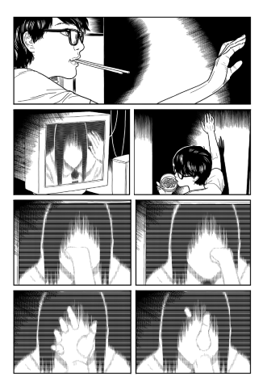  CHI: 黃油紙路  ENG: Yellow Lard-paper Road.
YANAI  自畫像Self-portrait  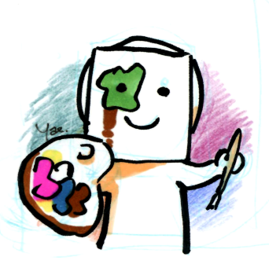 | YANAI  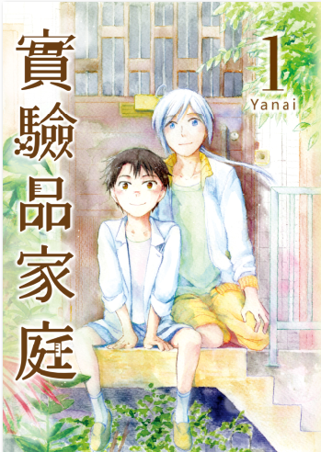  CHI: 實驗品家庭  ENG: Frankenstein Family
YANAI  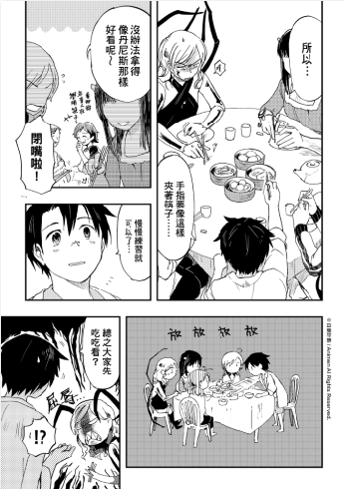  CHI: 實驗品家庭  ENG: Frankenstein Family | YANAI  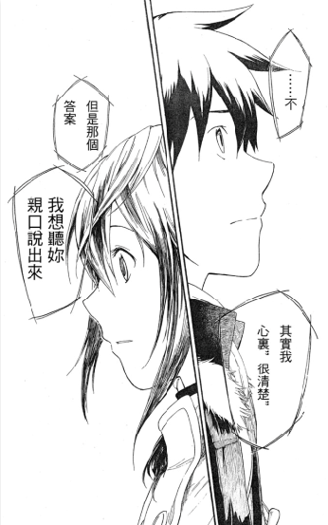  CHI: Denpa  ENG: Denpa
紙本分格zbfghk  LOGO | 紙本分格zbfghk  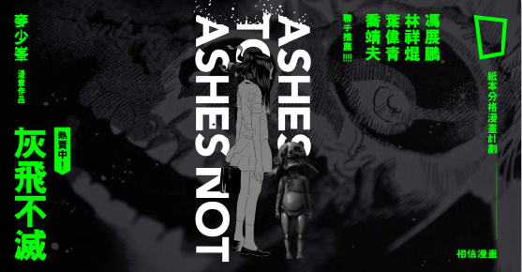  CHI: 紙本分格首個出版項目《灰飛不滅》  ENG: The first publishing project ”Ashes to Ashes Not” by zbfghk
紙本分格zbfghk
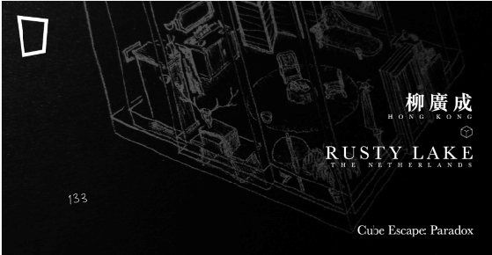
CHI: 紙本分格設計項目《Cube Escape: Paradox》
ENG: Publishing project “Cube Escape: Paradox” by zbfghk
彭俊波Henry PANG  自畫像Self-portrait | 彭俊波Henry PANG  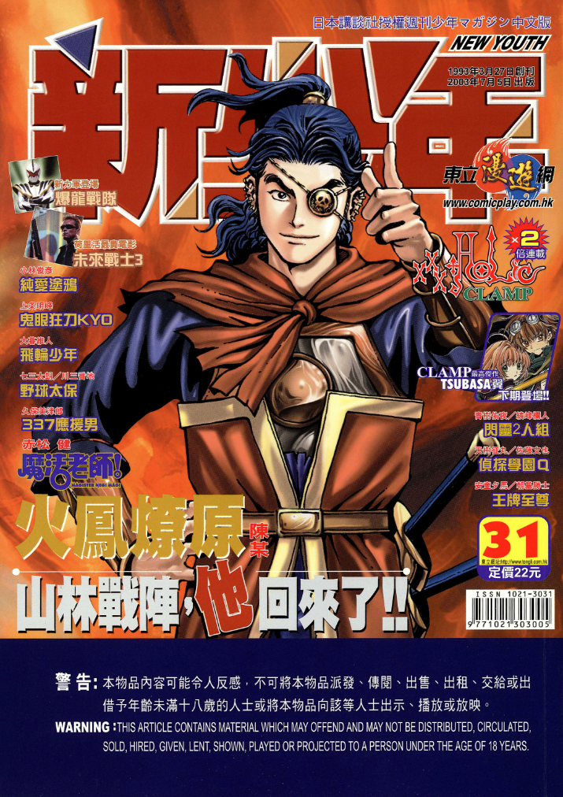  CHI: 彭俊波編輯之漫畫期刊《新少年》  ENG: The comics magazine “New Youth” edited by Henry Pang
彭俊波Henry PANG  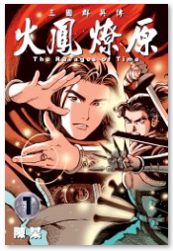  CHI: 彭俊波編輯之長篇劇情漫畫《火鳳燎原》  ENG: The drama comics “The Ravages of Time” edited by Henry Pang | 彭俊波Henry PANG  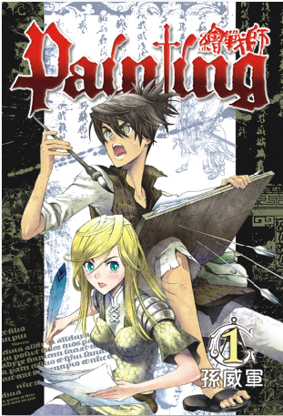  CHI: 彭俊波編輯之長篇劇情漫畫《繪戰師》  ENG: The drama comics “Painting” edited by Henry Pang
Claire Malary  Self-portrait  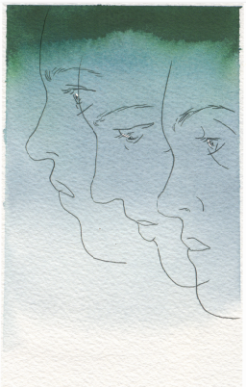 | Claire Malary  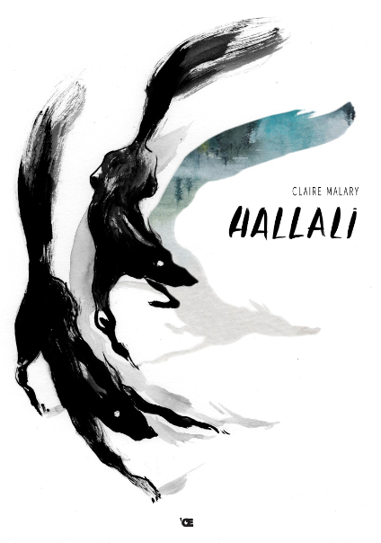  ENG: Hallali
Claire Malary  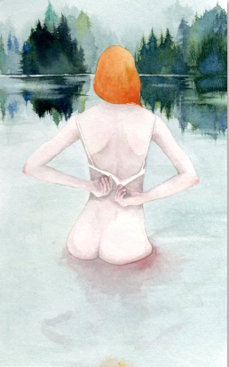  ENG: Hallali | Claire Malary  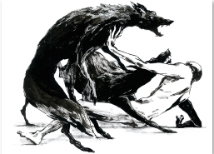  ENG: Hallali
Claire Malar
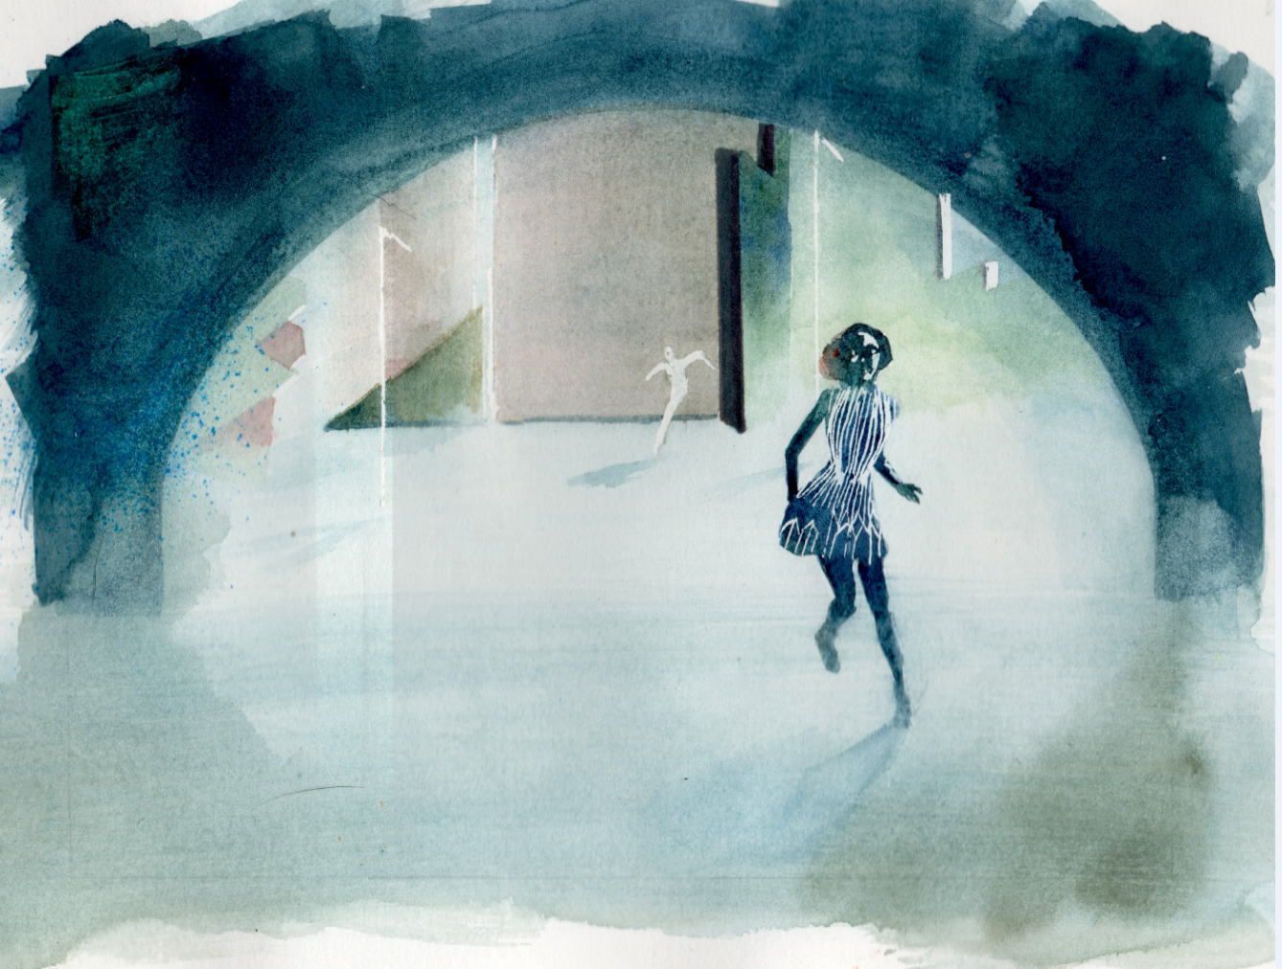
ENG: Hallali -Tunnel
Futuropolis ( LOGO ) | Sébastien GNAEDIG (Editor-in-Chief of Futuropolis) - Self-portrait  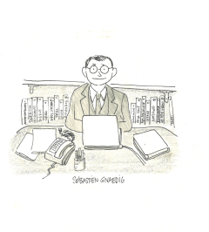
Sébastien GNAEDIG
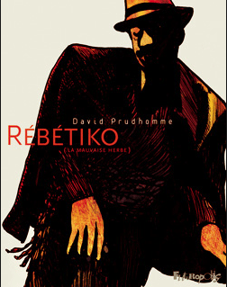
CHI: Futuropolis 出版之漫畫《Rebetiko》，
作者: David Prudhomme
ENG:《Rebetiko》published by Futuropolis ,
Author : David Prudhomme
Sébastien GNAEDIG  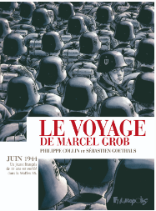  CHI: Futuropolis 出版之漫畫《Le voyage de Marcel Grob》作者: Sébastien Goethals & Philippe Collin  ENG: “Le voyage de Marcel Grob” published by Futuropolis ,  Author: Sébastien Goethals & Philippe Collin | Sébastien GNAEDIG  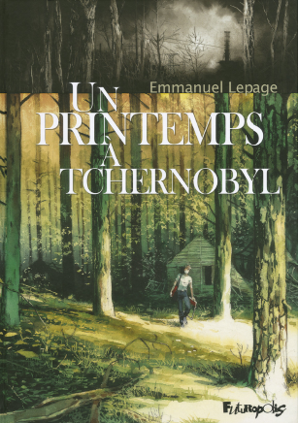  CHI: Futuropolis 出版之漫畫《Un printemps à Tchernobyl  》  作者: Emmanuel Lepage  ENG: “Un printemps à Tchernobyl ” published by Futuropolis ,  Author: Emmanuel Lepage
Sébastien GNAEDIG  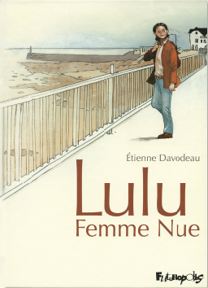  CHI: Futuropolis 出版之漫畫《lulu femme nue3》  作者: Etienne Davodeau  ENG: “lulu femme nue3” published by Futuropolis ,  Author: Etienne Davodeau | Actes Sud BD (LOGO)  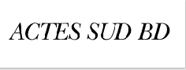
Thomas GABISON (Director of Collection Actes Sud BD） Self-portrait  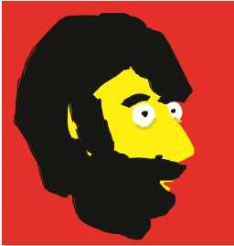 | Thomas GABISON  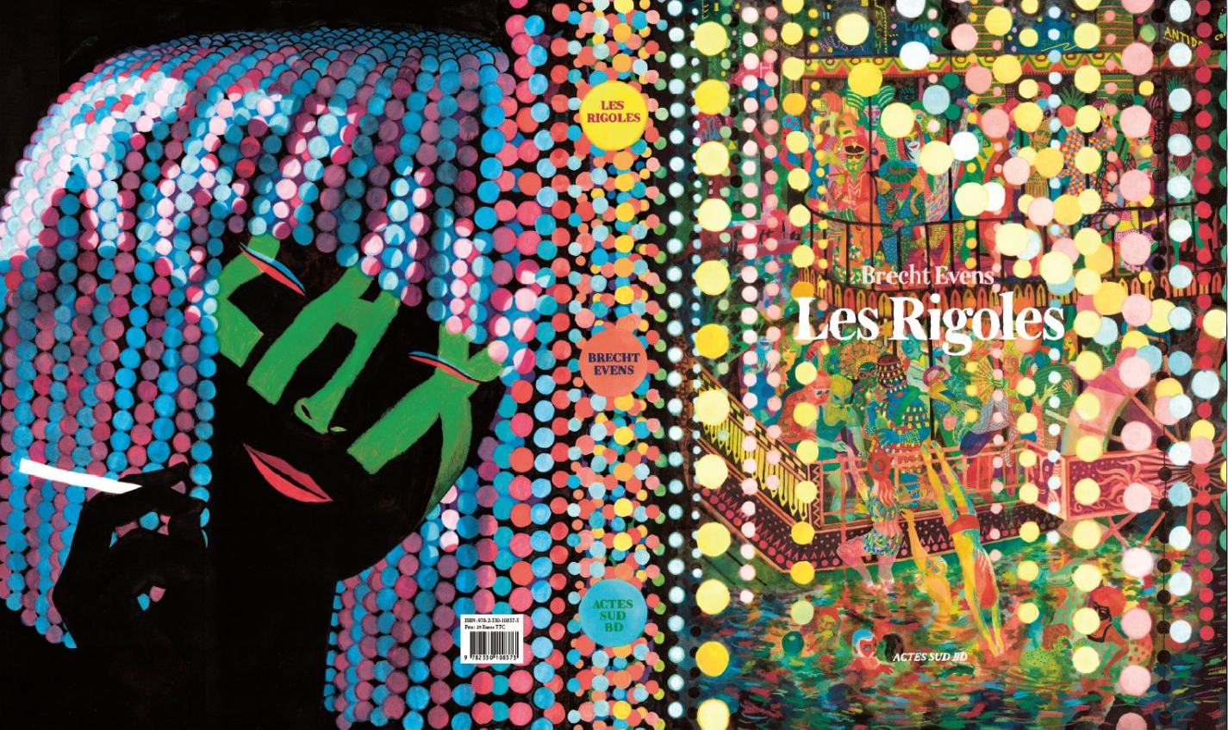  CHI: Actes Sud BD出版之漫畫《Les Rigoles》  作者: BRECHT EVENS  ENG: “Les Rigoles” published by Actes Sud BD  Author : BRECHT EVENS
Thomas GABISON  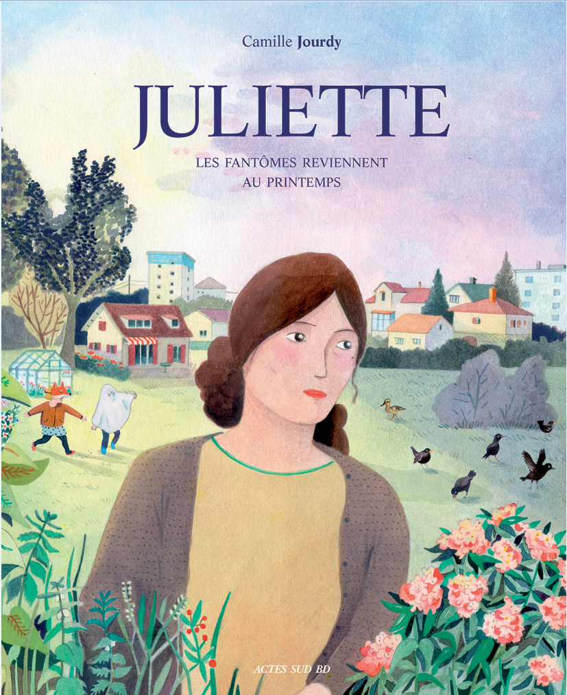  CHI: Actes Sud BD出版之漫畫《Juliette》  作者: Camille Jourdy  ENG: “Juliette” published by Actes Sud BD  Author: Camille Jourdy | Thomas GABISON  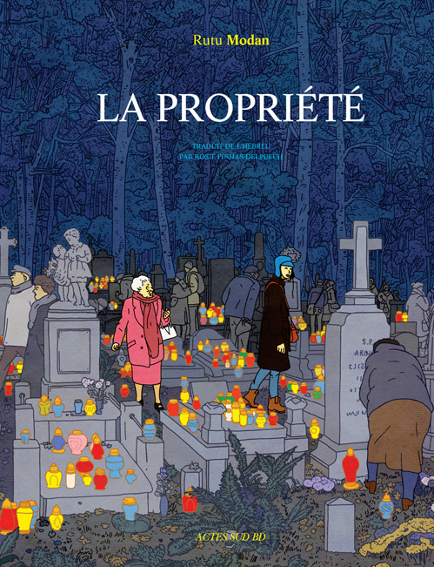  CHI: Actes Sud Bd出版之漫畫《La propriété》  - 作者: Rutu Modan  ENG: “La propriété”, Published By Actes Sud Bd  - Author:Rutu Modan
Thomas GABISON  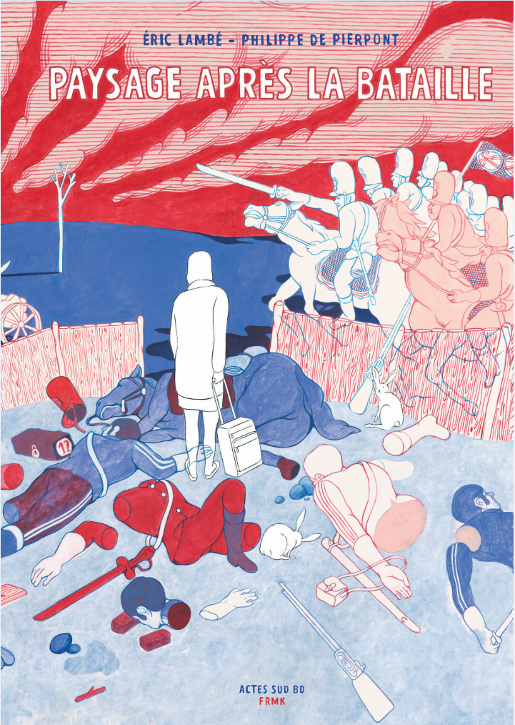  CHI: Actes Sud Bd出版之漫畫《Paysage après la bataille》  作者: Eric Lambe & Philippe De Pierpont  ENG: “Paysage après la bataille” Published By Actes Sud Bd  Author: Eric Lambe & Philippe De Pierpont | Stephane Levallois  Self-portrait  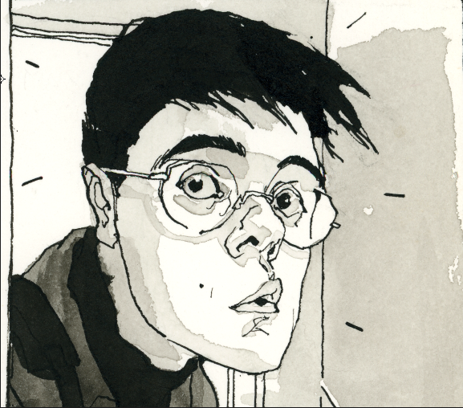
Stephane Levallois  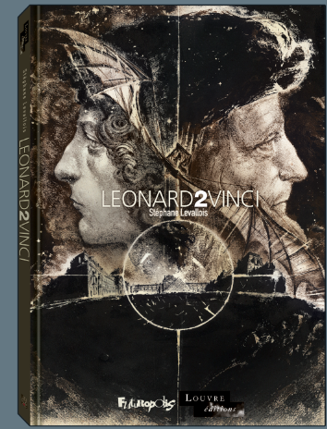  CHI: Futuropolis出版之漫畫《Leonard2Vinci》封面  ENG: “Leonard2Vinci” Published By Futuropolis, cover | Stephane Levallois  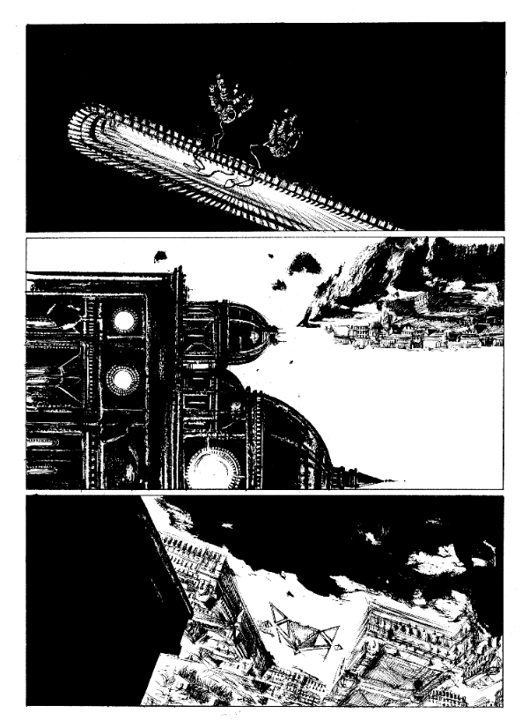  CHI: Futuropolis出版之漫畫《Leonard2Vinci》第5頁  ENG: “Leonard2Vinci” Published By Futuropolis, Page 5
Stephane BEAUJEAN (Artistic Director of Angouleme International Comics Festival)
