OUAT_Image Title

朱成Samson CHU  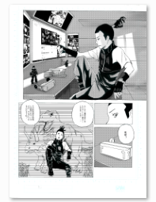  CHI: 再見地球  ENG: Goodbye, Earth | 朱成Samson CHU  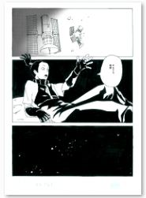  CHI: 再見地球  ENG: Goodbye, Earth
多利Dolly LEE  CHI: STEM少年偵探團  ENG: STEM Junior Detectives | 多利Dolly LEE  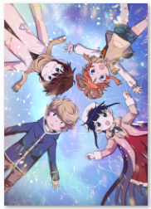  CHI: STEM少年偵探團  ENG: STEM Junior Detectives
李健良Kin-leung LEE  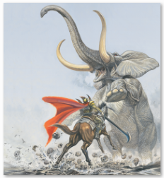  CHI: 黑武士  ENG: Dark Rider | 李健良Kin-leung LEE  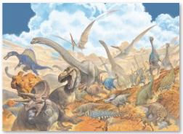  CHI: 古生命  ENG: Prehistorical Life
麥少峯Siu-fung MAK  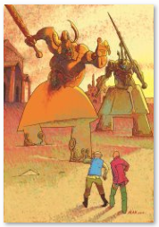  CHI: Back to Base  ENG: Back to Base | 麥少峯Siu-fung MAK  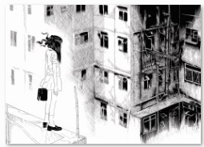  CHI: 灰飛不滅  ENG: Ashes to Ashes Not
YANAI  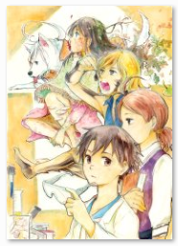  CHI: 實驗品家庭  ENG: Frankenstein Family | YANAI  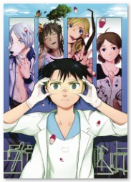  CHI: 實驗品家庭  ENG: Frankenstein Family
紙本分格zbfghk  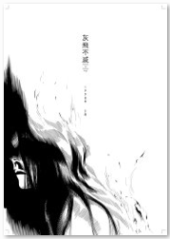  CHI: 灰飛不滅  ENG: Ashes to Ashes Not | 紙本分格zbfghk  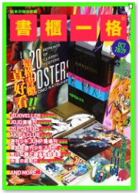  CHI: 書櫃一格_海報  ENG: Event Poster
彭俊波Henry PANG  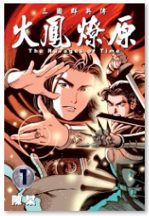  CHI: 火鳳燎原  ENG: The Ravages of Time | 彭俊波Henry PANG  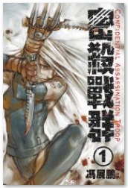  CHI: 密殺戰群  ENG: Confidential Assassination Troop

