Chan Clair Ka Kiu

Artist Biography
Chan Clair Ka Kiu (b. 1995) is an artist using videos and paintings as her main media. With help of different materials and installations, Chan depicts a picture of the attitude in the generation she stood in. Through the conversations in her artworks, she discuss the lightness/heaviness of the happenings and the emotions. Chan finds art as the means to merge literature, philosophy and pop-culture into daily events without boundaries.

Artwork List

- I will be back, Chan Ka Kiu, 2018
Oil on Canvas, set of 2, 121 x 91 cm
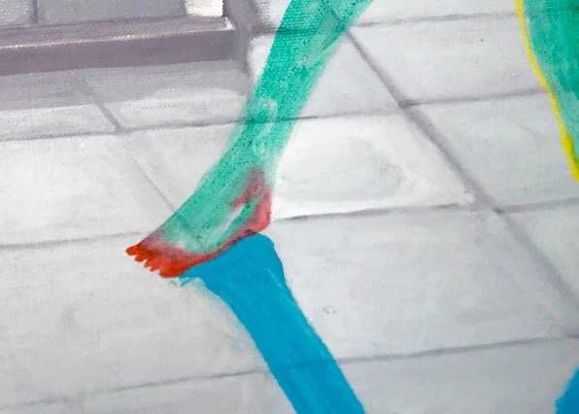

“ If death is a kind of fate, then what is flu?”

- Pocket Cure, Chan Ka Kiu, 2018
Mixed media, set of three, size variable
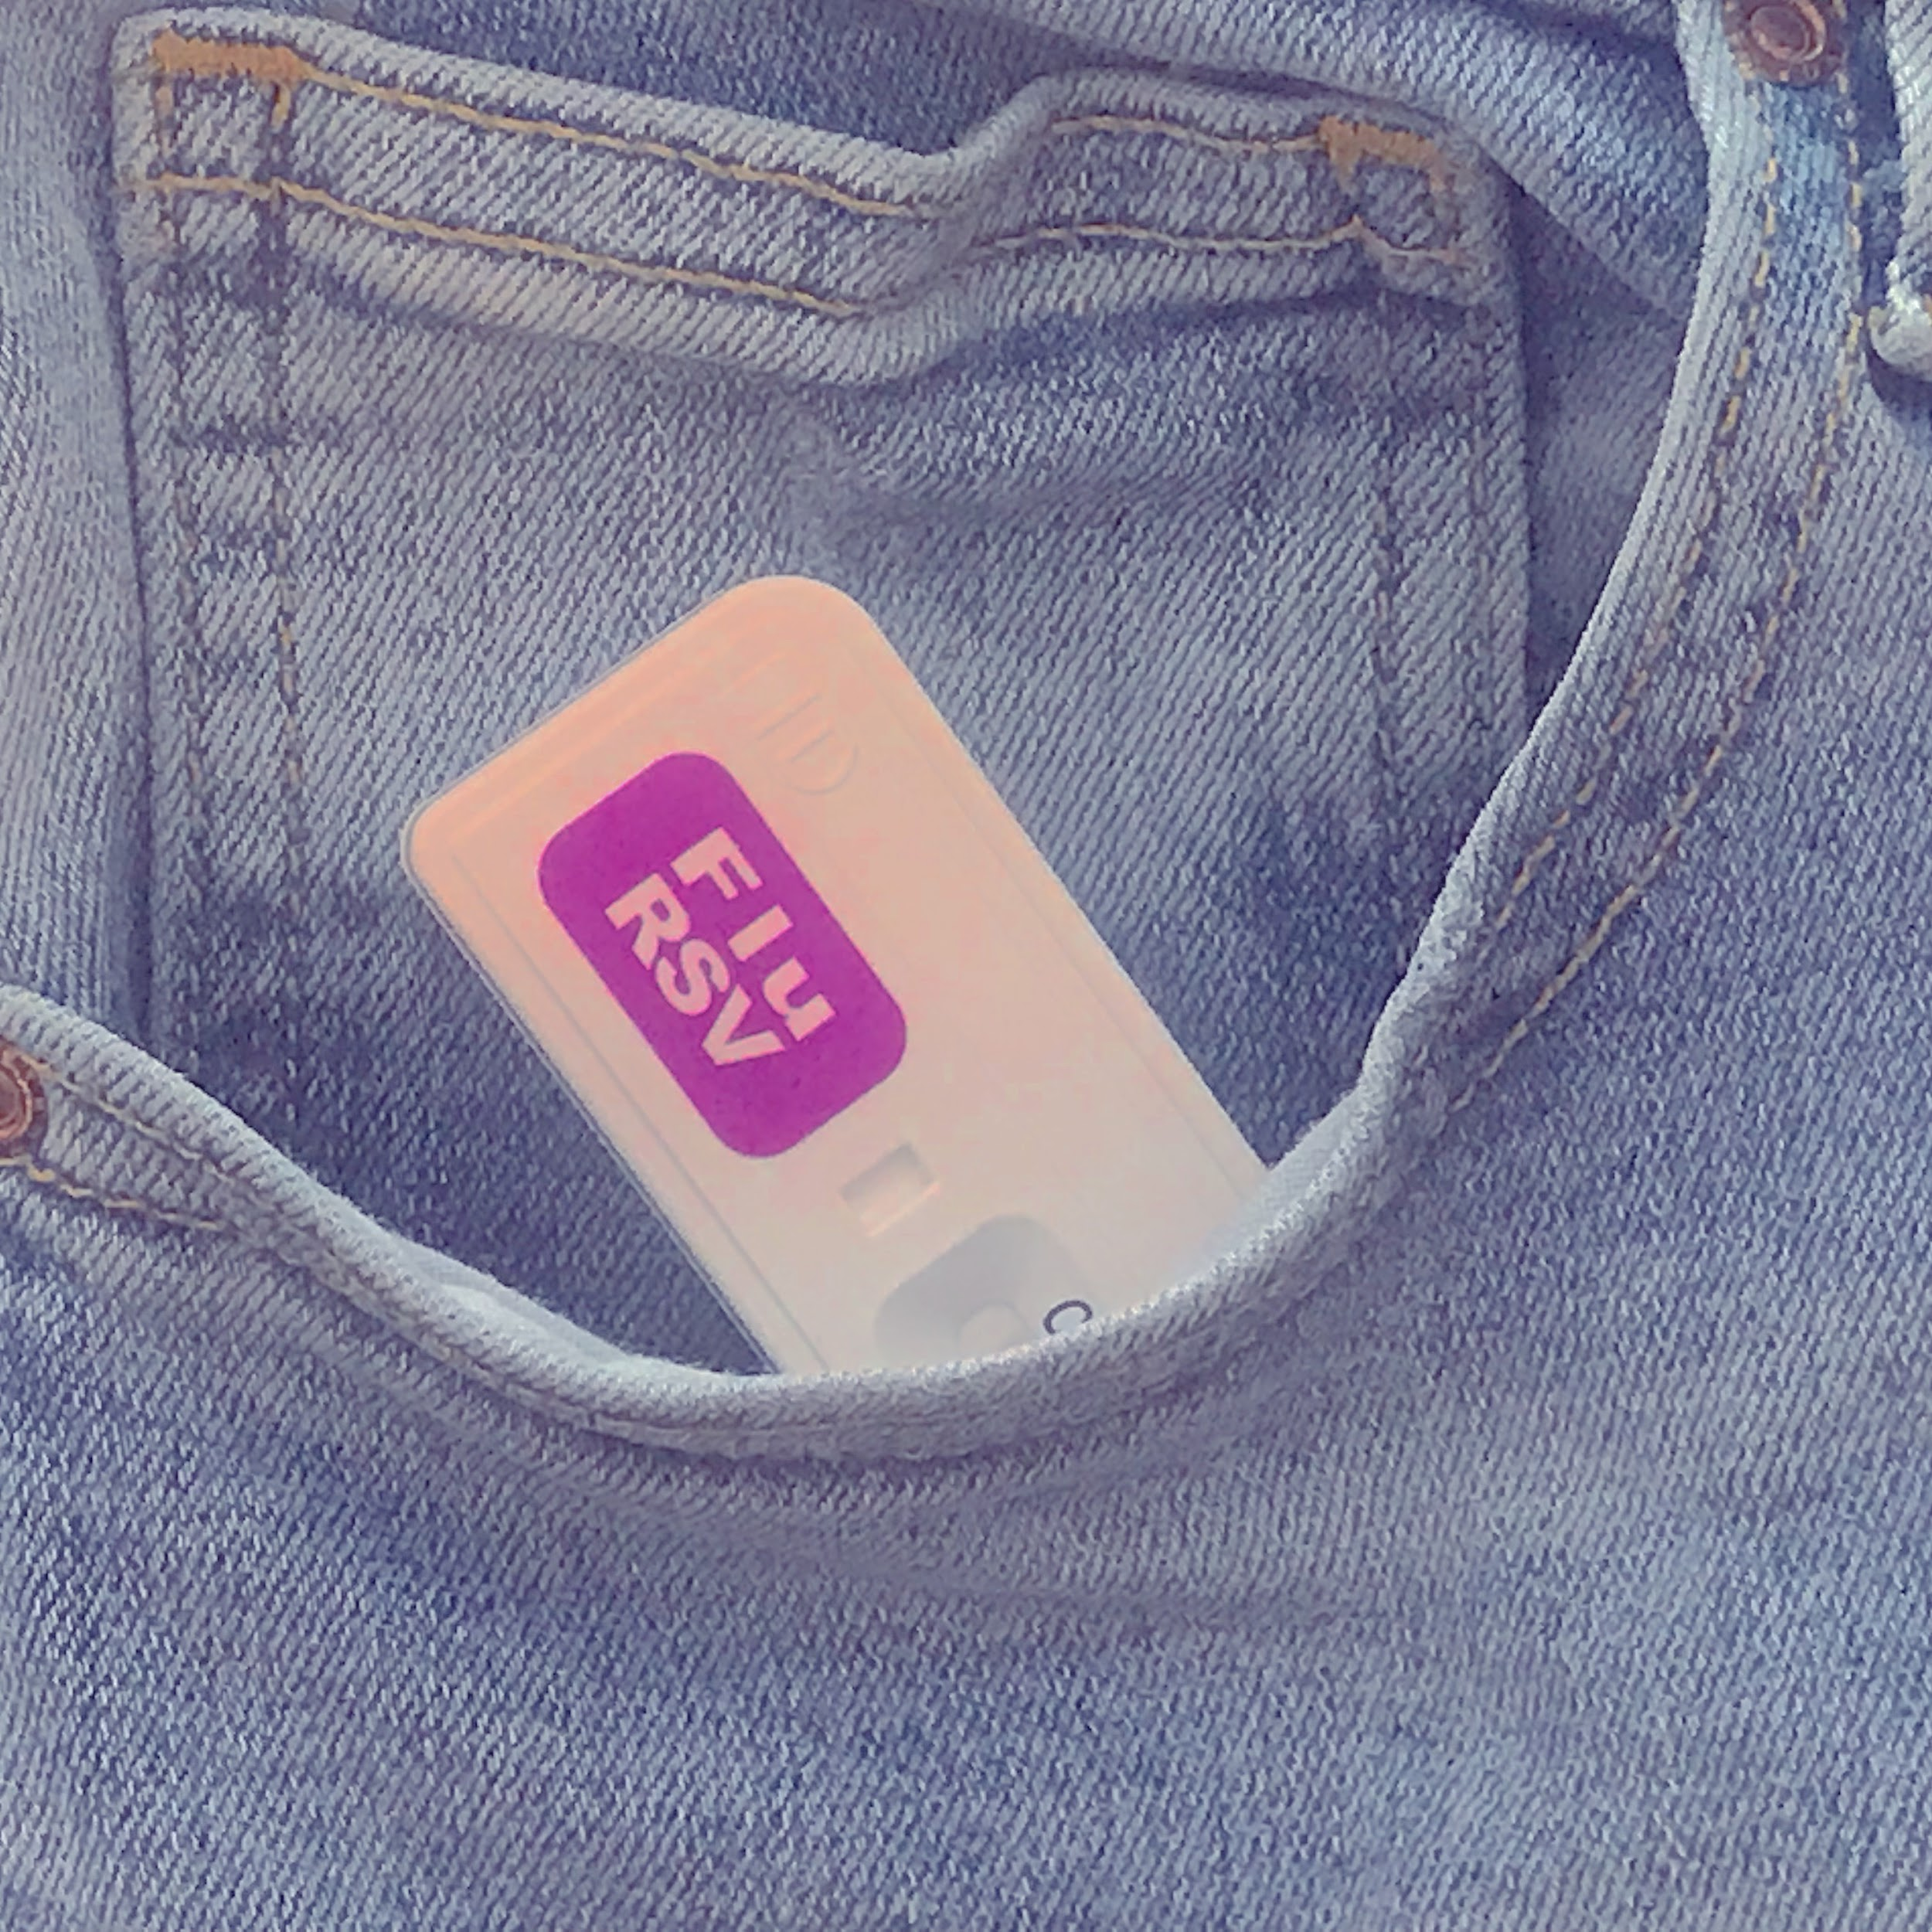

Caught a cold? It okay. We have all natural non-organic no injection needed pocket cure to go through the tough flu days with you. You will not be afraid of cough, nauseous feelings, sneeze anymore!
- So warm inside me, Chan Ka Kiu, 2018
Digital Video, 3’00’’

A virus told me all she wanted was to find a compatible person to live with.

